ENERGY EFFICIENT SYSTEM FOR ST MARTIN’S ISLAND OF BANGLADESH

M. Shamim Kaiser, S K Khadem, H R Ghosh, S Kaiser, S K Aditya
Department of Electronics and Telecommunication Engineering, Daffodil International University,
Dhaka-1207, Bangladesh.
Renewable Energy Research Centre, University of Dhaka, Dhaka-1000, Bangladesh

ABSTRACT

St Martin’s is one of the most beautiful Tourist Islands in Bangladesh where grid connected electric system for the inhabitants will not be possible to establish even in future. Diesel, Kerosene and wood are the main fuels for fulfilling the energy demand. Solar and Wind resources are the hybrid options for the Island. HOMER, a software for optimization of renewable based hybrid systems, has been used to find out the best technically viable renewable based energy efficient system for different numbers of households – 1, 10, 20, 30, 40 and 50. It shows that per unit (KWh) cost of energy varies from 48 to 19 taka.

INTRODUCTION

Saint Martin’s Island is Located on the southern-most tip of Bangladesh, roughly between 20° 34² - 20° 39² N and 92° 18² - 92° 21' E and 17 kilometers off Taknaf, the most southern main land of Bangladesh . The Island is flat and just only about 3m high from the sea level. The island is very much resourceful with enormous biological diversity such as existing fauna and flora Coral, Mollusk, Fish, Amphibian, Turtle, Snail, Bird and Mammals. Besides above coconut tree is the important cash crop [1]. Recently Government has taken decision to formulate a master plan for development and protection of bio-diversity of St Martin''s Island and also to build several establishments for the tourism development at St Martin''s Island [2]
A survey was done by the Sustainable Rural Energy (SRE) Programme of Local Government Engineering Department (LGED) in 2004 and recorded that the population of the Island is 5196 where most of them are fisherman and they belong to 778 families. The annual electric energy demand was found about 359MWh [3]. There is a 30 KW diesel generator in St. Martins Island installed by PDB, but it is not running [4] People meet there energy demand through kerosene, coconut palm or by other biomass plants. Some of the commercial shops and hotels meet their electricity demand by Diesel Generator.
The Island has a good potential of solar and wind energy resources. But till now there has no such activity to use these resources. Therefore HOMER (Hybrid optimization Model for Electric Renewables), a software developed by National Renewable Energy Laboratory (NREL), USA for micro-power optimization model, has been used to find out the best energy efficient renewable based hybrid system options for the Island. It contains a number of energy component models and evaluates suitable technology options based on cost and availability of resources [5]. Analysis has been done for single home user as well as combination of 10, 20, 30, 40 and 50 home users to get the most economic and technical viable options.

AVAILABILITY OF ALTERNATE ENERGY SOURCES

There is no ground measurement data of solar radiation for the Island. But from the NASA satellite, it has been found that the annual solar insulation over St Martin is 4.84 kwh/m²/day [6]. An estimation of solar insulation on horizontal surface has been done by using well known Angstrom Correlation and the sunshine hour data of Teknaf, Bangaldesh Meteorological Department, the nearest meteorological station from St Martin’s. Also a method has been developed by DLR, Germany which is a combination of DLR / SUNY –model output for Global Horizontal Insulation (GHI) is sampled for 10 km spatial resolution, and the calculated data has been collected from the SWERA Geospatial Toolkit for Bangladesh, developed under the SWERA project [7]. Table 1 shows the values of monthly solar insulation on horizontal surface for St Martin, observed from NASA for the period of 10 years (1983 – 1993) and estimated values from Teknaf sunshine data, also for 10 years (1992 – 2001). DLR method used three years (2000, 2002, 2003) satellite data for cloud cover, aerosol optical depth, water vapor to calculate GHI.

For Wind resources information, Bangladesh Council for Scientific and Industrial Research (BCSIR) has measured wind speed for the period of three years (1999 – 2001) at a height of around 30 meters above the ground level. Table 2 shows the monthly averaged measured wind speed at 30 m height and the NASA values for the same location at 10m height for terrain similar to airport. It has been found that wind speed goes to maximum and minimum at around 10 o’clock in the night and morning of local time respectively.

Biomass could be an alternative for energy sources. There are about 9000 coconut trees and 470 different kinds of fruit trees in the Island [1]. But for the analysis biomass has not been considered as the production seems not to be sufficient. Seven tidal gauge stations were set up by Bangladesh University of Engineering and Technology (BUET) for the feasibility study of tidal energy [8]. But the result was not in favor. So, only the solar and wind sources have been considered to find out the best hybrid options of renewable based efficient system.

Table 1: GHI values for St Maritn’s Island
Month | NASA | Estimated (from sunshine) | DLR
Jan | 4.84 | 4.00 | 4.63
Feb | 5.46 | 4.44 | 5.04
Mar | 6.41 | 5.37 | 5.62
Apr | 6.48 | 5.87 | 6.47
May | 5.96 | 5.43 | 4.94
June | 3.60 | 4.10 | 3.39
Jul | 3.62 | 3.87 | 3.31
Aug | 3.69 | 3.95 | 3.78
Sept | 4.34 | 4.09 | 3.96
Oct | 4.72 | 4.21 | 4.28
Nov | 4.42 | 3.72 | 4.54
Dec | 4.54 | 3.75 | 4.16
Annual | 4.84 | 4.40 | 4.50

Table 2: Wind Speed data for St Martin’s Island
Month | NASA (10m) | Measured (30m)
Jan | 3.27 | 5.03
Feb | 3.39 | 4.70
Mar | 3.57 | 4.24
Apr | 3.67 | 3.79
May | 3.89 | 5.07
June | 6.27 | 6.17
Jul | 6.35 | 5.56
Aug | 5.64 | 5.78
Sept | 4.05 | 4.47
Oct | 3.27 | 4.11
Nov | 3.24 | 3.53
Dec | 3.10 | 4.11
Annual | 4.14 | 4.71

HYBRID OPTIONS ANALYSIS FOR ENERGY EFFICIENT SYSTEM

A hybrid energy system generally consists of a primary energy sources working in parallel with standby secondary energy storage units. HOMER has been used to optimize the best energy efficient system for St Martin considering different load and wind – PV combination. Figure 1 shows the schematic diagram of a (a) hybrid energy system for power generation and (b) reflects the propose scheme as implemented in HOMER simulation tool. HOMER simulates the operation of a system by making energy balance calculations for each of the 8,760 hours in a year. For each hour, HOMER compares the electric and thermal demand in the hour to the energy that the system can supply in that hour, and calculates the flows of energy to and from each component of the system. For systems that include batteries or fuel-powered generators, HOMER also decides for each hour how to operate the generators and whether to charge or discharge the batteries.
HOMER performs these energy balance calculations for each system configuration that anybody wants to consider. It then determines whether a configuration is feasible, i.e., whether it can meet the electric demand under the conditions that have been specified, and estimates the cost of installing and operating the system over the lifetime of the project. The system cost calculations account for costs such as capital, replacement, operation and maintenance, fuel, and interest.

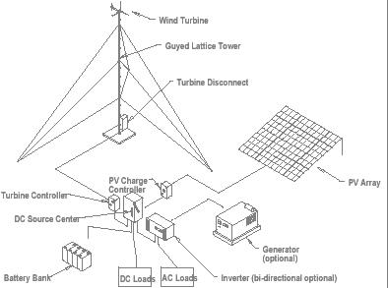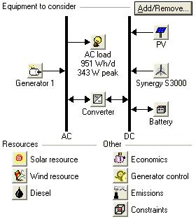

Figure 1: (a) Schematic diagram of hybrid energy system (b) proposed hybrid system in HOMER

Information about the load, resources, economic, constrains, controls and other component that have been used in HOMER are given below;

Electric Load

A typical load system (table 3) for single home in the remote areas has been considered for the analysis. Monthly averaged hourly load demand (Bangladesh perspective) has been given as an input of HOMER and then it generates daily and monthly load profile for a year (figure 2). It has been found that for this system each home user consume energy around 338 Wh/day with a peak demand of nearly 115 W.

Table 3: Appliances for single home user
Appliance | Quantity | Capacity (W) | Maximum use hour / day
Florescence Light | 4 | 10 | 4
B / W TV | 1 | 15 | 4
Radio / Cassette Player | 1 | 5 | 5

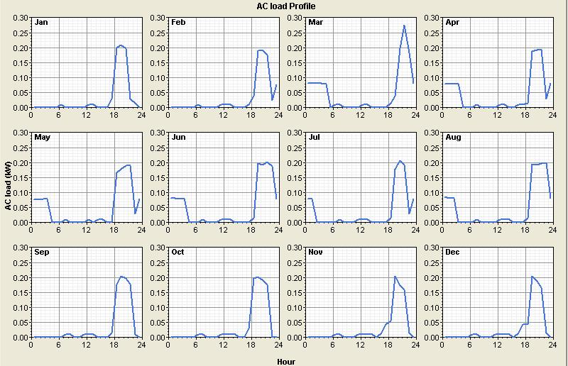
Figure 2: Monthly averaged hourly load profile for a single home user

Renewable Resources

As hourly data is not available therefore monthly averaged global radiation data has been taken from NASA. HOMER introduces clearness index from the latitude Information of the selected site (figure 3). HOMER creates the synthesized 8760 hourly values for a year using the Graham algorithm [9], which results in a data sequence that has realistic day-to-day and hour-to-hour variability and autocorrelation.

For wind monthly averaged (1999 – 2001) measured data from BCSIR have been used along with the information of height = 30m, elevation = 3m asl, surface roughness = 0.01m. HOMER synthesized these monthly average data based on the other parameters such as Weibull factor “k” = 1.8, Autocorrelation factor (randomness in wind speed) = 0.90, Diurnal pattern strength (wind speed variation over a day) = 0.25, Hour of peak wind speed = 22 to generate hourly data for a year. Figure 4 shows (a) the wind speed probability distribution function and (b) averaged hourly wind speed for 1 year.

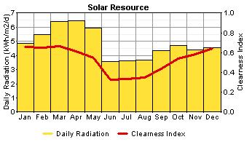
Figure 3:
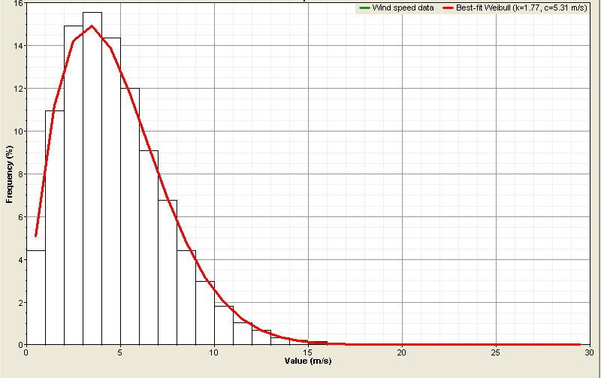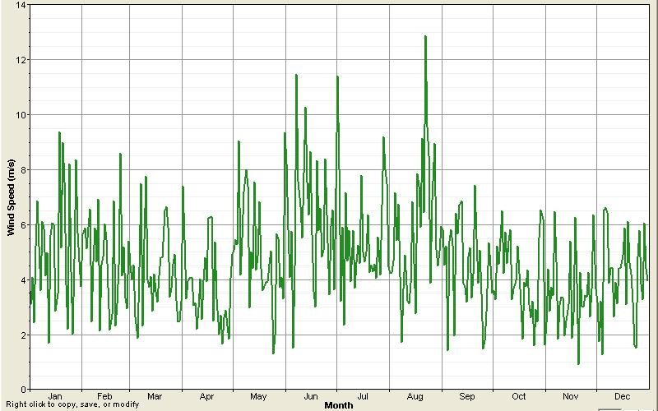
Figure 4: (a) Wind Speed Probability density function (b) daily Wind Speed for St Martin

Hybrid System Components

Photovoltaic Module:
The cost of PV module including installation has been considered as 220 BDT / W for Bangladesh. Life time of the modules has been taken as 25 years and these are tilted at 21 degree with no tracking mode. (1 USD = 63.5 BDT, 2005)

Wind Generator:
The load demand is very low for a single home system and the price per KW turbine cost is very high for low capacity wind turbine compare to that of high capacity ones. Also low capacity wind turbine is not much available. Now a day, research and development are going on to improve the technology and designing low capacity turbine with low cut-in speed at around 2.5 m/s. For these analysis a Synergy S 3000 turbine with a capacity of 0.5 KW has been considered. The cost of the turbine with tower and installation has been considered as 96000 BDT / turbine. For the load higher than 1 KW, turbine from Southwest Windpower, (model: W175, capacity: 3 KW) has been considered at the cost of 200000 DBT/ turbine with tower and installation.

Options analysis was done for only PV and Only Wind also.

Battery with Controller:
As the system considered the DC load only, battery and controller were also as a main part of the system. Battery from Trojan Company (Model: Trojan T- 105, nominal V: 6v nominal capacity: 225 Ah) has been used at a cost of 10,000.00 BDT / battery with charge controller.

Economics and Constraints:
The project life time has been considered to be 25 years and the annual real interest rate has been taken as 4%. As the system has been designed for single and also for multiple home users like 20, 30, 40 and 50 but the load consumed by the user is low so operation and maintenance cost has been taken 500 BDT / year. There is no capacity shortage for the system and operating reserve is 10% of hourly load. No cost subsidy has been taken.

Analysis

Analysis shows that the cost of energy (KWh) is low for the system which is the combination of 50 homes. Table 4 shows the load demand for each combination of homes with system architecture and financial summary. A detailed analysis and system architecture for the 50 homes system has been given figure 5

Table 4: HOMER analysis and results
Home | Load | PV module  (KW) | Wind Generator  (quantity) | Battery  (quantity) | Initial Cost  BDT | Total NPC | COE  (BDT/ KWh)
Single | 338 Wh/day  115 KW Peak | 0.15 | 0 | 2 | 51,890 | 93,470 | 48.5
20 | 6.8KWh/day  2.3 KW peak | 1.0 | 1 | 16 | 580,000 | 841,480 | 21.8
30 | 10.1 KWh/day  3.5 KW | 2.0 | 1 | 24 | 878,890 | 1,263,300 | 21.8
40 | 13.5 KWh/day  4.6 KW | 2.5 | 2 | 24 | 1,188,330 | 1,599,590 | 20.7
50 | 16.9 KWh/day  5.8 KW | 3.5 | 2 | 8  (Surrette 6CS25P) | 1,567,220 | 1,840,985 | 19.1

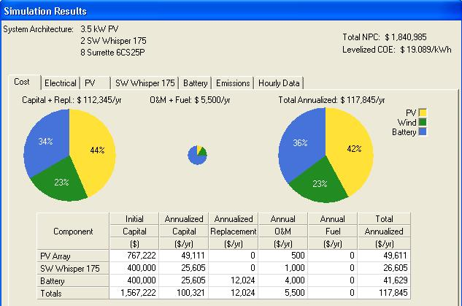
Figure 5: Simulation results for the 50 homes system

CONCLUSION

It could be summarized from the analysis that it will be better to use wind-pv combination system for 50 homes instead of single home system. The overall cost of energy would be low if the turbine cost decreases.

REFERENCE
- Biodiversity and Eco tourism project of St Martin’s, Bangladesh, http://www.stmartinsbd.org
- News from Voice of America, http://www.voanews.com/bangla/2005-01-16-voa3.cfm
- Electricity demand survey report at the St. Martin’s Island, SRE, LGED, Dhaka, Bangladesh, May-2004
- A Hossain, IIFC report “Remote Area Power Supply Systems (RAPSS)”, 2001
- HOMER, V – 2.14, National Renewable Energy Laboratory (NREL), USA, http://www.nrel.gov/homer
- NASA surface meteorology and solar energy, released 5.1, http://eosweb.larc.nasa.gov
- High Resolution Solar Radiation Assessment for Bangladesh, SWERA project, http://swera.unep.net
- S Islam, Tidal data at the St. Martin’s Island, BUET, Bangladesh, 2004
- Graham VA, Hollands KGT, A method to generate synthetic hourly solar radiation globally, Solar Energy, 44 (6), 333-341, 1990

