TOU analysis with HOMER (Initial)

PGE | Fresno | Summer rates | Winter rates | Savings (energy sold to utility)
 |  | May-Oct | Nov-April
TOU Peak | 12-6 m-f | .315 | .116
Off-peak | Evening, sat, sun | .085 | .088 | $2686  13% gain over tiered rates
Tiered rates | I | .116
 | II | .133 | Used this tier | $2395

SCE | Los Angeles
 |  | June-Sept | Oct-May
TOU Peak | 10-6pm m-f | .523 | .177
Off-peak | Evening, sat, sun | .141 | .128 | $4134  21% gain over tiered rates
Tiered rates | I baseline | .130
 | II <130% over baseline | .151
 | III 130-200% | .197
 | IV 200-300% | .236
 | V >300% | .260 | Used averaged II-IV as .192 | $3416

TOU does cause favor to west, but overall savings gain depends on exact rate structure. SCE has many fewer months but many more hours/day, and higher peak rate for summer, so higher gain over tiered rate structure.

[Graph Type: Surface Plot
Look at Grid Energy Cost for both Variables to Plot]

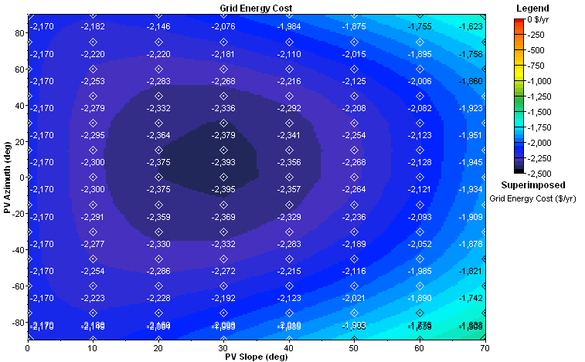
Grid Energy Cost for Tiered Rates (not TOU): PGE
Azimuth = 15 deg to west.

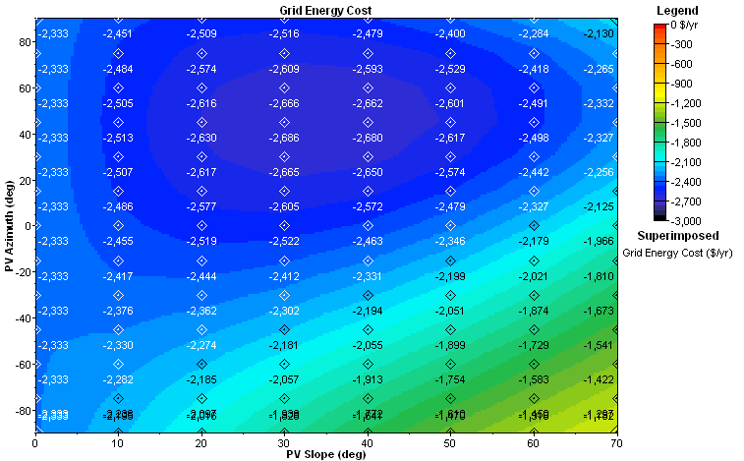
Grid Energy Cost for TOU tariff: PGE
Azimuth = 45 deg to west.

