Case study of Wind Energy at National Institute of Technology, Silchar-India
Author: Akash Joshi,
National Institute of Technology, Silchar

Abstract:

Owing to acute energy crisis that most developing countries including India are facing today, the interest in alternative energy sources has increased manifolds in the recent past. Wind being a non-polluting and nontoxic energy source, will go a long way in solving our energy requirements. Wind energy can be utilized to windmills, which in turn drive a generator to produce electricity. Wind can also be used for water pumping. However, in India, few designs were developed but could not sustain. An important reason could be that wind velocity in India, apart from the coastal region, is relatively low and varies appreciably with seasons. This low velocity and seasonal winds imply a high cost of exploitation of wind energy.
The solution lies with the proper analysis of Wind pattern and then only proper & commercial wind mill can be designed which can used in small scale capacity at low velocity in rural areas.
Keeping the above point in view, a case study was conducted at National Institute of Technology, Silchar which is situated in southern part of Assam, a backward place of North-Eastern region of India. Wind data from last three years was collected with the help of four-cup anemometer. The data collected, was complied using HOMER. We studied the wind pattern .It was observed that the wind velocity is quite low. The challenge lies within the proper design of windmill that can be used at this low wind velocity. With the help of HOMER, the wind data was compiled for different types of wind turbines and found that A Savonius rotor (S-rotor), a vertical axis turbine, is the most suitable for the wind pattern at NIT, Silchar. A Savonius Turbine is simple in construction, pollution free, having low operating speed and extremely cost effective. It was found that this S-rotor can be used for small power generation which can be used for domestic purpose in rural based communities. Thus solving the energy crisis to some extent!

Wind data at NIT, Silchar:

Wind is used as wind energy which is extracted with wind machines like wind turbines. To install a wind turbine we need sufficient wind velocity so that we get maximum of power density. Site selection is necessary in this case. For this we need to collect wind data. After collection of wind data, the compilation of that wind data is very important as it decides the type, design, and location of wind turbine.
Wind data were collected at National Institute of Technology, Silchar (Latitude: 24° 49’ N, Longitude: 92° 46’E), which is situated in southern part of Assam, a backward place of North-Eastern region of India. Wind data were collected with the help of Four-Cup anemometer. The data collected were compiled using the HOMER. Data recorded for the last three years and the sample data were depicted in [Fig 1]. After the analysis various graphs in HOMER for that particular data, we observed that wind velocity is quite low. The maximum wind velocity is obtained in summer.

Savonius Wind Turbine:

The Savonius rotor [Fig.2a] concept never became popular, probably because of its low efficiency. However it has the following advantages over the other conventional wind turbines.

1. Simple and cheap construction
2. Acceptance of wind from any direction thus eliminating the need for reorientation.
3. High starting torque.
4. Relatively low operating speed (rpm)
Considering these advantages of Savonius turbine, we conducted varies experiments on Savonius prototype in wind tunnel. The simple Savonius was a two-bladed system having 8 cm bucket diameter & 20 cm in height with provision for overlap variation [Fig.2b]. The material used was aluminum. The experiments were carried out in a low speed open circuit wind tunnel which provides an air velocity adjustable between 0 and 30 m/sec. Tests were conducted for S-rotor with and without overlap. The overlap variation was 16.2 % & 20% for both the cases. The rotor speed was measured using a digital tachometer having a least count of 1 rpm and the wind velocity was determined via the Pitot static tube.

Analysis:

The purpose of the study was to find out different observations for S-rotor with and without overlapping. The data collected during the experiments, were compiled with the help of HOMER and also by legacy system. The performance of the machine can be expressed in the form of Power Coefficient (Cp) versus tip-speed ratio (λ). For analysis, the following relations were used:-

i) Co-efficient of Performance, Cp = P_{rotor}
0.5ρV²

ii) Tip speed ratio (λ) = Velocity of blade tip
Free stream velocity

Conclusion:

From the experimental data and graphs [Fig.3], we concluded that S-rotor with 20% overlap will give the maximum co-efficient of performance (i.e. C_{p}= 21 % at 0.24 TSR). So while constructing the real Savonius rotor, 20 % overlap will give the best results.

ACKNOWLEDGEMENT:
The author sincerely thanks the staff of Fluid Mechanics and Workshop of NIT Silchar and staff of Meteorological office at NIT Silchar for their assistance and co-operation. Also, I sincerely thanks to HOMER team who offered this analyzer which was very helpful during our experiments.

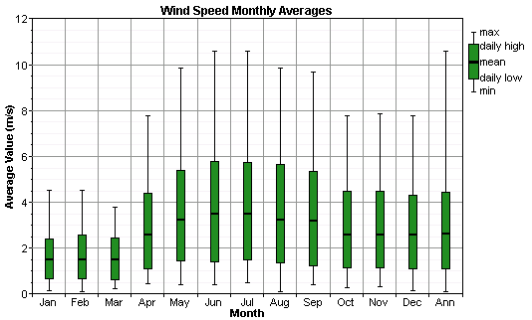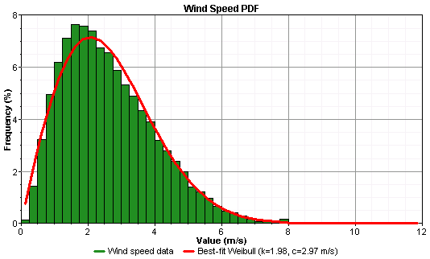

[Fig.1] Sample Wind data from NIT, Silchar

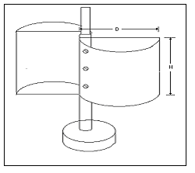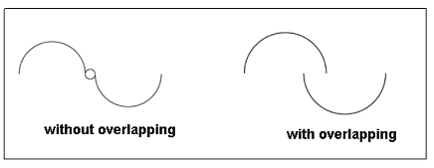
(a) (b)

[Fig.2] Savonius rotor model, with and without overlap

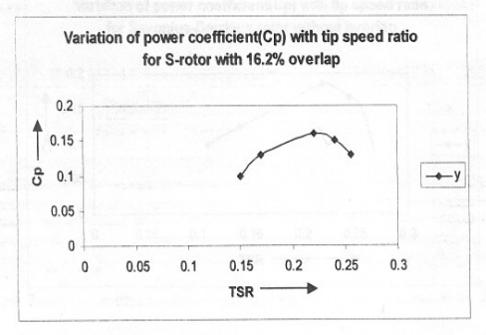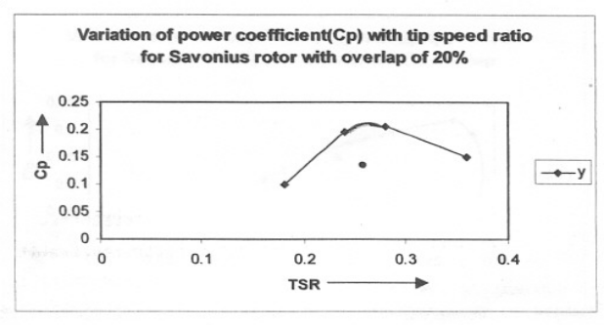

[Fig.3] Graphs showing experimental results for different overlapping

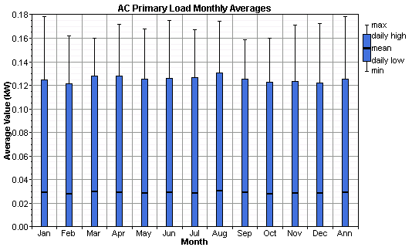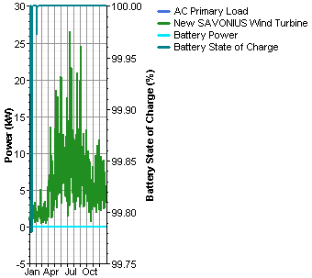

[Fig.4] Sample Graphs form HOMER for 3 SAVONIUS Wind Turbine,
1 Battery and 1 inverter of 2kW for wind data at NIT, Silchar

