1. Introduction
Topic: How to Make Inferences When Mode Effects May Exist: The Testimator, Bayesian, and Model Averaging Approaches
Background: Survey results are often influenced by mode effects, meaning that different data-collection modes can lead to different outcomes. Mode effects generally fall into two categories:
(1) Mode selection effect:
Different groups of people tend to select different survey modes.
- Younger respondents are more likely to answer telephone surveys (TEL), and this group tends to show higher support for the government.
- Older respondents are more likely to participate in face-to-face (FTF) interviews, and this group tends to show lower government support.
As a result, telephone surveys may produce higher estimates of government approval simply because the respondents differ.

Common Solution: Propensity Score Adjustment
A propensity score represents the probability that a respondent is assigned to a particular mode. The adjustment typically involves three steps:
(1) Estimate each respondent’s propensity score (e.g., via logistic regression).
(2) Reweight the data using these scores.
(3) Use the weighted data to estimate the target quantities.

For example:
- TEL group (younger): average support = 60%
- FTF group (older): average support = 45%
After propensity score adjustment, younger respondents receive higher weights and older respondents receive lower weights, making the FTF group more comparable to the TEL group in terms of age composition. The adjusted FTF estimate might increase to 55%. This adjustment reduces selection effect.

(2) Mode measurement effect:
the mode itself may change how people answer.
- In FTF interviews, respondents may feel uncomfortable criticizing the government directly, leading to higher reported support.
- In TEL surveys, the setting feels more anonymous, so respondents may report lower support.
- Cultural norms may also influence how comfortable people feel in different modes
Because of this, we often cannot determine which mode is closer to the true population value. This creates a more difficult challenge: when different modes give different answers, how should we combine them? There is currently no standard solution, and this issue is the core motivation for the study.

The study uses data from Arab Barometer Wave 6, the largest public opinion project in the Middle East and North Africa (MENA). Due to COVID-19, the research team shifted from purely FTF interviews to a mixed-mode design (FTF + TEL) in 2020 and conducted a randomized mixed-mode experiment in Jordan.

2. Proposed Method
In this section, we consider a setting where survey data are collected using two modes, Mode A and Mode B. The observed outcomes $y$ follow the models:
$$y_{ai} \sim i.i.d N\left(μ_{a}, σ_{a}^{\begin{aligned}2 \\ \end{aligned}}\right), where μ_{a}= θ+ δ_{a},$$
$$θ:true population mean,$$
$$δ_{a}:bias occured due to mode A$$
$$σ_{a}^{\begin{aligned}2 \\ \end{aligned}}:population variance and random measurement error associated with mode A$$
$$y_{bi} \sim i.i.d N\left(μ_{b}, σ_{b}^{\begin{aligned}2 \\ \end{aligned}}\right), where μ_{b}= θ+ δ_{b}$$
$$θ:true population mean,$$
$$δ_{b}:bias occured due to mode B$$
$$σ_{b}^{\begin{aligned}2 \\ \end{aligned}}:population variance and random measurement error associated with mode B \backslash overset\{\backslash text\{i.i.d.\}\}\{\backslash sim\}$$
We denote the sample mean and standard deviation of data collected with mode A as ${\overline{y}}_{a}$ and $S_{a}$ and mode B as ${\overline{y}}_{b}$ and $S_{b}$.$\backslash overset\{\backslash text\{i.i.d.\}\}\{\backslash sim\}$
Assumptions:
- At least one mode is unbiased ($δ_{a}= 0 or δ_{b}=0$). This ensures that even when mode effects exist the true population mean θ remains identifiable.
- Data from Mode A and Mode B cannot come from the same respondent
- Mode selection is independent of the potential outcomes ($M_{i}⊥(y_{ai},y_{bi})$) (e.g. Violations happen when people choose a survey mode based on their opinions. For example, people who dislike the government may avoid phone interviews because they fear being monitored. This makes the FTF group look more dissatisfied than it really is.)
[remark]
In real data, assumption (3) is relaxed to conditional independence given covariates. For example, if we compare FTF and TEL respondents only within the same age group (such as older adults), we can remove the mode selection differences caused by age.

Based on the observed data alone, we cannot tell which mode is unbiased. Therefore, the analysis must rely on external information, such as knowing which direction (higher or lower values) is expected to be closer to the truth. To address this, the authors consider three settings and corresponding inference strategies.
3 settings:
- Mode effects exist and the preferred direction is known
Take the estimate in the preferred direction to estimate the population mean.
- No mode effects exist ($δ_{a}= δ_{b}=0)$:
If both modes measure the construct without bias, then $\hat{θ}= {\hat{μ}}_{a}= {\hat{μ}}_{b}$.
- Mode effects exist but the preferred direction is unknown.
When we know the modes differ but do not know which is more accurate, the population mean is estimated by averaging the two mode-specific estimates:
$$\hat{θ}= \frac{{\hat{μ}}_{a}+{\hat{μ}}_{b}}{2}$$
2 philosophies:
- Testing-based
decide whether the mode-specific data can be pooled based on hypothesis tests
- Testimator
- Bayesian Approach
- Model-based
considers all possible models and weights them by their posterior probabilities
- Model Averaging

2.1 The Testimator Approach
The Testimator uses a two-stage testing procedure. Stage 1 tests whether the two modes have equal variances. Stage 2, based on the result of Stage 1, tests whether the two means are equal. The goal is to decide whether the data can be pooled or whether we should rely on the preferred mode.
2.1.1 When there is some information about the preferred direction
Stage I: F-test for equality of variances
We test:
$$H_{0 }: σ_{a}^{\begin{aligned}2 \\ \end{aligned}}= σ_{b}^{\begin{aligned}2 \\ \end{aligned}} vs. H_{1 }: σ_{a}^{\begin{aligned}2 \\ \end{aligned}}≠ σ_{b}^{\begin{aligned}2 \\ \end{aligned}}$$
with significance level $α_{1}$.
Test statistic:
$$F^{*}=\frac{S_{a}^{\begin{aligned}2 \\ \end{aligned}}}{S_{b}^{\begin{aligned}2 \\ \end{aligned}}} \sim F_{\left(n_{a}-1, n_{b}-1\right)}$$
Reject $H_{0 }: σ_{a}^{\begin{aligned}2 \\ \end{aligned}}= σ_{b}^{\begin{aligned}2 \\ \end{aligned}}$ if:
$F^{*}∉[F_{\frac{α_{1}}{2}\left(n_{a}-1, n_{b}-1\right)}, F_{1-\frac{α_{1}}{2}\left(n_{a}-1, n_{b}-1\right)}]$,
Stage II: t-test for equality of means
[Case 1: Variances are equal]
If $F^{*}∈[F_{\frac{α_{1}}{2}\left(n_{a}-1, n_{b}-1\right)}, F_{1-\frac{α_{1}}{2}\left(n_{a}-1, n_{b}-1\right)}]$, do not reject $H_{0 }: σ_{a}^{\begin{aligned}2 \\ \end{aligned}}= σ_{b}^{\begin{aligned}2 \\ \end{aligned}}$ and conduct a pooled-variance t-test:
$$H_{0 }: μ_{a}=μ_{b} vs. H_{1 }: μ_{a}≠μ_{b}$$
with significance level $α_{2}$.
Test statistic:
$T^{*}=\frac{{\overline{y}}_{a}- {\overline{y}}_{b}}{S_{p}^{2} ( \frac{1}{n_{a}}+ \frac{1}{n_{b}} )}\sim t_{(n_{a}+n_{b}-2)},where S_{p}^{2}= \frac{\left(n_{a}-1\right)S_{a}^{2}+ \left(n_{b}-1\right)S_{b}^{2}}{n_{a}+n_{b}-2 }$
Reject $H_{0 }: μ_{a}= μ_{b}$ if:
$$T^{*}∉[ -t_{\frac{α_{2}}{2}\left(n_{a}+n_{b}-2\right)}, t_{\frac{α_{2}}{2}\left(n_{a}+n_{b}-2\right)} ]$$
If we do not reject $H_{0 }: μ_{a}=μ_{b}$ (equal means, mode effect not exists)
We treat the two modes as measuring the same mean and pool the data.
Estimator:
$$\hat{θ}= \frac{n_{a}{\overline{y}}_{a}+n_{b}{\overline{y}}_{b}}{n_{a}+n_{b}}$$
Confidence interval:
$$CI=[ \hat{θ}- t_{\frac{α_{2}}{2}\left(n_{a}+n_{b}-2\right)}\frac{S_{p}}{\sqrt{n_{a}+n_{b}-2}}, \hat{θ}+ t_{\frac{α_{2}}{2}\left(n_{a}+n_{b}-2\right)}\frac{S_{p}}{\sqrt{n_{a}+n_{b}-2}} ]$$
If we reject $H_{0 }: μ_{a}= μ_{b}$ (different means, mode effect exists)
Since the preferred direction is known, we take the mode that provides the preferred estimate.
Estimator:
$$\hat{θ}=\left\{\begin{aligned}{\overline{y}}_{a}, if Mode A is preferred \\ {\overline{y}}_{b}, if Mode B is preferred\end{aligned}\right.$$
Confidence interval:
$$CI=\left\{\begin{aligned}[{\overline{y}}_{a}- t_{\frac{γ}{2}\left(n_{a}-1\right)}\frac{S_{a}}{\sqrt{n_{a}}}, {\overline{y}}_{a}+ t_{\frac{γ}{2}\left(n_{a}-1\right)}\frac{S_{a}}{\sqrt{n_{a}}}], use mode A \\ [{\overline{y}}_{b}- t_{\frac{γ}{2}\left(n_{b}-1\right)}\frac{S_{b}}{\sqrt{n_{b}}}, {\overline{y}}_{b}+ t_{\frac{γ}{2}\left(n_{b}-1\right)}\frac{S_{b}}{\sqrt{n_{b}}}], use mode B\end{aligned}\right.$$
$$where γ:type I error rate which could be different from α_{1} and α_{2}$$

[Case 2: Variances are not equal]
If $F^{*}∉[F_{\frac{α_{1}}{2}\left(n_{a}-1, n_{b}-1\right)}, F_{1-\frac{α_{1}}{2}\left(n_{a}-1, n_{b}-1\right)}]$, reject $H_{0 }: σ_{a}^{\begin{aligned}2 \\ \end{aligned}}= σ_{b}^{\begin{aligned}2 \\ \end{aligned}}$ and conduct Welch’s t-test:
$$H_{0 }: μ_{a}= μ_{b} vs H_{1 }: μ_{a}≠ μ_{b}$$
with significance level $α_{2}$.
Test statistic:
$T^{*}$ $=\frac{{\overline{y}}_{a}-{\overline{y}}_{b}}{\sqrt{\frac{S_{a}^{2}}{n_{a}}+\frac{S_{b}^{2}}{n_{b}}}} \sim t_{(v)}, where v=\frac{{(\frac{S_{a}^{2}}{n_{a}}+ \frac{S_{b}^{2}}{n_{b}})}^{2}}{\frac{{(\frac{S_{a}^{2}}{n_{a}})}^{2}}{n_{a}-1}+ \frac{{(\frac{S_{b}^{2}}{n_{b}})}^{2}}{n_{b}-1}}$
Reject $H_{0 }: μ_{a}= μ_{b}$ if:
$$T^{*}∉[ -t_{\frac{α_{2}}{2}\left(v\right)}, t_{\frac{α_{2}}{2}\left(v\right)} ]$$
If we do not reject $H_{0 }: μ_{a}=μ_{b}$ (equal means, mode effect not exists)
We estimate the population mean using the precision-weighted estimator:
$$\hat{θ}= \frac{\frac{n_{a}}{S_{a}^{2}}{\overline{y}}_{a}+\frac{n_{b}}{S_{b}^{2}}{\overline{y}}_{b}}{\frac{n_{a}}{S_{a}^{2}}+\frac{n_{b}}{S_{b}^{2}}}$$
Confidence interval:
$$CI=[ \hat{θ}-t_{\frac{α_{2}}{2}\left(v\right)}\frac{1}{{\left(\frac{n_{a}}{S_{a}^{2}}+\frac{n_{b}}{S_{b}^{2}}\right)}^{2}}, \hat{θ}+t_{\frac{α_{2}}{2}\left(v\right)}\frac{1}{{(\frac{n_{a}}{S_{a}^{2}}+\frac{n_{b}}{S_{b}^{2}})}^{2}} ]$$
If we reject $H_{0 }: μ_{a}=μ_{b}$ (different means, mode effect exists)
Since the preferred direction is known, we take the mode that provides the preferred estimate.
Estimator:
$$\hat{θ}=\left\{\begin{aligned}{\overline{y}}_{a}, if Mode A is preferred \\ {\overline{y}}_{b}, if Mode B is preferred\end{aligned}\right.$$
Confidence Interval:
$$CI=\left\{\begin{aligned}[{\overline{y}}_{a}- t_{\frac{γ}{2}\left(n_{a}-1\right)}\frac{S_{a}}{\sqrt{n_{a}}}, {\overline{y}}_{a}+ t_{\frac{γ}{2}\left(n_{a}-1\right)}\frac{S_{a}}{\sqrt{n_{a}}}], use mode A \\ [{\overline{y}}_{b}- t_{\frac{γ}{2}\left(n_{b}-1\right)}\frac{S_{b}}{\sqrt{n_{b}}}, {\overline{y}}_{b}+ t_{\frac{γ}{2}\left(n_{b}-1\right)}\frac{S_{b}}{\sqrt{n_{b}}}], use mode B\end{aligned}\right.$$
$$where γ:type I error rate which could be different from α_{1} and α_{2}$$

2.1.2 When there is no information about preferred direction
The Testimator still follows the same two-step procedure:
1. F-test to determine whether the two modes have equal variances.
2. t-test (pooled or Welch) to determine whether the two means are equal.
If the means are equal, pool the data and estimate θ as in the previous case. If the means differ, switch to an interval-based strategy instead of choosing one mode.

Interval-based strategy
(1) Compute separate confidence intervals for each mode
$$\left[L_{a},U_{a}\right]=[{\overline{y}}_{a}- t_{\frac{γ}{2}\left(n_{a}-1\right)}\frac{S_{a}}{\sqrt{n_{a}}}, {\overline{y}}_{a}+ t_{\frac{γ}{2}\left(n_{a}-1\right)}\frac{S_{a}}{\sqrt{n_{a}}}]$$
$$\left[L_{b},U_{b}\right]=[{\overline{y}}_{b}- t_{\frac{γ}{2}\left(n_{b}-1\right)}\frac{S_{b}}{\sqrt{n_{b}}}, {\overline{y}}_{b}+ t_{\frac{γ}{2}\left(n_{b}-1\right)}\frac{S_{b}}{\sqrt{n_{b}}}]$$
(2) Combine the two interval into one
$$\left[L, U\right]=[\min\left(L_{a},L_{b}\right),max⁡(U_{a},U_{b})]$$
(3) Estimate $θ$ using the midpoint
$$\hat{θ}=\frac{L+U}{2}$$

2.2 The Bayesian Approach
2.2.1 When there is some information about the preferred direction
- We model the outcomes as:
$$y_{ai}\sim N\left(μ_{a},σ_{a}^{2}\right), y_{bi}\sim N\left(μ_{b},σ_{b}^{2}\right)$$
with priors:
$$μ_{a}|σ_{a}^{-2}\sim N(β_{a},\frac{σ_{a}^{2}}{k_{a}}), μ_{b}|σ_{b}^{-2}\sim N(β_{b},\frac{σ_{b}^{2}}{k_{b}})$$
$$σ_{a}^{-2}\sim Gamma(\frac{v_{a}}{2},\frac{v_{a}}{2}τ_{a}^{2}),σ_{b}^{-2}\sim Gamma(\frac{v_{b}}{2},\frac{v_{b}}{2}τ_{b}^{2})$$
We use the squared-error loss function, so the Bayes estimator is the posterior mean.
- To check whether the two modes differ, we compute the effect size:
$$\hat{η}=\frac{{\hat{μ}}_{a}-{\hat{μ}}_{b}}{\sqrt{\frac{{\hat{σ}}_{a}^{2}+{\hat{σ}}_{b}^{2}}{2}}}$$
- We run R posterior simulations, obtaining samples:
$${\hat{μ}}_{a}^{\left(r\right)},{\hat{μ}}_{b}^{\left(r\right)},{{\hat{σ}}_{a}^{2}}^{\left(r\right)},{{\hat{σ}}_{b}^{2}}^{\left(r\right)}, r=1,…,R$$
For each draw, we compute ${\hat{g}}^{\left(r\right)}$, sort R values and form a 95% credible interval:
$$CI=[Q_{0.025}\left(\hat{g}\right),Q_{0.975}\left(\hat{g}\right)]$$
- Model selection
Case 1: No difference between modes ($0∈CI$)
We use the common mean model:
$$y_{ai}\sim N\left(μ,σ_{a}^{2}\right), y_{bi}\sim N\left(μ,σ_{b}^{2}\right)$$
with prior:
$$μ\sim N\left(β_{0},φ^{2}\right),σ_{a}^{-2}\sim Gamma(\frac{v_{a}}{2},\frac{v_{a}}{2}τ_{a}^{2}),σ_{b}^{-2}\sim Gamma(\frac{v_{b}}{2},\frac{v_{b}}{2}τ_{b}^{2})$$
Case 2: Mode B is preferred ($Q_{0.025}\left(\hat{g}\right)>0$and smaller mean is preferred)
We choose the model using Mode B only:
$$y_{bi}\sim N\left(μ_{b},σ_{b}^{2}\right)$$
With prior:
$$μ_{b}\sim N\left(β_{b},φ_{b}^{2}\right),σ_{b}^{-2}\sim Gamma(\frac{v_{b}}{2},\frac{v_{b}}{2}λ_{b}^{2})$$

Case 3: Mode A is preferred ($Q_{0.975}\left(\hat{g}\right)<0$and smaller mean is preferred)
We choose the model using Mode A only:
$$y_{ai}\sim N\left(μ_{a},σ_{a}^{2}\right)$$
With prior:
$$μ_{a}\sim N\left(β_{a},φ_{a}^{2}\right),σ_{a}^{-2}\sim Gamma(\frac{v_{a}}{2},\frac{v_{a}}{2}λ_{a}^{2})$$
- After choosing the appropriate model, we run R posterior simulations and obtain:
$$μ^{\left(1\right)},…,μ^{\left(r\right)}$$
The final estimator of the population mean is the posterior mean:
$$\hat{θ}=\frac{1}{R}\sum_{r=1}^{R}{u^{(r)}}$$
2.2.2 When there is some information about the preferred direction
- Same as section 2.2.1
- Same as section 2.2.1
- Same as section 2.2.1
- Model selection
Case 1: No difference between modes ($0∈CI$)
Same as section 2.2.1
Case 2: There is difference between modes ($0∉CI$)
Use the different-mean model in step (1) and generate R posterior draws:
$${\hat{μ}}_{a}^{\left(r\right)},{\hat{μ}}_{b}^{\left(r\right)},r=1,…,R$$
Next, we generate R Bernoulli(p = 0.5) random variables.
Each Bernoulli draw determines which mode contributes the $r^{th}$ draw of the population mean:
$$If r^{th} Bernoulli draw=0→u^{(r)}={\hat{μ}}_{a}^{\left(r\right)}$$
$$If r^{th} Bernoulli draw=1→u^{(r)}={\hat{μ}}_{b}^{\left(r\right)}$$
- Same as section 2.2.1

2.3 The Model Averaging Approach
2.3.1 When there is some information about the preferred direction
- We consider four possible models that differ in whether the means and variances are the same across modes:
- Model 1 (different means, different variances)
$$y_{ai}\sim N\left(μ_{a},σ_{a}^{2}\right), y_{bi}\sim N\left(μ_{b},σ_{b}^{2}\right)$$
$$μ_{a}|σ_{a}^{-2}\sim N(β_{a},\frac{σ_{a}^{2}}{k_{a}}), μ_{b}|σ_{b}^{-2}\sim N(β_{b},\frac{σ_{b}^{2}}{k_{b}})$$
$$σ_{a}^{-2}\sim Gamma(\frac{v_{a}}{2},\frac{v_{a}}{2}τ_{a}^{2}),σ_{b}^{-2}\sim Gamma(\frac{v_{b}}{2},\frac{v_{b}}{2}τ_{b}^{2})$$
- Model 2 (same means, different variances):
$$y_{ai}\sim N\left(μ,σ_{a}^{2}\right), y_{bi}\sim N\left(μ,σ_{b}^{2}\right)$$
$$μ\sim N\left(β_{0},φ^{2}\right),σ_{a}^{-2}\sim Gamma(\frac{v_{a}}{2},\frac{v_{a}}{2}τ_{a}^{2}),σ_{b}^{-2}\sim Gamma(\frac{v_{b}}{2},\frac{v_{b}}{2}τ_{b}^{2})$$
- Model 3 (different means, same variances):
$$y_{ai}\sim N\left(μ_{a},σ^{2}\right), y_{bi}\sim N\left(μ_{b},σ^{2}\right)$$
$$μ_{a}|σ^{-2}\sim N(β_{a},\frac{σ^{-2}}{k_{a}}), μ_{b}|σ^{-2}\sim N(β_{b},\frac{σ^{-2}}{k_{b}})$$
$$σ^{-2}\sim Gamma(\frac{v}{2},\frac{v}{2}λ^{2})$$
- Model 4 (same means, same variances):
$$y_{ai}\sim N\left(μ,σ^{2}\right), y_{bi}\sim N\left(μ,σ^{2}\right)$$
$$μ\sim N\left(β_{0},\frac{σ^{2}}{k}\right), σ^{-2}\sim Gamma(\frac{v}{2},\frac{v}{2}λ^{2})$$
- Using the observed data ${(y}_{a},y_{b})$, we compute the posterior probability that each model is correct. The posterior probability is:
$$π(M|y_{a},y_{b})=\frac{p\left(y | M\right)p(M)}{\sum_{m}{p\left(y | M_{m}\right)p(M_{m})}}$$
We then normalize these probabilities to obtain model weights:
$$W_{M}=\frac{π\left(M | y_{a},y_{b}\right)}{\sum{π\left(M | y_{a},y_{b}\right)}}$$
These weights reflect how strongly the data support each model.

- We draw R samples from a multinomial distribution using the model weight $W_{1},W_{2},W_{3},W_{4}$. Each draw tells us which model will be used to generate one posterior draw of the population mean θ.
- model 1 or model 3 (different means)
If the preferred direction is “lower mean,” we compare the posterior draws of$u_{a} and u_{b}$ and choose the smaller value as the estimate of θ.
- model 2 or model 4 (same means)
We take the posterior draw of the common mean $μ$ as the estimate of θ.
Repeating this process R times gives us R draws of θ:
$${\hat{θ}}^{(1)},…,{\hat{θ}}^{(R)}$$
- From these draws, we compute:
- posterior mean
$$E\left(\hat{θ}\right)=\frac{1}{R}\sum_{r=1}^{R}{{\hat{θ}}^{(r)}}$$
- posterior variance
$$V\left(\hat{θ}\right)$$
- $\left(1-γ\right)100\%$ credible interval
$$CI=[E\left(\hat{θ}\right) _{+}^{-} z_{\frac{1-γ}{2}}\sqrt{V\left(\hat{θ}\right)}]$$
2.3.2 When there is no information about the preferred direction
- Same as 2.3.1
- Same as 2.3.1
- We draw R samples from a multinomial distribution using the model weight $W_{1},W_{2},W_{3},W_{4}$. Each draw tells us which model will be used to generate one posterior draw of the population mean θ.
- model 1 or model 3 (different means)
We generate R Bernoulli(p = 0.5) random variables.
Each Bernoulli draw determines which mode contributes the $r^{th}$ draw of the population mean:
$$If r^{th} Bernoulli draw=0→{\hat{θ}}^{(r)}={\hat{μ}}_{a}^{\left(r\right)}$$
$$If r^{th} Bernoulli draw=1→{\hat{θ}}^{(r)}={\hat{μ}}_{b}^{\left(r\right)}$$
- model 2 or model 4 (same means)
same as 2.3.1
- same as 2.3.1

2.4 Naïve approach I: Use the Estimate in the Preferred Direction (Naïve Preferred)
In this naïve approach, we ignore model uncertainty and simply take the estimate that follows the preferred direction. For example, if a lower value is believed to be more accurate, we estimate the population mean as:
$$\hat{θ}=min or max ({\overline{y}}_{a},{\overline{y}}_{b})$$
Using the properties of the minimum of two normal variables, the expectation of $\hat{θ}$ is:
$$E\left(\hat{θ}\right)=μ_{a}Ф\left(\frac{μ_{b}-μ_{a}}{S}\right)+μ_{b}Ф\left(\frac{μ_{a}-μ_{b}}{S}\right)+S∅\left(\frac{μ_{b}-μ_{a}}{S}\right),$$
$$where S=\sqrt{\frac{σ_{a}^{2}}{n_{a}}+\frac{σ_{b}^{2}}{n_{b}}}, ∅\left(\right),Ф\left(\right) :pdf \& cdf of N(0,1)$$
The second moment is:
$$E\left({\hat{θ}}^{2}\right)=\left(μ_{a}+\frac{σ_{a}^{2}}{n_{a}}\right)Ф\left(\frac{μ_{b}-μ_{a}}{S}\right)+\left(μ_{b}+\frac{σ_{b}^{2}}{n_{b}}\right)Ф\left(\frac{μ_{a}-μ_{b}}{S}\right)-\left(μ_{a}+μ_{b}\right)S∅\left(\frac{μ_{b}-μ_{a}}{S}\right)$$
Thus, the variance is:
$$V\left(\hat{θ}\right)= E\left({\hat{θ}}^{2}\right)-{[E\left(\hat{θ}\right)]}^{2}$$
In practice, we replace $μ_{a},μ_{b}$ with the sample means ${\overline{y}}_{a},{\overline{y}}_{b}$, and we replace $σ_{a}^{2},σ_{b}^{2}$ with the sample variances $S_{a}^{2},S_{b}^{2}$. Finally, we construct $\left(1-γ\right)100\%$CI using the Z distribution.

2.5 Naïve Approach II: Pool the Data (Naïve Pooled)
In this naïve approach, we ignore the possibility of mode effects and treat all observations as if they come from a single mode. We combine the two samples and compute the pooled sample mean:
$$\hat{μ}=\overline{y}$$
The standard error of the pooled mean is estimated as:
$$SE\left(\hat{μ}\right)=\frac{S}{\sqrt{n_{a}+n_{b}}},$$
$$where S: sample standard deviation of the combined data$$
We then construct a $\left(1-γ\right)100\%$ CI for the population mean using a t-distribution with $n_{a}+n_{b}-1$ degrees of freedom.
3. Simulation Study
3.1 Simulation design
To study how the three methods perform under different levels of mode effects, we assume that the superpopulation outcomes for Mode A and Mode B follow a bivariate normal distribution:
$$\left[\begin{matrix}y_{ai} \\ y_{bi}\end{matrix}\right] \sim N( \left[\begin{matrix}0 \\ μ_{b}\end{matrix}\right], \left[\begin{matrix}1 & ρσ_{b} \\ ρσ_{b} & σ_{b}^{2}\end{matrix}\right] )$$
Mode A follows $N(0,1)$ and collects unbiased data ($θ=μ_{a}=0$).
Mode B is generated by changing $μ_{b}$ and $σ_{b}^{2}$ to simulate different levels of mode effects.
The effect size is defined as:
$$effect size=\frac{μ_{a}-μ_{b}}{\sqrt{\frac{σ_{a}^{2}+σ_{b}^{2}}{2}}}$$
We consider three correlation levels ($ρ=0.5, 0.75, 0.95$) and nine scenarios between the two modes. For each scenario, we draw 500 samples with $n_{a}=n_{b}=250$. We evaluate two settings:
(1) The preferred direction is known (smaller mean is preferred)
(2) The preferred direction is unknown.
Scenarios | $$μ_{b}$$ | $$σ_{b}^{2}$$ | Effect size
1 | 0 | 1 | 0
2 | 0 | 2 | 0
3 | 0.3 | 2 | 0.24
4 | 0.3 | 1 | 0.3
5 | 0.5 | 2 | 0.41
6 | 0.5 | 1 | 0.5
7 | 0.7 | 2 | 0.57
8 | 0.7 | 1 | 0.7
9 | 0.7 | 0.5 | 0.81
Figure 3.1: Set $y_{ai} \sim N(0,1)$. Simulate different mode effect by adjusting $μ_{b}$ and $σ_{b}^{2}$
- Testimator
We use a 0.05 significance level for both the F-test and the t-test and construct a 95% confidence interval using $γ=0.05$.
- Bayesian and Model Averaging
The prior parameters are:
$$φ^{2}=100, β_{a}=β_{b}=β_{0}=0, k_{a}=k_{b}=k=0.01,$$
$$\frac{v_{a}}{2}=\frac{v}{2}=\frac{v_{a}}{2}=0.001, \frac{v_{a}}{2}τ_{a}^{2}=\frac{v}{2}λ^{2}=\frac{v_{b}}{2}τ_{b}^{2}=0.001$$
We run R=5000 posterior simulations for each model.
Comparing the methods using the following criteria:
- Bias:
$$bias\left(\hat{θ}\right)=\frac{\sum{\hat{θ}}}{500}-θ$$
- RMSE:
$$RMSE\left(\hat{θ}\right)=\sqrt{\frac{\sum{{(\hat{θ}-θ)}^{2}}}{500}}$$
- Coverage rate:
The proportion of simulated confidence intervals that contain the true mean 𝜃.
- Actual interval length
The average (upper–lower) length of the CI across the 500 samples.
- Expected interval length
The interval length based on the overall distribution of the simulated estimates.

3.2 Compare the Results of Different Methods
3.2.1 When smaller mean is preferred
Figure 3.2-3.3 summarize the performance of each method when $ρ=0.95$.
- Naïve Methods
- No mode effect (Scenarios 1–2):
The Naïve Preferred method shows clear bias.
The Naïve Pooled method has almost no bias.
- Mode effects present (Scenarios 3–9):
The Naïve Preferred method has almost no bias.
The Naïve Pooled method shows clear bias.
Across all scenarios, the three proposed methods (Testimator, Bayesian, Model Averaging) greatly reduce bias and provide more robust results.
- Testimator
- Performs well when mode effects are moderate or large (Scenarios 5–9).
- When no mode effect exists (Scenarios 1–2), its coverage rates fall below 0.95.
- When mode effects are small (Scenarios 3–4), its bias is slightly higher than the Bayesian method with more sensitive cutoffs (50%, 75%, 90%).
- Because the Testimator tends to not reject $H_{0}$, it is conservative. As a result, it often concludes “no mode effect” when the effect size is small. This explains why Scenarios 3-4 show many cases where the t-test suggests equal means even though the true means differ.
- Bayesian Approach
- No mode effect (Scenario 1-2):
Wider intervals (e.g., 95%) perform better because they are less sensitive to detecting false differences.
- Small mode effect (Scenario 3-4):
Narrower intervals (e.g., 50%) perform better because they are more sensitive to small differences.
- Large mode effect (Scenarios 5–9):
The cutoff level has little influence; all intervals lead to similar conclusions.
There is a clear trade-off when selecting the cutoff:
a higher cutoff increases the chance of missing real mode effects, while a lower cutoff increases the risk of type I error (incorrectly rejecting “no mode effect”).
- Model Averaging
Model Averaging performs well in most scenarios, but shows higher bias and lower coverage when the effect size is small (Scenarios 3–5). This occurs because the posterior model weights are more spread out, increasing the chance of selecting the wrong model. In these scenarios, the method often favors the same-mean models (Model 2 or Model 4) when it should choose the different-mean models (Model 1 or Model 3).

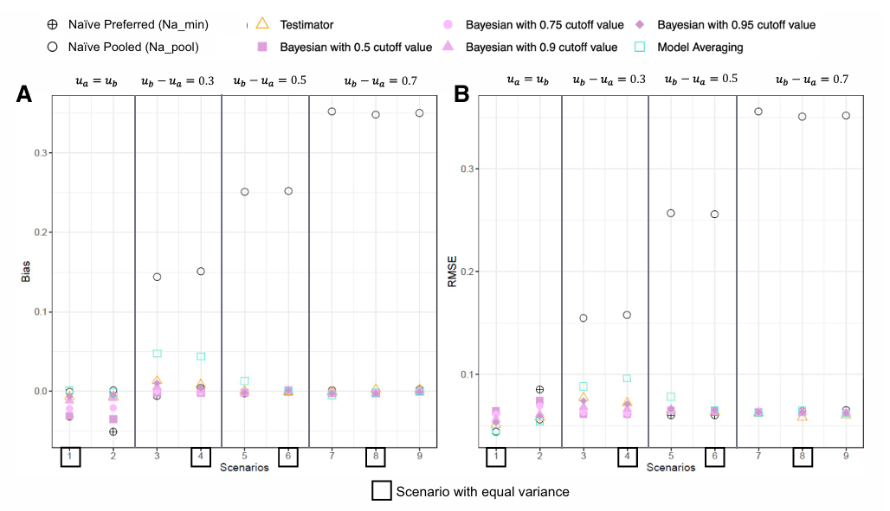
Figure 3.2: Bias and RMSE (smaller mean is preferred)
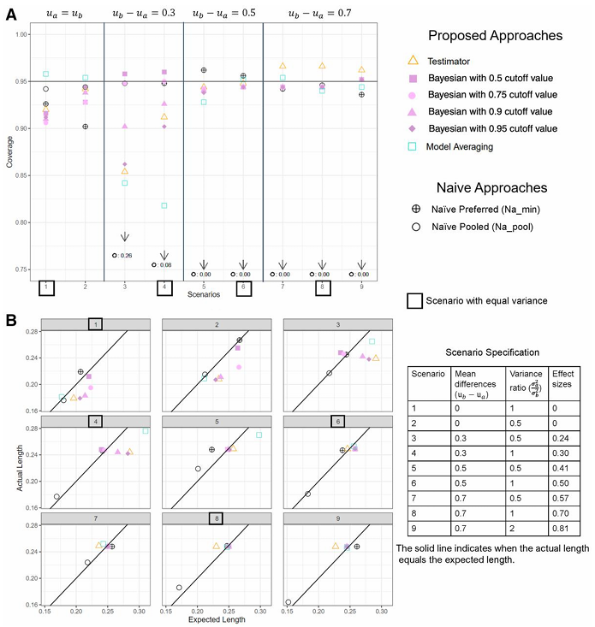
Figure 3.3: Coverage rate and Interval Length (smaller mean is preferred)
Figure 3.4-3.5 summarize the performance of model selection in Testimator and Model Averaging when $ρ=0.95$.
- Testimator
The probability of selecting the correct model equals the proportion of simulations where the model is chosen. The lower value happens at scenario 3 (0.764) and scenario 4(0.874).
- Model Averaging
Uses posterior weights, also generate lower values at scenario 3 (0.345), scenario 4 (0.595) and scenario 5 (0.830).
When effect sizes are between 0 and 0.5, both methods struggle because the modes differ only slightly. In such situation, the Testimator tends not to reject $H_{0}$ and the weights in Model Averaging become more evenly distributed, so the procedures often choose the wrong model.
Scenario | Effect size | M1 (D–D) | M2 (S–D) | M3 (D–S) | M4 (S–S)
$$u_{b}=0,σ_{b}^{2}=1$$ | 0.000 | 0.000 | 0.044 | 0.046 | 0.910
$$u_{b}=0,σ_{b}^{2}=2$$ | 0.000 | 0.058 | 0.942 | 0.000 | 0.000
$$u_{b}=0.3,σ_{b}^{2}=2$$ | 0.240 | 0.764 | 0.236 | 0.000 | 0.000
$$u_{b}=0.3,σ_{b}^{2}=1$$ | 0.300 | 0.052 | 0.004 | 0.874 | 0.070
$$u_{b}=0.5,σ_{b}^{2}=2$$ | 0.410 | 0.994 | 0.006 | 0.000 | 0.000
$$u_{b}=0.5,σ_{b}^{2}=1$$ | 0.500 | 0.054 | 0.000 | 0.946 | 0.000
$$u_{b}=0.7,σ_{b}^{2}=2$$ | 0.570 | 1.000 | 0.000 | 0.000 | 0.000
$$u_{b}=0.7,σ_{b}^{2}=1$$ | 0.700 | 0.034 | 0.000 | 0.966 | 0.000
$$u_{b}=0.7,σ_{b}^{2}=0.5$$ | 0.810 | 1.000 | 0.000 | 0.000 | 0.000
Figure 3.4: Probability of the Model Being Selected in the Testimator Approach ($ρ=0.95,n=500$)
Scenario | Effect size | M1 (D–D) | M2 (S–D) | M3 (D–S) | M4 (S–S)
$$u_{b}=0,σ_{b}^{2}=1$$ | 0.000 | 0.000 | 0.001 | 0.022 | 0.977
$$u_{b}=0,σ_{b}^{2}=2$$ | 0.000 | 0.018 | 0.911 | 0.002 | 0.070
$$u_{b}=0.3,σ_{b}^{2}=2$$ | 0.240 | 0.345 | 0.576 | 0.028 | 0.051
$$u_{b}=0.3,σ_{b}^{2}=1$$ | 0.300 | 0.001 | 0.000 | 0.595 | 0.404
$$u_{b}=0.5,σ_{b}^{2}=2$$ | 0.410 | 0.830 | 0.079 | 0.081 | 0.010
$$u_{b}=0.5,σ_{b}^{2}=1$$ | 0.500 | 0.002 | 0.000 | 0.989 | 0.009
$$u_{b}=0.7,σ_{b}^{2}=2$$ | 0.570 | 0.900 | 0.003 | 0.098 | 0.000
$$u_{b}=0.7,σ_{b}^{2}=1$$ | 0.700 | 0.001 | 0.000 | 0.999 | 0.000
$$u_{b}=0.7,σ_{b}^{2}=0.5$$ | 0.810 | 0.896 | 0.000 | 0.104 | 0.000
Figure 3.5: Average weight in the Model Averaging approach ($ρ=0.95,n=500$)

3.2.2 When there is no information about preferred direction
Figure 3.6-3.7 summarize the performance of each method when $ρ=0.95$
When the preferred direction is unknown, the three proposed methods show bias levels similar to the Naïve Pooled approach. As the mode effect becomes larger, the bias of all methods increases. However, their coverage rates remain noticeably higher than those of the Naïve Pooled method.
Overall, across all scenarios, the three methods provide more reliable inference than the naïve approaches. Still, when the mode effect is small, their performance may deteriorate because the difference between the two modes is difficult to detect.
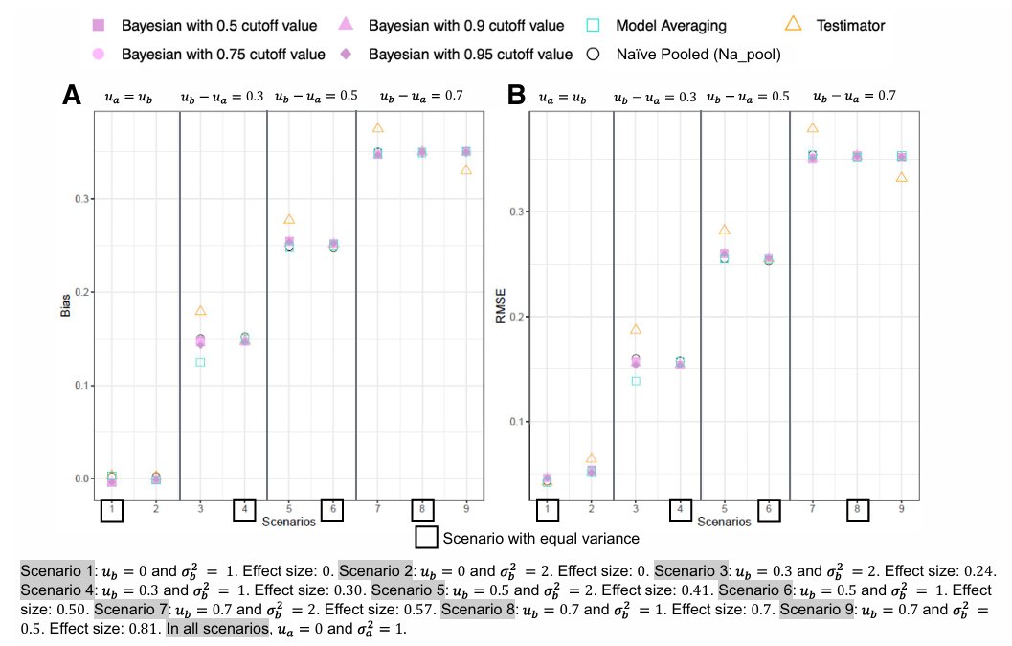
Figure 3.6: Bias and RMSE (no information about preferred direction)
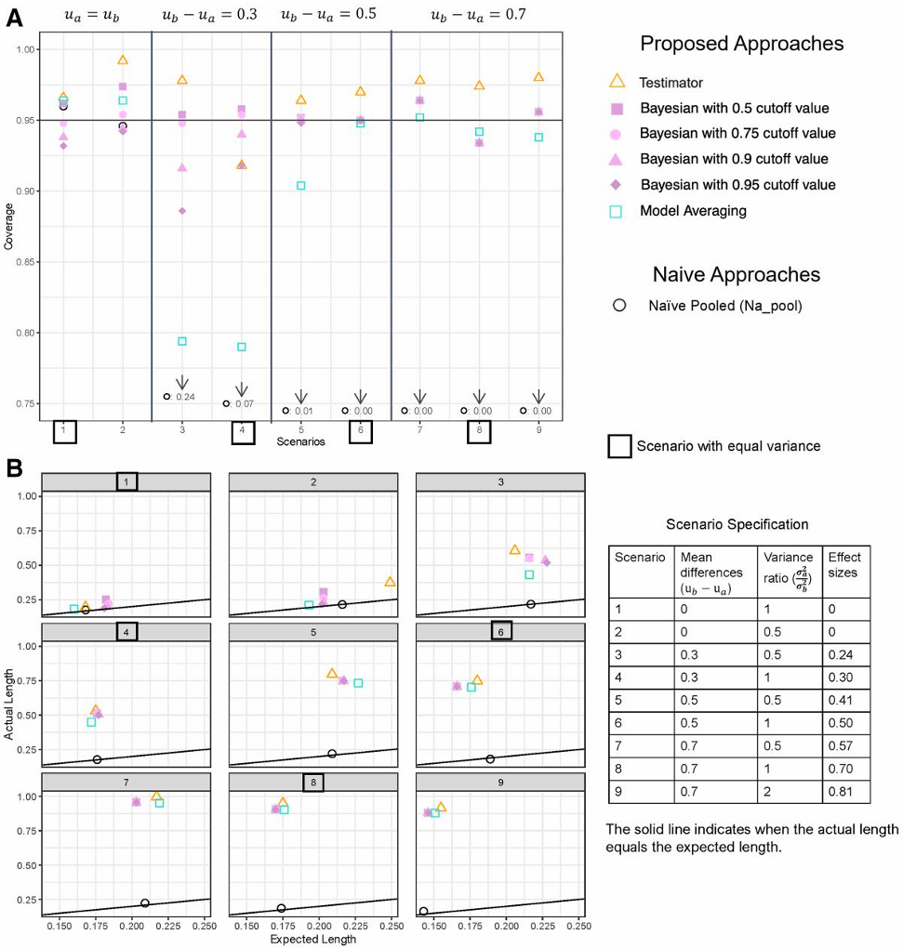
Figure 3.7: Coverage rate and Interval Length (no information about preferred direction)
3.2.3 Increase sample size to $n=5000$ (smaller mean is preferred)
Figure 3.8-3.10 summarize the performance of each method when increasing sample size to $n=5000$.
- Testimator
When the mode effect is small (Scenarios 3 and 4), the probability of selecting the correct model increases substantially with the larger sample size. However, even when the true variances are equal, the Testimator does not fully eliminate the chance of selecting a different-variance model. This shows that the F-test still makes occasional errors, and these errors do not disappear completely.

- Bayesian Approach
With a larger sample size, the Bayesian method achieves coverage rates above 90% in all scenarios (50%, 75%, 95% cutoff values). This indicates that its ability to detect mode effects improves greatly, and its interval estimates become more reliable.
- Model Averaging
For model averaging, increasing the sample size leads to almost perfect model identification. In nearly all scenarios, the method assigns close to 100% weight to the correct model.
Overall, increasing the sample size helps resolve most of the weaknesses observed in the three methods. With more data, the procedures detect mode effects more accurately, select the correct model more consistently, and provide more stable inference.

Scenario | Effect size | M1 (D–D) | M2 (S–D) | M3 (D–S) | M4 (S–S)
$$u_{b}=0,σ_{b}^{2}=1$$ | 0.000 | 0.002 | 0.036 | 0.048 | 0.914
$$u_{b}=0,σ_{b}^{2}=2$$ | 0.000 | 0.040 | 0.960 | 0.000 | 0.000
$$u_{b}=0.3,σ_{b}^{2}=2$$ | 0.240 | 1.000 | 0.000 | 0.000 | 0.000
$$u_{b}=0.3,σ_{b}^{2}=1$$ | 0.300 | 0.052 | 0.000 | 0.948 | 0.000
$$u_{b}=0.5,σ_{b}^{2}=2$$ | 0.410 | 1.000 | 0.000 | 0.000 | 0.000
$$u_{b}=0.5,σ_{b}^{2}=1$$ | 0.500 | 0.062 | 0.000 | 0.938 | 0.000
$$u_{b}=0.7,σ_{b}^{2}=2$$ | 0.570 | 1.000 | 0.000 | 0.000 | 0.000
$$u_{b}=0.7,σ_{b}^{2}=1$$ | 0.700 | 0.042 | 0.000 | 0.958 | 0.000
$$u_{b}=0.7,σ_{b}^{2}=0.5$$ | 0.810 | 1.000 | 0.000 | 0.000 | 0.000
Figure 3.8: Probability of the Model Being Selected in the Testimator Approach ($ρ=0.95,n=5000$)
Scenario | Effect size | M1 (D–D) | M2 (S–D) | M3 (D–S) | M4 (S–S)
$$u_{b}=0,σ_{b}^{2}=1$$ | 0.000 | 0.000 | 0.000 | 0.002 | 0.998
$$u_{b}=0,σ_{b}^{2}=2$$ | 0.000 | 0.005 | 0.995 | 0.000 | 0.000
$$u_{b}=0.3,σ_{b}^{2}=2$$ | 0.240 | 1.000 | 0.000 | 0.000 | 0.000
$$u_{b}=0.3,σ_{b}^{2}=1$$ | 0.300 | 0.000 | 0.000 | 1.000 | 0.000
$$u_{b}=0.5,σ_{b}^{2}=2$$ | 0.410 | 1.000 | 0.000 | 0.000 | 0.000
$$u_{b}=0.5,σ_{b}^{2}=1$$ | 0.500 | 0.002 | 0.000 | 0.998 | 0.000
$$u_{b}=0.7,σ_{b}^{2}=2$$ | 0.570 | 1.000 | 0.000 | 0.000 | 0.000
$$u_{b}=0.7,σ_{b}^{2}=1$$ | 0.700 | 0.000 | 0.000 | 1.000 | 0.000
$$u_{b}=0.7,σ_{b}^{2}=0.5$$ | 0.810 | 1.000 | 0.000 | 0.000 | 0.000
Figure 3.9: Average weight in the Model Averaging approach ($ρ=0.95,n=5000$)

Method | Bias | RMSE | Coverage | Expected Len. | Actual Len.
Scenario 3: $u_{b}=0.3,σ_{b}^{2}=2$
Te | -0.001 | 0.02 | 0.942 | 0.081 | 0.079
B50 | -0.001 | 0.021 | 0.958 | 0.077 | 0.078
B75 | -0.001 | 0.021 | 0.958 | 0.077 | 0.078
B90 | -0.001 | 0.021 | 0.958 | 0.077 | 0.078
B95 | -0.001 | 0.021 | 0.958 | 0.077 | 0.078
MA | -0.001 | 0.02 | 0.948 | 0.079 | 0.078
Scenario 4: $u_{b}=0.3,σ_{b}^{2}=1$
Te | 0.000 | 0.019 | 0.968 | 0.072 | 0.079
B50 | 0.001 | 0.020 | 0.936 | 0.082 | 0.078
B75 | 0.001 | 0.020 | 0.936 | 0.082 | 0.078
B90 | 0.001 | 0.020 | 0.936 | 0.082 | 0.078
B95 | 0.001 | 0.020 | 0.936 | 0.082 | 0.078
MA | 0.000 | 0.020 | 0.936 | 0.082 | 0.078
Scenario 5: $u_{b}=0.5,σ_{b}^{2}=2$
Te | -0.001 | 0.019 | 0.968 | 0.073 | 0.079
B50 | -0.001 | 0.020 | 0.958 | 0.076 | 0.078
B75 | -0.001 | 0.020 | 0.958 | 0.076 | 0.078
B90 | -0.001 | 0.020 | 0.958 | 0.076 | 0.078
B95 | -0.001 | 0.020 | 0.958 | 0.076 | 0.078
MA | 0.000 | 0.020 | 0.948 | 0.078 | 0.078
Figure 3.10: Performance in normal outcomes when smaller estimates are preferred ($ρ=0.95,n=5000$)

4. Application: Arab Barometer Wave 6 Jordan Experiment
We apply the three methods to data from the Arab Barometer Wave 6 mixed-mode experiment in Jordan. The dataset includes 2,531 respondents, with 1,193 interviewed face-to-face (FTF) and 1,338 interviewed by telephone (TEL). The TEL group was initially recruited through a short 5-minute FTF interview, and most survey questions were asked about one week later by phone.
Because the TEL sample comes from FTF respondents, mode selection effects may arise, and weights are used to reduce these differences. For example, if the TEL follow-up contains more women or older respondents than the FTF sample, the weights are adjusted to correct these imbalances.
To measure satisfaction with the government, we construct a composite index (gov_sat) using six items:
(a) security performance
(b) keeping prices down
(c) response to COVID-19
(d) overall performance
(e) education system
(f) healthcare system
Each item is coded on a four-point scale:
(a)(b)(c)
1 = “Completely satisfied”, 2 = “Satisfied”
3 = “Dissatisfied”, 4 = “Completely dissatisfied”
(d)(e)(f)
1 = “Very good”, 2 = “Good”, 3 = “Bad”, 4 = “Very bad”
We define:
$$gov_sat=25-\sum_{i=1}^{6}{Q_{i}}$$
so that higher values indicate higher satisfaction.
We consider two scenarios in the analysis:
- The smaller estimate is believed to be closer to the truth, which is reasonable in an authoritarian context with social desirability concerns.
- The preferred direction is unknown, as a sensitivity analysis.
The analysis proceeds in four steps:
- For each mode (FTF & TEL), compute survey weights, weighted means, weighted variances, and sampling variances under the stratified and clustered sample design.
- Calculate the design effect and the effective sample size for both FTF and TEL.
- Use the effective sample size and the design-based statistics (${\overline{y}}_{w}, S_{w}^{2}$) as inputs to the three methods.
- Estimate the sampling variances for both modes using linearization, which approximates complex survey estimates with a Taylor expansion.
Results and Conclusions
Method | Estimate | Interval | Interval Len.
Testimator | 7.521 | 7.197, 7.844 | 0.647
Bayesian (50%, 75%, 95%) | 7.519 | 7.193, 7.849 | 0.656
Model Averaging | 7.521 | 7.197, 7.851 | 0.654
Pool data | 8.295 | 8.058, 8.531 | 0.473
FTF | 7.521 | 7.200, 7.841 | 0.642
TEL | 9.088 | 8.825, 9.351 | 0.526
Figure 4.1: Results when smaller estimates are preferred
All three methods produce point estimates that are close to the FTF estimate. This indicates that each method detects a clear difference between the two modes, with FTF showing lower levels of government satisfaction than TEL. Under our preferred-direction assumption, this suggests that face-to-face interviews reduce social desirability pressure and lead to more truthful responses.
Method | Estimate | Interval | Interval Len.
Testimator | 8.275 | 7.197, 9.352 | 2.155
Bayesian (50%, 75%, 95%) | 8.293 | 7.254, 9.307 | 2.053
Model Averaging | 8.297 | 7.246, 9.304 | 2.058
Pool data | 8.295 | 8.058, 8.531 | 0.473
FTF | 7.521 | 7.200, 7.841 | 0.642
TEL | 9.088 | 8.825, 9.351 | 0.526
Figure 4.1: Results when there is no information about preferred direction
When we cannot determine the preferred direction, the three proposed methods produce very similar point estimates. However, their interval lengths are much wider than those from the naïve approaches. These wider intervals provide a more realistic reflection of the uncertainty in this setting and make it more likely that the true population mean is captured.
5. Discussion
- Core concepts of the three methods
- Testimator
Uses hypothesis testing to decide which model to use.
- Bayesian Approach
Uses the credible interval of the posterior effect size to determine whether a mode effect exists and selects the appropriate model.
- Model Averaging
Combines the four candidate models through their posterior weights and performs inference by averaging across models.
- Performance of the methods
- When the sample size is small, all three methods have limited sensitivity to small mode effects. In this case, the Bayesian approach with a smaller cutoff tends to produce lower bias.
- The Testimator is more conservative and often favors the “no mode effect” model when the difference between modes is small.
- Across all scenarios, the three proposed methods are more robust than the Naïve approaches.
- Increasing the sample size improves performance for all methods.
- Contributions of the study
- Introduces mode effects into a formal inferential framework.
- Provides an operational and practical approach for handling multi-mode inference, with or without a preferred direction.
- Extends naturally to non-normal outcomes.
- Can be generalized to more than two modes.
- Future directions
A potential improvement is to develop less conservative confidence interval constructions for the Testimator when the preferred direction is unknown.

