A Replication Study of “Three Approaches to Improve Inferences Based on Survey Data Collected with Mixed-mode Designs”
YUNG CHUN LAN, YUE CHEN WU

The goal of this study is to replicate the simulation results in Three Approaches to Improve Inferences Based on Survey Data Collected with Mixed-mode Designs (Yu, Elliott, and Raghunathan, Journal of Survey Statistics and Methodology).
We focus on the simulation setting with sample size $n=500$, $ρ=0.95$, and the case where a smaller mean is preferred, which corresponds to Section 3 of the original paper.
Our overall procedure follows the original paper. However, since some implementation details are not explicitly described, we outline our replication approach and present the results below.
1. Data Generation
The original paper does not explicitly specify the data-generating process. Therefore, based on the nine scenarios considered in the simulation study, we generate two correlated samples of size $n=250$ from the following bivariate normal distribution:
$$\left[\begin{matrix}y_{ai} \\ y_{bi}\end{matrix}\right] \sim N( \left[\begin{matrix}0 \\ μ_{b}\end{matrix}\right], \left[\begin{matrix}1 & ρσ_{b} \\ ρσ_{b} & σ_{b}^{2}\end{matrix}\right] )$$
- $y_{ai}$ in the first dataset is used as the simulated data for Mode A
- $y_{bi}$ in the second dataset is used as the simulated data for Mode B
This setup reflects a mixed-mode design in which outcomes from the two modes are correlated, while each individual responds using only one mode.
2. Posterior Distribution of Bayes Approach & Model Averaging
- Different means model:
Since the posterior parameters of the common mean model are not explicitly described in the paper, we derive them assuming a single sample for simplicity: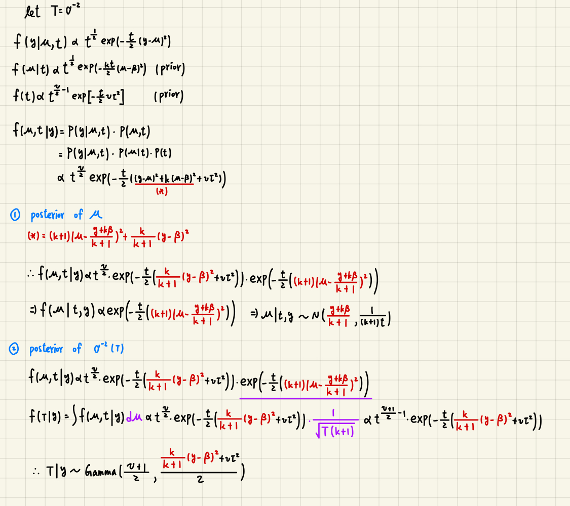
- Common means model:
The common mean model does not admit a closed-form solution. Therefore, we use Gibbs sampling to generate posterior draws.
3. Proposed Method (Original Paper Results / Our Results):
The results for model performance, model selection proportion of Testimator, and average model weights of Model Averaging are all very similar to those in the original paper, indicating that our simulation reproduces the same conclusions.
Method | Bias | RMSE |  | Coverage |  | Expected Len. |  | Actual Len.
Scenario 1: $u_{b}=0,σ_{b}^{2}=1$. Effect size = 0
Na_min | -0.032 / -0.038 | 0.062 / 0.065 |  | 0.926 / 0.930 |  | 0.207 / 0.207 |  | 0.219 / 0.220
Na_pool | -0.001 / -0.002 | 0.044 / 0.045 |  | 0.942 / 0.952 |  | 0.180 / 0.180 |  | 0.176 / 0.176
Te | -0.007 / -0.007 | 0.051 / 0.051 |  | 0.920 / 0.930 |  | 0.196 / 0.199 |  | 0.179 / 0.180
B50 | -0.031 / -0.031 | 0.064 / 0.064 |  | 0.916 / 0.920 |  | 0.220 / 0.221 |  | 0.212 / 0.213
B75 | -0.022 / -0.021 | 0.061 / 0.060 |  | 0.906 / 0.920 |  | 0.223 / 0.223 |  | 0.195 / 0.195
B90 | -0.012 / -0.012 | 0.056 / 0.054 |  | 0.910 / 0.926 |  | 0.214 / 0.208 |  | 0.183 / 0.184
B95 | -0.007 / -0.007 | 0.053 / 0.051 |  | 0.912 / 0.928 |  | 0.206 / 0.199 |  | 0.179 / 0.179
MA | 0.001 / -0.003 | 0.045 / 0.045 |  | 0.958 / 0.948 |  | 0.177 / 0.177 |  | 0.181 / 0.181
Scenario 2: $u_{b}=0,σ_{b}^{2}=2$. Effect size = 0
Na_min | -0.051 / -0.044 |  | 0.085 / 0.076 |  | 0.902 / 0.934 |  | 0.267 / 0.245 |  | 0.267 / 0.266
Na_pool | 0.001 / 0.000 |  | 0.056 / 0.052 |  | 0.944 / 0.958 |  | 0.212 / 0.204 |  | 0.215 / 0.215
Te | -0.007 / -0.007 |  | 0.058 / 0.057 |  | 0.942 / 0.942 |  | 0.234 / 0.224 |  | 0.208 / 0.208
B50 | -0.035 / -0.035 |  | 0.074 / 0.075 |  | 0.928 / 0.932 |  | 0.264 / 0.261 |  | 0.255 / 0.253
B75 | -0.021 / -0.021 |  | 0.069 / 0.069 |  | 0.928 / 0.934 |  | 0.266 / 0.257 |  | 0.226 / 0.226
B90 | -0.009 / -0.011 |  | 0.061 / 0.062 |  | 0.938 / 0.940 |  | 0.237 / 0.237 |  | 0.211 / 0.212
B95 | -0.005 / -0.007 |  | 0.059 / 0.057 |  | 0.944 / 0.940 |  | 0.229 / 0.224 |  | 0.207 / 0.207
MA | -0.002 / -0.001 |  | 0.054 / 0.049 |  | 0.954 / 0.962 |  | 0.211 / 0.192 |  | 0.209 / 0.210
Scenario 3: $u_{b}=0.3,σ_{b}^{2}=2$. Effect size = 0.24
Na_min | -0.006 / -0.006 |  | 0.062 / 0.066 |  | 0.948 / 0.944 |  | 0.244 / 0.257 |  | 0.245 / 0.246
Na_pool | 0.144 / 0.147 |  | 0.155 / 0.158 |  | 0.264 / 0.25 |  | 0.217 / 0.227 |  | 0.217 / 0.217
Te | 0.013 / 0.005 |  | 0.077 / 0.077 |  | 0.854 / 0.880 |  | 0.291 / 0.298 |  | 0.239 / 0.240
B50 | -0.002 / -0.006 |  | 0.061 / 0.066 |  | 0.958 / 0.944 |  | 0.235 / 0.258 |  | 0.248 / 0.248
B75 | 0.000 / -0.004 |  | 0.063 / 0.068 |  | 0.948 / 0.932 |  | 0.240 / 0.265 |  | 0.246 / 0.245
B90 | 0.005 / -0.001 |  | 0.068 / 0.071 |  | 0.902 / 0.91 |  | 0.270 / 0.280 |  | 0.242 / 0.241
B95 | 0.010 / 0.005 |  | 0.074 / 0.076 |  | 0.862 / 0.876 |  | 0.280 / 0.299 |  | 0.238 / 0.239
MA | 0.048 / 0.043 |  | 0.088 / 0.090 |  | 0.842 / 0.822 |  | 0.285 / 0.309 |  | 0.265 / 0.260
Scenario 4: $u_{b}=0.3,σ_{b}^{2}=1$. Effect size = 0.30
Na_min | 0.004 / 0.004 |  | 0.061 / 0.062 |  | 0.948 / 0.936 |  | 0.242 / 0.245 |  | 0.246 / 0.247
Na_pool | 0.151 / 0.152 |  | 0.158 / 0.158 |  | 0.084 / 0.072 |  | 0.169 / 0.169 |  | 0.177 / 0.178
Te | 0.008 / 0.010 |  | 0.072 / 0.074 |  | 0.912 / 0.884 |  | 0.285 / 0.289 |  | 0.244 / 0.242
B50 | -0.002 / 0.004 |  | 0.061 / 0.063 |  | 0.960 / 0.938 |  | 0.240 / 0.245 |  | 0.248 / 0.249
B75 | -0.001 / 0.005 |  | 0.062 / 0.064 |  | 0.950 / 0.944 |  | 0.245 / 0.251 |  | 0.247 / 0.248
B90 | 0.001 / 0.007 |  | 0.066 / 0.068 |  | 0.926 / 0.922 |  | 0.266 / 0.266 |  | 0.244 / 0.246
B95 | 0.004 / 0.010 |  | 0.071 / 0.074 |  | 0.902 / 0.884 |  | 0.282 / 0.287 |  | 0.242 / 0.242
MA | 0.044 / 0.049 |  | 0.096 / 0.010 |  | 0.818 / 0.82 |  | 0.310 / 0.341 |  | 0.276 / 0.279
Scenario 5: $u_{b}=0.5,σ_{b}^{2}=2$. Effect size = 0.41
Na_min | -0.003 / -0.001 |  | 0.060 / 0.060 |  | 0.962 / 0.948 |  | 0.223 / 0.236 |  | 0.248 / 0.248
Na_pool | 0.251 / 0.248 |  | 0.257 / 0.253 |  | 0.004 / 0.006 |  | 0.201 / 0.202 |  | 0.219 / 0.220
Te | 0.000 / 0.000 |  | 0.065 / 0.061 |  | 0.944 / 0.948 |  | 0.257 / 0.239 |  | 0.249 / 0.249
B50 | -0.002 / -0.001 |  | 0.065 / 0.060 |  | 0.942 / 0.950 |  | 0.248 / 0.236 |  | 0.248 / 0.248
B75 | -0.002 / -0.001 |  | 0.065 / 0.060 |  | 0.942 / 0.954 |  | 0.248 / 0.236 |  | 0.248 / 0.248
B90 | -0.002 / -0.001 |  | 0.066 / 0.061 |  | 0.940 / 0.946 |  | 0.249 / 0.239 |  | 0.248 / 0.248
B95 | -0.002 / 0.001 |  | 0.066 / 0.061 |  | 0.938 / 0.950 |  | 0.251 / 0.240 |  | 0.248 / 0.248
MA | 0.013 / 0.010 |  | 0.078 / 0.072 |  | 0.928 / 0.944 |  | 0.298 / 0.280 |  | 0.270 / 0.265
Scenario 6: $u_{b}=0.5,σ_{b}^{2}=1$. Effect size = 0.50
Na_min | -0.001 / -0.001 |  | 0.060 / 0.068 |  | 0.956 / 0.938 |  | 0.238 / 0.269 |  | 0.247 / 0.248
Na_pool | 0.252 / 0.248 |  | 0.256 / 0.252 |  | 0.000 / 0.000 |  | 0.183 / 0.178 |  | 0.181 / 0.180
Te | -0.001 / -0.001 |  | 0.063 / 0.069 |  | 0.948 / 0.938 |  | 0.246 / 0.269 |  | 0.249 / 0.249
B50 | 0.001 / -0.001 |  | 0.064 / 0.069 |  | 0.944 / 0.934 |  | 0.258 / 0.269 |  | 0.249 / 0.248
B75 | 0.001 / -0.001 |  | 0.064 / 0.069 |  | 0.944 / 0.936 |  | 0.258 / 0.269 |  | 0.249 / 0.248
B90 | 0.001 / -0.001 |  | 0.064 / 0.067 |  | 0.944 / 0.938 |  | 0.258 / 0.269 |  | 0.249 / 0.248
B95 | 0.001 / -0.001 |  | 0.065 / 0.069 |  | 0.944 / 0.934 |  | 0.258 / 0.269 |  | 0.249 / 0.248
MA | -0.001 / 0.001 |  | 0.065 / 0.073 |  | 0.952 / 0.928 |  | 0.256 / 0.286 |  | 0.253 / 0.254
Scenario 7: $u_{b}=0.7,σ_{b}^{2}=2$. Effect size = 0.57
Na_min | 0.001 / 0.000 |  | 0.063 / 0.063 |  | 0.942 / 0.952 |  | 0.257 / 0.247 |  | 0.248 / 0.249
Na_pool | 0.352 / 0.352 |  | 0.356 / 0.356 |  | 0.000 / 0.000 |  | 0.218 / 0.216 |  | 0.224 / 0.224
Te | -0.001 / 0.000 |  | 0.062 / 0.063 |  | 0.966 / 0.954 |  | 0.236 / 0.247 |  | 0.249 / 0.249
B50 | -0.003 / 0.000 |  | 0.063 / 0.063 |  | 0.944 / 0.952 |  | 0.250 / 0.247 |  | 0.248 / 0.249
B75 | -0.003 / 0.000 |  | 0.063 / 0.063 |  | 0.944 / 0.952 |  | 0.250 / 0.247 |  | 0.248 / 0.249
B90 | -0.003 / 0.000 |  | 0.063 / 0.063 |  | 0.944 / 0.954 |  | 0.250 / 0.247 |  | 0.248 / 0.249
B95 | -0.003 / 0.000 |  | 0.063 / 0.063 |  | 0.944 / 0.952 |  | 0.250 / 0.247 |  | 0.248 / 0.249
MA | -0.005 / 0.001 |  | 0.062 / 0.063 |  | 0.954 / 0.956 |  | 0.243 / 0.248 |  | 0.252 / 0.250
Scenario 8: $u_{b}=0.7,σ_{b}^{2}=1$. Effect size = 0.70
Na_min | -0.003 / 0.005 |  | 0.064 / 0.067 |  | 0.946 / 0.926 |  | 0.247 / 0.264 |  | 0.249 / 0.247
Na_pool | 0.348 / 0.353 |  | 0.351 / 0.356 |  | 0.000 / 0.000 |  | 0.171 / 0.179 |  | 0.186 / 0.186
Te | 0.002 / 0.005 |  | 0.058 / 0.067 |  | 0.966 / 0.926 |  | 0.230 / 0.263 |  | 0.248 / 0.249
B50 | -0.003 / 0.005 |  | 0.063 / 0.067 |  | 0.944 / 0.924 |  | 0.250 / 0.263 |  | 0.248 / 0.248
B75 | -0.003 / 0.005 |  | 0.063 / 0.068 |  | 0.944 / 0.916 |  | 0.250 / 0.263 |  | 0.248 / 0.248
B90 | -0.003 / 0.005 |  | 0.063 / 0.067 |  | 0.944 / 0.922 |  | 0.250 / 0.264 |  | 0.248 / 0.248
B95 | -0.003 / 0.005 |  | 0.063 / 0.067 |  | 0.944 / 0.920 |  | 0.250 / 0.263 |  | 0.248 / 0.248
MA | -0.002 / 0.005 |  | 0.065 / 0.067 |  | 0.940 / 0.924 |  | 0.247 / 0.264 |  | 0.247 / 0.248
Scenario 9: $u_{b}=0.7,σ_{b}^{2}=1.5$. Effect size = 0.81
Na_min | 0.002 / -0.001 |  | 0.065 / 0.062 |  | 0.936 / 0.948 |  | 0.261 / 0.244 |  | 0.248 / 0.249
Na_pool | 0.350 / 0.349 |  | 0.352 / 0.351 |  | 0.000 / 0.000 |  | 0.152 / 0.152 |  | 0.164 / 0.165
Te | 0.002 / -0.001 |  | 0.060 / 0.062 |  | 0.962 / 0.950 |  | 0.227 / 0.245 |  | 0.248 / 0.250
B50 | -0.001 / -0.001 |  | 0.062 / 0.062 |  | 0.952 / 0.944 |  | 0.245 / 0.245 |  | 0.248 / 0.249
B75 | -0.001 / -0.001 |  | 0.062 / 0.062 |  | 0.952 / 0.948 |  | 0.245 / 0.245 |  | 0.248 / 0.249
B90 | -0.001 / -0.001 |  | 0.062 / 0.062 |  | 0.952 / 0.950 |  | 0.245 / 0.244 |  | 0.248 / 0.249
B95 | -0.001 / -0.001 |  | 0.062 / 0.062 |  | 0.952 / 0.952 |  | 0.245 / 0.245 |  | 0.248 / 0.250
MA | 0.000 / -0.001 |  | 0.062 / 0.062 |  | 0.944 / 0.950 |  | 0.245 / 0.245 |  | 0.246 / 0.249
Figure 1: Models performance in different scenarios (original paper results / out results)

Scenario | Effect size | M1 (D–D) | M2 (S–D) | M3 (D–S) | M4 (S–S)
$$u_{b}=0,σ_{b}^{2}=1$$ | 0.000 | 0.000 / 0.000 | 0.044 / 0.052 | 0.046 / 0.052 | 0.910 / 0.896
$$u_{b}=0,σ_{b}^{2}=2$$ | 0.000 | 0.058 / 0.056 | 0.942 / 0.944 | 0.000 / 0.000 | 0.000 / 0.000
$$u_{b}=0.3,σ_{b}^{2}=2$$ | 0.240 | 0.764 / 0.802 | 0.236 / 0.198 | 0.000 / 0.000 | 0.000 / 0.000
$$u_{b}=0.3,σ_{b}^{2}=1$$ | 0.300 | 0.052 / 0.050 | 0.004 / 0.006 | 0.874 / 0.854 | 0.070 / 0.090
$$u_{b}=0.5,σ_{b}^{2}=2$$ | 0.410 | 0.994 / 0.994 | 0.006 / 0.006 | 0.000 / 0.000 | 0.000 / 0.000
$$u_{b}=0.5,σ_{b}^{2}=1$$ | 0.500 | 0.054 / 0.044 | 0.000 / 0.000 | 0.946 / 0.956 | 0.000 / 0.000
$$u_{b}=0.7,σ_{b}^{2}=2$$ | 0.570 | 1.000 / 1.000 | 0.000 / 0.000 | 0.000 / 0.000 | 0.000 / 0.000
$$u_{b}=0.7,σ_{b}^{2}=1$$ | 0.700 | 0.034 / 0.040 | 0.000 / 0.000 | 0.966 / 0.960 | 0.000 / 0.000
$$u_{b}=0.7,σ_{b}^{2}=0.5$$ | 0.810 | 1.000 / 1.000 | 0.000 / 0.000 | 0.000 / 0.000 | 0.000 / 0.000
Figure 2: Model selection proportion of Testimator (original paper results / out results)
Scenario | Effect size | M1 (D–D) | M2 (S–D) | M3 (D–S) | M4 (S–S)
$$u_{b}=0,σ_{b}^{2}=1$$ | 0.000 | 0.000 / 0.000 | 0.001 / 0.001 | 0.022 / 0.020 | 0.977 / 0.979
$$u_{b}=0,σ_{b}^{2}=2$$ | 0.000 | 0.018 / 0.019 | 0.911 / 0.912 | 0.002 / 0.002 | 0.070 / 0.068
$$u_{b}=0.3,σ_{b}^{2}=2$$ | 0.240 | 0.345 / 0.366 | 0.576 / 0.556 | 0.028 / 0.031 | 0.051 / 0.047
$$u_{b}=0.3,σ_{b}^{2}=1$$ | 0.300 | 0.001 / 0.001 | 0.000 / 0.001 | 0.595 / 0.594 | 0.404 / 0.404
$$u_{b}=0.5,σ_{b}^{2}=2$$ | 0.410 | 0.830 / 0.809 | 0.079 / 0.092 | 0.081 / 0.090 | 0.010 / 0.009
$$u_{b}=0.5,σ_{b}^{2}=1$$ | 0.500 | 0.002 / 0.001 | 0.000 / 0.000 | 0.989 / 0.983 | 0.009 / 0.016
$$u_{b}=0.7,σ_{b}^{2}=2$$ | 0.570 | 0.900 / 0.908 | 0.003 / 0.001 | 0.098 / 0.091 | 0.000 / 0.000
$$u_{b}=0.7,σ_{b}^{2}=1$$ | 0.700 | 0.001 / 0.001 | 0.000 / 0.000 | 0.999 / 0.999 | 0.000 / 0.000
$$u_{b}=0.7,σ_{b}^{2}=0.5$$ | 0.810 | 0.896 / 0.919 | 0.000 / 0.000 | 0.104 / 0.081 | 0.000 / 0.000
Figure 3: Average model weights of Model Averaging (original paper results / out results)

