Arab Barometer wave 6 Jordan mixed-mode experiment data:
$$n=2531, n_{FTF}=1193, n_{TEL}=1338$$
*TEL: initially recruited via FTF for a short 5-minute sur vey, and the majority of the survey items were asked approximately a week later in a TEL follow-up
*可能會產生mode selection effect，所以會調整權重來消除effect
(e.g.) TEL: 招募階段(FTF)1000人，50%女性，平均40y；TEL階段，70%女性，平均45y (女性與年長者較容易接電話)
女性過多 → 權重降低
男性過少 → 權重提升
年長過多 → 權重降低
年輕過少 → 權重提升

*建立gov_sat指標衡量政府滿意度:
- government’s performance on security
- government’s performance on keeping price down
- government’s performance on responding to COVID-19
- government’s performance overall
- government’s performance on education system
- government’s performance on healthcare system
(1)(2)(3)
1 = “Completely satisfied” 2 = “Satisfied”
3 = “Dissatisfied” 4 = “Completely dissatisfied”
(4)(5)(6)
1 = “Very good” 2 = “Good” 3 = “Bad” 4 = “Very bad”
gov_sat = 25-[(1)+(2)+(3)+(4)+(5)+(6) 越高越滿意

本研究考量2種情境:
- when we are aware that a smaller estimate is closer to the truth (威權國家社會期待，合理)
- when we cannot determine the preferred direction (敏感度分析)
step1: FTF、TEL下計算權重、分層與群集設計後的樣本變異$S_{w}^{2}$、抽樣變異$v_{w}^{2}$、樣本平均數${\overline{y}}_{w}$
step2: 計算design effect及各mode的effective sample size
step3: 將有效樣本數與基於設計的充分統計量(${\overline{y}}_{w}, S_{w}^{2}$)納入3種方法
step4: 使用linearization估計兩種mode的抽樣變異
*linearization: 用泰勒展開將複雜統計量近似為線性

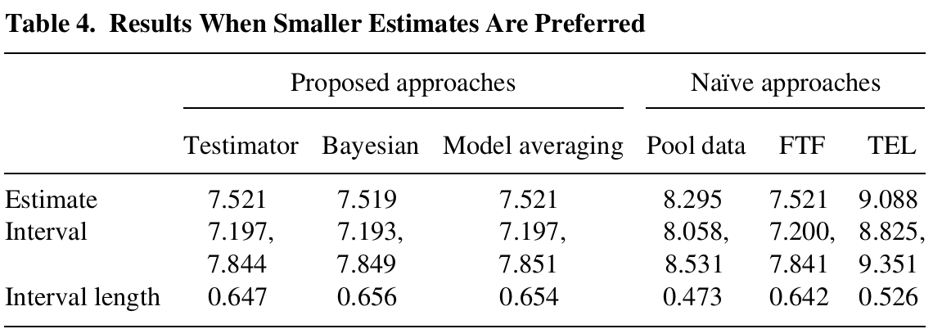
備註: Bayesian的4種cutoff值皆產生相同結果，因此只呈現其中一組

3種模型給出的點估計皆與FTF相近，表示3種方法皆偵測出FTF滿意度顯著低於TEL，套用原先設定，表示面訪能減少社會期許，給出較誠實的回答

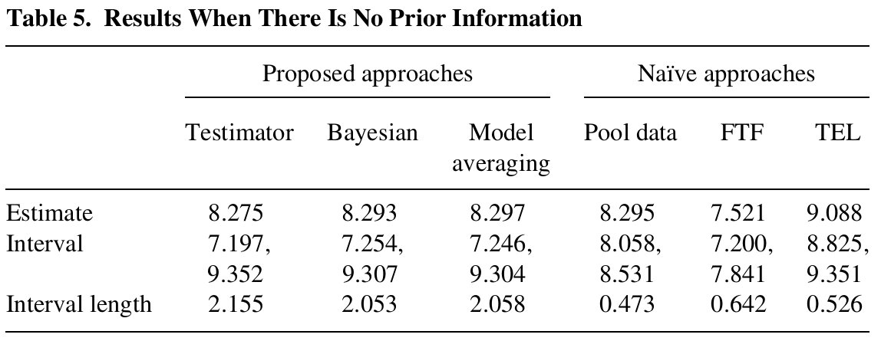
無法得知偏好方向時，點估計值差不多，但這些方法產生的Interval length都來都比Naïve方法寬，更合理的反應不確定性，也更容易涵蓋到母體真實平均數

