Pedestrian Navigation

Navigation Systems VU, WS 2018/19, laboratory # 2

Authors Name

Graz University of Technology

Graz, Austria

authors email

*Abstract*—Pedestrians spend 80% of their time in indoor environments. Given that a vast majority of pedestrians own a smartphone, it would be convenient if an indoor positioning solution purely based on smartphone sensors existed. This paper focuses on one possible approach, namely Pedestrian Dead Reckoning based on inertial sensors from a smartphone.

Keywords—smartphone; inertial sensors; dead reckoning; navigation;

# Introduction

This Global Navigation Satellite Systems and their absolute positioning methods have limitations in the sector of Indoor Navigation. Pedestrian Dead Reckoning (PDR) offers a good alternate methodology to calculate a pedestrians trajectory and position with a smartphone and its sensors motion recognition capabilities. Sensors that log acceleration and magnitude in three axes and a barometer are at nearly every smartphone on the market available. With that information relative positioning solutions can be applied and used.

This paper describes the procedure if PDR using 3 minutes of logged smartphone sensor data, acquired at the University of Technology – Institute of Geodesy Graz in a handheld position. The Process is parted in two main sections: the *filtering* of the data and the trajectory estimation with 3 *sub steps step detection, step length estimation* and the *direction estimation*.

# Methodology Approach

## Filtering

Due to the noise in the signals, the first step is to filter the data. For the acceleration and magnetic data a Savitzky Golay (SG) filter was used. The filtered acceleration data was used to calculate the total acceleration (ACCT), witch will play a leading role in the step detection part.

${acc}_{total}=\sqrt{{acc}_{x}^{2}+{acc}_{y}^{2}+{acc}_{z}^{2}}$

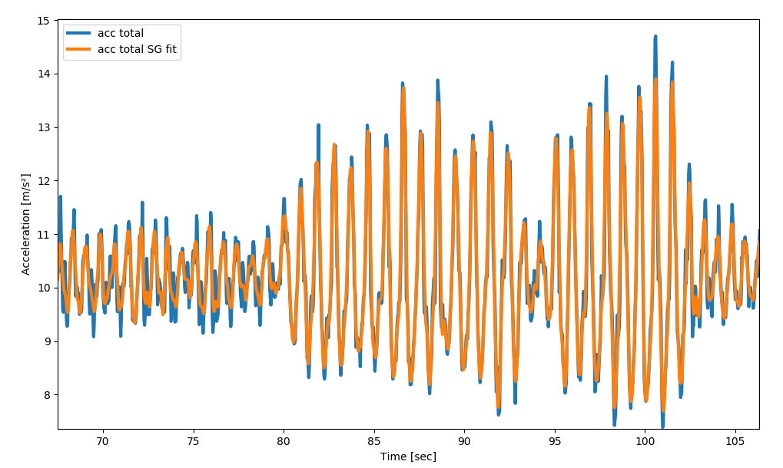

Figure 1 Raw and filtered Total Acceleration

The barometer data showed some extreme noise which was filtered out first with a median filter to remove the outliars and that result was smoothed with a SG filter too. With the Barometric formula the barometric data could be transformed into altitude difference.



In a further step the slope of that function was calculated over time to be used as an indicator, if the person that recorded the inertial data is walking up stairs. That is important for the step estimation and classification process (Figure 2). 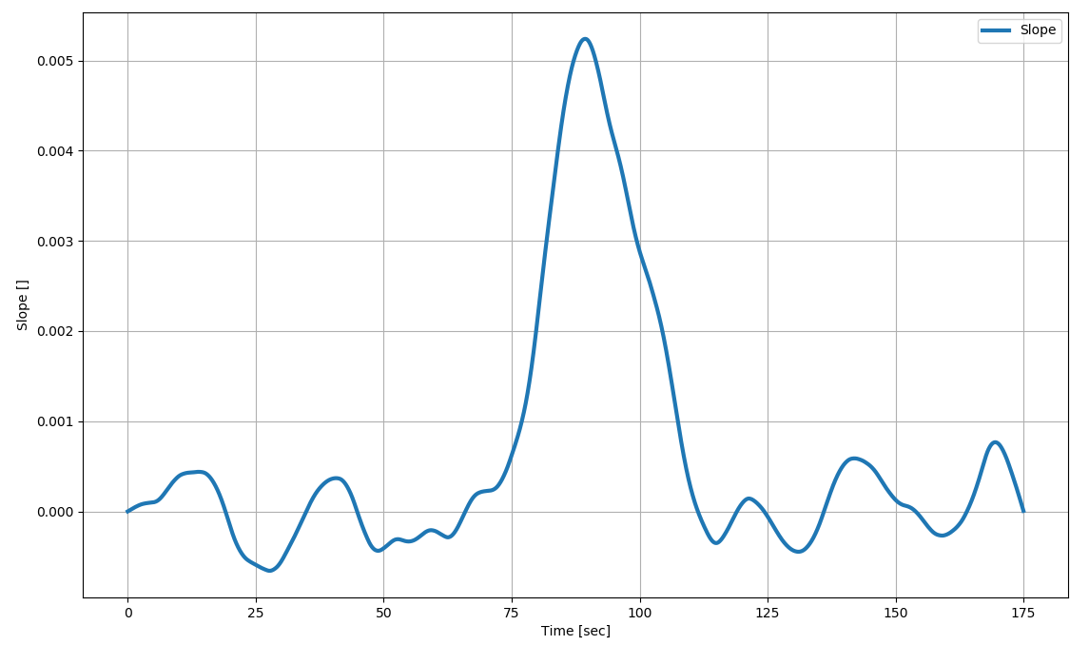

Figure 2 Gradient of the Preasure Data

## Step Detection

With the computed total accelerometer time series you can tell, if the foot of the pedestrian is in motion or not. When the feet is on the ground the acceleration should mark a minimum and when the foot makes a swing motion it should peak. That information is used for the step detection in the ACCT time series. I have decided to search for local minima, which are according to [1] more distinct than peaks and so more suitable. A Threshold was assigned, where all valleys under a value of 10 should be found. Figure 3 shows all detected steps for minima and maxima in a certain time window. A second threshold was assigned to the minimum search function, which compares the neighbor data values, so no sub-minima disturb the valley detection. The result of this detection is that we know WHEN the pedestrian has made a step and how often.

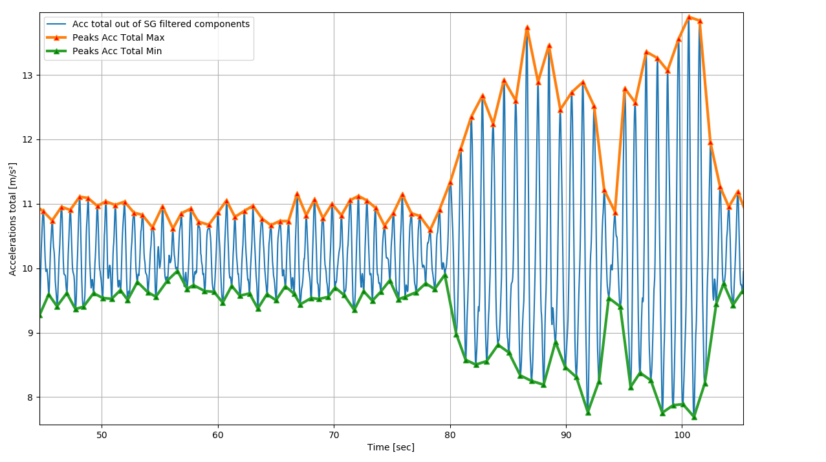

Figure 3 Detected Steps with local Minima and Maxima found in the SG filtered ACCT

## Step Length Estimation

In the literature a variety of algorithms for step length estimation can be found e.g. which adapts the step length according to the frequency change. But for this lab a fixed step length for normal walking and stair climbing was used. In general, the step length derives the information how far we are heading in a certain direction. When a person moves up a stairway, the acceleration pointing to the z axe will increase and marks a classification target to change the step length. I decided not to look at the acceleration data, but instead perform a linear regression with a moving window over the barometric data, which derives me the slope of the barometric function over time. The barometric gradient will increase when the person walks up the stairway and will flatten again if the person moves on a chosen floor. With a threshold assigned, the step length changes dynamically with the time and gradient changing.

## Step Direction Estimation

Now we now how often a step was made, how long it is but not in which direction the person is heading. The magnetic heading angle can be calculated by the acceleration and magnetic data from all 3 axes.

$$roll=\tan^{-1}\left(\frac{{-a}_{y}}{{-a}_{z}}\right) pitch= \tan^{-1}\left(\frac{a_{x}}{\sqrt{a_{y}^{2}}+a_{z}^{2}}\right)$$

$$y_{mag}=\tan^{-1}\left(\frac{{-m}_{y}\cos\left(roll\right)+m_{z}\sin\left(roll\right)}{m_{x}\cos\left(pitch\right)+m_{y}\sin\left(pitch\right)\sin\left(roll\right)+m_{z}sin\left(pitch\right)cos(roll)}\right)$$

Before the magnetic yaw is calculated roll and pitch are filtered first with a median filter followed by a SG filter. With that information and the counted steps we can calculate the trajectory of the pedestrian using

$$N_{t+q}=N_{t}+{StepLength}_{t}cos⁡(y_{mag})$$

$$E_{t+q}=E_{t}+{StepLength}_{t}sin⁡(y_{mag})$$ For the visualization relative position x,y is transformed into geographic coordinates φ and λ:

$$dx=R∙dφ \\ dy=R∙cosφ∙dλ$$

# Preliminary Results

The following graph shows the trajectory calculated under several different processing outcomes. It is obvious that a fixed single step length leads to a biased trajectory than the result with a dynamic step length.

Finally, complete content and organizational editing before formatting. Please take note of the following items when proofreading spelling and grammar:

# Conclusion

PDR is a promising way to calculate positions in indoor environments. With the possibilities of data integration derived by other systems ( Bluetooth finger printing) and the rapid development of fast microcontrollers and better smartphone sensors, this field will see a big expand in the future.

##### References

1. [1] E. Anderson, “Motion Classification and Step Lentgth Estimation for GPS/INS Pedestrian Navigation” Master Thesis. Stockholm, KTH, School of Electrical Engineering (EES) , 2012.
2. J. Clerk Maxwell, A Treatise on Electricity and Magnetism, 3rd ed., vol. 2. Oxford: Clarendon, 1892, pp.68-73.
3. I.S. Jacobs and C.P. Bean, “Fine particles, thin films and exchange anisotropy,” in Magnetism, vol. III, G.T. Rado and H. Suhl, Eds. New York: Academic, 1963, pp. 271-350.