Pedestrian Navigation
Navigation Systems VU, WS 2018/19, laboratory # 2

Arzberger Paul
Graz University of Technology
Graz, Austria
paul.arzberger@tugraz.at

Abstract—Pedestrians spend 80% of their time in indoor environments. Given that a vast majority of pedestrians own a smartphone, it would be convenient if an indoor positioning solution purely based on smartphone sensors existed. This paper focuses on one possible approach, namely Pedestrian Dead Reckoning based on inertial sensors from a smartphone.
Keywords—smartphone; inertial sensors; dead reckoning; navigation;

Introduction
Global Navigation Satellite Systems and their absolute positioning methods have limitations in the sector of Indoor Navigation. Pedestrian Dead Reckoning (PDR) offers a good alternate methodology to calculate a pedestrians trajectory and position with a smartphone and its sensors motion recognition capabilities. Sensors that log acceleration and magnitude in three axes and a barometer are at nearly every smartphone on the market available. With that information relative positioning solutions can be applied and used.
This paper describes the procedure if PDR using 3 minutes of logged smartphone sensor data, aquired at the University of Technology – Institue of Geodesy Graz in a handheld position. The Process is parted in two main sections: the filtering of the data and the trajectory estimation with 3 substeps step detection, step length estimation and the direction estimation.

Methodology Approach

A. Filtering
Due to the noise in the signals, the first step is to filter the data. For the acceleration and magnetic data a Savitzky Golay (SG) filter was used (Fig 1 +2). The filtered acceleration data was used to calculate the absolute acceleration witch will play a leading role in the step detection part.
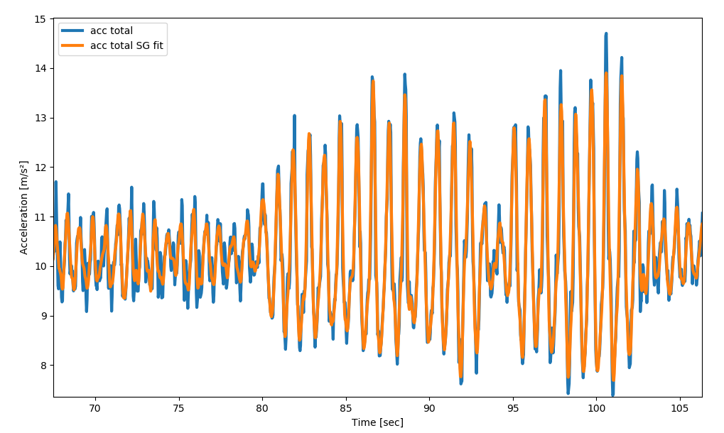Fig 1: Total Acceleration raw and filtered
The barometer data showed some extreme noise which was filtered out first with a median filter to remove the outliars and that result was smoothed with a SG filter too (Fig 3 + 4).

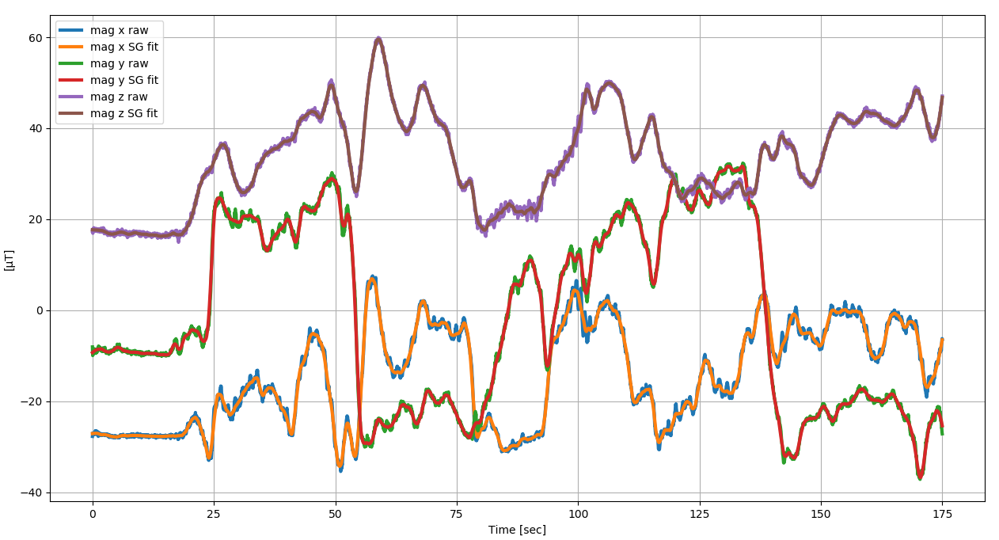Fig 2: Raw and Filtered Magnetometer Data
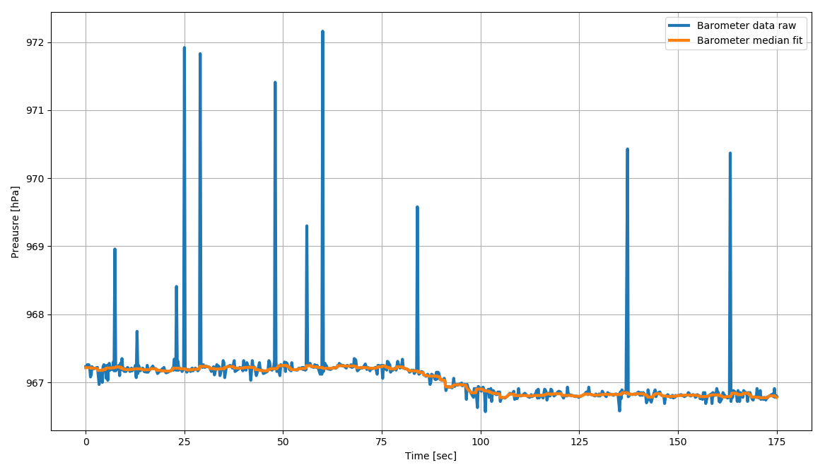Fig 3: Barometer Data raw and SG filtered

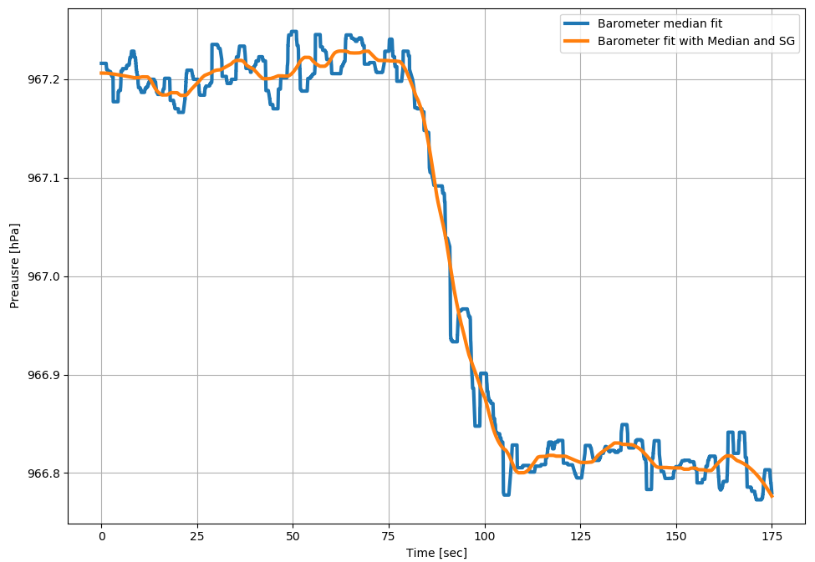Fig 4: Barometric Data filtered with median and SG
With the Barometric formula the barometric data could be transformed into altitude difference.

In a further step the slope of that function was calculated over time to be used as an indicator, if the person that recorded the inertial data is walking up stairs. That is important for the step estimation and classification process.
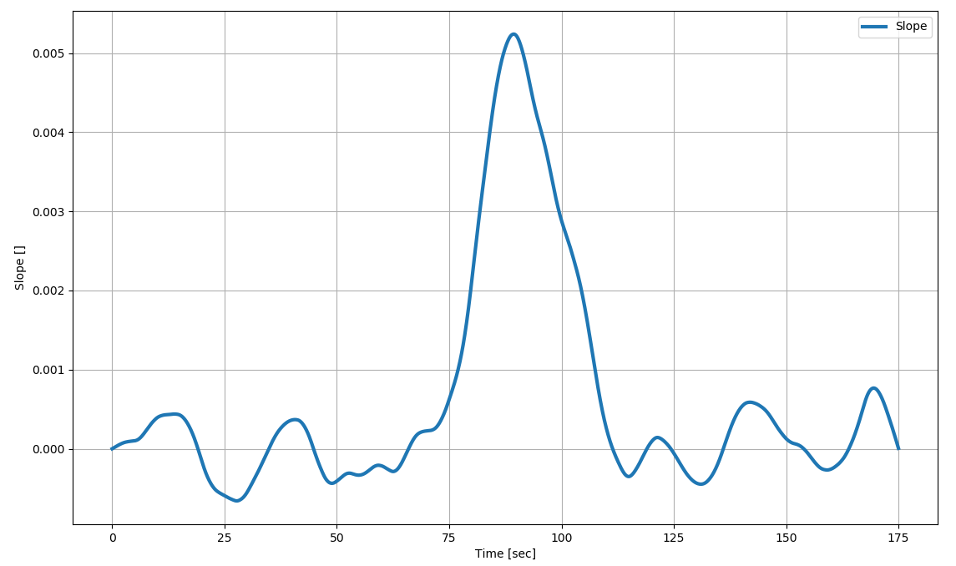Fig 5: Slope of the Altitude Difference

B. Step Detection
With the computed total accelerometer time series you can tell if the foot of the pedestrian is in motion or not. When the feet is on the ground the acceleration should mark a minimum and when the foot makes a swing motion it should peak. That information is used for the step detection in the total acceleration time series. I have decided to search for local minima, which are according to [1] more distinct than peaks and so more suiteable. A Threshold of was asigned, where all valleys under a value of 10 should be found. Fig 6 shows all detected steps for minima and maxima in a certain time window. A second threshold was asigned to the minimum search function, which compares the neigbour data values so no sub-minima disturb the valley detection. The result of this detection is that we know WHEN the pedestrian has made a step and how often.

C. Step length estimation
In the literature a variaty of algorithms for step length estimation can be found e.g which adapts the step length according to the frequency change. But for this lab a fixed step length for normal walking and stair climbing was used. In general the step length derives the information how far we are heading in a certain direction. When a person moves up a stairway, the acceleration pointing to the z axe will increase and marks a classification target to change the step length. I decided not to look at the acceleration data, but instead perform a linear regression with a moving window over the barometric data, which derives me the slope of the barometric function over time. The barometric gradient will increase when the person walks up the stairway and will flatten again if the person moves on a chosen floor. With a threshold assigned, the step length changes dynamically with the time and gradient changing.
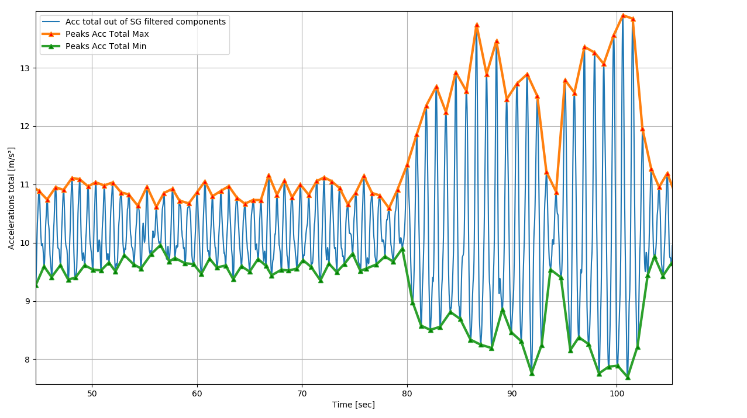Fig 6: Step Detection with local Minima and Maxima
entire proceedings, and not as an independent document. Please do not revise any of the current designations.

Preliminary Results
Before you begin to format your paper, first write and save the content as a separate text file. Keep your text and graphic files separate until after the text has been formatted and styled. Do not use hard tabs, and limit use of hard returns to only one return at the end of a paragraph. Do not add any kind of pagination anywhere in the paper. Do not number text heads-the template will do that for you.
Finally, complete content and organizational editing before formatting. Please take note of the following items when proofreading spelling and grammar:

Conclusion
After the text edit has been completed, the paper is ready for the template. Duplicate the template file by using the Save As command, and use the naming convention prescribed by your conference for the name of your paper. In this newly created file, highlight all of the contents and import your prepared text file. You are now ready to style your paper; use the scroll down window on the left of the MS Word Formatting toolbar.

References
[1] E. Anderson, “Motion Classification and Step Lentgth Estimation for GPS/INS Pedestrian Navigation” Master Thesis. Stockholm, KTH, School of Electrical Engineering (EES) , 2012.

