Pipe-Up → SAP
Integration Architecture
How field-verified cost data flows from Pipe-Up into SAP ERP
March 2026 | Pipe-Up Inc.
Prepared for discussion with Roman Mucenski

1. The Problem This Solves
On every large-diameter pipeline project running Time & Material or Target Priced contracts, there is a fundamental gap between what is happening in the field and what is being approved in the office. SAP is the system of record for financial accounting, procurement, and project controls. But SAP has no way to independently verify that the costs being posted against WBS elements reflect what was actually built, inspected, and measured on the ground.
The result is predictable: contractors submit billing, project controls enters it into SAP, and the system treats it as fact. There is no field-level reconciliation layer. No cross-reference between what the inspector observed and what the contractor claimed. The project team is making financial decisions based on unverified data.
Pipe-Up closes that gap. It captures inspector-verified field data at the point of work, reconciles it against contractor billing in real time, and produces a clean, auditable cost dataset that SAP can trust.

2. What Pipe-Up Provides That SAP Cannot
- Field-verified daily reports — Inspector observations, crew counts, equipment on-site, progress by chainage, weather, and activity logs captured at the point of work.
- Contractor LEM reconciliation — Contractor billing (Labour, Equipment, Materials) is matched line-by-line against inspector-verified field data. Discrepancies are flagged before they reach accounts payable.
- WBS-tagged actuals — Every reconciled line item is tagged to a WBS element matching the FEED estimate structure, producing a clean estimate-vs-actual variance at any point during construction.
- Risk register with field closeouts — FEED-identified risks are tracked through construction and closed against actual field outcomes with real cost impact data.
- Full audit trail — Every financial adjustment, reconciliation decision, and status change is logged with user, timestamp, and reason. No behind-the-scenes changes.

3. Data Flow: Pipe-Up Tables → SAP Modules
The following table maps each Pipe-Up data source to its SAP destination, the API method used, and the sync trigger.
Pipe-Up source | SAP module | SAP object | API method | Trigger
Lem line items | CO | Cost element posting | BAPI_ACC_ACTIVITY_ALLOC_POST | On reconciliation approval
Feed wbs actuals | PS | WBS element actual | BAPI_PS_PRECOMMIT_POST | On WBS tagging
Contractor lem uploads | FI | AP invoice posting | BAPI_INCOMINGINVOICE_CREATE | On invoice approval
Feed wbs actuals (variance) | PS / EVM | Earned value update | OData: /sap/opu/odata/sap/API_ENTERPRISE_PROJECT | Nightly batch
Feed risks (closeouts) | PS | Contingency drawdown | BAPI_PS_PRECOMMIT_POST | On risk closeout
SAP MM → Pipe-Up | MM | Purchase order sync | BAPI_PO_GETDETAIL | On PO creation (inbound)

4. The API Handshake

4.1 Authentication
The integration authenticates via SAP’s standard OAuth 2.0 client credentials flow through SAP Business Technology Platform (BTP). Pipe-Up registers as a trusted application, receives a client ID and secret, and exchanges these for a bearer token on each sync cycle. Tokens are short-lived (typically 12 hours) and scoped to the specific SAP modules and operations defined in the integration role.

4.2 Outbound flow (Pipe-Up → SAP)
When a reconciliation is approved in Pipe-Up, the system packages the reconciled line items into an SAP-compatible payload. The flow is:
- Pipe-Up fires a webhook on reconciliation status change (status = ‘reconciled’).
- The integration layer retrieves the LEM line items, WBS tags, and associated daily report references.
- Data is transformed: Pipe-Up WBS codes are mapped to SAP PS WBS element IDs, cost categories are mapped to SAP CO cost elements, and amounts are validated against the FEED estimate tolerance.
- The payload is posted to SAP via the appropriate BAPI or OData endpoint.
- SAP returns a document number (cost posting ID, AP document number, etc.) which Pipe-Up stores against the original line item for traceability.
- If SAP rejects the posting, the error is queued for retry with full diagnostic detail. The Pipe-Up record remains in a ‘pending sync’ state until confirmed.

4.3 Inbound flow (SAP → Pipe-Up)
Purchase orders created in SAP MM are synced to Pipe-Up so that contractor LEM uploads can reference the correct PO number. This enables the full chain: SAP PO → Pipe-Up LEM reconciliation → SAP AP posting, all traceable to a single purchase order.
The sync runs on a scheduled poll (configurable interval, typically every 4 hours) using BAPI_PO_GETDETAIL or the S/4HANA OData equivalent. Only POs tagged to the relevant project WBS structure are retrieved.

4.4 Payload example
A simplified example of a reconciled LEM line item being posted to SAP CO:
{
"source": "pipe-up",
"lem_line_item id": "v_line_hdd_1",
"sap_wbs_element": "CLX2.1.2",
"sap cost element": "420100",
"posting date": "2014-05-20",
"amount": 4200000.00,
"currency": "CAD",
"description": "HDD Pembina River 210m remedial",
"po_number": "4500012345",
"reconciliation_status": "reconciled",
"inspector_report_ref": "DR-2014-05-20-001",
"variance_note": "Pembina River sand collapse"
}
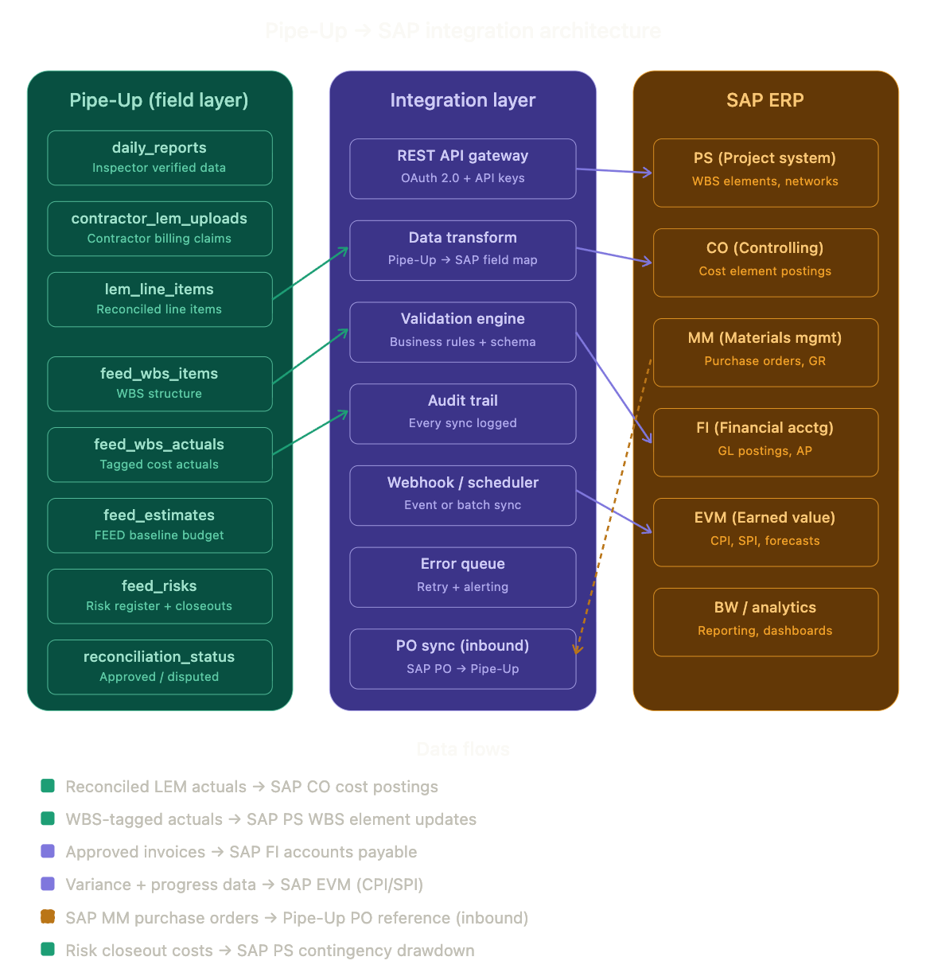

5. What Changes for the Owner
Capability | Without Pipe-Up | With Pipe-Up
Cost posting accuracy | Contractor-submitted billing entered into SAP as-is. No independent field verification. | Every cost posting to SAP has been reconciled against inspector-verified field data. Discrepancies resolved before posting.
Earned value integrity | Progress reported by contractor. CPI and SPI calculated on unverified data. | Progress verified by inspector. EVM metrics reflect actual field status.
Change order justification | Change orders supported by contractor claims and estimates. | Change orders supported by inspector daily reports, reconciled LEMs, and risk closeout data with actual cost impact.
Audit readiness | Paper trail assembled post-hoc. Manual cross-referencing between SAP and field records. | Full audit trail built in real time. Every SAP posting traceable back to field source.
Variance detection | Variance discovered at month-end reporting, often too late to act. | Variance flagged at point of reconciliation. Actionable in real time.

6. Implementation Approach

6.1 Phase 1: Outbound cost posting (4–6 weeks)
Connect reconciled LEM actuals to SAP CO cost element postings. This is the highest-value integration point — every dollar posted to SAP has been field-verified. Requires: SAP BTP access, CO posting authorization, WBS element mapping between Pipe-Up and SAP PS structure.

6.2 Phase 2: Inbound PO sync (2–3 weeks)
Sync SAP MM purchase orders into Pipe-Up so that LEM uploads reference the correct PO. Completes the traceability chain from PO to field reconciliation to SAP posting.

6.3 Phase 3: EVM and FI integration (4–6 weeks)
Push WBS-tagged progress and variance data into SAP PS for earned value management. Connect approved invoices to SAP FI accounts payable. Push risk closeout costs for contingency drawdown tracking.

6.4 Phase 4: Reporting layer (2–4 weeks)
Feed Pipe-Up benchmarking data (cost-per-metre by WBS category, labour/equipment splits, HDD cost-per-crossing-metre) into SAP BW or the owner’s reporting layer for cross-project comparison.

7. The Bottom Line
SAP tells you what was committed and what was paid. Pipe-Up tells you whether what was paid matches what was actually built. Without that field verification layer, SAP is processing invoices on faith.
The integration is not a replacement for SAP. It is the missing input that makes SAP’s project controls data trustworthy. Every cost element posting, every earned value update, every AP invoice — verified at the source before it enters the system of record.
The API handshake is standard SAP (BAPIs, OData, OAuth 2.0). The data mapping is natural because Pipe-Up already structures costs by WBS element. The implementation is phased so value is delivered from the first connection point.
Contact: Rick Judson | Pipe-Up Inc. | 780.699.4358

