## Architecture Pattern

The team has decided on a software architecture pattern for the Smart City Project.

For the Smart City project, we will use a two-tier web based architecture pattern that consists of two logical components, the user interface and business logic layer and the database layer.

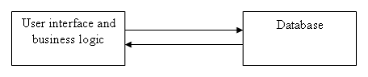

*Logical separation of system layers*

The purpose of following this structure is to construct a website with the desired functionality organised in these layers to keep the client and business logic separate from the database.

In our case, the user interface and business logic will be comprised of a web server and an application server, which will contain the compiled code and be used for the websites dynamic content. The database will be on a separate layer and will hold the permanent data.

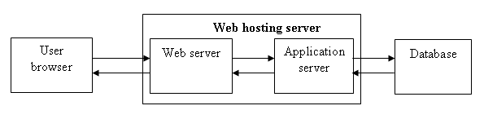

*Physical separation of system layers*

Since the project is on quite a small scale, the team decided that a two-tier architecture pattern is most suitable for the project, and will allow us to keep the users from interacting directly with the database, which would cause security concerns.