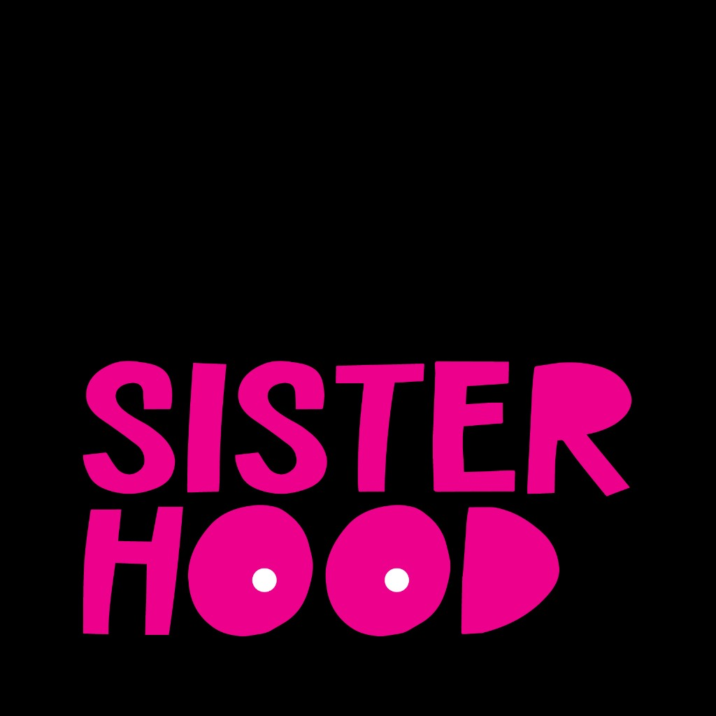

Beyond the Bell

Navigating the Realities of Breast Cancer Survivorship

Executive Summary
Across 24 participants spanning diverse ethnic backgrounds and countries, a clear narrative emerges about the profound gaps between acute cancer treatment and the long-term realities of survivorship.
A dangerous systemic bias where younger women's symptoms are dismissed with 'you're too young' leads to critical diagnostic delays, a finding well-supported by external research on the topic.
Patients describe a 'survivorship cliff' after active treatment ends, where structured medical support disappears, leaving them isolated and unequipped to manage the aftermath—a finding strongly corroborated by literature on post-treatment care gaps.
Significant information gaps force patients into the second job of self-education on critical topics like fertility, medical menopause, and sexual health, which are often unaddressed by their care teams.
In response to this isolation and lack of information, patients build and rely on peer communities as an essential lifeline for validation, practical advice, and emotional healing, a key protective factor identified in both this research and external studies.

Participant Demographics
Total Participants: 24
Age Range: 33–63 (Mean: 42.5, Median: 40.5)
Age Distribution:
25-34: 2 participants
35-44: 13 participants
45-54: 8 participants
55-64: 1 participants
Ethnicity:
WOC: 16 (66.7%)
Caucasian: 8 (33.3%)
Geographic Scope: 21 US-based, 3 international

Key Insights

Younger women consistently report that their symptoms are dismissed by healthcare providers with variations of 'you're too young for that,' a dangerous bias that delays critical diagnoses and forces them to become persistent self-advocates to receive appropriate care.
"And one of the things we hear, so we, many of us have heard so much, is, oh, you're too young and oh, it can't be. And oh, you have nothing to worry about. And, uh, one mother, uh, at who was in my cabin at, at a breast cancer camp last year was like, you know, they're gaslighting us." - patient (Episode: BH_009.docx)
"All the healthcare professionals, I'm sure they meant well, but they all said, you know what, you're too young. It's probably nothing. You're too young. It's probably nothing. That's what I kept hearing" - patient (Episode: BH_015.docx)

Patients report a sharp decline in structured medical and community support after active treatment concludes, creating a 'survivorship cliff' or 'no man's land' that leaves them feeling isolated and unequipped to manage the ongoing physical, mental, and emotional challenges of recovery on their own.
"That is the time when we need the most support. Because now we don't have the structure of that act, active treatment. We don't have the structure of people helping on a daily basis, people checking in. It's a lonely time." - patient (Episode: BH_002.docx)
"in some ways survivorship is a no man's land where you kind of have to choose your own adventure and figure out how to, to then process and heal." - patient (Episode: BH_011.docx)

Patients are frequently left unprepared for the realities of survivorship, as healthcare teams fail to proactively provide vital information on topics like fertility preservation, medical menopause, sexual health, and practical recovery, compelling patients to undertake exhaustive self-education and seek answers from peer communities.
"in the beginning of my journey, I was not told about IVF or fertility preservation. Um, so I didn't find out about that until my sixth, until I was in my sixth round. Yeah, and I text my nurse navigator and I literally only found out because of Instagram" - patient (Episode: BH_007.docx)
"and it's exhausting and you're already exhausted and you're already traumatized trying to figure out like you're a cancer diagnosis and to ex. Just the curve that you have to get educated and make decisions is steep and it's, it feels like a very impossible climb when it's overwhelming information." - patient (Episode: BH_001.docx)

Patients report that their concerns about long-term quality of life—including body image, sexual health, and the severe side effects of treatment—are frequently dismissed by providers focused narrowly on clinical survival, compelling patients to advocate for their whole person to be considered in treatment planning.
"It wasn't only about saving my life. Thank you so much that it's about that, and thank you for saving my life, but it's also about the life I have after this. And that's something I really believe that matters so much to younger breast cancer survivors, and maybe sometimes our healthcare people are not in that frame of mind." - patient (Episode: BH_005.docx)
"Honestly, I really just think it is elevating menopause and the sequelae of menopause to the level of recurrence risk. Because right now it is not taken as seriously" - clinician (Episode: BH_019.docx)

To combat the profound isolation of a cancer diagnosis, patients actively build and rely on peer communities, often through social media, as a vital lifeline that provides a unique sense of validation, practical information, and belonging that is missing from formal healthcare.
"just having people who can sit in that space with you, they know what it feels like. They know how monumental this is. Um, like that has been second to none because you don't really have to explain yourself, you know?" - patient (Episode: BH_020.docx)
"I was the youngest in the room by decades and didn't feel like I could relate to anybody there. ... I can't be the anomaly that like I feel like and people are treating me like, and so I went to social media." - patient (Episode: BH_008.docx)

Contrary to the celebratory image of 'ringing the bell,' the end of active treatment often initiates a prolonged and challenging emotional aftermath, where survivors grapple with a persistent fear of recurrence, grief, and environmental triggers that represent unseen, long-lasting scars.
"I think the first few years post active treatment were definitely the hardest for me, just because of that fear of recurrence... I was just scared, like every single sensation. I was worried about, and you know, it impacted my mental health, it impacted my relationships, it impacted, you know, everything. Like, it was all I could think about." - patient (Episode: BH_008.docx)
"I thought, oh, I'll be going back to how I would be feeling, you know, I'd be back to myself, but that was totally. Not it, I was a new self... there are things that still trigger, even though I'm gonna be, you know, this August will be seven years out, but still, it's still triggering." - patient (Episode: BH_010.docx)

Methodology
Episodes Analyzed: 24
Moments Segmented: 96
Confidence Threshold: High

