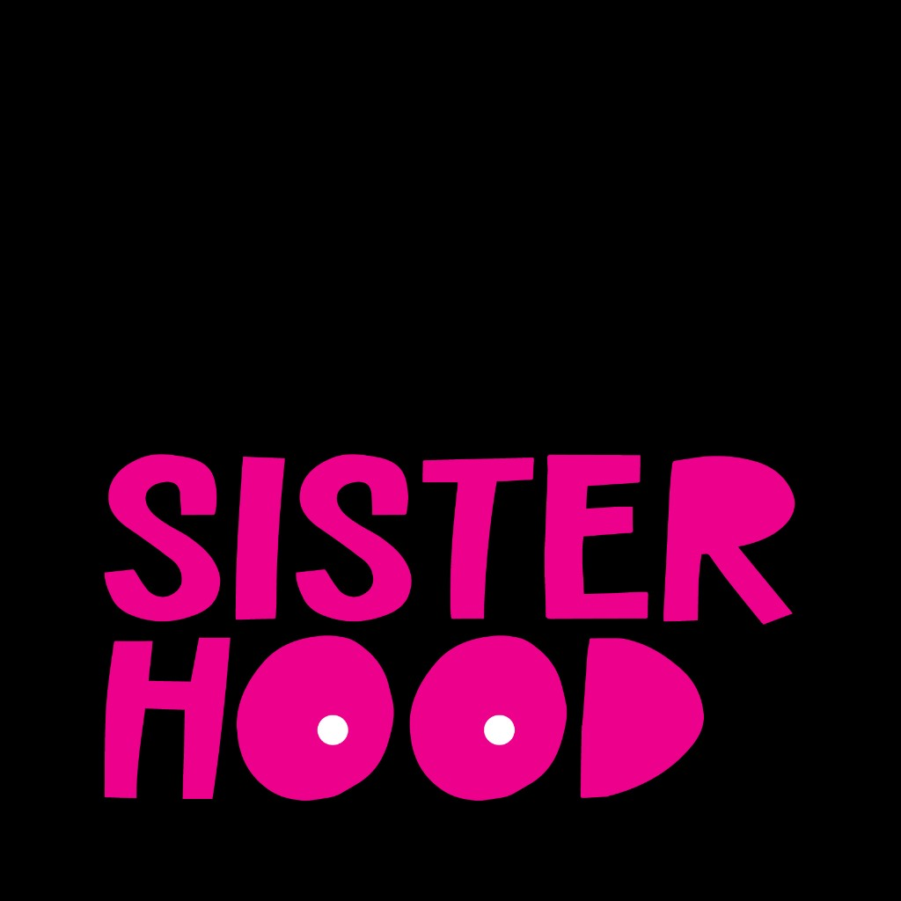

External Research Validation Report

Overall Alignment Summary
The overall alignment between the promoted insights and the external research is strong, with the majority of insights being either fully or partially supported. The strongest corroborations exist for systemic issues like the 'survivorship cliff,' critical information gaps, the burden of financial toxicity, and the protective role of peer communities. Notable gaps in alignment include two insights—rushed medical decisions and the tension between survival and quality of life—which were not addressed in the external review. Furthermore, the external document highlights the theme of 'breaking generational silences' as lacking strong corroboration in authoritative literature, and it elevates the 'fear of recurrence' to a level of prominence not fully captured by a single promoted insight.

External Source
The external document is a review of key insights from a report titled 'The Second Battle', assessing them against authoritative literature from sources like NCI, NIH, NCCN, and peer-reviewed systematic reviews. It provides an executive assessment and an insight-by-insight review, rating each claim as Supported, Partially supported, or Not well supported, and includes verbatim excerpts and analysis.

Insight-by-Insight Validation

Patient Self-Advocacy as a Necessary Countermeasure to Provider Dismissal
Status: Partially Supported
The external literature supports the core concept that self-advocacy is a necessary response for women with cancer, particularly younger women who face diagnostic delays due to low suspicion from providers. However, the review notes that specific actions mentioned in the insight, such as 'changing providers,' are less directly established in authoritative sources compared to the general need to 'speak up'.
Alignment: The alignment is partial because while the central theme of self-advocacy as a response to systemic issues is supported, the external review qualifies some of the specific components. It treats the exact phrasing of dismissal (e.g., 'you're too young') and certain actions (e.g., 'changing providers') as more specific to patient narratives than broadly established in the reviewed literature.
"The self-advocacy portion of this claim is well supported."
"Cancer self-advocacy is defined in the literature as the ability to overcome challenges in getting one’s needs, preferences, and values met, and studies in women with cancer show themes such as speaking up, interacting strategically with the healthcare team, and relying on support from others."
"The external literature strongly supports the core direction of this insight: younger women with breast cancer face diagnostic delays, limited suspicion, and awareness gaps."

Critical Knowledge Gaps in Cancer Care Impede Informed Decision-Making
Status: Supported
The external document strongly supports this insight, stating that the survivorship literature repeatedly identifies information needs as one of the most common unmet domains for breast cancer survivors. The review confirms that patients often have to fill these gaps themselves, which aligns with the insight's claim of forced self-education.
Alignment: The alignment is very strong. The external review cites multiple sources, including a 2023 scoping review and NCI's survivorship work, that corroborate the existence of significant information gaps regarding side effects, follow-up care, and quality of life.
"This insight is strongly supported."
"The survivorship literature repeatedly identifies information needs as one of the most common unmet domains for breast cancer survivors."
"In the 2023 scoping review, information needs appeared frequently across studies and remained one of the most commonly reported unmet needs."

The "Survivorship Cliff": Abrupt Cessation of Support After Cancer Treatment Creates Isolation
Status: Supported
The external review finds this insight is 'strongly aligned with the survivorship literature.' It cites NCI standards and a large scoping review which confirm that many survivors experience unmet physical and psychosocial needs long after treatment ends, corroborating the concept of a post-treatment drop-off in support.
Alignment: The alignment is direct and robust. The external evidence validates the core components of the insight: the sharp decline in structured support and the resulting unmet needs in the post-treatment phase.
"This insight is strongly aligned with the survivorship literature."
"NCI’s National Standards for Cancer Survivorship Care notes that many survivors experience physical and psychosocial symptoms during and long after treatment, remain at risk for recurrence, and require long-term follow-up care."
"A large scoping review of unmet supportive care needs in breast cancer survivors found that social support, fear of recurrence, daily activity, and information support were among the top unmet needs."

Peer Community as an Irreplaceable Pillar of Cancer Survivorship
Status: Supported
This insight is strongly supported by the external review, which cites NCI guidance and systematic reviews on the effectiveness of peer support. The evidence confirms that support groups help people feel less alone and can improve psychosocial outcomes like anxiety and quality of life for breast cancer patients.
Alignment: The alignment is excellent. The external review specifically notes that peer support provides a 'distinct layer of understanding and coping support that formal systems often do not fully provide,' which directly mirrors the insight's statement.
"This insight is strongly supported."
"NCI states that cancer support groups can help people feel less alone, work through feelings, and handle practical problems."
"A systematic review and meta-analysis found that peer support may improve psychosocial adaptation, including anxiety and quality of life."

High-Stakes Medical Decisions are Rushed, Lacking Adequate Time and Information
Status: Not Addressed
The external research document does not contain a specific section or analysis related to the time pressure or rushed nature of medical decision-making for cancer patients. While it discusses information gaps, it does not evaluate the claim that patients are frequently pressured to make urgent, life-altering decisions with inadequate time for consideration.
Alignment: There is no alignment as the topic is not covered in the provided external review. The review focuses on other aspects of the patient experience like diagnostic delays, information needs, and post-treatment support, but not the specific issue of time constraints in decision-making.

Breaking Generational Silence Around Family Health History is a Survival Imperative
Status: Partially Supported
The external review addresses the concept of 'breaking generational silences' and finds that it is not a well-established, generalizable finding in the authoritative breast cancer literature it reviewed. The document suggests this theme is more likely rooted in qualitative patient narratives rather than broad external consensus.
Alignment: The alignment is partial at best. The external review explicitly lists 'breaking generational silences' as a claim that was 'not strongly corroborated as written,' indicating a gap between the insight and the reviewed evidence base.
"I did not find strong authoritative literature showing it as a broadly established breast-cancer survivorship finding in the same way as fear of recurrence, unmet information needs, or financial toxicity."
"the self-advocacy core is supported; the added specificity is better treated as a qualitative patient-level theme than as a settled external consensus."

Compounding Barriers of Cost and Logistics Force Impossible Healthcare Choices
Status: Supported
This insight is strongly supported by the external review, which confirms that 'financial toxicity' is a well-documented issue in cancer care. It cites the NCI's definition and findings that cancer survivors are more likely to experience financial problems related to the cost of care, which can affect their ability to work and pay bills.
Alignment: The alignment is very strong. The external review's assessment directly corroborates the insight's framing of financial stress as a 'secondary crisis' on top of the health battle.
"This insight is strongly supported by authoritative sources."
"NCI defines financial toxicity as problems related to the cost of medical care and states that people with cancer and survivors are more likely to experience it than people without cancer."
"The literature therefore strongly supports the report’s framing of financial toxicity as a second crisis layered on top of illness."

Healthcare Focus on Survival Overlooks Younger Patients' Quality of Life Post-Treatment
Status: Not Addressed
The external research document does not specifically evaluate the tension between the healthcare system's focus on survival versus the long-term quality of life for younger patients. While it mentions 'quality-of-life management' as an information gap and 'psychosocial symptoms' post-treatment, it does not address the unique context for younger survivors or the specific framing of this insight.
Alignment: There is no direct alignment. The external review does not contain an analysis of this specific systemic pattern, making it impossible to validate the claim based on the provided text.

Insights Not Found in External Research

High-Stakes Medical Decisions are Rushed, Lacking Adequate Time and Information
The external review did not include an assessment of the time pressures involved in medical decision-making, focusing instead on other aspects of the patient journey like diagnostic delays and post-treatment support.

Healthcare Focus on Survival Overlooks Younger Patients' Quality of Life Post-Treatment
The external review did not evaluate the specific dynamic between a focus on acute survival and the long-term quality of life concerns (e.g., fertility, sexual health) that are particularly relevant to younger cancer patients.

Novel Findings from External Research

Fear of Recurrence as a Primary Survivorship Concern
The external review identifies fear of recurrence as one of the most common and persistent unmet psychosocial concerns among cancer survivors. It is consistently highlighted in NCI literature, systematic reviews, and NCCN guidelines as a major issue that can reduce quality of life.
Relevance: This is a core emotional component of the survivorship experience that significantly impacts mental health and well-being long after treatment ends. While related to the 'survivorship cliff,' its prominence in the literature suggests it could be a standalone insight.

Self-Advocacy as a Compensatory Response to Systemic Gaps
The external literature suggests that self-advocacy is not merely an individual trait but often emerges as a necessary, compensatory response when healthcare systems fail to provide adequate care, information, or coordination. This reframes the behavior as an indicator of systemic shortcomings.
Relevance: This finding adds a critical layer of nuance to the self-advocacy insight, shifting the focus from individual patient behavior to the systemic conditions that necessitate it. It provides a more structural critique of the healthcare system.

