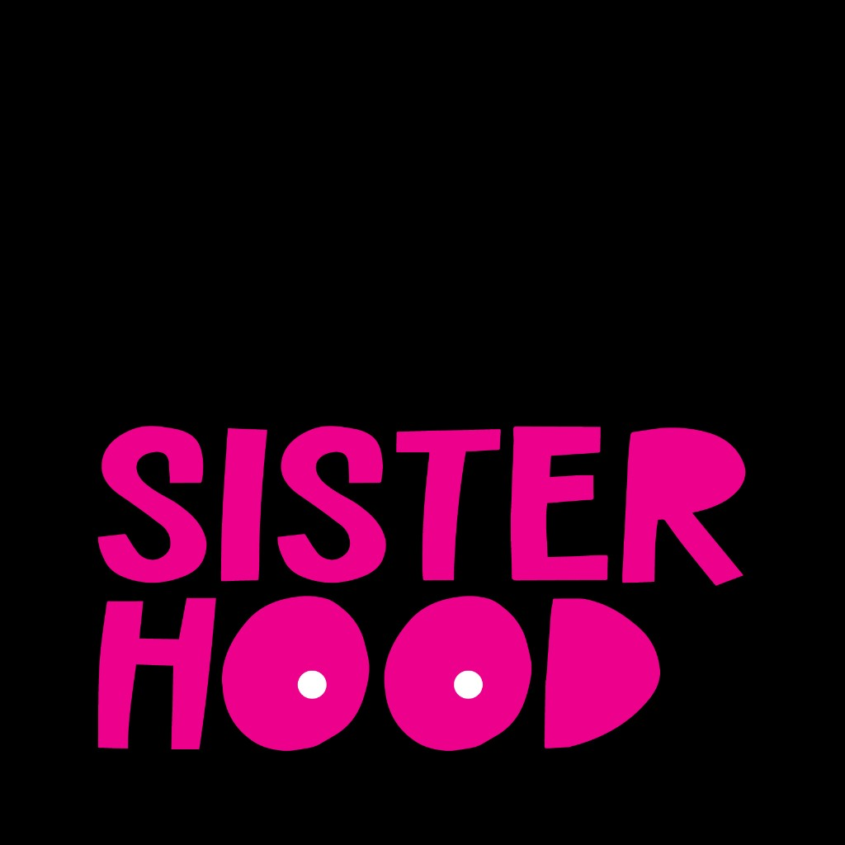

Navigating the Aftermath

Lived Experiences in Breast Cancer Survivorship

Executive Summary
Across 24 international participants from diverse backgrounds, a clear narrative emerges about the journey through breast cancer survivorship, a journey marked by systemic gaps and profound resilience.
Patients consistently describe a 'survivorship cliff' where formal support abruptly ends after treatment, forcing them to navigate the complex emotional and physical aftermath alone in a disorienting 'no man's land'.
In response to these gaps and frequent dismissal from providers—particularly regarding quality-of-life concerns—patients are compelled to become fierce self-advocates, fighting to be heard and seen as whole people.
To counteract the isolation and fill critical information voids, peer communities have become an essential, non-negotiable lifeline, providing the validation, practical advice, and belonging that the formal healthcare system often fails to deliver.
These lived experiences are strongly corroborated by external research, confirming that these patterns are major, well-documented themes in cancer care that demand systemic attention.

Participant Demographics
Total Participants: 24
Age Range: 0–0 (Mean: 0, Median: 0)
Age Distribution:
Ethnicity:
37: 5 (20.8%)
35: 2 (8.3%)
49: 2 (8.3%)
39: 2 (8.3%)
I didn’t include it in the form: 2 (8.3%)
54: 1 (4.2%)
42: 1 (4.2%)
52: 1 (4.2%)
46: 1 (4.2%)
34: 1 (4.2%)
44: 1 (4.2%)
33: 1 (4.2%)
63: 1 (4.2%)
45: 1 (4.2%)
47: 1 (4.2%)
48: 1 (4.2%)
Geographic Scope: 0 US-based, 24 international

Key Insights

Patients report a sharp decline in structured medical and community support after active treatment, creating a 'survivorship cliff' or 'no man's land' that leaves them feeling isolated and unequipped to manage the ongoing physical, mental, and emotional challenges of recovery without a clear roadmap.
"That is the time when we need the most support. Because now we don't have the structure of that act, active treatment. We don't have the structure of people helping on a daily basis, people checking in. It's a lonely time." - patient (Episode: BH_002.docx)
"in some ways survivorship is a no man's land where you kind of have to choose your own adventure and figure out how to, to then process and heal." - patient (Episode: BH_011.docx)

Patients, particularly younger women, consistently encounter dismissal from healthcare providers who normalize symptoms or prioritize clinical survival over quality-of-life concerns, compelling them to develop forceful self-advocacy skills to secure life-saving care and protect their future wellbeing.
"And one of the things we hear, so we, many of us have heard so much, is, oh, you're too young and oh, it can't be. And oh, you have nothing to worry about. And, uh, one mother, uh, at who was in my cabin at, at a breast cancer camp last year was like, you know, they're gaslighting us." - patient (Episode: BH_009.docx)
"It wasn't only about saving my life. Thank you so much that it's about that, and thank you for saving my life, but it's also about the life I have after this. And that's something I really believe that matters so much to younger breast cancer survivors, and maybe sometimes our healthcare people are not in that frame of mind." - patient (Episode: BH_005.docx)

In the absence of sufficient institutional support and understanding from friends or family, patients actively build and rely on peer communities as a vital lifeline to combat isolation, finding a unique sense of validation, practical information, and sacred healing that is missing from formal healthcare.
"just having people who can sit in that space with you, they know what it feels like. They know how monumental this is. Um, like that has been second to none because you don't really have to explain yourself, you know?" - patient (Episode: BH_020.docx)
"I did not realize the level of healing that I was still missing until I got involved in community and it's a different type of healing and it's so sacred and special." - host (Episode: BH_002.docx)

Patients frequently encounter significant information gaps regarding diagnosis, treatment side effects, and long-term quality of life, compelling them to undertake exhaustive self-education—often through social media—to make informed decisions and prepare for the realities of survivorship.
"and it's exhausting and you're already exhausted and you're already traumatized trying to figure out like you're a cancer diagnosis and to ex. Just the curve that you have to get educated and make decisions is steep and it's, it feels like a very impossible climb when it's overwhelming information." - patient (Episode: BH_001.docx)
"in the beginning of my journey, I was not told about IVF or fertility preservation. Um, so I didn't find out about that until my sixth, until I was in my sixth round. Yeah, and I text my nurse navigator and I literally only found out because of Instagram" - patient (Episode: BH_007.docx)

The end of active treatment initiates a prolonged emotional aftermath where survivors grapple with a persistent fear of recurrence and profound social isolation, as they are unable to discuss the 'taboo' realities of their new life with friends and family who don't share their experience.
"I think the first few years post active treatment were definitely the hardest for me, just because of that fear of recurrence... I was just scared, like every single sensation. I was worried about, and you know, it impacted my mental health, it impacted my relationships, it impacted, you know, everything. Like, it was all I could think about." - patient (Episode: BH_008.docx)
"My, we call them muggles, right? Non-cancer friends. I just also, when they're like, oh, how are you doing? I, you can't talk about these taboo things about your. You know, like your vagina or your sex life or whatever, or even like your boobs with them. So I'm like, I don't, I don't know what to tell you." - patient (Episode: BH_016.docx)

Patients face the overwhelming burden of 'financial toxicity,' where the high cost of care, medication co-pays, and the inability to work during treatment create a secondary crisis of financial stress and instability on top of their health battle.
"I don't work because of the pain, because of the treatment... But I have to pay for healthcare, which costs me. A good $14,000 a year. I have $2,000 copay for medication and I don't work. So, um, that is the hardest part to manage is getting people to understand like, where's this money gonna come from?" - patient (Episode: BH_014.docx)
"he literally asked me if I had $20,000 in the bank and I said no... And he's like, then I don't know what you're doing sitting here because you can't afford this." - patient (Episode: BH_013.docx)

Methodology
Episodes Analyzed: 24
Moments Segmented: 96
Confidence Threshold: Medium or higher

