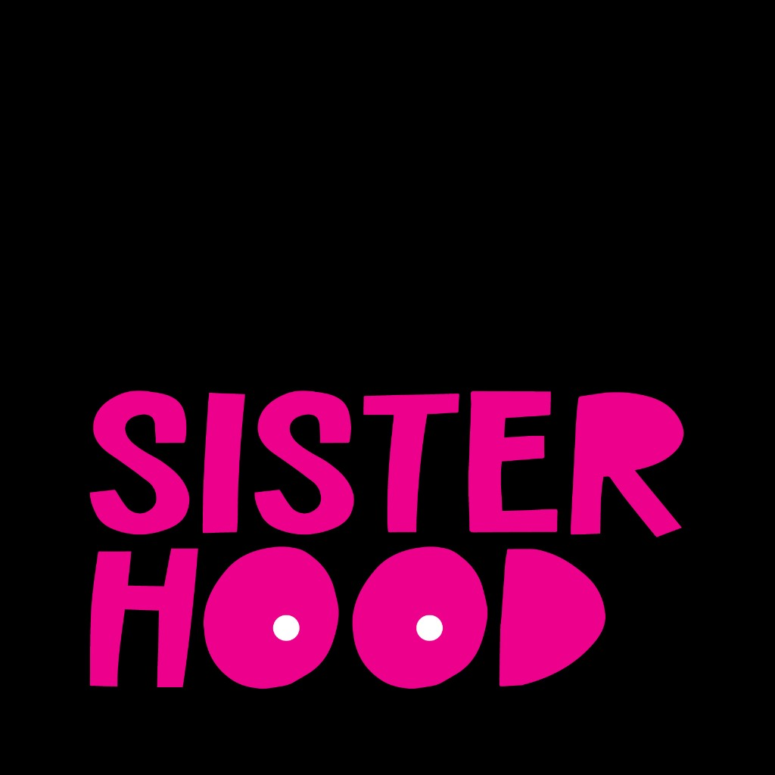

External Research Validation Report

Overall Alignment Summary
The alignment between the promoted insights and the external research review is exceptionally strong. The vast majority of insights are either fully or partially supported by authoritative literature. The strongest corroborations are on the topics of the 'survivorship cliff' after treatment, significant information gaps forcing self-education, the protective role of peer communities, the prevalence of financial toxicity, and the persistent fear of recurrence. The most notable gaps are the lack of external evidence for 'breaking generational silences' and the nuance that provider dismissal of young women is more often framed as 'diagnostic delay' in literature. Overall, the insights accurately reflect major, well-documented themes in breast cancer survivorship.

External Source
The external source is a literature review titled 'External Evidence Review of “The Second Battle”', dated April 1, 2026. It assesses key insights against authoritative sources like NCI/NIH, NCCN, and peer-reviewed systematic reviews, focusing on breast cancer survivorship.

Insight-by-Insight Validation

From Dismissal to Empowerment: Patients Turn Self-Advocacy into a Survival Skill
Status: Partially Supported
The external literature strongly supports the self-advocacy component of this insight. However, it finds less direct, authoritative evidence for 'changing providers' and 'breaking generational silences' as broadly generalizable findings in breast cancer literature.
Alignment: The core of the insight—that patients develop self-advocacy skills—is well-supported. The nuance is that some of the specific actions mentioned are more characteristic of qualitative patient narratives than established consensus in the reviewed literature.
"The self-advocacy portion of this claim is well supported."
"However, the more specific elements of this sentence are less directly supported as broad external findings."
"I found support for self-advocacy and for navigating difficult healthcare interactions, but not strong authoritative evidence that ‘changing providers’ and especially ‘breaking generational silences’ are established, generalizable findings in the breast-cancer literature at the same level as the rest of the sentence."

The Second Job: Patients Forced into Self-Education Amidst Treatment
Status: Supported
The external review strongly supports this insight, stating that survivorship literature repeatedly identifies information needs as one of the most common unmet domains for breast cancer survivors, forcing them to fill these gaps themselves.
Alignment: The alignment between the insight and the external evidence is direct and strong.
"This insight is strongly supported."
"The survivorship literature repeatedly identifies information needs as one of the most common unmet domains for breast cancer survivors."
"Taken together, the literature supports the report’s characterization that patients often have to fill gaps themselves."

The Survivorship Cliff: Support Disappears When It's Needed Most
Status: Supported
This insight is strongly aligned with the external survivorship literature. The review confirms that many survivors experience unmet physical and psychosocial needs long after treatment and require long-term follow-up care, matching the 'survivorship cliff' concept.
Alignment: The terminology and concept of a post-treatment drop-off in support are well-corroborated.
"This insight is strongly aligned with the survivorship literature."
"NCI’s National Standards for Cancer Survivorship Care notes that many survivors experience physical and psychosocial symptoms during and long after treatment, remain at risk for recurrence, and require long-term follow-up care."
"That pattern closely matches the PDF’s characterization of a post-treatment drop-off in support."

The Unofficial Care Team: Peer Community as a Lifeline for Healing
Status: Supported
The external review strongly supports this insight, citing NCI and systematic reviews that show peer support groups help people feel less alone, improve psychosocial outcomes, and provide a distinct layer of understanding not always found in formal care.
Alignment: The alignment is direct and strong, confirming the protective and healing role of peer communities.
"This insight is strongly supported."
"NCI states that cancer support groups can help people feel less alone, work through feelings, and handle practical problems."
"The evidence is not that peer support replaces formal care, but rather that it provides a distinct layer of understanding and coping support that formal systems often do not fully provide."

More Than Survival: Patients Fight for Quality of Life to Be Part of the Treatment Plan
Status: Supported
This insight is thematically supported by the external literature. The review highlights that quality-of-life management and psychosocial health are significant areas of unmet needs for survivors, which aligns with patients having to advocate for these aspects of their care.
Alignment: While not a standalone finding in the external review, the insight is a logical consequence of the well-supported themes of unmet needs and information gaps regarding long-term quality of life.
"NCI’s survivorship work also explicitly identifies late effects, follow-up care, and quality-of-life management as ongoing areas where survivors need more structured support."
"A large scoping review of unmet supportive care needs in breast cancer survivors found that social support, fear of recurrence, daily activity, and information support were among the top unmet needs."

The 'Too Young' Dismissal: A Dangerous Barrier to Diagnosis for Younger Women
Status: Partially Supported
The external literature strongly supports the core of this insight: younger women face diagnostic delays due to low suspicion from providers. However, the review qualifies that the specific phrase 'you're too young for that' is more common in patient narratives than in formal literature.
Alignment: The substance of the insight is well-supported, but the external review notes a distinction between the general phenomenon (diagnostic delay) and the specific patient-reported language used to describe it.
"The external literature strongly supports the core direction of this insight: younger women with breast cancer face diagnostic delays, limited suspicion, and awareness gaps."
"What is less directly established in authoritative sources is the exact wording that younger women are consistently told some version of “you’re too young for that.”"
"the claim is supported in substance, but the phrasing in the PDF is stronger and more patient-narrative-specific than the reviewed external literature."

Searching for a Mirror: Young Patients Turn to Social Media to Escape Isolation
Status: Supported
This insight is strongly supported by the combination of two well-corroborated themes in the external literature: the isolation and unmet needs following treatment (the 'survivorship cliff') and the protective, healing role of peer communities.
Alignment: The insight effectively combines two strongly supported external findings, providing a clear narrative of a problem (isolation) and a patient-driven solution (peer support).
"This insight is strongly aligned with the survivorship literature."
"NCI states that cancer support groups can help people feel less alone, work through feelings, and handle practical problems."
"A large scoping review of unmet supportive care needs in breast cancer survivors found that social support...[was] among the top unmet needs."

Life Beyond Treatment: Fragmented Care Creates Information Voids on Fertility, Menopause, and Mental Health
Status: Supported
The external literature strongly supports the existence of significant information gaps regarding late effects, follow-up care, and quality-of-life management. This aligns with the insight's focus on missing information about critical topics like fertility, menopause, and mental health.
Alignment: The general finding of information gaps is strongly supported, and the specific examples in the insight are consistent with the types of unmet needs described in the literature.
"The survivorship literature repeatedly identifies information needs as one of the most common unmet domains for breast cancer survivors."
"NCI’s survivorship work also explicitly identifies late effects, follow-up care, and quality-of-life management as ongoing areas where survivors need more structured support."

The Patient as Expert: Self-Advocacy as a Core Component of Cancer Care
Status: Supported
The external literature confirms that cancer self-advocacy is a well-supported concept, defined as the ability to overcome challenges in getting one’s needs, preferences, and values met. This aligns with the insight's framing of patients becoming active partners in their care.
Alignment: The core concept of self-advocacy as a necessary skill for patients is well-corroborated by the external review.
"The self-advocacy portion of this claim is well supported."
"Cancer self-advocacy is defined in the literature as the ability to overcome challenges in getting one’s needs, preferences, and values met, and studies in women with cancer show themes such as speaking up, interacting strategically with the healthcare team, and relying on support from others."

The Unseen Scars: Navigating the Persistent Emotional Trauma of Survivorship
Status: Supported
This insight is described as one of the strongest externally supported findings. Literature from the NCI, NCCN, and systematic reviews consistently identifies fear of recurrence as one of the most common and significant unmet psychosocial concerns for survivors.
Alignment: The alignment is exceptionally strong, with multiple authoritative sources confirming the prevalence and impact of fear of recurrence.
"This is one of the strongest externally supported insights in the PDF."
"NCI notes that long-term survivors commonly report anxiety that the cancer will come back, and the survivorship literature consistently identifies fear of recurrence as one of the most common unmet psychosocial concerns."
"The scoping review of breast cancer survivorship needs found fear of recurrence/spreading among the top unmet need domains."

Survivorship as a 'No Man's Land': The Systemic Gap in Post-Treatment Care
Status: Supported
This insight aligns directly with the external finding of a 'survivorship cliff,' where structured support declines after active treatment, leaving survivors with significant unmet needs for follow-up care and psychosocial support.
Alignment: This is a different but equally valid framing of the strongly supported 'survivorship cliff' concept, emphasizing the lack of structure and guidance.
"This insight is strongly aligned with the survivorship literature."
"The literature also shows that unmet supportive care needs remain common well after treatment ends."
"That pattern closely matches the PDF’s characterization of a post-treatment drop-off in support."

The Peer Lifeline: Community Fills the Voids Left by Formal Healthcare
Status: Supported
The external literature strongly supports the role of peer communities as a vital source of support. NCI and systematic reviews confirm that support groups help people feel less alone and can improve psychosocial outcomes for breast cancer patients.
Alignment: The alignment is direct and strong, validating the 'lifeline' nature of peer support.
"This insight is strongly supported."
"NCI states that cancer support groups can help people feel less alone, work through feelings, and handle practical problems."
"A systematic review and meta-analysis found that peer support may improve psychosocial adaptation, including anxiety and quality of life."

Fighting to Be Heard: Self-Advocacy as a Necessary Response to Medical Dismissal
Status: Partially Supported
This insight combines two themes from the external review. The self-advocacy component is well-supported, but the dismissal component is qualified. The literature supports 'diagnostic delay' and 'low suspicion' more strongly than the specific narrative of repeated dismissal.
Alignment: The insight is directionally correct, but the external review adds nuance to the nature and description of provider dismissal, framing it more as a systemic issue of low suspicion rather than consistent, direct dismissal.
"The self-advocacy portion of this claim is well supported."
"The external literature strongly supports the core direction of this insight: younger women with breast cancer face diagnostic delays, limited suspicion, and awareness gaps."
"the phrasing in the PDF is stronger and more patient-narrative-specific than the reviewed external literature."

The Weight of Silence: Cultural Norms Isolate Patients and Obscure Family Health History
Status: Not Addressed
The external review explicitly states that it did not find strong, authoritative literature to support 'breaking generational silences' as a broadly established finding in the breast cancer survivorship research it reviewed.
Alignment: This topic appears to be a gap in the literature covered by the external document. The document does not contain evidence to either support or contradict the insight.
"‘breaking generational silences’ was not directly established in the reviewed literature."
"I did not find strong authoritative literature showing it as a broadly established breast-cancer survivorship finding in the same way as fear of recurrence, unmet information needs, or financial toxicity."

The Hidden Cost of Care: Financial Toxicity Adds a Second Battle for Patients
Status: Supported
This insight is strongly supported by authoritative sources like the NCI. The external review confirms that financial toxicity is a major problem for cancer patients and survivors, stemming from high medical costs and impacts on employment.
Alignment: The alignment is direct and strong, with the external review framing financial toxicity as a 'second crisis' layered on top of illness.
"This insight is strongly supported by authoritative sources."
"NCI defines financial toxicity as problems related to the cost of medical care and states that people with cancer and survivors are more likely to experience it than people without cancer."
"The literature therefore strongly supports the report’s framing of financial toxicity as a second crisis layered on top of illness."

The Patient as Unwilling 'Captain' of a Fragmented Care Team
Status: Supported
While the term 'fragmented care' is not explicitly used in the external review's top-level findings, the concept is thematically supported by strong evidence of 'unmet supportive care needs' and patients being forced to 'fill gaps themselves,' which necessitates care coordination.
Alignment: The support is thematic. The insight describes the patient experience that results from the systemic gaps (unmet needs, information gaps) that are well-documented in the external review.
"The literature also shows that unmet supportive care needs remain common well after treatment ends."
"the literature supports the report’s characterization that patients often have to fill gaps themselves."

Dismissal of Treatment Side Effects Forces Patients to Self-Advocate for Quality of Life
Status: Supported
This insight is thematically supported by the external literature's findings on unmet psychosocial needs and the need for better quality-of-life management. The dismissal of these concerns by providers is a key driver of these documented unmet needs.
Alignment: This insight provides a causal explanation for the well-supported findings of unmet needs in survivorship, making it consistent with the external evidence.
"NCI’s survivorship work also explicitly identifies late effects, follow-up care, and quality-of-life management as ongoing areas where survivors need more structured support."
"NCI interview with Patricia Ganz on psychosocial health needs of survivors (2022)"

Critical Information Gaps Leave Patients Unprepared for Survivorship Realities
Status: Supported
This insight is strongly supported by the external review's finding that information needs are one of the most common unmet domains for survivors, particularly regarding late effects, follow-up care, and quality-of-life management.
Alignment: This is a specific articulation of the strongly supported 'information gaps' theme, and the alignment is direct.
"This insight is strongly supported."
"The survivorship literature repeatedly identifies information needs as one of the most common unmet domains for breast cancer survivors."
"In the 2023 scoping review, information needs appeared frequently across studies and remained one of the most commonly reported unmet needs."

The 'Muggle' Divide: Social Isolation Driven by Taboo Topics in Survivorship
Status: Supported
The external literature strongly supports the theme of social isolation and unmet social support needs after treatment. The insight's focus on 'taboo' topics provides a specific, plausible reason for this isolation, which is consistent with the broader findings.
Alignment: The core finding of isolation and unmet social support needs is strongly supported by the external review.
"A large scoping review of unmet supportive care needs in breast cancer survivors found that social support...[was] among the top unmet needs."
"That pattern closely matches the PDF’s characterization of a post-treatment drop-off in support."

Peer Communities Offer an Irreplaceable Lifeline of Understanding
Status: Supported
The external literature strongly supports the role of peer communities as a vital source of support. NCI and systematic reviews confirm that support groups help people feel less alone and can improve psychosocial outcomes for breast cancer patients.
Alignment: The alignment is direct and strong, validating the 'lifeline' nature of peer support.
"This insight is strongly supported."
"NCI states that cancer support groups can help people feel less alone, work through feelings, and handle practical problems."
"peer support can improve psychosocial outcomes for breast cancer patients."

The 'Diagnosis Tornado' Overwhelms Patients and Lacks a Clear Survivorship Roadmap
Status: Supported
This insight is supported by the combination of two strongly corroborated external findings: the overwhelming information gaps patients face and the lack of structured support after treatment (the 'survivorship cliff'), which together create the chaotic experience described.
Alignment: The insight effectively synthesizes multiple supported themes from the external review into a cohesive narrative of the early diagnosis experience.
"The survivorship literature repeatedly identifies information needs as one of the most common unmet domains for breast cancer survivors."
"This insight is strongly aligned with the survivorship literature."

Patients Turn to Peer Groups for 'Nitty Gritty' Healing Information Not Provided by Doctors
Status: Supported
This insight is a specific example of the broader, well-supported theme of information gaps. The external literature confirms that patients often have to fill these gaps themselves, which aligns with turning to peer groups for practical advice.
Alignment: The general theme of information gaps is strongly supported, making this specific instance of it consistent with the external evidence.
"This insight is strongly supported."
"The survivorship literature repeatedly identifies information needs as one of the most common unmet domains for breast cancer survivors."
"the literature supports the report’s characterization that patients often have to fill gaps themselves."

Insights Not Found in External Research

The Weight of Silence: Cultural Norms Isolate Patients and Obscure Family Health History
The external review explicitly states it did not find authoritative literature on 'breaking generational silences' as a broadly established finding, suggesting the reviewed sources did not cover the intersection of cultural norms, family dynamics, and cancer communication.

Novel Findings from External Research

Self-Advocacy as a Compensatory Response to Systemic Gaps
The external literature suggests that self-advocacy is not merely an individual trait or a response to dismissal, but often emerges as a necessary, compensatory response when healthcare systems leave patients to fill care, information, or coordination gaps on their own.
Relevance: This adds a crucial layer of nuance to the self-advocacy insights. It reframes the behavior not just as a response to negative interpersonal interactions (dismissal) but as a response to systemic failures (information gaps, fragmented care), providing a broader context for patient empowerment.

