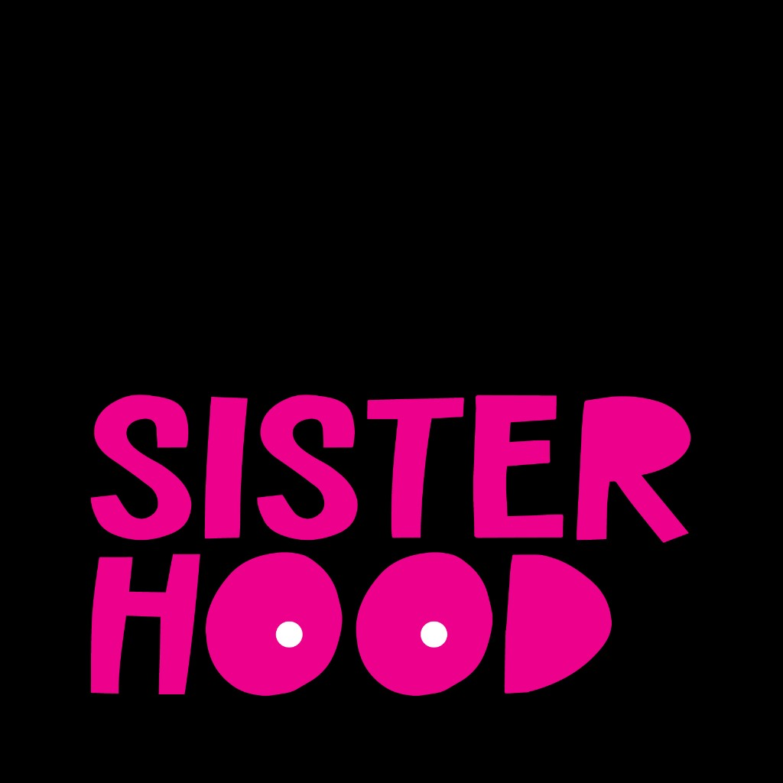

Voices of Survivorship

Navigating the Gaps in Breast Cancer Care

Executive Summary
Across 24 participants spanning diverse ages, ethnic backgrounds, and geographic locations, a clear narrative emerges of a healthcare system that excels at acute treatment but often fails to support the long-term, holistic needs of breast cancer survivors.
Younger women consistently face dangerous diagnostic delays due to the persistent dismissal of their symptoms by providers who tell them they are 'too young' for breast cancer.
After active treatment, patients experience a 'survivorship cliff,' where structured medical and community support abruptly disappears, leaving them isolated and unequipped to manage the long-term aftermath.
Significant gaps in information regarding quality-of-life issues like fertility, medical menopause, and mental health force patients into the second job of exhaustive self-education during a time of crisis.
In response to these systemic failures, patients build and rely on peer communities as an essential lifeline for validation, practical information, and a unique form of healing that formal healthcare does not provide.
These lived experiences are strongly corroborated by external research, which confirms the prevalence of diagnostic delays for young women, the challenges of the post-treatment phase, and the critical role of peer support.

Participant Demographics
Total Participants: 24
Age Range: 33–63 (Mean: 42.5, Median: 40.5)
Age Distribution:
25-34: 2 participants
35-44: 13 participants
45-54: 8 participants
55-64: 1 participants
Ethnicity:
WOC: 16 (66.7%)
Caucasian: 8 (33.3%)
Geographic Scope: 21 US-based, 3 international

Key Insights

Younger women consistently report being dismissed by healthcare providers with variations of 'you're too young for that,' which normalizes their symptoms, delays critical diagnoses, and necessitates persistent self-advocacy to receive appropriate medical imaging and care.
"And one of the things we hear, so we, many of us have heard so much, is, oh, you're too young and oh, it can't be. And oh, you have nothing to worry about. And, uh, one mother, uh, at who was in my cabin at, at a breast cancer camp last year was like, you know, they're gaslighting us." - patient (Episode: BH_009.docx)
"when I found that lump, the doctor dismissed me. She's like, you're so young, you have no family history. Like, what are you, what are you doing back at this appointment? I just saw you a couple weeks ago. Um, so definitely had to advocate to get that imaging to ultimately get a diagnosis." - patient (Episode: BH_008.docx)

Patients report a sharp decline in structured medical and community support after active treatment concludes, creating a 'survivorship cliff' or 'no man's land' that leaves them feeling isolated and unequipped to manage the ongoing physical, mental, and emotional challenges of recovery.
"That is the time when we need the most support. Because now we don't have the structure of that act, active treatment. We don't have the structure of people helping on a daily basis, people checking in. It's a lonely time." - patient (Episode: BH_002.docx)
"in some ways survivorship is a no man's land where you kind of have to choose your own adventure and figure out how to, to then process and heal." - patient (Episode: BH_011.docx)

Patients frequently encounter significant information gaps from their healthcare providers regarding diagnosis, treatment side effects, and long-term quality of life—including fertility, menopause, and mental health—compelling them to undertake exhaustive self-education and turn to peer networks for practical advice.
"and it's exhausting and you're already exhausted and you're already traumatized trying to figure out like you're a cancer diagnosis and to ex. Just the curve that you have to get educated and make decisions is steep and it's, it feels like a very impossible climb when it's overwhelming information." - patient (Episode: BH_001.docx)
"in the beginning of my journey, I was not told about IVF or fertility preservation. Um, so I didn't find out about that until my sixth, until I was in my sixth round. Yeah, and I text my nurse navigator and I literally only found out because of Instagram" - patient (Episode: BH_007.docx)

Patients face the overwhelming burden of 'financial toxicity,' where the high cost of healthcare, medication co-pays, and the inability to work during treatment create a secondary crisis of financial stress and instability on top of their health battle.
"I don't work because of the pain, because of the treatment... But I have to pay for healthcare, which costs me. A good $14,000 a year. I have $2,000 copay for medication and I don't work. So, um, that is the hardest part to manage is getting people to understand like, where's this money gonna come from?" - patient (Episode: BH_014.docx)
"he literally asked me if I had $20,000 in the bank and I said no... And he's like, then I don't know what you're doing sitting here because you can't afford this." - patient (Episode: BH_013.docx)

In the face of systemic gaps and social isolation, patients actively build and rely on peer communities as a vital lifeline, finding a unique sense of validation, belonging, and practical healing that is missing from formal healthcare interactions.
"I did not realize the level of healing that I was still missing until I got involved in community and it's a different type of healing and it's so sacred and special." - host (Episode: BH_002.docx)
"just having people who can sit in that space with you, they know what it feels like. They know how monumental this is. Um, like that has been second to none because you don't really have to explain yourself, you know?" - patient (Episode: BH_020.docx)

Contrary to the celebratory image of 'ringing the bell,' the end of active treatment often initiates a prolonged and challenging emotional aftermath, where survivors grapple with persistent fear of recurrence, grief, and environmental triggers, long after physical treatment has ceased.
"I think the first few years post active treatment were definitely the hardest for me, just because of that fear of recurrence... I was just scared, like every single sensation. I was worried about, and you know, it impacted my mental health, it impacted my relationships, it impacted, you know, everything. Like, it was all I could think about." - patient (Episode: BH_008.docx)
"I thought, oh, I'll be going back to how I would be feeling, you know, I'd be back to myself, but that was totally. Not it, I was a new self... there are things that still trigger, even though I'm gonna be, you know, this August will be seven years out, but still, it's still triggering." - patient (Episode: BH_010.docx)

Methodology
Episodes Analyzed: 24
Moments Segmented: 96
Confidence Threshold: This report exclusively features insights that have achieved a 'High' confidence level, indicating they are strongly supported by coherent evidence from a minimum of three distinct episodes.

