README

Prerequisites

Install JDK 1.8, Eclipse for Java Developers, Eclipse Buildship: Eclipse Plug-ins for Gradle

**Step 1**

Download the GradleJavaExample project

git clone <https://github.com/rickqiu/GradleJavaExample.git>

**Step 2:** Import the Gradle project into Eclipse

* 1. Open the “Import” popup window by selecting the “Import” menu item on “File” menu

2.2 Expand the “Gradle” folder, then select “Existing Gradle Project”.

2.3 In the “Import Gradle Project” popup window, the full path for the project root directory.

2.4 Click “Finish” button to complete the project importation.

**Step 3**

Make sure the project can be built successfully.

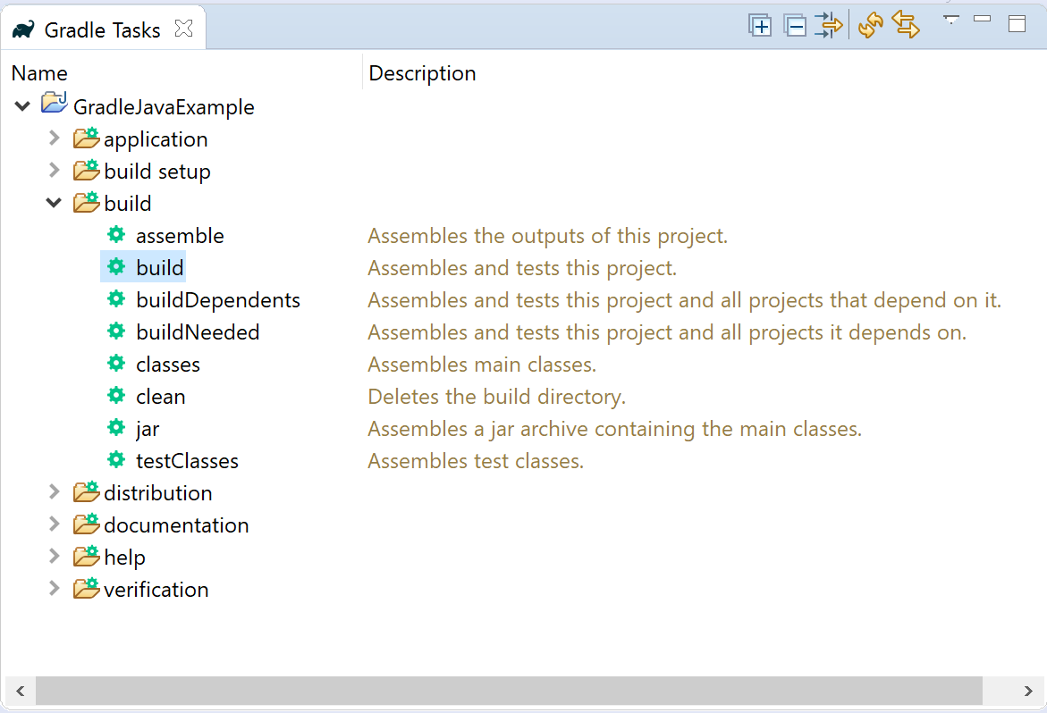

**Step 4**

Run the com.compay.app.MainApp

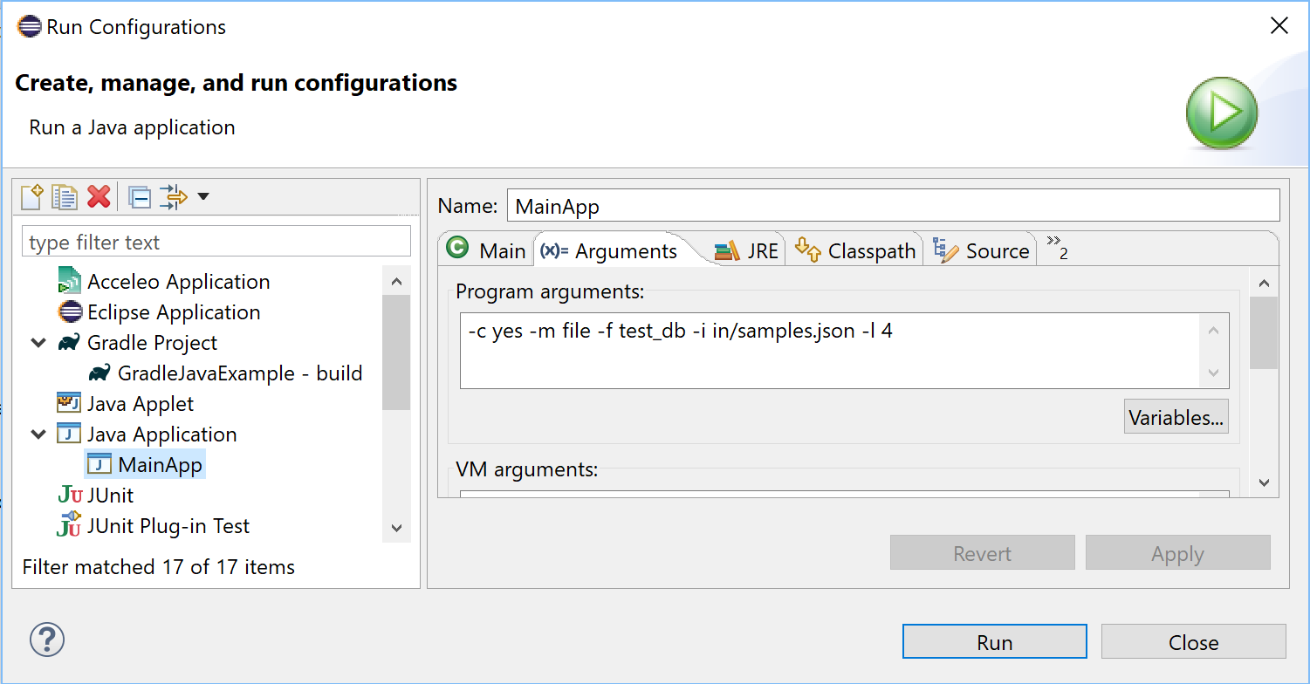

**Step 5**

Check the results after the MainApp run.

* 1. Check the result in the app.log in project root directory

2018-07-21 15:24:04,277 INFO c.c.p.DatabaseOperationImpl [Test worker] 4 events inserted into DB.

5.2 Check the result in the test_db.log in project root directory

/*C1*/SET SCHEMA SYSTEM_LOBS

INSERT INTO BLOCKS VALUES(0,2147483647,0)

COMMIT

/*C2*/SET SCHEMA PUBLIC

CREATE TABLE IF NOT EXISTS alert_events ( id INTEGER GENERATED BY DEFAULT AS IDENTITY PRIMARY KEY, user_id VARCHAR(20) NOT NULL, state CHAR(8) NOT NULL, type VARCHAR(20), host VARCHAR(20), timestamp BIGINT NOT NULL, alert TINYINT NOT NULL)

DISCONNECT

/*C3*/SET SCHEMA PUBLIC

INSERT INTO ALERT_EVENTS VALUES(0,'scsmbstgra','STARTED ','APPLICATION_LOG','12345',1491377495212,1)

COMMIT

INSERT INTO ALERT_EVENTS VALUES(1,'scsmbstgra','FINISHED','APPLICATION_LOG','12345',1491377495217,1)

COMMIT

INSERT INTO ALERT_EVENTS VALUES(2,'scsmbstgrc','STARTED ',NULL,NULL,1491377495210,1)

COMMIT

INSERT INTO ALERT_EVENTS VALUES(3,'scsmbstgrc','FINISHED',NULL,NULL,1491377495218,1)

COMMIT

DISCONNECT