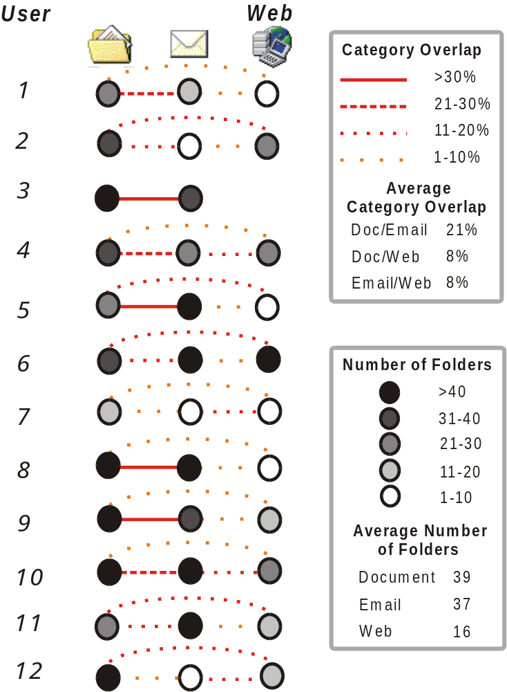

Figure 5.3: Category overlaps for individual users

