|  |  |
| --- | --- |
| I used [1] in making this assignment when finished I compared initial values with Prajish Kumar (4743873). | **Rick Staa, #4511328**  **HW set 3 due 13/03/2018**  **ME41060** |

# **1. Statement of integrity**



# **2. Problem statement**

In this assignment we use the TMT method to model a simple passive dynamic walker (PDW). This model consists of two slender legs hinged at the hip. The two legs are identical, with length and mass (distributed equally around the legs). The body of this PDW is modelled as an extra point mass at the hip. Further he ground this model is walking on is tilted by an angle . The generalized coordinates used in this model are the angle of the stance leg w.r.t. the ground normal and the angle of the swing leg w.r.t. the ground normal. This results in the following state .

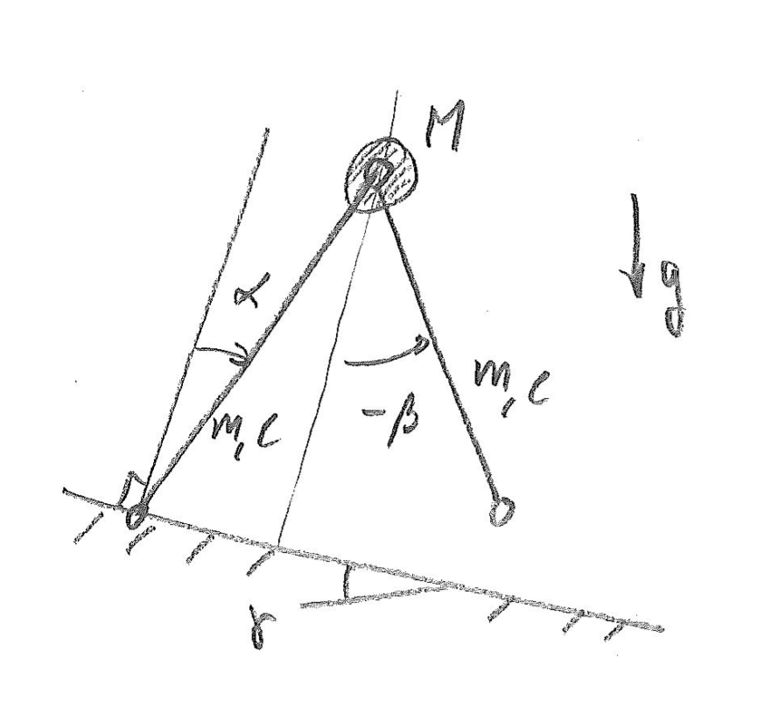

**Figure 1:** A sketch of the Passive Dynamic walker used in this assignment.

# **3. Method**

We were asked to derive the equations of motion of the PDW by means of two methods, The LaGrange method and the Virtual power TMT method. In this section both methods will be discussed. However, since we already extensively reviewed the Lagrange method only a brief overview of this method will be given.

# **3.1 Lagrange Method**

This method makes use of the conservation of energy principle and Lagrange Multipliers to derive the equations of motions. This is done by Solving the following LaGrange constrain equation:

|  |  |  |
| --- | --- | --- |
|  |  | (1) |
|  |  |  |

Where T is the kinetic energy of the system, V the potential energy and generalised forces. This last one is equal to zero in this problem. How this kinetic and potential energy can be calculated is explained in the next subsection. In equation (1) we see that instead of x we now use generalised state q. This generalised state is a comprised of the minimum number of coordinates to express the full motion of the system. The generalised coordinates of which this state is comprised in our problem is:

|  |  |  |
| --- | --- | --- |
|  |  | (2**)** |

**Kinetic energy**

|  |  |  |
| --- | --- | --- |
|  |  | (3) |

Where is the mass matrix:

|  |  |  |
| --- | --- | --- |
|  |  | (4) |

of the COM’s of the segments expressed in the generalised coordinates: The global coordinate system was said to be perpendicular to the slope since this made the calculations easier.

|  |  |  |
| --- | --- | --- |
|  |  | (5) |

|  |  |  |
| --- | --- | --- |
|  |  |  |

**Potential energy**

The potential energy of the system can be calculated as follows:

|  |  |  |
| --- | --- | --- |
|  |  | (6**)** |

In which F is the vector with potential forces as described in the global coordinate system:

|  |  |  |
| --- | --- | --- |
|  |  | (7) |
|  |  |  |
|  |  | (8) |

**Equations of motion**

To get the EOM we rewrite formula (1) as a matrix vector product with the known terms at the right side we get:

|  |  |  |
| --- | --- | --- |
|  |  | (9) |

Since we have the expressions for the potential (T) and kinetic energy (V) we can solve this equation to get . After obtaining we can get the equations of motion expressed in the centre of mass coordinates by solving:

|  |  |  |
| --- | --- | --- |
|  |  | (10) |

For the implementation you are referred to appendix A.

# **3.2 Virtual Power TMT method**

The Virtual Power TMT method is like the Lagrange method but differs in the fact that it doesn’t go into the energy domain. Instead it stays in the forces domain and uses an incremental approach to obtain the equations of motion. Like the Lagrange method the TMT method uses generalized coordinates. With these generalized coordinates we can derive the TMT method by first looking at the virtual power equation in which the D’Alembert forces are included:

|  |  |  |
| --- | --- | --- |
|  |  | **(11)** |

The TMT method makes use of a transformation matrix T to transform the virtual COM velocities in this equation into generalized virtual velocities. The transformation is done follows:

|  |  |  |
| --- | --- | --- |
|  |  | (12) |

The kinematic-ally acceptable velocities now become:

|  |  |  |
| --- | --- | --- |
|  |  | (13) |

The Transformation matrix can then be obtained by taking the Jacobean of equation 5 with respect to the generalized coordinates. This Jacobean was derived using the MATLAB symbolic toolbox. The script that was used in doing this can be found in appendix A. Filling in equation 13 in equation 11 we now get the following expression for the virtual power:

|  |  |  |
| --- | --- | --- |
|  |  | (14) |

Since we introduced a new set of coordinates we now also get generalized forces . With these generalized forces and virtual velocities, the virtual power expression is now almost fully expressed in terms of generalized coordinates. The only thing we need to do next is get rid of the COM accelerations  , We can do this by taking the derivative of expression in equation 12. Doing this we get the following result:

|  |  |  |
| --- | --- | --- |
|  |  | (15**)** |

When we fill this in to the generalised coordinates. As a result we obtain the following equation:

|  |  |  |
| --- | --- | --- |
|  |  | **(16)** |

In this is the derivative of the matrix with respect to the first derivative of the generalised state . After noting that this equation must hold for all virtual velocities and rearranging the equation a bit we obtain:

|  |  |  |
| --- | --- | --- |
|  |  | **(17)** |

Where:

|  |  |  |
| --- | --- | --- |
|  |  | **(18)** |

In this T represents the transformation matrix which can be calculated by taking the Jacobian of the states x w.r.t. the general coordinates. The M is again the mass matrix and the F contains the applied forces and moment at the COM’s of the segments. The new G matrix is a convective term that arises due to deriving the virtual accelerations. Again since we get the generalised accelerations to get the accelerations expressed in the COM coordinates we still need to solve:

|  |  |  |
| --- | --- | --- |
|  |  | (19) |

The MATLAB code implementing the TMT method can be found in Appendix B.

# **4. Results and discussion**

To rule out random effects two sets of parameters and initial states were used to compare the both methods. This comparison can be found below:

# **4.1 Results and discussion**

For the first test the following parameters were used:

|  |  |
| --- | --- |
| **Parameter** | **Value** |
|  |  |
|  |  |
|  |  |
|  |  |
|  |  |

Table 1: Parameters used

The following initial states were used:

|  |  |
| --- | --- |
| **Initial states** | **Value** |
|  |  |
|  |  |
|  |  |
|  |  |

Table 2: Initial states used

The results for both methods are shown in table 3 on the next page. From this table both methods give the same result.

|  |  |  |
| --- | --- | --- |
|  | Lagrange | TMT |
|  |  |  |
|  |  |  |
|  |  |  |
|  |  |  |
|  |  |  |
|  |  |  |
|  |  |  |
|  |  |  |
|  |  |  |

Table 3: Results for given initial conditions

# **4.1 Results and discussion**

For the first test the following parameters were used:

|  |  |
| --- | --- |
| **Parameter** | **Value** |
|  |  |
|  |  |
|  |  |
|  |  |
|  |  |

Table 4: Parameters used

The following initial states were used:

|  |  |
| --- | --- |
| **Initial states** | **Value** |
|  |  |
|  |  |
|  |  |
|  |  |

Table 5: Initial states used

The results for both methods are shown in table 6 on the next page. From this table both methods give the same result.

|  |  |  |
| --- | --- | --- |
|  | Lagrange | TMT |
|  |  |  |
|  |  |  |
|  |  |  |
|  |  |  |
|  |  |  |
|  |  |  |
|  |  |  |
|  |  |  |
|  |  |  |

Table 6: Results for given initial conditions

# **4. Cons and Pros**

From the results we can see that both methods give the same result. This was to be expected since they both use the principle of virtual power. The only differen is that the TMT method stays in the forces domain where the LaGrange method briefly goes into the energy domain. Without looking at adding additional passive and active elements the TMT method is easier to implement since you only are calculating the transformation matrix. As a result, the TMT method is less prone to errors and it is easier to add additional segments. Although here was no noticeable difference for this small system it is possibly also computationally faster when working with larger systems since less differentials need to be evaluated. Further the TMT method is easier to interpret compared to the LaGrange method you now stay in the state and force space. The downside is however that you don’t directly get any information about the energy of the system, but this can be easily calculated within the algorithm.

**Appendix A (Lagrange)**

**MATLAB CODE**

%% MBD_B: Assignment 5 - Passive dynamic walker (Lagrange and TMT aproach)

% Rick Staa (4511328)

% Last edit: 27/03/2018

% - Question A: Lagrange method -

clear all; close all; clc;

fprintf('--- A5_a ---\n');

tic

%% Parameters and variables

% Initialise parameters and variables

syms l m I M % Initialize model Parameters

syms x1 y1 phi1 x2 y2 phi2 x3 y3 phi3 % Initialize variables

syms x1p y1p phi1p x2p y2p phi2p x3p y3p phi3p % Initialize derivatives

syms alpha beta alphap betap % Initialize generalised coordinates

syms gamma g % Initialize enviroment variables

% Calculate additional parameters

I = (1/12)*m*(l^2); % Mass moment of inertia of each leg about the COM

% Devine state and its derivative

q = [alpha;beta];

qp = [alphap;betap];

%% Generate equations of motion

% Express coordinates of the COM in terms of generalised coordinates

x1 = 0.5*l*sin(alpha);

y1 = 0.5*l*cos(alpha);

phi1 = 0.5*pi - alpha;

x2 = l*sin(alpha);

y2 = l*cos(alpha);

phi2 = 0;

x3 = l*sin(alpha) + 0.5*l*sin(0.5*pi + beta);

y3 = l*cos(alpha) + 0.5*l*cos(0.5*pi + beta);

phi3 = 0.5*pi + beta;

% Put in one state vector

x = [x1;y1;phi1;x2;y2;phi2;x3;y3;phi3];

% Compute the jacobian of these expressions

Jx_q = simplify(jacobian(x,q));

% Calculate derivative of the state vector

xp = Jx_q*qp;

% Compute energies

T = 0.5*xp.'*diag([m;m;I;M;M;0;m;m;I])*xp; % Kinetic energy

V = -([m*g*sin(gamma) -m*g*cos(gamma) 0 M*g*sin(gamma) -M*g*cos(gamma) 0 m*g*sin(gamma) -m*g*cos(gamma) 0]*x); % Potential energy

%% Now compute the lagrangian constraint equations of motion

% Compute partial derivatives w.r.t q

T_q = simplify(jacobian(T,q.')).'; % Term 2 in Lagrange equation reader

V_q = simplify(jacobian(V,q.')).'; % Term 3 ...

% Compute partial derivatives w.r.t. qp

T_qp = simplify(jacobian(T,qp.')).';

% Compute terms of total derivative

T_qp_qp = simplify(jacobian(T_qp,qp.'));

T_qp_q = simplify(jacobian(T_qp,q.'));

% Combine matrixes to get the lagrangian euqations of motion in matrix

% vector form

Qj = 0; % Non-conservative forces

Q = T_qp_qp;

F = (-T_qp_q*qp + T_q - V_q + Qj);

% Calculate result expressed in generalized coordinates

qdp = Q\F;

% Get result back in COM coordinates

xdp = simplify(jacobian(xp,qp.'))*qdp + simplify(jacobian(xp,q.'))*qp;

%% Calculate for a initial state

x0 = [deg2rad(30),deg2rad(45),-pi,0];

parms = [0.8,12,9.81,36,pi/12]; % parms = [l,m,g,M,gamma];

xdp = subs(xdp, [l,m,g,M,gamma],parms);

xdp = double(subs(xdp, [alpha,beta,alphap,betap],[x0]));

disp(xdp)

toc

# **Appendix B (TMT)**

**MATLAB CODE**

%% MBD_B: Assignment 5 - Passive dynamic walker (Lagrange and TMT aproach)

% Rick Staa (4511328)

% Last edit: 27/03/2018

% - Question A: Lagrange method -

clear all; close all; clc;

fprintf('--- A5_b ---\n');

tic

%% Parameters and variables

% Initialise parameters and variables

syms l m I M % Initialize model Parameters

syms x1 y1 phi1 x2 y2 phi2 x3 y3 phi3 % Initialize variables

syms x1p y1p phi1p x2p y2p phi2p x3p y3p phi3p % Initialize derivatives

syms alpha beta alphap betap % Initialize generalised coordinates

syms gamma g % Initialize enviroment variables

% Calculate additional parameters

I = (1/12)*m*(l^2); % Mass moment of inertia of each leg about the COM

% Devine state and its derivative

q = [alpha;beta];

qp = [alphap;betap];

%% Generate equations of motion

% Express coordinates of the COM in terms of generalised coordinates

x1 = 0.5*l*sin(alpha);

y1 = 0.5*l*cos(alpha);

phi1 = 0.5*pi - alpha;

x2 = l*sin(alpha);

y2 = l*cos(alpha);

phi2 = 0;

x3 = l*sin(alpha) + 0.5*l*sin(0.5*pi + beta);

y3 = l*cos(alpha) + 0.5*l*cos(0.5*pi + beta);

phi3 = 0.5*pi + beta;

% Put in one state vector

x = [x1;y1;phi1;x2;y2;phi2;x3;y3;phi3];

% Compute the jacobian of these expressions

Jx_q = simplify(jacobian(x,q.'));

% Calculate derivative of the state vector

xp = Jx_q*qp;

% Solve with virtual power

M_bar = Jx_q.'*diag([m,m,I,M,M,0,m,m,I])*Jx_q;

F = [m*g*sin(gamma), -m*g*cos(gamma), 0, M*g*sin(gamma), -M*g*cos(gamma), 0, m*g*sin(gamma), -m*g*cos(gamma), 0];

T_qq = simplify(jacobian(Jx_q*qp,q)*qp);

Q = simplify(Jx_q.'*(F.' - diag([m,m,I,M,M,0,m,m,I])*T_qq));

% Calculate result expressed in generalized coordinates

qdp = M_bar\Q;

% Get result back in COM coordinates

xdp = simplify(jacobian(xp,qp.'))*qdp + simplify(jacobian(xp,q.'))*qp;

%% Calculate for a initial state

x0 = [deg2rad(30),deg2rad(45),-pi,0];

parms = [0.8,12,9.81,36,pi/12]; % parms = [l,m,g,M,gamma];

xdp = subs(xdp, [l,m,g,M,gamma],parms);

xdp = double(subs(xdp, [alpha,beta,alphap,betap],[x0]));

disp(xdp)

toc