|  |  |
| --- | --- |
| I used [1] in making this assignment when finished I compared initial values with Prajish Kumar (4743873). | **Rick Staa, #4511328**  **HW set 1 due 26/02/2018**  **ME41060** |

# Problem Statement

In the assignment we were given a model of a double pendulum attached to the ground. For this pendulum we were asked to compute the equations of motion and possible constraint equations. Following we were asked to calculate the full state vector out of the known angles and angular velocities (inputs of our mode). This report shows how to complete the given assignment.

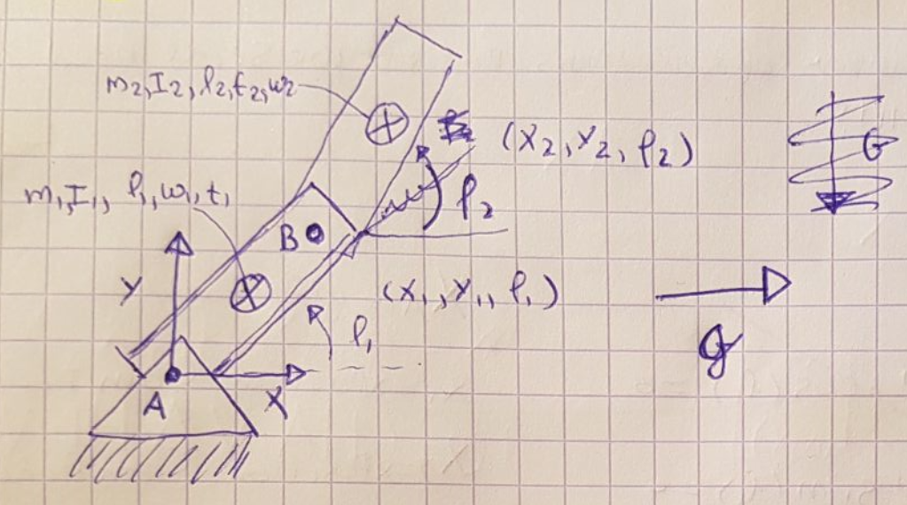

Figure 1: Sketch of double pendulum with 2 DOF. In this sketch l1,l2 are L2, L1

## Given model Parameters

## Calculated parameters

For solving the problem we need to calculate the mass and the moments of inertia of both rigid bodies. The moment of inertias are taken relative to the CM.

## Conventions

Our model has the angles and angular velocities of both segments (displayed in radians) as its inputs inputs:

The model has the second derivative of the state and the reaction forces as its output:

In our out put matrix X the reaction forces are explained in Netwon while the linear velocities are in and the angular velocities are in .

# Equations of motion and constraint equations

To create the equations of motion and the constraint equations it is very usefull to draw a free body diagram:

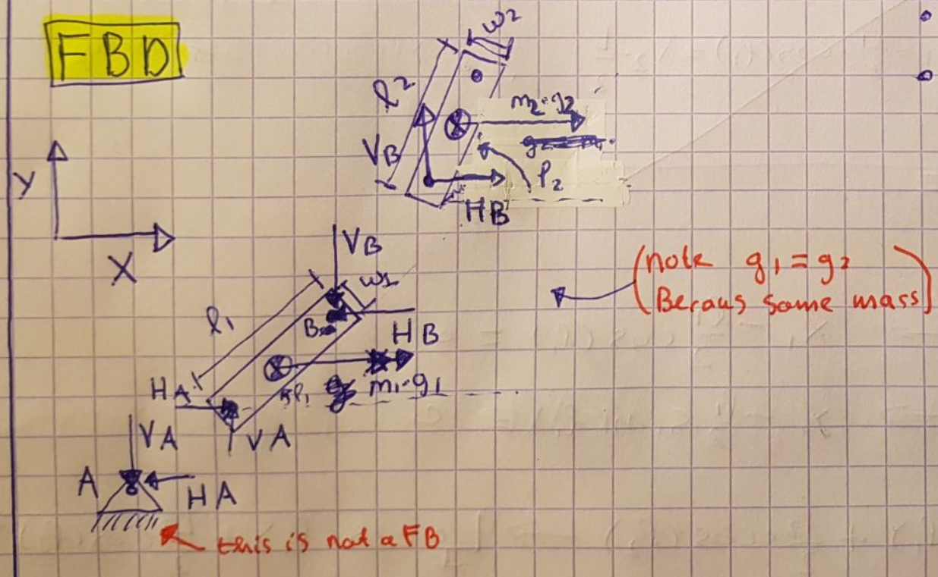



Figure 2: Free body diagram of the double pendulum.

With this free body diagram and the Newton-Euler equations we can now create the **equations of motion:**

**Bar 1:**

|  |  |  |
| --- | --- | --- |
|  |  | **(1)** |
|  |  | **(2)** |
|  |  | **(3)** |

**Bar 2:**

|  |  |  |
| --- | --- | --- |
|  |  | **(4)** |
|  |  | **(5)** |
|  |  | **(6)** |

Because we have 10 unknowns and only 6 equations we need 4 more constraint equations for the system to have a unique. In our case these constraints are created by the 2 joints. For our model the constraint equations become:

|  |  |  |
| --- | --- | --- |
|  |  | **(7)** |
|  |  | **(8)** |
|  |  | **(9)** |
|  |  | **(10)** |

Because we need to represent these contraints in the known and unknown parameters we need to differentiate these equations two times. Further for convenience we bring the known terms to the right side of the equal sign and the unknown terms to the left. We then get the following result:

|  |  |  |
| --- | --- | --- |
|  |  | **(11)** |
|  |  | **(12)** |
|  |  | **(13)** |
|  |  | **(14)** |

To be able to solve these equations in matlab we need to put it in the following matrix form:

|  |  |  |
| --- | --- | --- |
|  |  | **(15)** |

|  |  |  |
| --- | --- | --- |
|  |  | **(16)** |

In which

*NOTE: The – sign is needed because of how the way I defined my matrix*

## Calculate linear and angular accelerations out ofinitial states

Following we solve the matrix vector product above to get the output state X at the three in the assignment specified configurations.

­­­

We do this with the help of the initial state which is defined as:

The MATLAB code in which this operation was performed can be found in appendix A.

### Both bars vertical up and zero speed

With we get the following result:

|  |  |
| --- | --- |
|  | 6.31 |
|  | 0.00 |
|  | -22.93 |
|  | 10.51 |
|  | 0.00 |
|  | 7.64 |
|  | -0.36 N |
|  | 0.00 N |
|  | 0.09 N |
|  | 0.00 N |

If we interprent this result we can see that the second pendulum is accelerating faster than the first pendulum. This is due to the fact that the first pendulum is obstructed in the ground joint. As a result the first pendulum has a negative while the second pendulum has a positive .

### Both bars horizontal to the right and zero speed

With we get the following result:

|  |  |
| --- | --- |
|  | 0.00 |
|  | 0.00 |
|  |  |
|  | 0.00 |
|  | 0.00 |
|  | 0.00 |
|  | -2.55 N |
|  | 0.00 N |
|  | -1.27 N |
|  | 0.00 N |

If we interprent this result we can see that both pendulums have no acceleration this is due to the fact that they are perfectly alighned with the gravity field. We also see that the ground provides a horizontal reaction force on segment 1 resulting in a zero net force on segment 1. Following segment 1 provides a reaction Force on segment 2 resulting in a zero net force on segment 2.

### Both bars horizontal and with an initial angular speed on both bars of 60 rpm.

Since 60 rmp is equal to 2 rad/s we use as the initital state we then the following result:

|  |  |
| --- | --- |
|  | -10.8566 |
|  | 0.00 |
|  |  |
|  |  |
|  | 0.00 |
|  | 0.00 |
|  | -8.1834 N |
|  | 0.00 N |
|  | -5.5009 N |
|  | 0.00 N |

In constrast to the situation we encountered before here there is a horizontal acceleration on both segment 1 and 2. These are a direct result of the induced angular velocities. Further we can see that the horizontal reaction forces are also bigger due to these angular velocities.

To get the velocities we used the first derivative of the constraint equations defined earlier:

|  |  |  |
| --- | --- | --- |
|  |  | **(17)** |
|  |  | **(18)** |
|  |  | **(19)** |
|  |  | **(20)** |

The MATLAB script implementing this can be found in appendix A. The resulting velocities are:

|  |  |
| --- | --- |
|  | 0.00 |
|  | 1.7279 |
|  |  |
|  |  |

The vertical velocities can be explained by the induced angular avelocity.

# Appendix 1

%% MBD_B: Assignment 1 - Double pendulum EOM using FBD and newton-euler

% Rick Staa (4511328)

% Last edit: 24/02/2018

clear all; close all; clc;

fprintf('--- A1 ---\n');

%% Parameters

% Segment 1

parms.L1 = 0.55; % [m]

parms.w1 = 0.05; % [m]

parms.t1 = 0.004; % [m]

parms.p1 = 1180; % [kg/m^3]

parms.m1 = parms.p1 * parms.w1 * parms.t1 * parms.L1; % [kg]

parms.I1 = (1/12) * parms.m1 * parms.L1^2; % [kg*m^2]

% Segment 2

parms.L2 = 0.55; % [m]

parms.w2 = 0.05; % [m]

parms.t2 = 0.004; % [m]

parms.p2 = 1180; % [m]

parms.m2 = parms.p2 * parms.w2 * parms.t2 * parms.L2; % [kg]

parms.I2 = (1/12) * parms.m2 * parms.L2^2; % [kg*m^2]

% World parameters

parms.g = 9.81; % [m/s^2]

%% Initial states

% b).

x0 = [0.5*pi 0.5*pi 0 0]; % [phi_1 phi_2 phi_1_p phi_2_p];

x_dd.b = state_calc(x0,parms);

% c).

x0 = [0 0 0 0]; % [phi_1 phi_2 phi_1_p phi_2_p];

x_dd.c = state_calc(x0,parms);

% d).

w = (60/60)*2*pi; % Convert to rad/s

x0 = [0 0 w w];

x_dd.d = state_calc(x0,parms);

% Calculate velocities

x1_d = -(parms.L1/2)*sin(x0(1))*x0(3);

y1_d = (parms.L1/2)*cos(x0(1))*x0(3);

x2_d = x1_d - (parms.L1/2)*sin(x0(1))*x0(3) - (parms.L2/2)*sin(x0(2))*x0(4);

y2_d = y1_d + (parms.L1/2)*cos(x0(1))*x0(3) + (parms.L2/2)*cos(x0(2))*x0(4);

% Put in table

results = [x_dd.b x_dd.c x_dd.d];

x_d.d = [x1_d y1_d x2_d y2_d];

%% Functions

function [x_dd] = state_calc(x0,parms)

% Equations of motions + Contraints in vector matrix form

% Get variables out of struct and initial state

phi_1 = x0(1);

phi_2 = x0(2);

phi_1_p = x0(3);

phi_2_p = x0(4);

names = fieldnames(parms);

for i=1:length(names)

evalc([names{i} '=parms.' names{i} ]);

end

% Create matrices

M = diag([m1 m1 I1 m2 m2 I2]);

Fg = [m1*g 0 0 m2*g 0 0]';

a = [ -(L1/2)*cos(phi_1)*phi_1_p^2; ...

-(L1/2)*sin(phi_1)*phi_1_p^2; ...

-(L1/2)*cos(phi_1)*phi_1_p^2 - (L2/2)*cos(phi_2)*phi_2_p^2; ...

-(L1/2)*sin(phi_1)*phi_1_p^2 - (L2/2)*sin(phi_2)*phi_2_p^2];

b = [Fg;a];

A = [ -1 0 1 0; ...

0 -1 0 1; ...

-(L1/2)*sin(phi_1) (L1/2)*cos(phi_1) -(L1/2)*sin(phi_1) (L1/2)*cos(phi_1); ...

0 0 -1 0; ...

0 0 0 -1; ...

0 0 -(L2/2)*sin(phi_2) (L2/2)*cos(phi_2)];

B = [ 1 0 (L1/2)*sin(phi_1) 0 0 0; ...

0 1 -(L1/2)*cos(phi_1) 0 0 0; ...

-1 0 (L1/2)*sin(phi_1) 1 0 (L2/2)*sin(phi_2); ...

0 -1 -(L1/2)*cos(phi_1) 0 1 -(L2/2)*cos(phi_2)];

% Calculate state out of Ax=b and the initial state

x_dd = [M A;B zeros(size(B,1),size(A,2))]\b;

end