Lab belonging to GIT workshop

Start with downloading the documentation from github :

git clone https://github.com/rickvek/Workshop-GIT.git

Exercise :

Go to https://github.com/ and create an account, if you do not have this already. Account can be deleted afterwards, so even temporarily it will do.

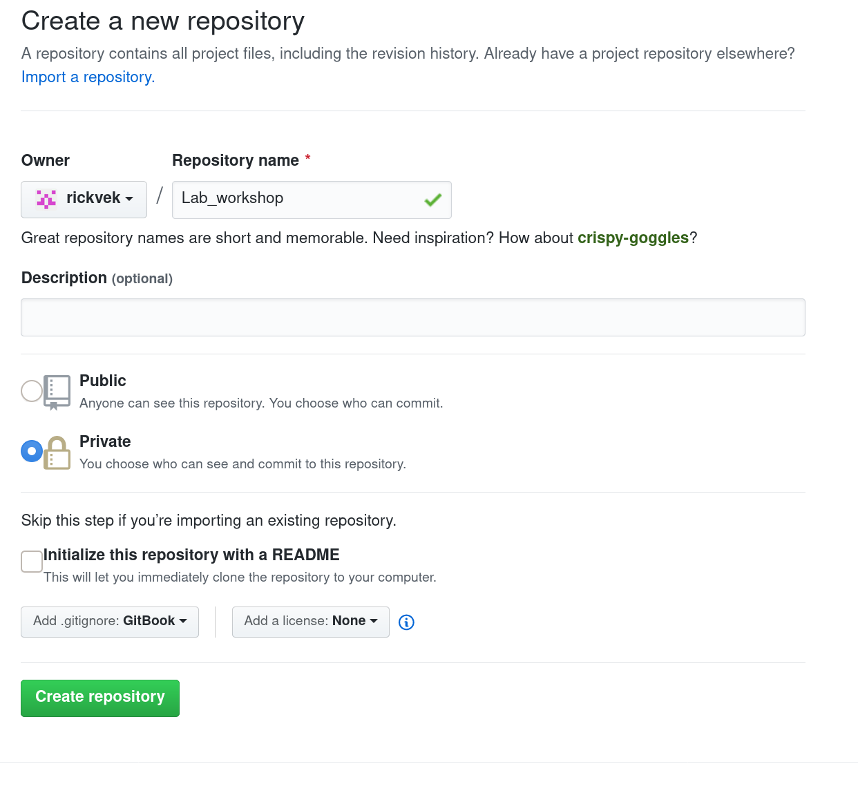

Options chosen :

.gitignore, privat, Repository Name
!note do not select .gitignore if the repository initially be filled with your local repository.

Setting up the Repository :

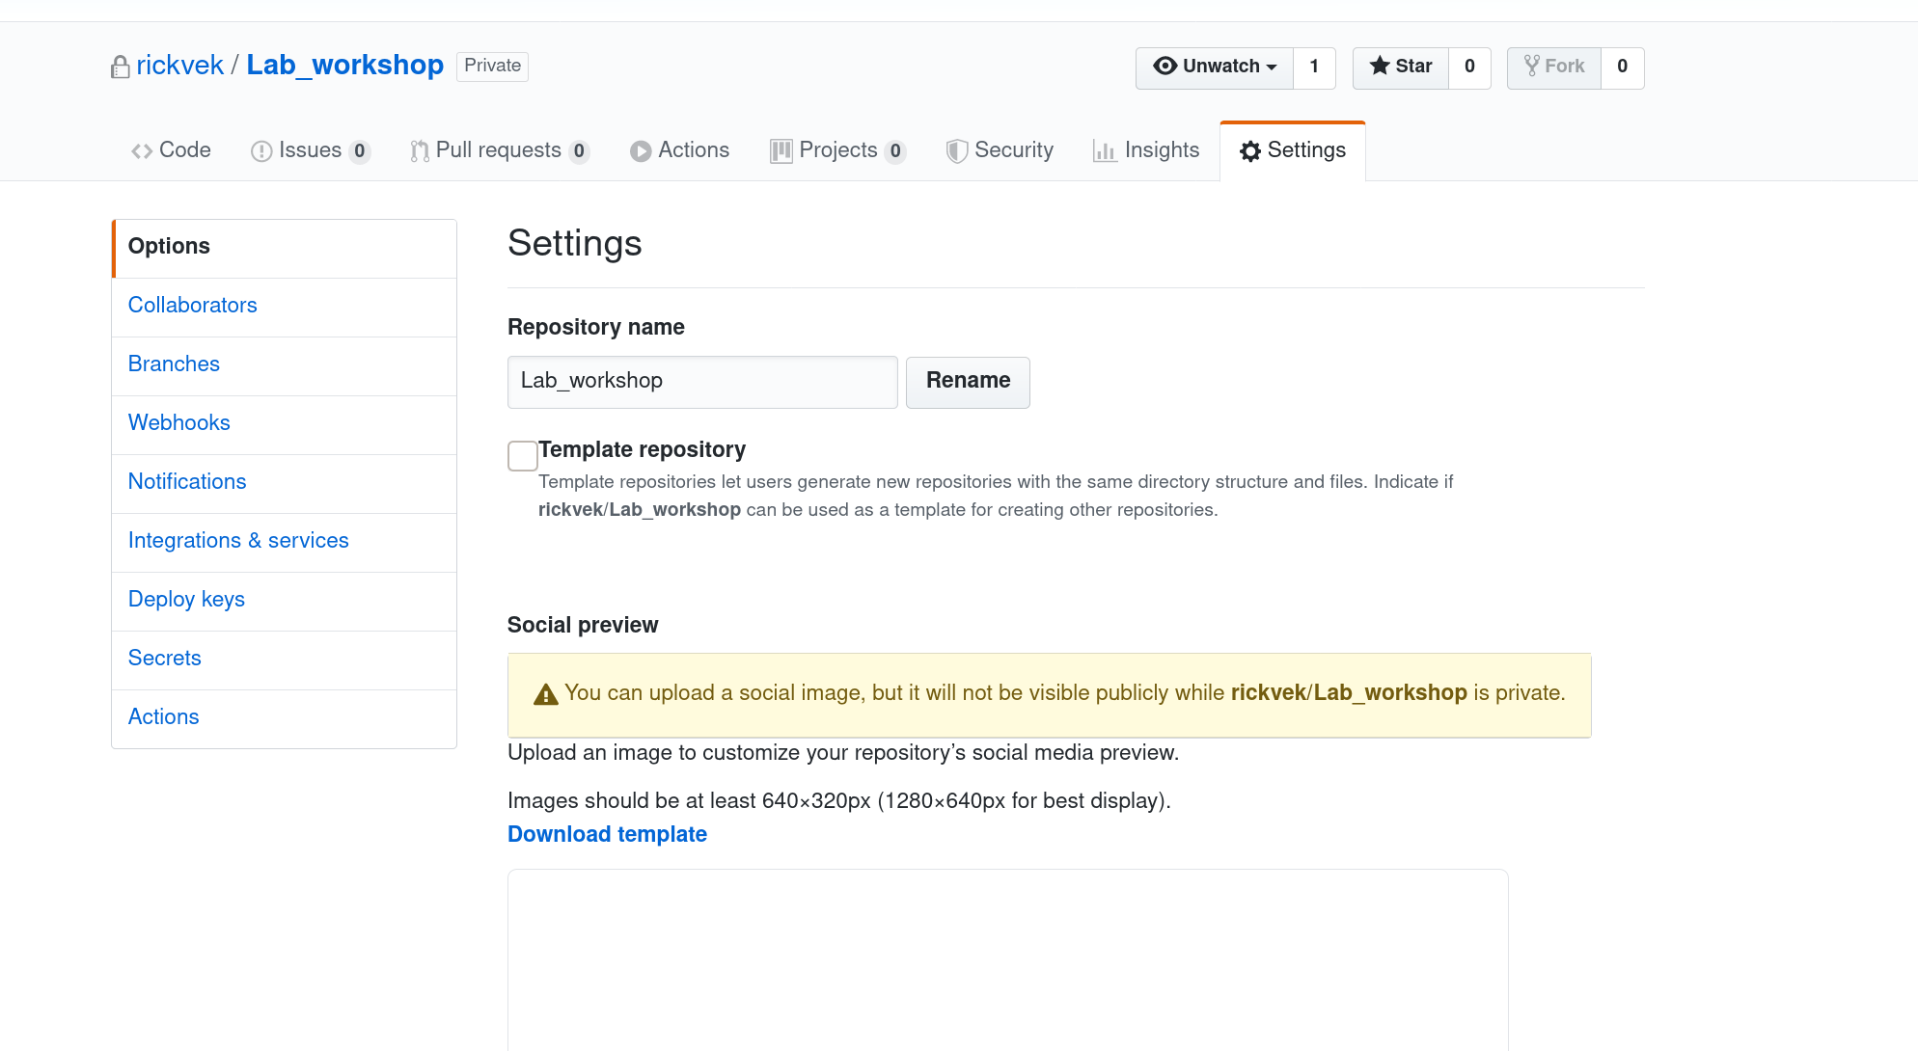

Under branches the master can be locked ( paid version). This is what usually is done for the master. Prevents accidental overwriting releases with development files. For this exercise we pretend this is done.
Section Notifications and Actions are also worth while to look into.

Now there are two options, we continue to set it up and the clone this to the workstation. Or we can start working on the workstation and push everything to the remote repository.
For the second option continue with the ‘create local repository’ section below. (your branch needs to be empty, so no .ignore file selection)

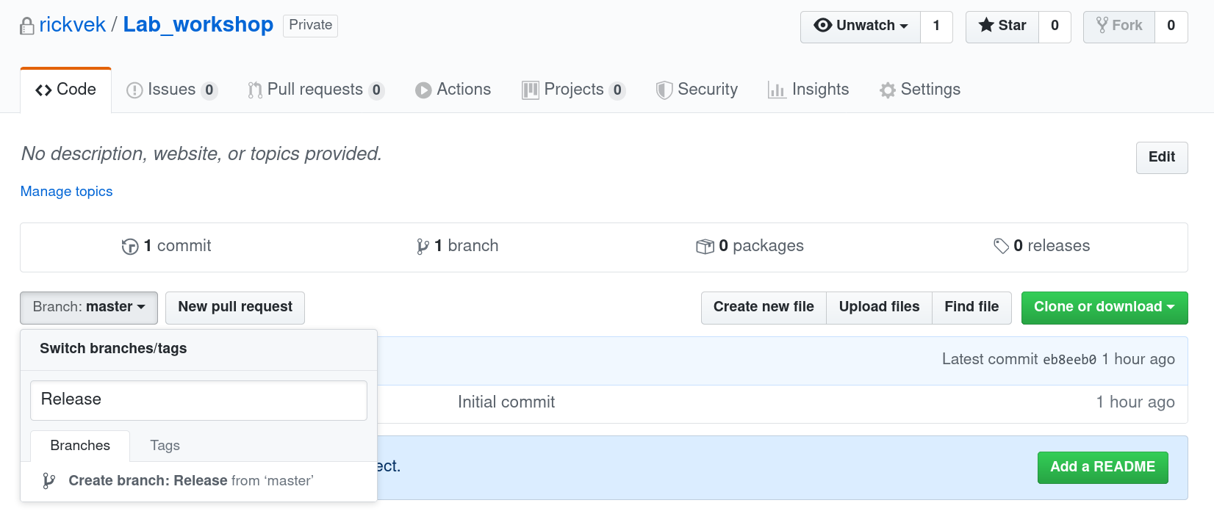

We create our Release branch, we will be pushing the development branch which will be merged here with Release, then we can merge with master.
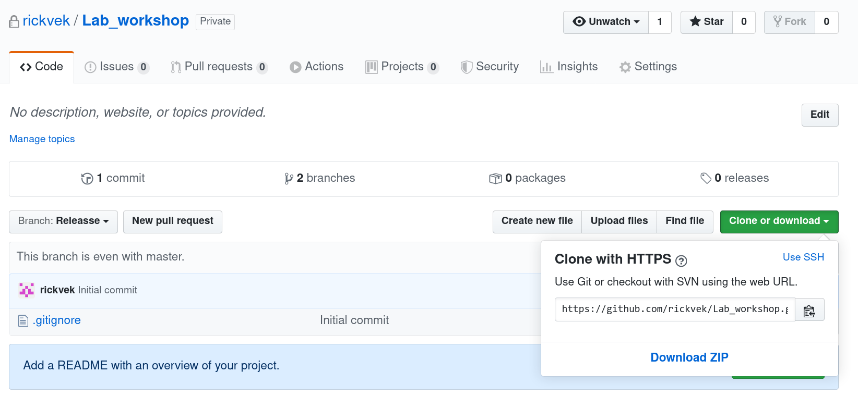

Clone repository
We copy the string from the remote repository and look for a suitable location on the local disk. Following steps will be done from the command line.
[Workshop-GIT]$ pwd
/home/rickvek/temp/lab/Workshop-GIT
[Workshop-GIT]$ cd ..
[lab]$ git clone git@github.com:rickvek/Lab_workshop.git
Cloning into 'Lab_workshop'...
Tunnel device open failed.
Could not request tunnel forwarding.
remote: Enumerating objects: 3, done.
remote: Counting objects: 100% (3/3), done.
remote: Compressing objects: 100% (2/2), done.
remote: Total 3 (delta 0), reused 0 (delta 0), pack-reused 0
Receiving objects: 100% (3/3), done.

We wil be asked for password as we have not set up a ssh key, in the example above the account already had a ssh key configured.

Setting up our development branch and project branches. Jump to section ‘Setup branches’

Create local repository

Now we create a local repository which we later will push to the remote repository. Which will give us a starting point.

TBD

Setting up branches.
We now setting up the branches we are going to work with.
[lab]$ cd Lab_workshop/
[Lab_workshop]$ git checkout -b Release
Switched to a new branch 'Release'
[Lab_workshop]$ git checkout -b Development
Switched to a new branch 'Development'
[Lab_workshop]$ git checkout -b Proj1
Switched to a new branch 'Proj1'
[Lab_workshop]$ git branch
Development
* Proj1
Release
master
remote

Now we have our environment setup, time to do some work. Remember this one?

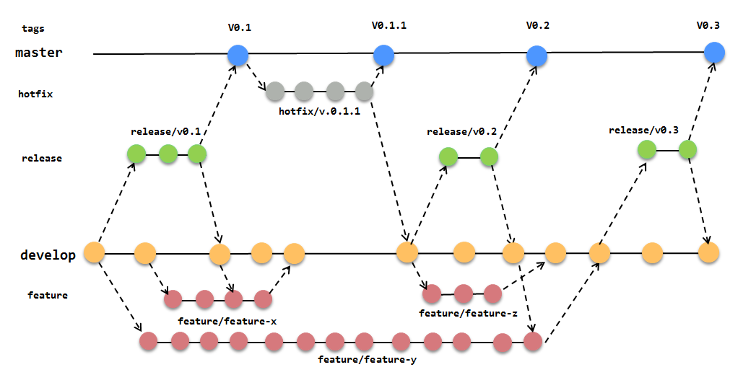

You can now replay this example by yourself or follow the chapter below. Check your status with following commands :

git branch
git status
git log –oneline –graph
git diff <branch>

There are no tags in the example, recommendation is to do this. Feel free to fill in some tags and trace them….

NAME
git-tag - Create, list, delete or verify a tag object signed with GPG

SYNOPSIS
git tag [-a | -s | -u <keyid>] [-f] [-m <msg> | -F <file>] [-e]
<tagname> [<commit> | <object>]
git tag -d <tagname>...
git tag [-n[<num>]] -l [--contains <commit>] [--no-contains <commit>]
[--points-at <object>] [--column[=<options>] | --no-column]
[--create-reflog] [--sort=<key>] [--format=<format>]
[--[no-]merged [<commit>]] [<pattern>...]
git tag -v [--format=<format>] <tagname>...

Working local with GIT

[lab] git clone git@github.com:rickvek/Lab_workshop.git
[lab]$ cd Lab_workshop/
[Lab_workshop]$ git checkout -b Release
[Lab_workshop]$ git checkout -b Development
[Lab_workshop]$ git checkout -b Proj1
[Lab_workshop]$ git branch
[Lab_workshop]$ for no in 1 2 3 4 5 6 7 8 9 10
do
echo file${no} >> file${no}.txt
done
[Lab_workshop]$ ll
[Lab_workshop]$ git add file*.txt
[Lab_workshop]$ git commit -m "Added filesXX.txt"
[Lab_workshop]$ git checkout Development
[Lab_workshop]$ git checkout -b Proj2
[Lab_workshop]$ for no in 1 2 3 4 5 6 7 8 9
do
echo Proj2_file${no}.txt >> Proj2_file${no}.txt
done
[Lab_workshop]$ ll
[Lab_workshop]$ git add Proj*
[Lab_workshop]$ git commit -m "Added Proj2 files"
[Lab_workshop]$ git checkout Development
[Lab_workshop]$ git merge Proj2

[Lab_workshop]$ git log --oneline --graph
[Lab_workshop]$ git checkout Release
[Lab_workshop]$ git checkout -b HF
[Lab_workshop]$ for no in 1 2 3 4 5 6 7 8 9
do
echo HF_file${no}.txt >> HF_file${no}.txt
done
[Lab_workshop]$ git add HF*
[Lab_workshop]$ git commit -m "Hot Fix done"
[Lab_workshop]$ git checkout Release
[Lab_workshop]$ git merge HF
[Lab_workshop]$ git branch -d HF

[Lab_workshop]$ git checkout Development
[Lab_workshop]$
[Lab_workshop]$ git checkout -b Proj3
[Lab_workshop]$ for no in 1 2 3 4 5 6 7 8
do
echo Proj3_file${no}.txt >> Proj3_file${no}.txt
done
[Lab_workshop]$ git add Proj*
[Lab_workshop]$ git commit -m "added Proj3 file "
[Lab_workshop]$ git checkout Development
[Lab_workshop]$ git merge Proj3
[Lab_workshop]$ git branch -d Proj3
[Lab_workshop]$ git checkout Proj1
[Lab_workshop]$ ls
[Lab_workshop]$ for no in 1 2 3 4 5 6 7 8 9
do
echo Proj1_file${no}.txt >> Proj1_file${no}.txt
done
[Lab_workshop]$ git add Proj1_file*
[Lab_workshop]$ git commit -m "added Project1 files"
[Lab_workshop]$ git checkout Development
[Lab_workshop]$ git merge Proj1
[Lab_workshop]$ git branch -d Proj1

[Lab_workshop]$ git checkout Release
[Lab_workshop]$ git rebase Development
or
[Lab_workshop]$ git merge Development

Last step, push it to the remote repository.

[Lab_workshop]$ git push origin Release
Tunnel device open failed.
Could not request tunnel forwarding.
Enumerating objects: 58, done.
Counting objects: 100% (58/58), done.
Delta compression using up to 4 threads
Compressing objects: 100% (12/12), done.
Writing objects: 100% (57/57), 3.25 KiB | 302.00 KiB/s, done.
Total 57 (delta 6), reused 0 (delta 0)
remote: Resolving deltas: 100% (6/6), done.
remote:
remote: Create a pull request for 'Release' on GitHub by visiting:
remote: https://github.com/rickvek/Lab_workshop/pull/new/Release
remote:
To github.com:rickvek/Lab_workshop.git
* [new branch] Release -> Release
Done and now to the remote server to finish it.

Purging on the server

The next step is making a purge request.

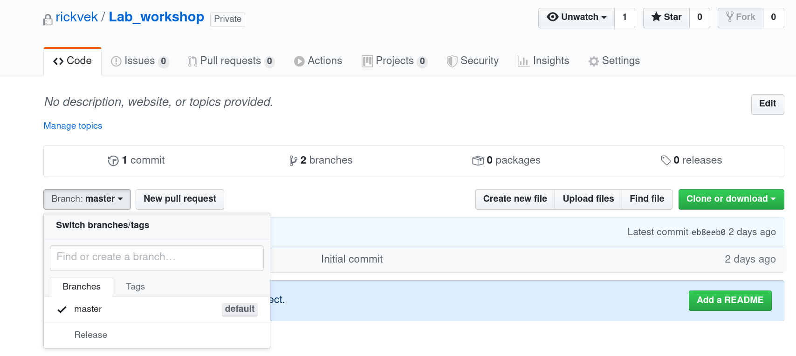
There are now two branches, next to it is the “ New pull request” button..
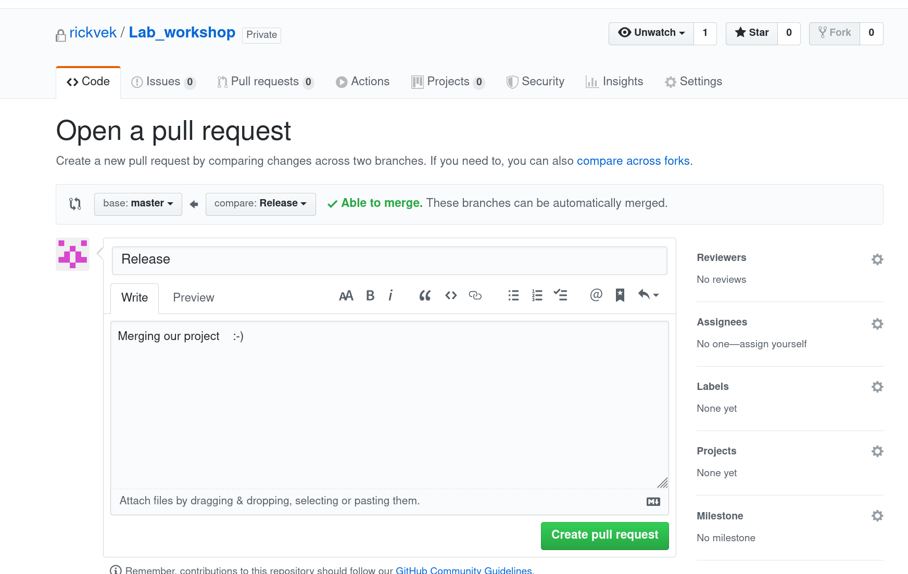

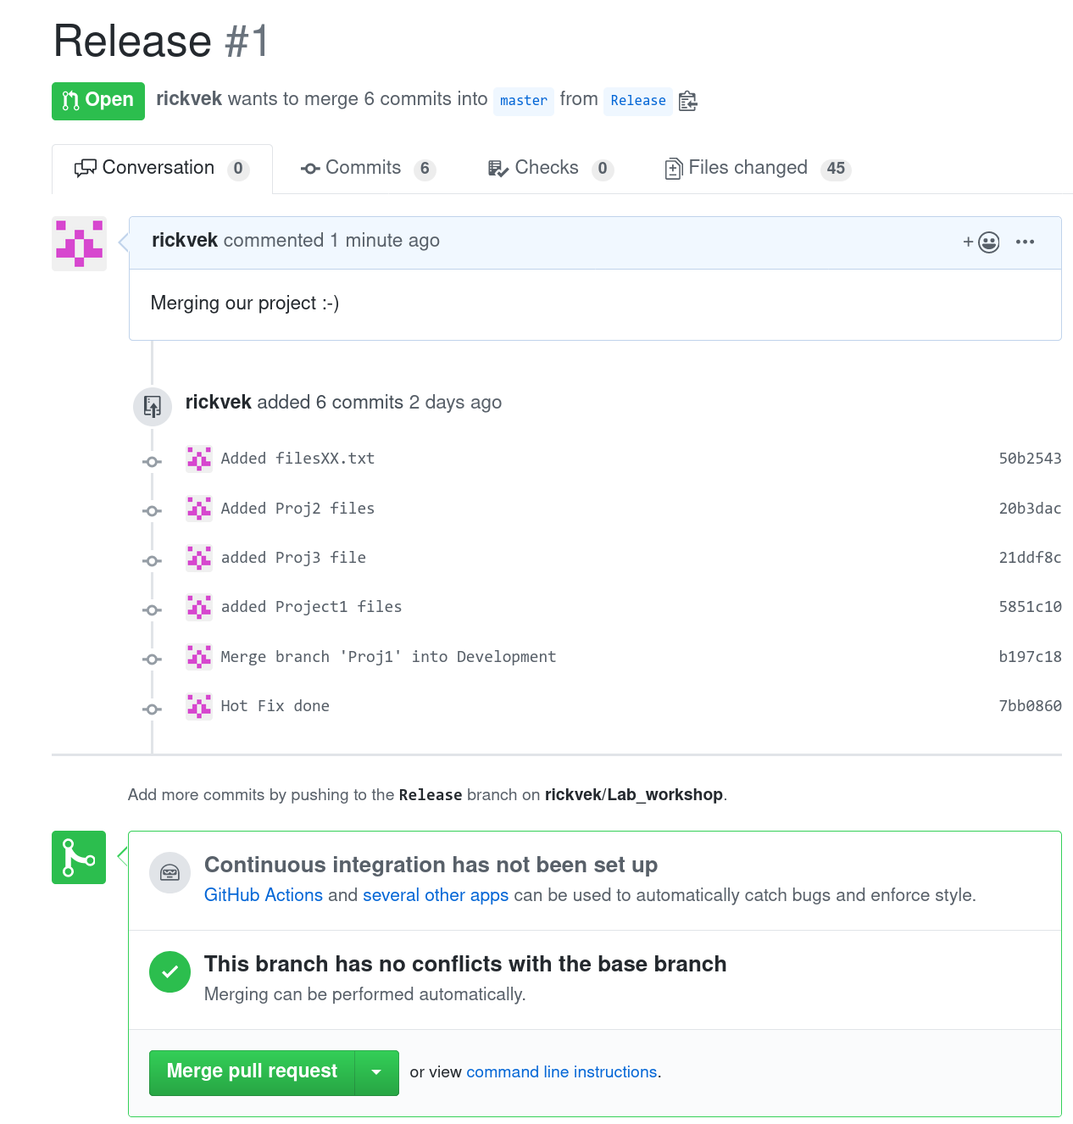

Depending on the size the server is busy checking the merge conditions. When everything is ok, then the button for merging is green.

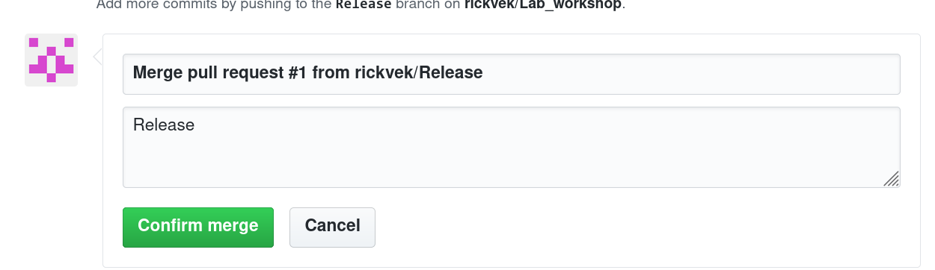
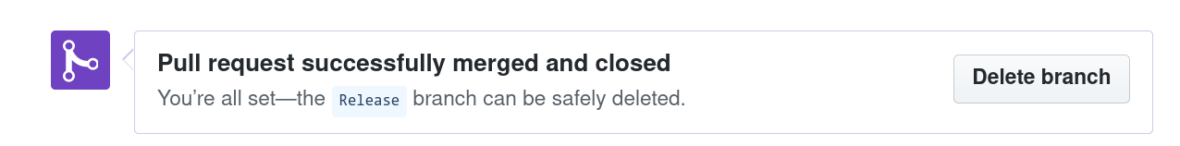
When the merge is done and successful, then the branch can be deleted. Not needed any more so why keep it ….

