Agentic AI Integration Plan
Where and How Agentic AI Operates in the Prior Authorization / CMS-0057-F Platform
Prepared for: Richard Williams, IBM
Date: August 6, 2026
Companion to: Prior Authorization Modernization Plan; RFI 2026HCA13 response to Washington State HCA

This plan identifies every point in the CRD → DTR → PAS Golden Thread — plus Patient Access, Provider Access, Payer-to-Payer, Network Adequacy, and the Intelligent Policy Engine — where an agentic AI component can reduce manual effort, and specifies exactly how far that agent's autonomy extends before a human, or specifically a licensed clinical peer, must take over. The autonomy boundaries below are not arbitrary: they are set directly against Washington's newly enacted prior-authorization AI law (ESSB 5395), CMS's Medicare Advantage guidance on algorithmic coverage determinations, and the NAIC's AI governance model bulletin, so that this design is defensible in front of a state regulator, not just efficient.

1. Purpose
IBM's current CRD/DTR/PAS platform is deliberately conservative about AI today: the Intelligent Policy Engine uses AI to parse payer policy into structured resources, and a separate, deterministic rules engine evaluates coverage. That split was the right starting point, but it leaves real efficiency on the table — a reviewer still reads every Work Queue case from scratch, a provider still has to interpret a CRD checklist unassisted, and a Payer-to-Payer match exception still waits for a person to notice it. This plan closes that gap by defining a fuller set of agentic AI components — agents that can plan, call tools, and take multi-step action within a bounded scope — for every major process in the platform, and by fixing, in writing, exactly where each agent's authority stops and a human's begins.
The plan is organized in five parts: the regulatory guardrails every agent must be designed against (Section 2); the shared technical architecture all agents run on (Section 3); a catalog of the specific agents themselves, process by process, including the Intelligent Policy Agent (Section 4); a consolidated governance matrix mapping every agent to its autonomy level and required human gate (Section 5); and a phased roadmap and risk register for building this out (Sections 6–7).

2. Guiding Principles & Regulatory Guardrails
Agentic AI in prior authorization is under more active, and more specific, regulatory scrutiny in 2026 than almost any other AI use case in health care. Washington in particular has just enacted a law that speaks directly to what this platform's agents may and may not do. Rather than design agents first and check compliance later, this plan starts from the regulation and derives the agent boundaries from it.

2.1 Washington ESSB 5395 (2026) — the controlling law for this platform
What it does — ESSB 5395, "Making improvements to transparency and accountability in the prior authorization determination process," was signed into law on March 23, 2026 and takes effect June 11, 2026. It governs how AI may be used specifically in Washington prior-authorization determinations.
- AI may be used to process and approve prior authorization requests, but an AI system may not deny a request based on medical necessity — any denial must be reviewed and issued by a licensed health professional.
- Where AI is used in a medical-necessity review, the review criteria must incorporate the specific enrollee's individual medical history and clinical circumstances, not group-level data alone.
- Clinical review criteria must be evidence-based, must be evaluated and updated at least annually, and must account for new and emerging information relevant to Black and Indigenous people, other people of color, gender, and other underserved populations.
- On any adverse benefit determination, the carrier must make a peer-to-peer review discussion available to the requesting provider.
- Retrospective denial of previously authorized care is banned (with a monthly interest penalty for violations).
- Carriers must file an annual AI-transparency report, starting January 2027.
This is the single most important design constraint in this plan: it is the reason every agent below is built to approve-fast-path or draft-and-recommend, and never to independently deny.

2.2 Washington E2SHB 1357 (2023) — turnaround-time baseline
What it does — Washington's broader prior-authorization modernization law sets determination timeframes of 3 calendar days for standard electronic requests and 1 day for expedited electronic requests, and requires that only a clinical peer may issue a denial.
This is materially faster than the 72-hour expedited / 7-day standard baseline defined in CMS-0057-F, which is the default SLA timer built into the platform's Work Queue today. For a Washington deployment, the platform's SLA timers need a Washington-specific configuration — 1-day expedited / 3-day standard — rather than the federal default, and this is exactly the kind of workload where a triage agent's speed advantage matters most, since a human-only queue has far less slack to work with under Washington's clock than under the federal one.

2.3 CMS guidance on AI and algorithms in coverage determinations
What it does — CMS has clarified that Medicare Advantage organizations may use AI and algorithmic tools to assist in coverage determinations, but that the determination itself must be based on the individual enrollee's circumstances — their medical history, treating physician's recommendations, and clinical notes — not on an algorithm or data set that doesn't account for the individual. Predictive AI outputs may assist providers or plans, but are not sufficient, on their own, to make the decision.
This mirrors Washington's ESSB 5395 individualization requirement almost exactly, and confirms that the design principle already embedded in this platform's Golden Thread — that the propensity-to-deny score and the DTR match tree are decision support, and the ClaimResponse from the payer is the only real determination — is aligned with federal expectations.

2.4 NAIC Model Bulletin on insurers' use of AI
What it does — The NAIC's Model Bulletin (adopted with variation by roughly half of states as of 2025–2026) expects insurers to maintain a documented AI governance program — an "AIS Program" — covering the full AI lifecycle: governance structure spanning compliance, legal, clinical, and data-science stakeholders; audit procedures; risk management and internal controls; and third-party AI vendor management.
IBM does not currently have confirmation of whether Washington has adopted the NAIC bulletin specifically; the governance structure in Section 5 of this plan is written to satisfy it regardless, since the underlying expectations — documented governance, auditability, and vendor oversight — are a reasonable-care baseline that HCA is likely to expect even absent a formal bulletin adoption.

2.5 The Five Rules — derived design principles for every agent in this platform
- 1. Agents may draft, recommend, auto-route, and fast-path clear approvals. No agent — including the Policy Engine and any LLM-based component — may independently issue a denial. Every denial requires review and sign-off by a licensed clinical peer.
- 2. Every uncertain or adverse-leaning case is routed to a licensed clinical peer matched to the relevant specialty where possible, with a peer-to-peer review discussion explicitly offered to the requesting provider, per ESSB 5395.
- 3. Every agent recommendation is individualized: it must be grounded in the specific member's aggregated clinical record in the PA Aggregation FHIR Server, never in group-level statistical inference alone, per both ESSB 5395 and CMS's MA guidance.
- 4. Every agent action — a drafted rationale, a proposed match, a triage priority, a policy-conversion output — is written to the Evidence Record's append-only EvidenceTimeline with a citation back to its source data, so the record is sufficient to support Washington's annual AI-transparency report and a NAIC-style audit without additional instrumentation.
- 5. The clinical review criteria agents apply are evidence-based, reviewed at least annually, and explicitly checked for disparate impact across race, gender, and underserved-population lines before each annual refresh is adopted, per ESSB 5395.

3. Shared Agent Architecture
Every agent described in Section 4 is an instance of the same underlying pattern, run through the platform's Agent Orchestration Engine component — already scoped as a core-platform module in IBM's RHTP cost model and, at roughly 1,600 development hours, the single largest build line in the platform's 23-module architecture. Standardizing on one orchestration layer, rather than building bespoke AI logic per feature, is what makes the governance model in Section 5 enforceable: a rule applied to the orchestration layer applies to every agent that runs through it.

3.1 Grounding
Every agent reads from the same durable, FHIR-native data sources the rest of the platform already uses — the PA Aggregation FHIR Server, the Policy Engine's structured Coverage Determination output, and the Evidence Record — rather than from a separate document store or vector index that could drift out of sync with the record of truth. Where an agent needs to reason over unstructured content (a scanned payer policy, a clinical note), it does so through a retrieval step that is itself logged, so the specific passage an agent relied on is always recoverable.

3.2 Tool-calling, not free text
Agents act by calling a fixed set of platform tools — run-eligibility-check, evaluate-policy, propose-match, draft-rationale, flag-for-peer-review, and similar — rather than by generating unconstrained text or code. This is what keeps an agent's action space bounded to exactly what Section 5's governance matrix says it may do; an agent cannot submit a claim, deny a case, or alter a policy criterion because no such tool is exposed to it.

3.3 Confidence gating
Every agent output carries a confidence signal, and the platform's existing design already distinguishes deterministic, structured-data matches (which can proceed automatically) from low-confidence, NLP/AI-derived matches (which must be flagged for clinician confirmation before being treated as satisfying a criterion). This plan extends that same confidence-threshold pattern to every agent in the catalog below, and treats the specific numeric threshold as a clinical-governance decision to be set with HCA's or a payer's clinical stakeholders, not a purely technical one.

3.4 Observability
Every agent action is appended to the Evidence Record's EvidenceTimeline with a timestamp, the tool calls made, the source data cited, and a plain-language rationale. This is the same audit substrate the platform already uses for gold-card checks, propensity scoring, and eligibility determinations, extended to cover AI-agent activity specifically, so that Washington's annual AI-transparency report (Section 2.1) can be generated from existing platform data rather than a bolt-on logging system.

4. Agent Catalog
Figure 1 maps each agent below onto the six-stage Golden Thread, color-coded by autonomy level. The Intelligent Policy Agent is shown as a foundation layer because its output — structured, FHIR-referential policy criteria — is what every other agent in the CRD, DTR, and Gold-Carding path reasons against.
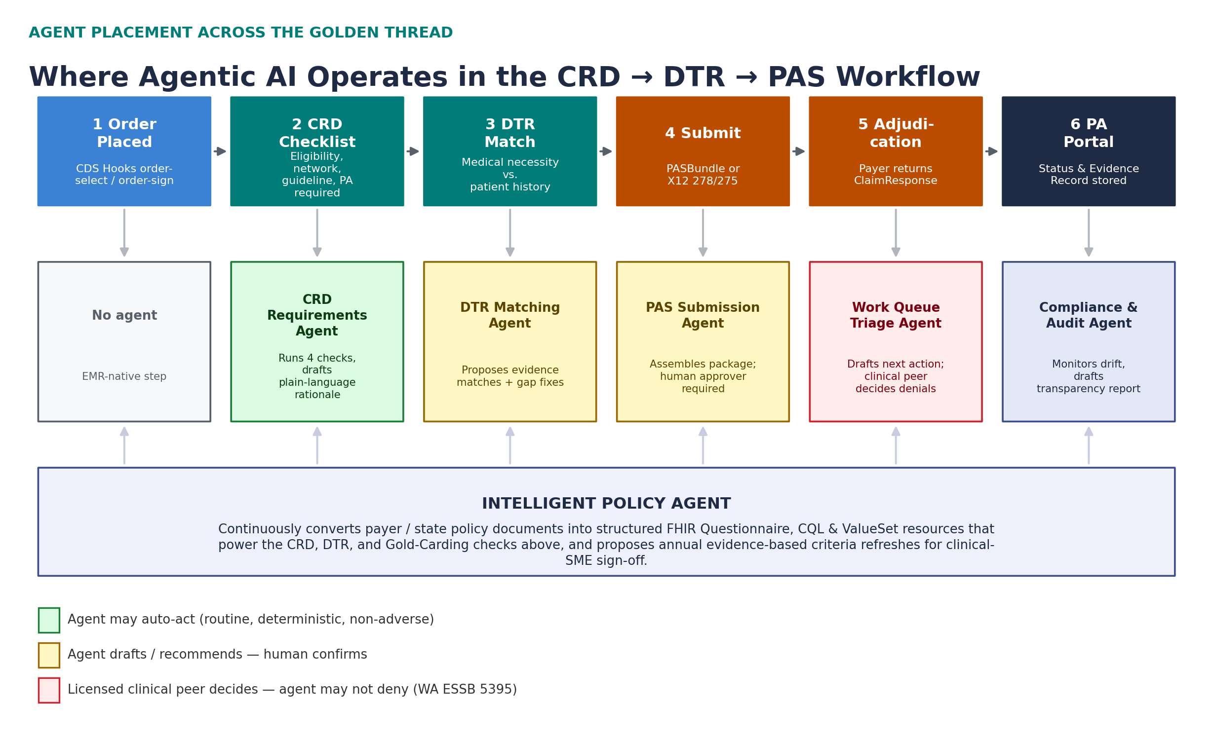
Figure 1. Agent placement across the Golden Thread — autonomy level is color-coded against the Five Rules in Section 2.5.

4.1 Intelligent Policy Agent (Policy Transformation)
This is the agent HCA's RFI specifically calls out, and it already exists in an early form: it converts unstructured payer or state-agency medical policy — scanned PDFs, narrative UM guidelines — into structured FHIR Questionnaire, CQL, and ValueSet resources, seeded today with real, parsed Aetna cardiac CPBs and UnitedHealthcare PA-requirement lists. This plan extends it in three directions. First, from a one-time conversion tool into a continuously running agent that monitors a payer's or HCA's published policy library for updates and proactively flags — or, for low-risk formatting changes, auto-drafts — the corresponding structured-resource revision. Second, into the system that operationalizes ESSB 5395's annual clinical-review-criteria refresh requirement: once a year, the agent assembles a proposed criteria update per policy, packaged with its evidence citations and an automated bias/disparate-impact scan across the demographic factors the law names, for clinical-SME sign-off — turning a compliance obligation into a scheduled, semi-automated workflow rather than a manual annual scramble. Third, into the authoring tool for CRD content itself: because the agent's structured output is what the CRD PA-required check and the DTR criteria tree both evaluate against, giving policy analysts a reviewable, diffable draft of each conversion — rather than a black-box output — is what makes it practical for a human policy owner to approve quickly.
Autonomy: the agent may draft structured policy resources and proposed annual criteria updates. It may not publish a criteria change into production without a named clinical or policy-SME approval — this is the same human-gating pattern the platform already uses for DTR submission, applied to policy authorship instead of case submission.

4.2 CRD Requirements Agent
Today, the CRD checklist already runs four deterministic checks — eligibility and enrollment, provider network status, Milliman/InterQual guideline conflicts, and the PA-required policy lookup — and returns a pass/fail CDS Card. The agentic extension is not to change what those checks decide, since they are appropriately deterministic and non-adverse, but to add a layer that explains the result: drafting a plain-language summary of why PA is or is not required for this specific order, synthesizing the four check results into language a front-desk scheduler or a provider unfamiliar with a specific payer's rules can act on immediately, and proactively suggesting the fastest compliant path — for example, noting that switching the rendering provider to a gold-carded NPI for this procedure would avoid PA entirely, where that is true and permitted.
Autonomy: green. Because the underlying checks are deterministic and never produce an adverse coverage determination on their own, the agent may auto-generate and display this explanation without a human review step; it is drafting an explanation of an already-computed, rules-based result, not making a new decision.

4.3 DTR Medical-Necessity Matching Agent
This is the highest-value and highest-risk agent in the catalog, because it sits closest to a medical-necessity determination. Today, CQL rules deterministically match structured ICD-10/CPT/HCPCS codes against the aggregated patient record; the matching agent's job is to extend that matching into the harder cases the deterministic rules can't reach alone — for example, proposing that a clinical note's narrative description of a symptom corresponds to a coded criterion the structured record doesn't explicitly contain, or drafting a suggested attestation for a clinician to review when a genuine documentation gap exists and a CDex document upload isn't available. Every proposed match is required to cite the specific source passage or resource it was drawn from, exactly as the platform's existing DTR tree already shows a source citation for deterministic matches.
Autonomy: yellow, with a hard rule underneath it. Deterministic, structured-data matches continue to resolve automatically, exactly as today. Any match derived from unstructured, NLP, or AI-based interpretation — the new capability this agent adds — is flagged Gap-pending-review rather than Met until a clinician confirms it; the agent proposes, it does not mark a criterion satisfied on its own. This is the same open confidence-threshold question flagged in IBM's Modernization Plan, and this plan recommends resolving it by defining any AI-derived (non-structured-data) match as always below the auto-accept threshold, full stop, rather than tuning a numeric confidence score — a simpler and more defensible rule under ESSB 5395's individualization requirement.

4.4 PAS Submission Agent
Once DTR criteria are satisfied, this agent assembles the submission package — selecting the FHIR PASBundle vs. X12 278/275 channel per the receiving payer's capability, pre-filling the claim from the case's Evidence Record, and drafting the reviewer-facing case notes that accompany it. The platform's existing human-gate is preserved exactly as built: the submit action stays disabled until a named human approver is entered. The agent's contribution is to make that human's job a one-click confirmation of an already-assembled, correctly-channeled package rather than manual data entry.
Autonomy: yellow. The agent assembles and drafts; a named human approver must confirm before anything is transmitted to a payer, unchanged from the platform's current design.

4.5 Gold-Carding & Propensity-to-Deny Agent
The propensity-to-deny score and its named contributing factors are already computed deterministically and explainably. The agentic layer here has two jobs: translating the score and its factors into a short natural-language explanation for the reviewer ("this case scores high-propensity primarily because the rendering provider's approval rate for this CPT code has fallen in the last two quarters"), and periodically proposing which providers have crossed a plan's gold-card threshold for a given NPI × procedure × payer combination, for a human UM administrator to confirm before that provider is formally exempted from PA. The underlying threshold math stays rules-based; nothing about who qualifies for gold-carding is decided by an LLM.
Autonomy: yellow for the explanation and the gold-card nomination; the underlying score itself remains a deterministic, non-agentic calculation, and formal gold-card status changes require UM administrator confirmation, consistent with the platform's existing "human review required" pattern for provider-network-affecting actions.

4.6 Work Queue Triage & Peer-Review Preparation Agent
This agent is new. It reads the Work Queue's five disposition groups and drafts a recommended next action per case — "ready to submit," "request the missing conservative-therapy note from the provider," "route to Dr. X, cardiology, for peer review" — and prioritizes the queue by a combination of SLA time-remaining and case complexity, rather than leaving reviewers to work strictly first-in-first-out. For any case trending toward an adverse outcome, it prepares a peer-review packet: the DTR match-tree state, the specific unmet criteria, and the individualized clinical facts relied on, formatted for the licensed clinical peer who — per ESSB 5395 — must be the one to actually issue a denial. It also drafts the peer-to-peer review discussion summary the law requires be made available to the requesting provider whenever a determination is adverse.
Autonomy: split by outcome. For cases the agent's triage clearly places in the auto-cleared / criteria-met path, it may fast-path the case forward (green), fully logged. For anything uncertain or adverse-leaning, the agent's role is strictly preparation and drafting for a licensed clinical peer (red) — it never issues or drafts the denial notice itself, only the supporting packet the peer reviews before writing one, in line with Washington's requirement that adverse determination notices include the credentials of the reviewing clinician.

4.7 Patient Access Member Assistant Agent
A conversational agent scoped to the Patient Access surface, grounded strictly in the member's own Coverage, Condition, and ClaimResponse resources and the Evidence Record for any related PA case, that answers member questions in plain language — "why was my MRI denied," "what do I need to do next" — always by citing the specific denial reason or evidence already on record, never by inferring or guessing at coverage rules the record doesn't contain. This directly extends the denial-reason transparency the Patient Access screen already surfaces as a CMS-0057-F requirement.
Autonomy: yellow. The agent may answer directly from the member's own already-adjudicated record; if a question requires interpreting a live, in-progress case, it hands off to the Work Queue / reviewer flow rather than speculating.

4.8 Provider Access Agent
A narrower assistant for provider-office staff using the $member-match and treatment-relationship authorization flow, that helps resolve ambiguous member-match results (for example, near-duplicate demographic matches) and flags when a requested data release falls outside the treatment-relationship authorization basis so staff can redirect to the correct consent pathway before a request is denied for the wrong reason.
Autonomy: yellow — proposes a match resolution or authorization-basis correction; the underlying $member-match and authorization check remain the deterministic system of record.

4.9 Payer-to-Payer Exception Agent
Bulk $member-match jobs already return Matched / Unmatched / Consent-Constrained counts. This agent reviews the unmatched and consent-constrained subsets, proposes likely matches for human confirmation (using the same identity-resolution logic as the Knowledge Graph & Master Person Index module), and drafts an exception report for the operations team rather than leaving unmatched records to sit silently until someone happens to notice the job's summary counts.
Autonomy: yellow. Proposed matches and consent-constraint resolutions require human confirmation before any additional record is pulled into the export.

4.10 Network Adequacy Analyst Copilot (extension)
The analyst copilot already answers gap-analysis, compliance-validation, and augmentation-recommendation questions, grounded deterministically in the adequacy engine, with augmentation recommendations already marked "human review required." The agentic extension is multi-step reasoning across standards and geographies in one pass — for example, cross-referencing time-distance, ratio, and in-network-percentage gaps simultaneously to propose a single augmentation strategy that resolves more than one deficiency at once, rather than answering one standard at a time — and drafting the state-reviewer-facing compliance narrative alongside the pass/fail verdicts it already produces.
Autonomy: green for analysis and validation answers, since these are deterministic and reproducible from the engine; yellow for augmentation recommendations, unchanged from today's human-review gate, since those recommendations affect real provider-contracting decisions.

4.11 Compliance & Audit Agent (new)
This agent exists specifically because of Section 2: it periodically reviews the Evidence Record corpus for the patterns Washington's law and the NAIC bulletin care about — denial rates and criteria-application patterns segmented in ways that could indicate disparate impact by race, gender, or underserved-population status; clinical review criteria that are approaching or past their annual-review deadline; and agent actions that fall outside the autonomy boundaries defined in Section 5, which it flags as governance exceptions. On a scheduled cadence, it assembles a draft of Washington's required annual AI-transparency report directly from this data, for compliance and clinical leadership to review and file, rather than that report being a manual, once-a-year research exercise.
Autonomy: yellow, functionally always — this agent's entire purpose is to produce drafts and flags for a compliance and clinical governance function to review; it has no path to directly change a policy, a case outcome, or a report filing on its own.

5. Governance & Autonomy Matrix
Figure 2 illustrates the specific escalation path Rule 1 and Rule 2 (Section 2.5) impose on any agent whose output touches a coverage determination — the DTR Matching Agent and the Work Queue Triage Agent, primarily. The table that follows consolidates every agent's autonomy level, required human gate, the regulatory driver behind that gate, and the audit artifact it produces, in one place, so this matrix — not any individual engineer's judgment call — is the source of truth for what an agent is allowed to do.
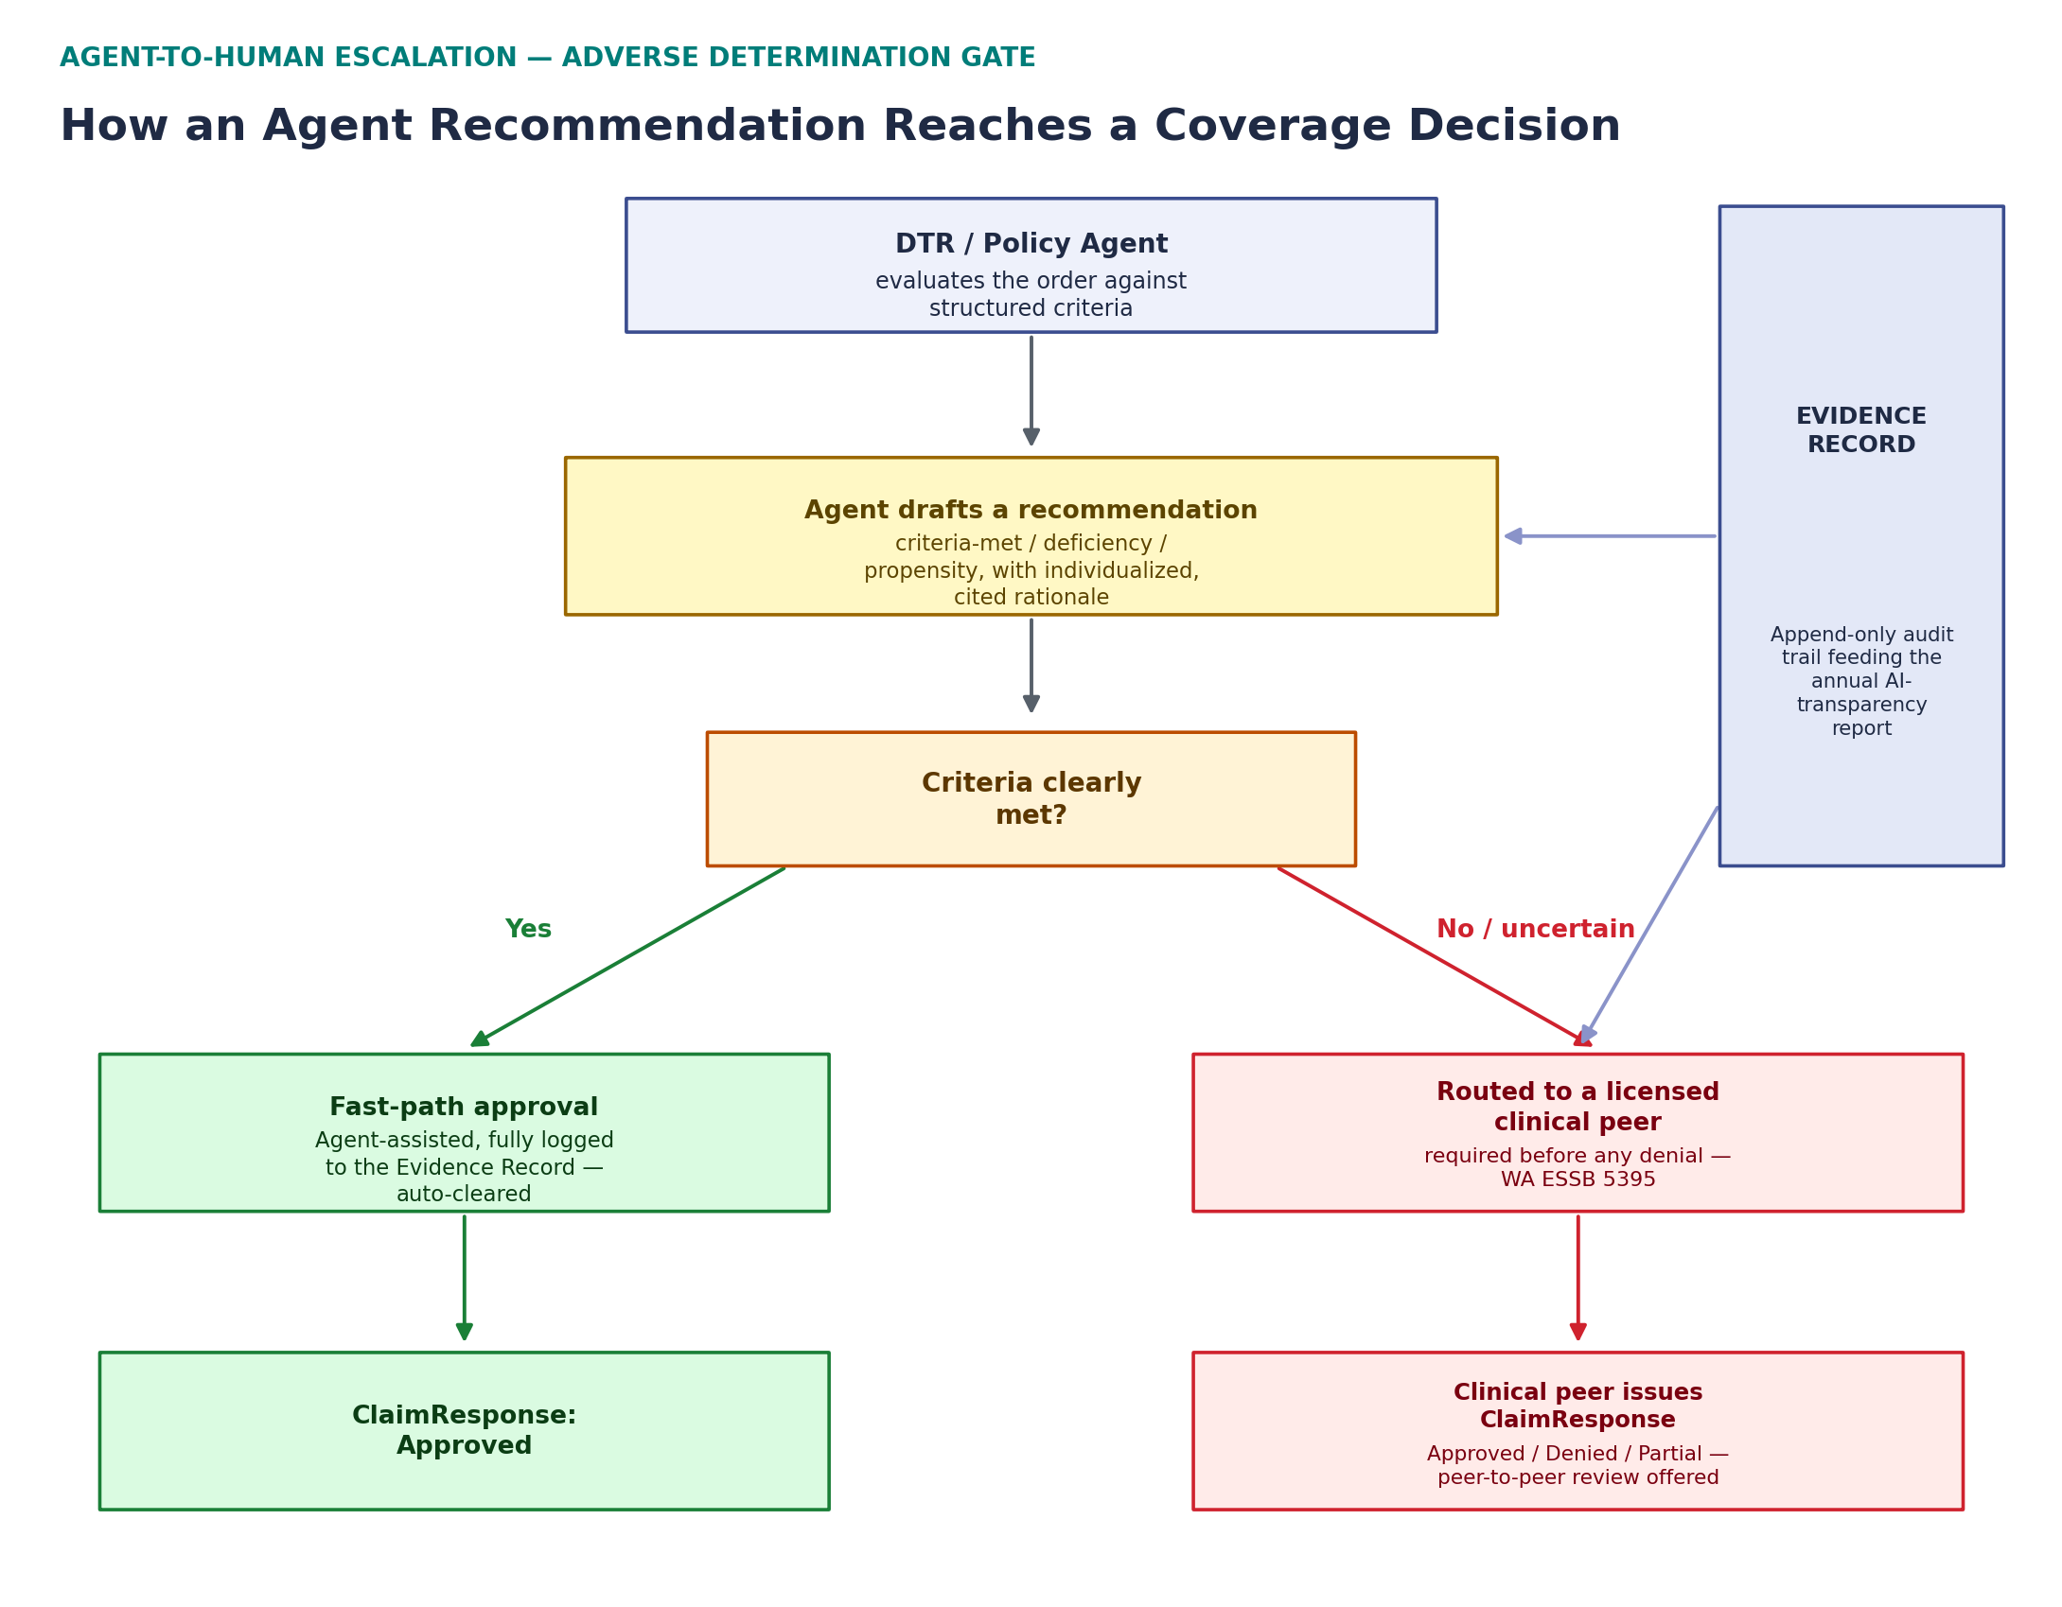
Figure 2. Agent-to-human escalation for adverse determinations — the path every DTR or Work Queue agent recommendation must follow once it is uncertain or adverse-leaning.
Agent | Autonomy | Required Human Gate | Regulatory Driver | Audit Artifact
Intelligent Policy Agent | Draft only | Clinical/policy SME sign-off before publishing | ESSB 5395 (annual criteria review + bias check) | Versioned policy resource + bias-scan log
CRD Requirements Agent | Auto-act | None (explains an already-deterministic result) | n/a — non-adverse | CDS Card + rationale in EvidenceTimeline
DTR Matching Agent | Draft only for AI-derived matches | Clinician confirms any non-structured-data match | ESSB 5395; CMS MA individualization guidance | Cited match proposal in DTR tree + EvidenceTimeline
PAS Submission Agent | Draft/assemble only | Named human approver before transmission | Existing platform design principle | Submitted PASBundle/X12 + approver ID
Gold-Carding & Propensity Agent | Draft explanation; nominate only | UM administrator confirms gold-card status changes | Existing "human review required" pattern | Score + factors + nomination log
Work Queue Triage Agent | Auto-act (clear approvals) / draft only (adverse-leaning) | Licensed clinical peer decides all denials | ESSB 5395 (denial + peer-to-peer review) | Peer-review packet + EvidenceTimeline
Patient Access Member Assistant | Auto-act, grounded only in adjudicated record | Hands off live cases to reviewer flow | CMS-0057-F denial-reason transparency | Conversation log citing source resources
Provider Access Agent | Draft only | Staff confirms match/authorization resolution | Provider Access authorization-basis rules | Resolution log
Payer-to-Payer Exception Agent | Draft only | Human confirms proposed matches | Consent/identity-resolution accuracy | Exception report
Network Adequacy Copilot | Auto-act (analysis) / draft only (augmentation) | Human review required before provider outreach | Existing platform design principle | Grounded answer log + recommendation record
Compliance & Audit Agent | Draft only | Compliance/clinical leadership review & file | ESSB 5395 annual AI-transparency report; NAIC bulletin | Draft transparency report + governance-exception log

6. Roadmap & Phasing
This plan is sequenced onto the same phase structure already used in IBM's cost model and its RFI 2026HCA13 response, so that agentic AI work is scoped alongside — not as a separate track from — the rest of the platform build.

Already built (Phase 0/1 today)
- Intelligent Policy Agent v1 — policy-to-FHIR conversion, seeded with real Aetna and UnitedHealthcare policy content
- Deterministic, explainable propensity-to-deny scoring with named factors
- Network Adequacy analyst copilot — grounded gap analysis and compliance validation
- Human-gated DTR submission and human-gated augmentation recommendations — the governance pattern this whole plan extends

Near-term (Phase 1–2)
- CRD Requirements Agent — plain-language checklist explanation (low-risk, non-adverse; fastest to ship)
- DTR Matching Agent v1 — AI-assisted match proposals with the always-flag-for-review rule for non-structured matches
- Work Queue Triage Agent v1 — prioritization and next-action drafting
- Washington-specific SLA timer configuration (1-day expedited / 3-day standard, per E2SHB 1357) alongside the federal CMS-0057-F default

Mid-term (Phase 2–3)
- PAS Submission Agent — package assembly and case-note drafting
- Peer-review packet preparation, wired to the Work Queue Triage Agent
- Payer-to-Payer Exception Agent and Provider Access Agent
- Patient Access Member Assistant Agent
- Intelligent Policy Agent v2 — continuous policy-change monitoring, annual criteria-refresh drafting with bias scan

Ongoing / Phase 3+
- Compliance & Audit Agent, timed to be operational well before Washington's first annual AI-transparency report is due in January 2027
- Network Adequacy Copilot multi-standard reasoning extension
- Annual bias/disparate-impact review cycle, formalized as a recurring governance process rather than a one-time build item

7. Risk Register
Risk | Description | Mitigation
Autonomous denial drift | An agent's fast-path logic gradually expands scope until it is effectively denying cases without a peer | Tool-level enforcement (Section 3.2) — no agent has a deny tool at all, not just a policy against using one; Compliance & Audit Agent flags any governance exception
Disparate impact / bias | Structured criteria or matching logic produce different outcomes across race, gender, or underserved populations | Mandatory annual bias scan tied to the Intelligent Policy Agent's criteria-refresh cycle, per ESSB 5395; Compliance & Audit Agent segments outcome data on an ongoing basis, not just annually
Hallucination / unsupported claim | An agent cites a source that doesn't actually support its recommendation, especially in NLP-derived DTR matching | Every agent output requires a resolvable citation to a specific FHIR resource or document passage; unsupported outputs are rejected at the tool layer before reaching a reviewer
Regulatory patchwork | Washington's ESSB 5395 is stricter than the CMS-0057-F federal baseline and than other states' rules, and other states may diverge further | Autonomy rules are configured per state/payer in the governance matrix (Section 5) rather than hard-coded, so a stricter state's rules don't need a code change to apply, and a state without an AI-specific law still gets Washington's rules as the conservative default
Over-reliance / reviewer deskilling | Reviewers begin rubber-stamping agent recommendations rather than independently evaluating adverse-leaning cases | Peer-review packets are designed to present underlying evidence prominently, not just the agent's conclusion; Compliance & Audit Agent monitors peer-review override/agreement rates as a leading indicator
Vendor / model dependency | The underlying LLM provider changes behavior, pricing, or availability | Agent Orchestration Engine abstracts model calls behind the shared tool-calling architecture (Section 3), so a model swap does not require re-architecting individual agents

8. Regulatory References
- Washington ESSB 5395 (2026), "Making improvements to transparency and accountability in the prior authorization determination process" — signed March 23, 2026; effective June 11, 2026.
- Washington E2SHB 1357 (2023) — prior authorization modernization, determination timeframes, and clinical-peer denial requirement.
- CMS guidance and FAQs on Medicare Advantage organizations' use of AI and algorithms in coverage determinations (2024–2026 guidance cycle).
- NAIC Model Bulletin on the Use of Artificial Intelligence Systems by Insurers, adopted December 4, 2023, and subsequently adopted with variation by roughly half of U.S. states.
[CONFIRM BEFORE USE: verify current bill/section numbers, effective dates, and Washington's specific NAIC bulletin adoption status directly against the Washington Legislature and OIC websites before citing this plan externally — this section reflects IBM's research as of August 2026 and should be re-checked against any amendments before the platform's Washington go-live.]

