RESPONSE TO RFI 2026HCA13
Federal & State Interoperability and Prior Authorization Project (FSIPAP)
Washington State Health Care Authority
Submitted by: IBM
Submission Date: [insert final submission date — due no later than 08/19/2026, 5:00 PM PT]
File name convention: RFI 2026HCA13_IBM

Formatting & Submission Compliance Checklist
[Delete this page before final submission — reference only]
- 20-page limit (excludes cover page, table of contents, and attachments)
- Submit as MS Word or Adobe PDF — no zipped/compressed files
- File name: RFI 2026HCA13_IBM
- Indicate up front whether this is a complete or partial response; if partial, specify which sections are included
- Sections must be signposted using the same headings and order as the RFI (5.2–5.8, as reflected below)
- Mark any proprietary/confidential pages with "confidential" in the lower right-hand corner — do not mark the entire response confidential
- Include a listing of all submission files and a description of each in the submission email
- Email to RFI Coordinator Jack Kent (Jack.Kent@hca.wa.gov) with RFI No. 2026HCA13 in the subject line
- Written responses due 08/19/2026 by 5:00 PM PT
CONFIRM BEFORE SUBMISSION — This draft currently contains no material marked confidential. Before submission, review the pricing (5.7) and architecture (5.2.2) sections and apply the "confidential" footer to any page IBM wants to protect.

Table of Contents
[Insert a Word-generated Table of Contents here (References > Table of Contents) once headings are finalized. Section headings below are tagged with Word Heading styles so this will populate automatically.]

5.1 General Response
[Owner: Richard Williams]
This is a complete response to RFI 2026HCA13. IBM addresses all requested sections — Solution Overview (5.2), Functional Capabilities (5.3), covering both API development (5.3.1) and policy transformation (5.3.2), Security & Privacy (5.4), Reporting & Analytics (5.5), Implementation, Testing & Timeline (5.6), Pricing & Delivery Model (5.7), and Experience & References (5.8).
IBM's response describes a single, unified platform — internally referred to during development as RHTP (Rural Health / Total Cost of Care Platform) — that natively implements the four CMS-0057-F interoperability provisions (Patient Access, Provider Access, Payer-to-Payer, and Prior Authorization via the Da Vinci Coverage Requirements Discovery, Documentation Templates and Rules, and Prior Authorization Support implementation guides) alongside a generalized Policy Engine that performs the policy-transformation work described in Section 5.3.2. The platform already runs end-to-end against a seeded FHIR back end in an offline development tier, and is designed to connect to a live, standards-conformant CMS-0057-F reference implementation for production deployment, as described in Section 5.2.2.
CONFIRM BEFORE SUBMISSION — Before submission, confirm with HCA's RFI Coordinator whether IBM intends to bid on the full FSIPAP scope or a defined subset, and adjust this statement of complete vs. partial response accordingly.

5.2 Solution Overview

5.2.1 High-Level Description
[Owner: Richard Williams]
This is a complete solution response. IBM proposes a standards-based, SMART on FHIR prior authorization and interoperability platform that replaces free-text, AI-mediated workflows with conformant CDS Hooks, DTR Questionnaires, and PAS $submit transactions, while preserving the strongest ideas from earlier IBM designs — including AI-assisted policy parsing and evidence auto-matching — as decision-support underneath a standards-based interaction model rather than as the determination itself.
At a high level, the platform gives providers and payers a single, continuously threaded workflow — what IBM calls the Golden Thread — that carries a patient's order from eligibility and coverage discovery, through medical-necessity matching, through prior authorization submission and adjudication, and finally into a patient cost estimate. Every stage of that thread is backed by a persisted, immutable Evidence Record, which functions as the Da Vinci Coverage Determination Record referenced in the CMS-0057-F implementation guides, so that HCA and its business associates have a single, auditable source of truth for how each determination was reached.
Implementation status varies by capability. The Coverage Requirements Discovery (CRD), Documentation Templates and Rules (DTR), Prior Authorization Support (PAS), Patient Access, Provider Access, and Payer-to-Payer surfaces are currently implemented and demonstrable end-to-end against a seeded FHIR server, with dev-stubbed CRD cards standing in for a live CDS Hooks/CRD service — an explicitly documented near-term increment. Gold carding, the propensity-to-deny model, the reviewer work-queue, and the Network Adequacy module with its analyst copilot are also currently implemented and live-demonstrable. Connection to a production, standards-conformant CMS-0057-F reference implementation for real payer and EMR endpoints is the next phase of work and is scoped in Section 5.6.
IBM will never use AI to make a prior authorization determination. AI in this platform is used deliberately and narrowly for process automation and the reduction of administrative burden — not for coverage or medical-necessity decisions. This is a bright-line design rule, not a stated preference: Washington's ESSB 5395 (effective June 11, 2026) prohibits an AI system from denying a prior authorization request based on medical necessity, requires that any AI-assisted review be grounded in the specific enrollee's own individual medical history rather than group-level data, and requires that any adverse determination be issued by a licensed clinical peer, with a peer-to-peer review discussion made available to the requesting provider. CMS has issued parallel guidance for Medicare Advantage confirming that coverage determinations must likewise be individualized and that algorithmic or AI tools may assist a determination but may never be its sole basis. IBM's platform is architected to this standard, not retrofitted to it after the fact.
Concretely, the Intelligent Policy Engine uses AI only to convert unstructured payer medical-policy documents (PDFs, scanned policy manuals) into structured FHIR Questionnaire, CQL, and ValueSet resources — administrative preparation work, described further in Section 5.3.2 — and a separate, deterministic, rules-based Policy Engine then evaluates a member's order against those structured criteria to produce a Coverage Determination. IBM's platform uses agentic AI — orchestrated through a dedicated Agent Orchestration component capable of planning and taking bounded, multi-step action — specifically to automate administrative effort for providers, reviewers, and state analysts: drafting a plain-language explanation of a CRD checklist result, proposing (never finalizing) an evidence match in the DTR criteria tree, assembling a submission package for human sign-off, and prioritizing the reviewer Work Queue. Every one of these functions is explicitly human-review-gated and produces no adverse outcome on its own: DTR submission stays disabled until a named human approver is entered, augmentation recommendations are marked "human review required," and any case trending toward a denial is routed to a licensed clinical peer rather than resolved by the agent. IBM is glad to walk HCA through the specifics of this agentic AI implementation in more detail on request; the system's own guidance to reviewers is explicit on the underlying point regardless: no AI component — agentic or otherwise — ever sets a case to Approved or Denied. That determination comes only from the payer's returned ClaimResponse, consistent with ESSB 5395.

5.2.2 Solution Architecture & Deployment
[Owner: Richard Williams]
The solution is offered as SaaS. It is architected around a server-mediated FHIR backend-for-frontend (BFF): browser clients never call FHIR services directly, and every read or write is proxied and authorized server-side, which both simplifies the security posture described in Section 5.4 and gives IBM a single point to enforce consent, audit logging, and rate limiting across all four CMS-0057-F provisions.
The architecture is organized around a Prior Auth Service that acts as the orchestration hub for coverage checks, requirement discovery, evidence matching, and submission, supported by five additional components: a PAS-FHIR Repository holding a point-in-time patient record for the submission process; a PA Aggregation FHIR Server that merges EMR data (pulled under US Core v3 profiles via SMART OAuth) with payer Patient Access API data (pulled under a separate, patient-authorized token) into one coherent clinical picture, resolving conflicts in favor of the EMR/clinical source and tagging every fact with a Provenance resource; an Intelligent Policy Engine that performs AI-assisted, and increasingly structured, policy-to-FHIR conversion; an EDI Translator that converts FHIR/JSON payloads to X12 275/278 transactions for payers or lines of business that still require the legacy EDI channel; and CDS-Hooks-triggered SMART app landing pages that launch DTR and CRD experiences directly from the ordering workflow.
Consistent with CMS-0057-F's own standard — that a payer must expose USCDI v3 and prior-authorization data "to the extent maintained," not acquire it on demand — the PA Aggregation FHIR Server is architected as a persistent, longitudinal store, not merely a per-case scratch space. Clinical facts captured during a DTR medical-necessity match are retained, with their Provenance tag, past the life of the case that captured them, so a member's next Patient Access or Provider Access read is served from that durable record rather than requiring a fresh EMR round-trip. Because DTR-triggered capture only reaches members with a recent prior-authorization event, IBM's architecture also supports a separate, ongoing supplemental-data ingestion path — health information exchange (HIE) feeds, accountable-care or value-based-care data-sharing arrangements, and direct EHR-to-payer integrations HCA or a managed care plan already has in place — so that USCDI v3 coverage is not solely dependent on prior-authorization volume. Real-time, SMART-launched EMR access is used specifically at DTR launch for the order at hand; it is not required, and is not used, to serve the Patient Access, Provider Access, or Payer-to-Payer read APIs themselves, which are served from this persistent store.
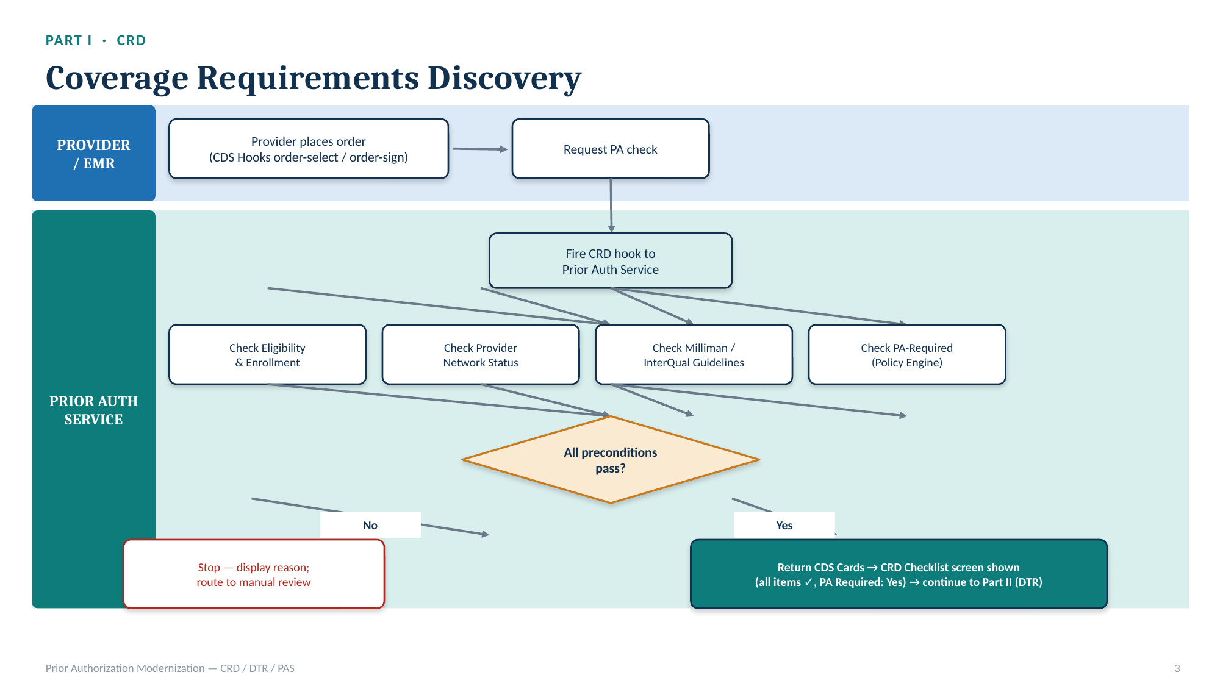
Figure 1. Part I — Coverage Requirements Discovery (CRD) flow — provider order through parallel eligibility, network, guideline, and PA-required checks to a pass/fail CDS Card response.
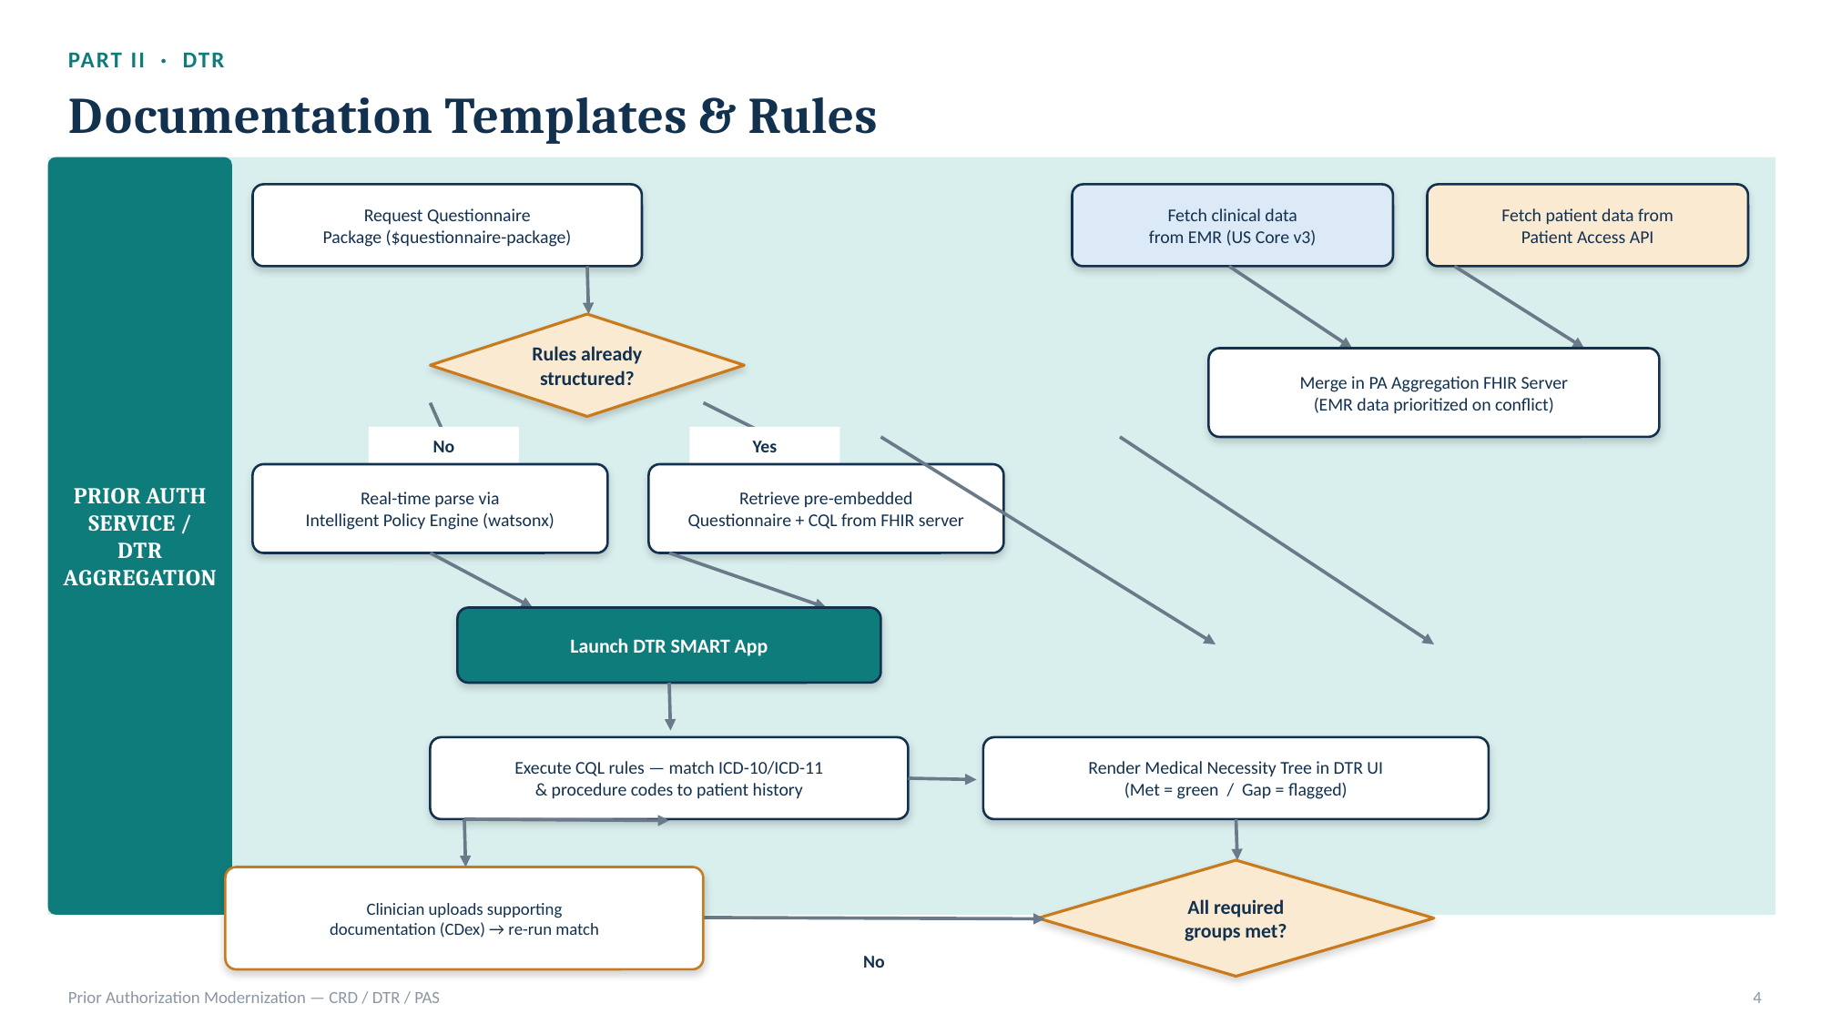
Figure 2. Part II — Documentation Templates and Rules (DTR) flow — questionnaire retrieval, EMR + payer data aggregation, and CQL-based medical-necessity matching.
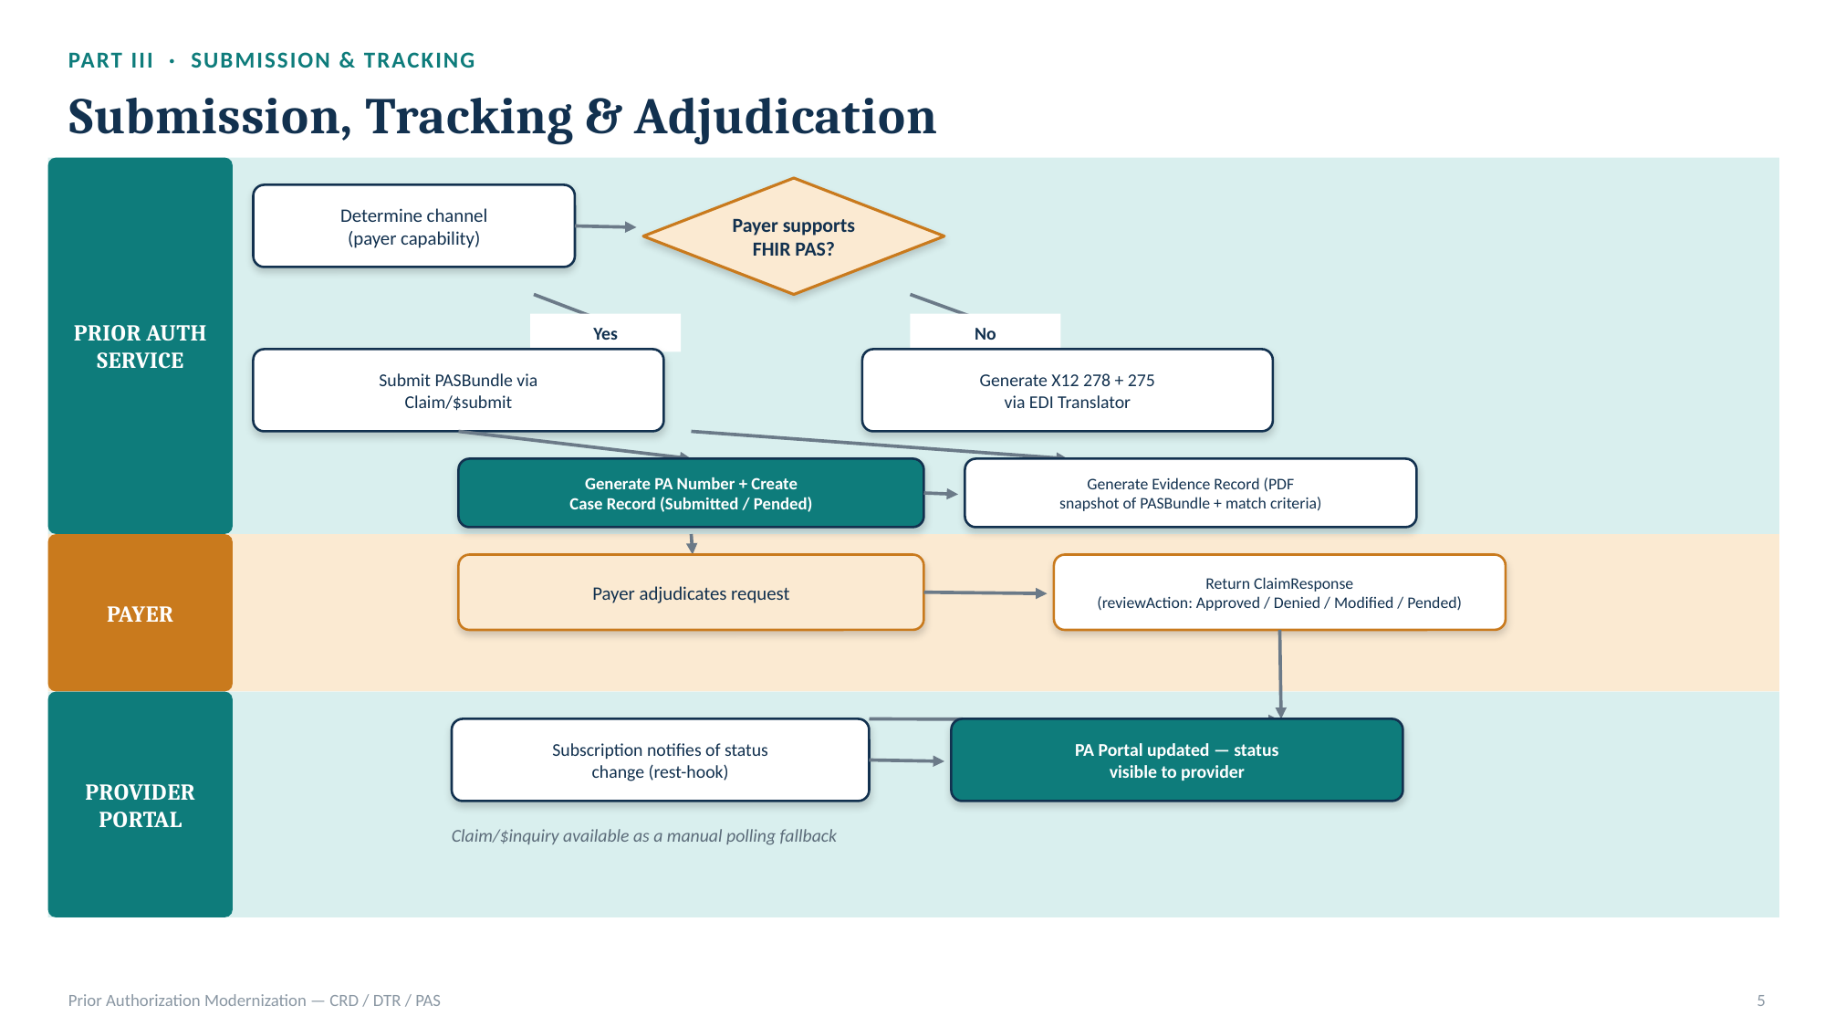
Figure 3. Part III — Submission, Tracking & Adjudication flow — channel selection (FHIR PAS vs. X12 278/275), case creation, Evidence Record generation, and status tracking.
Hosting is supported in two tiers to fit HCA's environment and timeline. A Tier A / offline configuration runs the full platform — all four CMS-0057-F provisions and the complete Golden Thread — against dev stubs and a seeded HAPI FHIR server, entirely within IBM's or HCA's cloud tenancy with no external dependency, and is the configuration IBM uses today for demonstration and internal testing. A Tier B / live configuration connects the same application layer to a standards-conformant CMS-0057-F reference implementation (in IBM's reference deployments, WSO2 API Manager, WSO2 Identity Server, and the WSO2 Open Healthcare accelerator) for production eligibility checks (X12 270/271), live Da Vinci CRD → DTR → PAS transactions, and X12 278/275 conversion. Both cloud and on-premises/hybrid hosting of the Tier B backbone are supportable; IBM will confirm the specific hosting model (IBM Cloud, HCA-hosted, or a hybrid split between the application layer and the FHIR/interoperability backbone) during solutioning with HCA.
The data model is FHIR R4-native throughout, aligned to the US Core, Da Vinci PAS/CRD/DTR, Da Vinci CDex, and Da Vinci Health Record Exchange (HRex) implementation guides referenced in CMS-0057-F. Coverage, Condition, ClaimResponse, Consent, Provenance, QuestionnaireResponse, and Claim/PASBundle resources are first-class throughout the platform rather than being translated in and out of a proprietary internal schema, which is what allows the same Coverage Determination logic to serve the Patient Access, Provider Access, and Prior Authorization surfaces from one source of truth.
Scalability and future-proofing follow directly from this architecture: because the Policy Engine ingests any payer or state-agency medical policy into one normalized model, adding a new line of business, a new payer, or a new state (the platform is already seeded for both South Dakota and Georgia in the Network Adequacy module, for example) is a data-onboarding exercise rather than a code change. Performance benchmarks for the Tier B production configuration will depend on the throughput of the connected CMS-0057-F reference implementation and HCA's payer and EMR trading partners; IBM proposes to define specific benchmarks and target response times (including the sub-15-second Claim/$submit round-trip target referenced in Section 5.6) jointly with HCA during the implementation planning phase.
CONFIRM BEFORE SUBMISSION — Specific SLA percentages (uptime, response-time targets) are not yet finalized in IBM's internal materials for this proposal. Populate this subsection with IBM's standard SaaS SLA language, or note that SLAs will be negotiated as part of contracting, before submission.

5.2.3 System Reliability & Operations
[Owner: Richard Williams]
Because the platform is FHIR-native and evidence-first, reliability is designed around two principles: nothing is adjudicated without a durable, replayable record, and every automated action degrades gracefully to a human-reviewable state rather than failing silently. The reviewer Work Queue is rebuilt directly from persisted Evidence Records — described further in Section 5.5 — so that queue state is always a derived view of durable data rather than a separate system of record that could drift out of sync.
Uptime monitoring, structured error handling, and disaster recovery for the production (Tier B) deployment will follow IBM's standard cloud-hosting operational practices, including health-check-driven monitoring of the Prior Auth Service, the PA Aggregation FHIR Server, and the connected CMS-0057-F reference-implementation backbone; automated alerting on SLA-timer breaches (the same 72-hour expedited / 7-day standard clocks shown to reviewers in the Work Queue are natural triggers for operational, not just clinical, alerting); and backup/restore and multi-zone failover for the FHIR data stores. IBM will document specific recovery time objective (RTO) and recovery point objective (RPO) targets, along with the disaster-recovery architecture for HCA's specific hosting model, during implementation planning.
CONFIRM BEFORE SUBMISSION — This subsection currently describes reliability principles evidenced in the built platform (evidence-first design, human-reviewable fallback) but does not yet cite IBM's standard enterprise uptime/DR commitments (e.g., specific RTO/RPO numbers, named DR tooling). Insert IBM's standard cloud operations language here before submission.

5.3 Functional Capabilities
[Respond to 5.3.1, 5.3.2, or both depending on scope of response — both are addressed below.]

5.3.1 APIs and Directory Services
[Owner: Richard Williams]
IBM's platform implements each of the CMS-0057-F API provisions as a first-class, independently demonstrable surface behind the FHIR BFF described in Section 5.2.2, unified by the Golden Thread so that a single member and order can be walked through every provision in one continuous session.

Patient Access API
The Patient Access surface performs live FHIR reads for a member's coverage, USCDI v3 clinical data, and prior-authorization history — Coverage, Condition, and ClaimResponse resources today — through the BFF, and explicitly surfaces the denial reason on a denied ClaimResponse, which IBM has implemented as a distinct CMS-0057-F requirement beyond the prior CMS-9115 baseline (where a payer could return a bare denial with no reason). Per CMS-0057-F's own standard, IBM's obligation — and its implementation — is to expose USCDI v3 data classes to the extent the platform maintains them: Condition is live today, and the remaining USCDI v3 classes (medications, allergies and intolerances, laboratory results, vital signs, procedures, care team, and clinical notes, among others) are mapped in the same PA Aggregation FHIR Server pattern described in Section 5.2.2 as each is onboarded. The screen also displays a 42 CFR Part 2 consent panel and a Provenance badge identifying the data's originating system, so members and their authorized representatives can see both what is shared and where it came from.

Provider Access API
The Provider Access surface performs a member match ($member-match) and then applies an authorization-basis check — canReadMemberData(role: provider, purpose: treatment, treatmentRelationship: true) — before releasing claims/encounter data, USCDI v3 data, and prior-authorization status to the requesting provider. This is deliberately modeled as a distinct authorization basis from the member-initiated consent used in Patient Access, consistent with the different regulatory basis for provider treatment-relationship access versus member-directed sharing, and gives IBM a clean extension point to add HCA-specific opt-out consent recording for Provider Access, as requested in Section 5.4. Bulk delivery to a provider organization's attributed member panel is implemented as a Bulk FHIR $export job, authenticated via SMART Backend Services rather than an individual user token, scoped to CMS-0057-F's 5-year look-back window from the date of the request.

Payer-to-Payer API
The Payer-to-Payer surface initiates an asynchronous bulk export job against a prior payer and polls job status through a StatusTimeline that explicitly begins with a Consent step, followed by Export requested, Export in-progress, and Imported — reflecting the opt-in consent model requested in Section 5.4. The export itself uses the same Da Vinci $davinci-data-export bulk pattern and NDJSON transfer format specified for this provision, covering claims/encounter data, USCDI v3 data, and prior-authorization status back to January 1, 2016 or the member's enrollment date, whichever is later. IBM's platform implements this bulk-export mechanism natively and is also built to interoperate with a specialist third-party Payer-to-Payer accelerator where a payer trading partner already has one in place, rather than requiring every counterparty to standardize on IBM's own implementation, described further in Section 5.7.

Prior Authorization APIs — CRD (Coverage Requirements Discovery)
CRD is implemented as a CDS Hooks integration fired at order-select (an early signal as the order is composed) and order-sign (the authoritative check once the order is finalized). On receipt, the Prior Auth Service orchestrates four parallel checks — eligibility and enrollment, ordering/rendering provider network status, a secondary Milliman/InterQual guideline check, and a PA-required determination from the Policy Engine — and returns the result as CDS Cards rendered as a pass/fail checklist (Patient Enrolled, Patient Eligible, Provider In-Network, No Conflicting Guideline, Prior Authorization Required). Figure 1 (Section 5.2.2) illustrates this flow. The process for creating CRD content is addressed in Section 5.3.2: payer medical policy is converted into the structured PA-required determinations and criteria that this check evaluates against.

Prior Authorization APIs — DTR (Documentation Templates and Rules)
When a CRD check indicates PA is required, DTR retrieves a Questionnaire Package for the specific procedure — either parsed on demand by the Intelligent Policy Engine, for policies not yet structured, or retrieved pre-embedded from the FHIR server — and launches a SMART app that merges EMR and payer clinical data into the PA Aggregation FHIR Server described in Section 5.2.2. CQL rules then match ICD-10-CM/ICD-11 diagnosis codes and CPT/HCPCS procedure codes against that merged record, and results render as a criteria tree with a clear Met (green, with evidence and source citation) or Gap status per leaf. For any Gap, the clinical user can upload supporting documentation directly against that criterion — via the CDex attachment pattern, as a PDF, C-CDA, or text document wrapped as a DocumentReference — or provide an attestation, and re-run the match. Figure 2 illustrates this flow.

Prior Authorization APIs — PAS (Prior Authorization Support)
Once DTR criteria are satisfied, the platform determines the submission channel based on the receiving payer's published capability — a FHIR PASBundle via Claim/$submit for FHIR-capable payers, or an X12 278 request plus X12 275 attachment transactions via the EDI Translator for payers still requiring the legacy channel — generates an internal PA tracking number and case record, and creates an immutable Evidence Record (an audit snapshot of the submitted PASBundle, the CRD checklist, and the DTR match-tree state). Status updates are received via FHIR Subscription (rest-hook) for pended cases, with Claim/$inquiry available as a manual polling fallback, and incoming ClaimResponse reviewAction codes are mapped into the Portal's status vocabulary (Submitted, Pended, Approved, Partially Approved/Modified, Denied). Figure 3 illustrates this flow. Submission itself is always human-gated: the DTR submit action is disabled until a named human approver is entered.

Provider Directory Services
Provider-level data — NPI, specialty, and network participation — is already a first-class input to the platform's Network Adequacy module, described in Section 5.5, where it is used to measure network adequacy by specialty, county, and line of business. A standalone, CMS-0057-F-conformant Provider Directory API (a searchable, publicly accessible provider directory endpoint) is on IBM's near-term roadmap and would be built on this same provider data model rather than as a separate system; IBM proposes to scope and sequence this alongside the Tier B production rollout described in Section 5.6.

5.3.2 Policy Transformation
[Owner: Richard Williams]
IBM's approach to transforming an unstructured payer or state-agency policy environment into a digitally referential, structured environment is the Intelligent Policy Engine. It ingests medical policy in whatever form the payer or state agency currently holds it — most commonly scanned PDFs or narrative policy documents — and converts that content into structured JSON, and ultimately into Da Vinci FHIR-compliant resources: Questionnaire and QuestionnaireResponse resources for DTR, CQL logic for medical-necessity evaluation, and ValueSet resources for the code sets referenced by a given policy. The engine is seeded today with real, parsed examples — Aetna's cardiac Clinical Payment and Coverage Policies (CPBs) and UnitedHealthcare's prior-authorization requirement lists — which IBM uses in its live demonstrations to show the engine correctly branching a member's order into a PA-required determination, a criteria-gated medical-necessity evaluation, or (for services outside a payer's covered-policy set) a transparently flagged experimental/likely-denial outcome, with the underlying reasoning attributable at every step.
Once a policy has been converted, the platform's generalized Policy Engine evaluates a specific member's order against that structured model to produce a Coverage Determination — requires-PA, criteria-met, criteria-gated with a named deficiency, or a propensity-scored likely outcome — using one common evaluate() function regardless of which payer's or state's policy is being applied. This is the same technology that answers the CRD PA-required check in Section 5.3.1 and drives the DTR medical-necessity tree, so a state agency or payer only has to structure a policy once to have it apply consistently across coverage discovery, documentation matching, and gold-carding/propensity scoring.
For utilization-management and coverage-determination content specifically, IBM's recommended implementation approach — reflected in its internal modernization plan for this workstream — is to validate the policy engine's JSON-to-Questionnaire/CQL output schema early, on a short, isolated design-spike branch, before building the downstream CRD PA-required lookup and DTR medical-necessity matching against it, precisely because this conversion step is the most novel and highest-risk piece of the architecture and the one every other CMS-0057-F provision ultimately depends on. IBM would apply the same disciplined, spike-first approach to HCA's and Apple Health managed care plans' policy libraries.
The Intelligent Policy Engine operates in an agentic mode: it monitors a payer's or HCA's published policy library for updates and proposes the corresponding structured-resource revisions, rather than requiring a manual re-conversion each time a policy changes. This remains strictly an administrative-automation function, consistent with Section 5.2.1: proposed revisions are queued for clinical or policy-SME sign-off before publication, and never take effect automatically, which also gives IBM a natural mechanism to satisfy ESSB 5395's requirement that clinical review criteria be evidence-based and evaluated at least annually with human oversight.

5.4 Security & Privacy
[Owner: Richard Williams]
Describe how the solution meets WA State security requirements (watech.wa.gov/policies).
Security and privacy are designed into the platform's architecture rather than layered on top of it: every client — provider, member, or reviewer — reaches FHIR data only through the server-mediated BFF described in Section 5.2.2, which gives IBM one enforcement point for authentication, authorization, consent, and audit logging across all four CMS-0057-F provisions.
Authentication and authorization use OAuth2 and SMART App Launch throughout: the DTR SMART app, the CRD-triggered CDS Hooks integration, the EMR data pull (under US Core v3 profiles), and the payer Patient Access API pull each operate under their own SMART-issued, scope-limited token, and the payer-side pull specifically requires a separate patient-authorized token reflecting the member's consent for that payer to share their record with the requesting provider.
Patient identity matching uses a Master Patient Index capability — the platform's Knowledge Graph & Master Person Index component resolves and links records for the same individual across EMR, payer, and state-agency sources into one master person record, which is the same resolved-identity layer that supports the $member-match operation used in Provider Access and Payer-to-Payer. IBM will work with HCA to determine whether this resolves against HCA's existing Master Patient/Client Index or operates as a standalone MPI for the FSIPAP scope.
Consent management is a dedicated architectural component (Consent & Governance) rather than a bolt-on flag. The platform already demonstrates an opt-in consent pattern for Payer-to-Payer, where a bulk export cannot proceed until a Consent step is recorded and shown on the export's StatusTimeline, and an explicit 42 CFR Part 2 consent panel on the Patient Access screen. Provider Access is currently modeled on a treatment-relationship authorization basis rather than member consent, consistent with the different regulatory basis for that provision; IBM's Consent & Governance component is built to capture FHIR Consent resources generically, so adding HCA's required opt-out consent workflow for Provider Access — including consent revocation and ongoing consent-status management — is a configuration of an existing capability rather than new development. IBM is also prepared to discuss integration with an existing HCA or Apple Health consent management solution if HCA prefers to keep consent-of-record in a system it already operates, with IBM's platform consuming and honoring that system's FHIR Consent resources rather than maintaining a separate, competing consent store. The supplemental-data sources described in Section 5.2.2 — HIE feeds, ACO/value-based-care data-sharing arrangements, and direct EHR-payer integrations — sit on their own data-use basis, governed by the underlying data-sharing agreement HCA or a managed care plan already has with that source, rather than by the member-consent or treatment-relationship bases used for the three read APIs; IBM's Consent & Governance component records and enforces whichever basis applies per source.
Audit logging is implemented as a first-class data structure, not a side log file: the Evidence Record's EvidenceTimeline is an append-only, per-stage, timestamped audit trail (determination, gold-card check, propensity scoring, eligibility, estimation), and every clinical fact ingested into the PA Aggregation FHIR Server is tagged with a Provenance resource identifying its originating system, which supplies both the audit trail needed to demonstrate how a medical-necessity determination was reached and the source citation shown alongside matched evidence in the DTR tree.
On HIPAA and related compliance, the platform's operational cost model already provisions for SOC 2 Type II certification with annual renewal, and includes an optional line item for HITRUST CSF certification if HCA or a specific payer trading partner requires it. IBM will map the platform's control set against WaTech's specific security policies (watech.wa.gov/policies) as part of implementation planning, and will provide any additional state-specific attestations, security questionnaires, or control mappings HCA's Office of the Chief Information Officer requires.
IBM's approach to AI governance is built directly around Washington's prior-authorization AI requirements rather than a generic AI-ethics framework. Under ESSB 5395, no AI component in IBM's platform is permitted to deny a prior authorization request; every AI-assisted step is grounded in the specific enrollee's own aggregated record rather than group-level data; and any case an AI component cannot clearly resolve in the enrollee's favor is routed to a licensed clinical peer, with a peer-to-peer review discussion made available to the requesting provider on any adverse determination, as described in Section 5.2.1. The same Evidence Record and Provenance-based audit trail described above is designed to support Washington's annual AI-transparency reporting requirement, effective January 2027, by capturing what each AI-assisted step did and the data it relied on as a normal by-product of processing a case, rather than through separate instrumentation added solely for reporting.
CONFIRM BEFORE SUBMISSION — This subsection states that SOC 2 Type II is budgeted and HITRUST is available as an option, based on IBM's internal cost model, but does not cite a specific, current SOC 2 report date, HIPAA Business Associate Agreement template, or a completed WaTech OCIO security policy crosswalk. Attach or reference IBM's current SOC 2 report and standard BAA, and complete a WaTech policy crosswalk, before submission.

5.5 Reporting & Analytics
[Owner: Richard Williams]
Reporting in IBM's platform is built from the same durable, evidence-first data model used for adjudication, so every number a dashboard shows can be traced back to the Evidence Record or Coverage Determination that produced it, rather than to a separately maintained reporting extract.
The reviewer-facing Work Queue is the platform's primary operational dashboard today: it groups every open case by disposition — High-risk review, Ready to submit, More info, Denied-appeal, and Auto-cleared — and shows each case's SLA due date against the CMS-0057-F 72-hour expedited and 7-day standard clocks, with breach flags rendered in red once a case passes its deadline. Because the queue is rebuilt directly from persisted Evidence Records rather than a separate tracking system, prior-authorization turnaround-time reporting (time to determination, percentage resolved within the expedited and standard windows, and breach counts by payer, provider, or procedure) can be derived from this same data without a parallel reporting pipeline.
Denial metrics are captured at the source: the Patient Access screen already surfaces the denial reason on a denied ClaimResponse as a distinct, CMS-0057-F-driven data element, and the Policy Engine's three-way branching (PA-required, criteria-gated with a named deficiency, or likely-denial/experimental) gives IBM a structured basis for denial-reason analytics beyond a bare approved/denied count — for example, distinguishing denials driven by a missing-diagnosis-code deficiency from denials driven by a service falling outside a payer's covered-policy set.
The Network Adequacy module includes a second analytics surface purpose-built for state-agency use: a KPI summary bar (average adequacy percentage, cells measured, gap count), a prioritized gap table that ranks the worst network gaps by specialty, county, and line of business against CMS time-and-distance, in-network-percentage, wait-time, and provider-to-member-ratio standards, and a natural-language analyst copilot that answers questions — "prioritize the worst behavioral-health gaps," "validate this network against CMS standards," "recommend augmentation for this gap" — grounded deterministically in the same underlying engine, so every number the copilot returns is reproducible and defensible for state-reviewer certification and audit purposes, and requires no external AI API key to run.
A packaged library of CMS-required regulatory reports (for example, standardized turnaround-time and denial-rate submissions in the format CMS ultimately specifies for CMS-0057-F oversight reporting) is not yet built as a named, one-click export; IBM proposes to scope the specific report formats HCA needs during implementation planning, since the underlying data — SLA timers, denial reasons, Evidence Records, and network-adequacy compliance verdicts — already exists to support them. Alerting today is implemented as in-app breach flags on the Work Queue; email/SMS or webhook-based alerting and notification (for example, notifying a UM supervisor when a case is within a defined window of an SLA breach) is a near-term extension of the same SLA-timer logic and can be prioritized for HCA.

5.6 Implementation, Testing, & Timeline
[Owner: Richard Williams]
IBM's implementation approach is phased and additive: it treats already-working foundation (a live FHIR server, identity/authentication, and data plumbing) as a stable base that is never modified in place, and sequences new capability onto isolated feature branches built on top of that base. In IBM's own prior build of this platform, that discipline meant that Coverage Requirements Discovery, Documentation Templates and Rules, and Prior Authorization Support were added as a single, clearly scoped increment (internally sequenced as sub-phases 4a through 4e) on top of three already-stable foundation phases, with a short, isolated design-spike branch used first to validate the Intelligent Policy Engine's highest-risk output — its JSON-to-Questionnaire/CQL conversion schema — before any downstream feature was built against it. IBM proposes the same pattern for HCA: validate the riskiest, most novel component (policy-to-FHIR conversion for HCA's and Apple Health managed care plans' specific policy libraries) early and in isolation, then build outward.
Requirements gathering from HCA subject-matter experts is front-loaded into a dedicated discovery phase rather than spread thinly across the engagement, so that the highest-risk unknowns — HCA's specific UM vendor landscape, existing consent and MPI systems, and current policy libraries — are resolved before development sequencing is finalized. Based on IBM's cost and schedule modeling for a comparably scoped platform build, IBM estimates a discovery and foundation-setup phase of approximately six weeks (1.5 months) is sufficient to gather this information, assuming timely access to HCA subject-matter experts; IBM will confirm this estimate against HCA's specific availability during proposal discussions.

Sample Implementation Timeline
Phase | Description | Duration | Key Milestones
Phase 0 — Discovery & Foundation | Requirements gathering, environment setup, policy-engine design spike | ~1.5 months | HCA SME interviews complete; policy-conversion schema validated; environments stood up
Phase 1 — MVP / First Value | Core CRD/DTR/PAS flow, Patient Access, initial policy library onboarded | ~3.5 months | First live end-to-end PA case processed; first HCA policy set structured
Phase 2 — Expand Reach & Real-Time | Provider Access, Payer-to-Payer, real-time eligibility (Tier B), USCDI v3 class expansion, supplemental-data ingestion (HIE/ACO feeds) | ~3 months | Live payer/EMR trading-partner connections; real-time eligibility checks; expanded USCDI v3 coverage live
Phase 3 — Program & Population Scale | Additional lines of business, Network Adequacy rollout, reporting | ~6 months | Full policy library structured; state-reviewer reporting live
This is the same phase structure and duration IBM uses in its own internal planning for a comparably scoped build (roughly 14 months end to end for the full 23-module scope); IBM would jointly re-baseline this timeline with HCA once FSIPAP's specific scope, existing systems, and trading-partner landscape are confirmed. USCDI v3 class expansion and supplemental-data ingestion are sequenced into Phase 2 alongside Provider Access and Payer-to-Payer specifically because all three depend on the same underlying data-mapping and bulk-extract work, described in Section 5.2.2.

Testing Approach
IBM validates the Policy Engine's determinism with automated tests before any branch is demonstrated live — for example, the criteria-met (fully approved) path through the DTR medical-necessity tree is proven today in an automated test suite using an ICD-10-coded cardiac diagnosis, even in cases where a live demo persona's seed data does not happen to exercise that exact path. In IBM's live demonstrations, the same Policy Engine is shown correctly branching a single procedure code into three distinct outcomes — a PA-required-list hit, a criteria-gated deficiency (for example, a mismatch between a patient's SNOMED-coded conditions and a policy written against ICD-10), and a transparently flagged experimental/likely-denial outcome — which IBM uses as a repeatable acceptance test for policy correctness whenever a new payer or state policy library is onboarded. IBM proposes to extend this same test discipline to HCA's user-acceptance testing: automated regression tests for policy-engine determinism, plus scripted, SME-witnessed walkthroughs of each CMS-0057-F provision using HCA's own test data before go-live.

Sample Work Plan & Data Migration
Data migration work for this engagement falls into two categories: policy-content migration and, if applicable, consent-record migration. Policy-content migration — converting HCA's and Apple Health managed care plans' existing utilization-management and coverage-determination policies into structured FHIR resources — is the core function of the Intelligent Policy Engine described in Section 5.3.2 and is scoped as an ongoing, policy-by-policy onboarding workstream rather than a single cutover event, so that new or revised policies can be structured continuously rather than only at go-live. Consent-record migration depends on whether HCA elects to have IBM's Consent & Governance component serve as the system of record or to integrate with an existing HCA/Apple Health consent management solution, as described in Section 5.4; IBM will scope the specific migration effort once that decision is made.
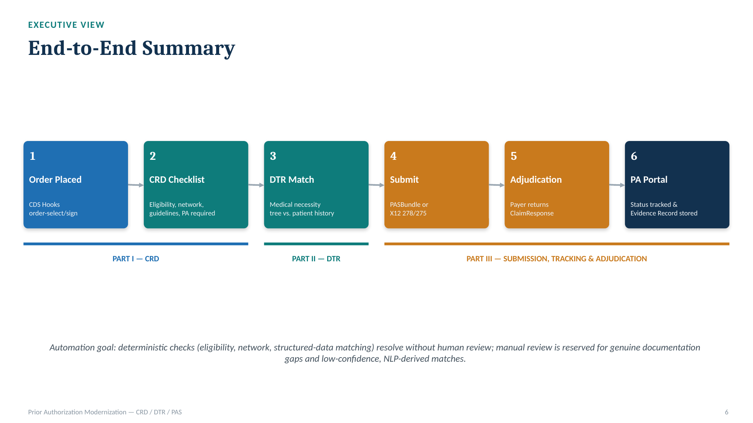
Figure 4. End-to-end executive summary — the six-step lifecycle — order placed, CRD checklist, DTR match, submission, adjudication, and PA Portal status tracking — that IBM's implementation plan and testing approach are organized around.

5.7 Pricing & Delivery Model
[Owner: Richard Williams]
CONFIRM BEFORE SUBMISSION — The figures below are drawn from IBM's internal illustrative cost models for a comparably scoped build and are explicitly labeled placeholder/illustrative in IBM's source materials. They are presented here to give HCA a realistic order of magnitude and cost structure, not a firm quote. Replace with IBM's finalized, HCA-specific pricing before submission.
IBM proposes a Design, Development, and Implementation (DDI) plus ongoing Operations & Maintenance (O&M) pricing model, consistent with typical state-agency procurement structure, priced by project phase and by the scope of policy libraries, payer connections, and lines of business HCA elects to bring into scope.

Illustrative DDI Costs
For the CRD/DTR/PAS-specific build scoped to a single representative payer's test environment, IBM's internal cost model estimates total labor cost across a nine-role delivery team — Tech Lead, two Backend/FHIR Engineers, a Data/Integration Engineer, a Frontend Engineer, a QA Engineer, a Security Engineer, a Product/Clinical SME, and a Project Manager — at approximately $221,575, built from blended daily labor rates ranging from $900/day (QA Engineer) to $1,450/day (Tech Lead).
Role | Person-Days | Illustrative Cost
Tech Lead | 7.5 | $10,875
Backend/FHIR Engineer 1 | 57 | $62,700
Backend/FHIR Engineer 2 | 47 | $51,700
Data/Integration Engineer | 13 | $14,300
Frontend Engineer | 32 | $32,000
QA Engineer | 28 | $25,200
Security Engineer | 4 | $5,000
Product/Clinical SME | 12 | $15,600
Project Manager | 4 | $4,200
At the full platform scope — all 23 core-platform, persona, and data-connector modules across Discovery and three build phases, described in Section 5.6 — IBM's internal model estimates total DDI cost of approximately $2.11 million under a fully custom build (Approach A). IBM also models an asset-leverage delivery approach (Approach B), in which IBM funds an upfront, reusable platform investment and a client's incremental build cost is substantially lower as a result: under that model, a first client's incremental DDI cost is estimated at approximately $157,000 rather than $1.15 million for the same Phase 1 / MVP scope, with total time to first live functionality compressed from roughly 5 months to roughly 3.75 months. IBM proposes to discuss with HCA whether a fully custom build or an asset-leverage delivery model better fits FSIPAP's budget and schedule.

Illustrative Ongoing O&M Costs
Post-go-live run-rate for the CRD/DTR/PAS-specific scope is modeled at approximately $48,900 per month (roughly $587,000 annualized), comprising infrastructure and hosting (~$7,560/mo), third-party clinical-guideline licensing such as Milliman/InterQual (~$15,080/mo), backend/FHIR and QA support labor (~$16,820/mo combined), additional EMR and payer connection monitoring (~$3,750/mo), amortized SOC 2 Type II annual renewal (~$2,080/mo), amortized clinical policy-revision review (~$890/mo), and facility connectivity (~$2,700/mo). At the full 23-module platform scope, steady-state annual run cost is modeled at approximately $2.27 million under a fully custom build, or approximately $2.06 million under the asset-leverage model.
CONFIRM BEFORE SUBMISSION — The DDI and O&M figures above were scoped to the CRD/DTR/PAS build against a single payer test environment and do not yet carry a separate line item for full USCDI v3 class-by-class mapping (beyond the Condition resource already built) or for standing up the supplemental-data ingestion path (HIE feeds, ACO/value-based-care data-sharing integrations) described in Section 5.2.2. Both are real, additional cost drivers HCA is likely to ask about; size and add them before this pricing is finalized with HCA.

Cost Drivers & Assumptions
- Labor rates shown are illustrative, U.S.-blended rates and will be finalized against IBM's contracted rate card for the specific contracting vehicle used (see Section 5.8).
- Third-party clinical-guideline licensing (Milliman Care Guidelines and/or InterQual) is priced as a pass-through and depends on which guideline source HCA's payers and managed care plans already use.
- Cloud hosting cost scales with the number of connected payer and EMR trading partners and with transaction volume, particularly under the Tier B live configuration described in Section 5.2.2.
- HITRUST CSF certification is an optional cost driver, included only if HCA or a specific trading partner requires it beyond the SOC 2 Type II baseline.

Integration & Partnership with Other Vendors
IBM's delivery model is designed to integrate with, rather than displace, specialist vendors already in HCA's or its managed care plans' environments. For Payer-to-Payer specifically, IBM's platform implements the Da Vinci bulk member-match and $davinci-data-export/NDJSON mechanics natively, and is also built to connect to a third-party P2P accelerator for the underlying bulk-export plumbing where a payer trading partner already has one under contract, rather than requiring every counterparty to standardize on IBM's own implementation. Similarly, on the medical-necessity side, IBM's Policy Engine is designed to consume existing clinical-guideline licenses (Milliman Care Guidelines, InterQual) as an input rather than replacing them, and to ingest data from existing HIE and value-based-care data-sharing arrangements, described in Section 5.2.2, rather than requiring HCA to renegotiate those relationships. IBM welcomes a conversation with HCA about which existing vendor relationships — consent management, MPI, clinical guidelines, HIE feeds, or P2P accelerators — IBM should plan to integrate with as a condition of the engagement.

5.8 Experience & References
[Owner: Richard Williams]
CONFIRM BEFORE SUBMISSION — This section requires IBM-verified, publicly citable engagement details (client names, contract vehicles, dates) before submission. The narrative below describes real work products IBM has produced but intentionally omits or genericizes client-identifying details that have not been confirmed as shareable. Replace bracketed items with confirmed references before submission.
IBM has direct, hands-on experience assessing CMS-0057-F readiness for state Medicaid managed care programs. IBM has completed a full CMS-0057 Assessment Questionnaire engagement for a state Medicaid managed care health plan serving more than 300,000 members, covering plan structure, prior-authorization volumes and turnaround times, utilization-management vendor relationships, and a maturity assessment across all four CMS-0057-F API provisions. That engagement found the plan already at a "Managed" maturity level on Patient Access API (fully implemented and monitored) but only "Initial" maturity on Provider Access, Payer-to-Payer, and Prior Authorization APIs — a pattern IBM has found typical of health plans approaching the January 1, 2027 compliance deadline, and one that directly informs the phased implementation approach described in Section 5.6, which deliberately sequences the harder, less-mature provisions (Provider Access, Payer-to-Payer, full Prior Authorization) after an initial Patient Access-anchored foundation.
CONFIRM BEFORE SUBMISSION — [INSERT: name and citability of the health plan referenced above, or confirm it should remain anonymized as "a state Medicaid managed care client."]
IBM has experience working with HIPAA-protected and other legally protected health care data throughout this platform's design: the consent, Provenance, and audit-logging architecture described in Section 5.4 was built specifically to support 42 CFR Part 2-sensitive data alongside standard PHI, and IBM's cost and delivery model provisions for SOC 2 Type II certification (with HITRUST CSF available as an option) as a baseline expectation for any production deployment handling this class of data.
On prior CMS and health care interoperability initiatives, IBM's work on this platform directly targets the CMS Interoperability and Prior Authorization Final Rule (CMS-0057-F) and builds on the CMS-9115 Patient Access API baseline referenced throughout this response. IBM's Da Vinci FHIR implementation experience spans all three prior-authorization implementation guides in CMS-0057-F's scope — Coverage Requirements Discovery (CRD), Documentation Templates and Rules (DTR), and Prior Authorization Support (PAS) — as well as the Da Vinci CDex attachment pattern used for DTR evidence upload and the Da Vinci Health Record Exchange (HRex) patterns underlying Payer-to-Payer bulk data exchange, each of which is implemented and demonstrable in the platform described in Sections 5.2 and 5.3, not only designed on paper.
IBM has implemented working versions of Patient Access, Provider Access, Prior Authorization (CRD/DTR/PAS), and Payer-to-Payer APIs within this platform, each independently demonstrable end-to-end, and has implemented the policy-transformation capability described in Section 5.3.2 — including a working Intelligent Policy Engine seeded with real, parsed payer policy content (Aetna cardiac Clinical Payment and Coverage Policies and UnitedHealthcare prior-authorization requirement lists) converted into structured, FHIR-referential artifacts.
IBM's Network Adequacy module additionally reflects direct experience translating state-specific regulatory standards — Medicare Advantage §422.116, Medicaid §438.68 and the 2024 Access rule, and Qualified Health Plan §156.230 — into an operational, auditable compliance tool, seeded and demonstrated against South Dakota (including the Pine Ridge and Rosebud reservation counties) and Georgia network data, which IBM believes is directly relevant to Washington's Apple Health managed care network-adequacy obligations.

Relevant References & Case Studies
CONFIRM BEFORE SUBMISSION — [INSERT: named, verified client references and case studies IBM is authorized to share with HCA, including contact information where permitted by the reference client.]

Contracting Vehicles
CONFIRM BEFORE SUBMISSION — [INSERT: applicable contracting vehicles IBM can offer HCA — e.g., DES statewide contract, NASPO ValuePoint, GSA Schedule — and the specific contract/schedule numbers.]

State Medicaid / State Government References
CONFIRM BEFORE SUBMISSION — [INSERT: any additional state Medicaid or state government references IBM is authorized to cite, beyond the engagement described above.]

