Introduction

This assignment is the last of six assignments. In this assignment, you will implement a shopping cart

experience for your customers.

Before you begin this assignment, you must finish your previous assignment. All objectives listed for this

assignment are to be made “on top” of your previous assignment.

This assignment is worth 9% of your final grade.

**--Technical Requirements**

• All back-end functionality must be done using Node.js and Express.

• You will use the body-parser module to handle form submissions.

• You will use the express-session module to handle user session state information.

• You will use bcrypt.js to encrypt user passwords.

• Your views must be created with Express-Handlebars.

• You can use a front-end CSS framework such as Bootstrap, Bulma or Materialize CSS to make

your website responsive and aesthetically pleasing.

• You are not allowed to use any Front-End JavaScript Frameworks. For example, you may not

use React, Vue, or Angular.

• You must use MongoDB as your database engine.

--Objectives

**Data Loading**

Create a throw-away “load data” controller but do not delete the controller; the controller must be

submitted so it can be marked by your professor.

The “load data” controller must contain a route that will populate meal kit data. The following are the

requirements for the route:

1. A data clerk can load meal kit data to the database by accessing the URL “/load-data/meal-kits”.

2. This functionality must be placed in its own controller and must be coded using the MVC design

patterns learned in class.

3. You must check to ensure there are no meal kits in the database before adding new meal kits;

this is it to prevent adding of duplicate entries.

4. You must populate a minimum of three “top meals” and four “on the menu” meals.

a. The “on the menu” page should contain at least two different categories.

b. It is okay for “top meals” to appear on both the home page and the “on the menu”

page.

5. After accessing a load data route, display a Handlebars view with a message describing the

outcome:

a. If data was loaded to the database, display a message like “Added meal kits to the

database”.

b. If data has already been loaded to the database, display a message like “Meal kits have

already been added to the database”.

c. Only data clerks can load data. If the user is not a data clerk, display a message like “You

are not authorized to add meal kits”.

d. The message is displayed on a page showing the proper header and navigation bar.

Data Entry Clerk Module

You are required to implement a Data Entry Clerk Module that allows a data entry clerk to perform the

following tasks:

1. Create meal kits. The data entry clerk must be able to add new meal kits to the database. At

minimum, the following data can be specified when adding a new meal kit:

a. Title – Sautéed Ground Pork over Jasmine Rice

b. What is included? – Toasted Peanuts & Quick-Pickled Cucumber Salad

c. Description (This is a text area, not an text input) – Gingery pork, crunchy cucumbers and

toasty peanuts make for a classic culinary …

d. Category – Classic Meals

e. Price – $19.99

WEB322 – ASSIGNMENT #5 – FALL 2021 DUE: DECEMBER 3, 2021 @ 11:59 PM EST

f. Cooking Time – 25 minutes

g. Servings – 2

h. Calories Per Serving – 890

i. Is it a Top Meal? – true

j. Upload a photo of the meal kit (to keep the project simple, only upload one image per

meal kit).

2. Ensure that all new meal kits that were entered into the database are populated on the frontend of the web application.

a. All meal kits must appear on the “on-the-menu” page.

b. Only the meal kits that were set as “Top Meals” should be populated in the “Top Meals”

section of the home page.

c. A visitor does not need to be logged in to view the meal kits that were created by the

data entry clerk.

3. Ensure that a user can only upload images stored in an appropriate file type. For example: jpg,

gif, or png.

4. View a list of all the meal kits.

5. Edit and change meal kit details for a selected meal kit. For example: price, title, etc.

A data entry clerk must be logged-in to the web application to perform the tasks mentioned above. That

is, a data entry clerk must log in to create meal kits, view all meal kits, and change meal kit details.

Meal Kit Description Page

Logged in users must be able to “purchase” meal kits by adding selected meal kits to their shopping cart.

From the “on the menu” page, when a user clicks on a particular meal kit, they should be navigated to

the Meal Kit Description page (of the clicked kit). From this description page, users can add the meal

package to their shopping cart.

A meal kit description page may look like the following screenshot:

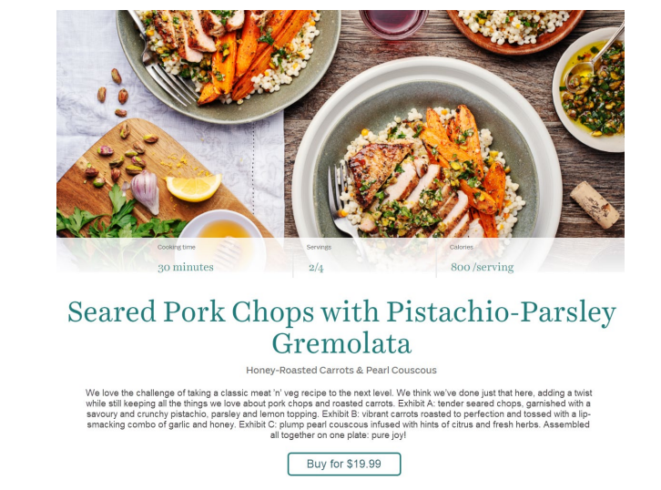

The meal kit description page of any meal package should include, at minimum, the following:

• Meal kit image

• Title

• Description

• Price

• Cooking time

• Number of servings

• Calories per serving

• Add to order button

When the user clicks the “Add to Order” button, the kit will be added to the user's shopping cart.

Shopping Cart Module

The customer’s dashboard should have a link to the logged-in user’s shopping cart. This page must

display all the meal kits added to the shopping cart as well as a quantity for each. The page should also

include a “Place your order” button and the order total.

When the “Place your order” button is pressed, your web application will send an email to the logged-in

user’s email, showing all the packages purchased along with the quantity for each. The email must

include the customer’s order total but do not worry about taxes.

After the email is sent, clean (zero-out) the shopping cart.

Rubric

|  |  |  |  |
| --- | --- | --- | --- |
| **Criteria** | **Not**  **Implemented (0)**  Little or no work  done.  Unacceptable  attempt | **Partially**  **Implemented (1)**  Work is minimally  acceptable but is  incomplete or  needs significant  modification. | **Fully**  **Implemented (2)**  Work is complete  and done perfectly. |
| **Data Clerk Module**  • The data entry clerk can view a list of all meal kits.  • A data entry clerk can create meal kits supplying necessary data.  • The data entry clerk can edit all meal kit details.  • A data entry clerk can upload a photo for a new meal kit or an existing meal kit.  • Only images files can be uploaded as a photo.  • New meal kits appear on the “on-the-menu” page with the correct category.  • Meal kits that are set as top  meals are shown on the home page.  **Load Data Module**  • Functionality is stored in a dedicated controller. Only data clerks can load the data by navigating to “/load-data/meal-kits”.  • Controller will not add duplicate meal kits if run multiple times.  • At least three “top meals” and four “on the menu” meal kits are added. There are at least two categories  in the “on the menu” page.  • Correct message is displayed, and the message is formatted with the  header and navigation bar present. |  |  |  |

|  |  |  |  |
| --- | --- | --- | --- |
| **Meal Kit Details**  • Clicking a meal kit will show the details of the meal kit with all necessary fields. There is an “Add to Order” button.  **Ordering Module**  • Only logged in users can  add meal kits to their shopping cart.  • User’s can view the purchased meal kits and the quantity in their shopping  cart. The shopping cart includes the total amount (taxes are not necessary).  • When the user clicks the  “Place Order” button, the  application must “clear” the  shopping cart and send an  email with the entire order  information.  **Look and Feel**  • Overall site looks polished  on all devices |  |  |  |