Assignments 1 - COMP122 (Section 4) Winter 2021

Due Date is Midnight of Febr 24th

Student Name :

Student Number :

Instructions:

* Each question is worth 25 mark ( total 100)
* Please copy paste every command you run for each question under each number.
* Your Commands ,any entry , any notes should be RED color.
* And also Capture screen shot of your results and copy paste under each question number.

(You can use below Snipping Tool to take screen capture. You can find this tool in Windows on your computer by Searching)

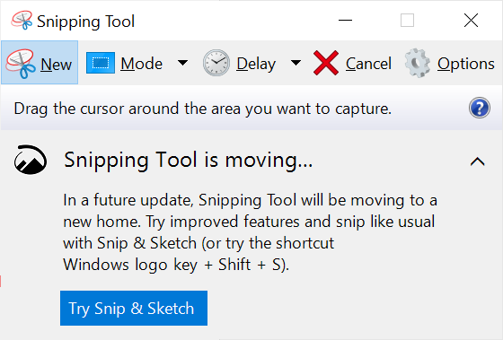

**Questions & Tasks**

1. Create a table named DEPT based on the following chart.

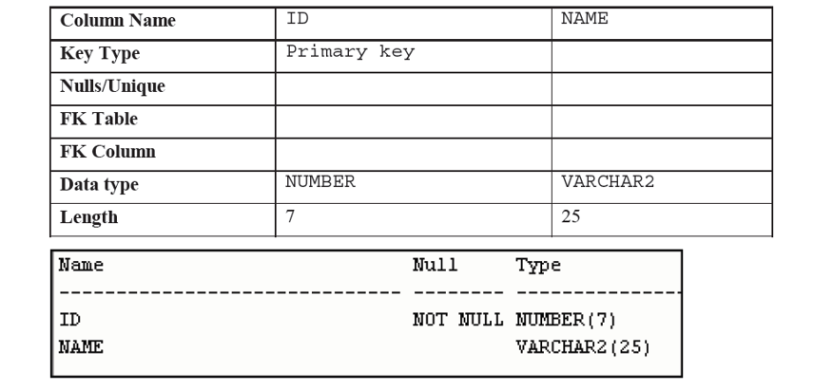

create table DEPT(

ID number(7) primary key,

NAME varchar2(25)

);

desc DEPT

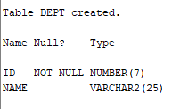

2)

a) INSERT a new record to table DEPT (the table you created in Question 1) by executing below command in SQL Developer screen.

*INSERT INTO DEPT (ID , NAME) VALUES (40, ‘Sales’) ;*

Explain if this insert run successfully and added record . YES

 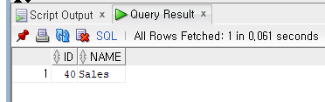

b) Run another Insert statement / command

*INSERT INTO DEPT (ID , NAME) VALUES (40, ‘Accounting’) ;*

Explain if this insert run successfully and added record this time? NO

Why?

unique constraint (COMP122_W21_ERS_155.SYS_C00852365) violated

Because the value that tried to INSERT is already the primary key of the table and the value already exists. The value of the primary key can’t be duplicated.

P.S: Make sure you rewrite these INSERT statements in SQL Developer by yourself or if you copy paste from this word document then fix (rewrite) single ‘ ‘ quote.

2) Add two new columns to this DEPT table (Manager_ID and City Columns)

a)

|  |  |  |
| --- | --- | --- |
| **Column Names** | Manager_ID | City |
| Key Type |  | UNIQUE KEY |
| Data Type | NUMBER | VARCHAR2 |
| Lenght | 5 | 30 |

Hints: Use ALTER TABLE ADD column command

ALTER TABLE XXXXX ADD **Manager_ID ……**

ALTER TABLE XXXXX ADD **City ……**

ALTER TABLE DEPT ADD Manager_ID NUMBER(5);

ALTER TABLE DEPT ADD City VARCHAR2(30) UNIQUE;

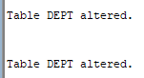

Then also run another ALTER TABLE command to add constraint for **Unique Key** on City column.

ALTER TABLE XXXXX ADD CONSTRAINT

ALTER TABLE DEPT ADD CONSTRAINT city UNIQUE(City);

b) Use DESCRIBE command to show final structure of DEPT table. Get command and your result copy paste here and also capture screen shot of your SQL Developer and place here.

desc DEPT

Name Null? Type

---------- -------- ------------

ID NOT NULL NUMBER(7)

NAME VARCHAR2(25)

MANAGER_ID NUMBER(5)

CITY VARCHAR2(30)

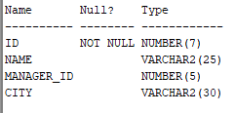

**3) Create a table named EMP based on the following chart below.**

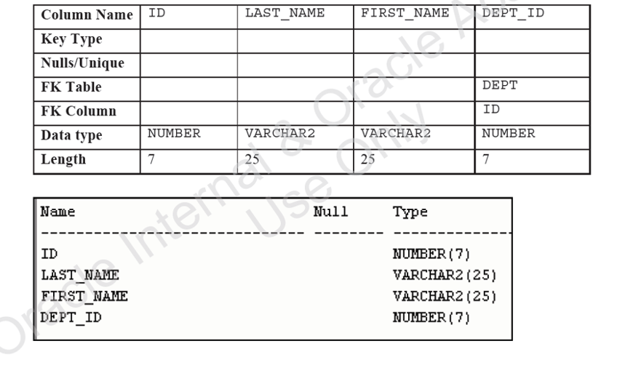

**CREATE TABLE EMP(**

**ID NUMBER(7),**

**LAST_NAME VARCHAR2(25),**

**FIRST_NAME VARCHAR2(25),**

**DEPT_ID NUMBER(7),**

**CONSTRAINT DEPT_ID FOREIGN KEY(ID)**

**REFERENCES DEPT(ID)**

**);**



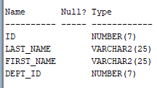**Name Null? Type**

**---------- ----- ------------**

**ID NUMBER(7)**

**LAST_NAME VARCHAR2(25)**

**FIRST_NAME VARCHAR2(25)**

**DEPT_ID NUMBER(7)**

**4. Create the new table name EMPLOYEE2 based on your existing Employees table. Use Clone / Copy techniques from another table by using SELECT statement.**

Include only EMPLOYEE_ID, FIRST_NAME, LAST_NAME, SALARY and DEPARTMENT_ID columns.

When you develop your SELECT statement for Create Table include employees only who work for Department 50 or 60.

CREATE TABLE EMPLOYEE2

AS (SELECT ID, FIRST_NAME, LAST_NAME, DEPT_ID FROM EMP WHERE DEPT_ID = 50 OR DEPT_ID = 60);

ALTER TABLE EMPLOYEE2 ADD SALARY NUMBER(7);

SELECT*FROM EMPLOYEE2;

