**Assignment 2**

**This assignment is 10% worth of your overall grade**

Due Date is Midnight of March 19th

Student Name : Sungmin Lee

Student Number : 301136725

Instructions:

* Each question is worth 1 mark ( total 10)
* Please copy paste every command you run for each question under each number.
* Your Commands ,any entry , any notes should be RED color.
* And also Capture screen shot of your results and copy paste under each question number.

(You can use Snipping Tool to take screen capture. You can find this tool in Windows on your computer by Searching

Submit your word document file (with SQL and Screen shots inside) in the dropbox **Assignment 2** folder.

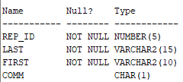This will be on JustLee Book sales database.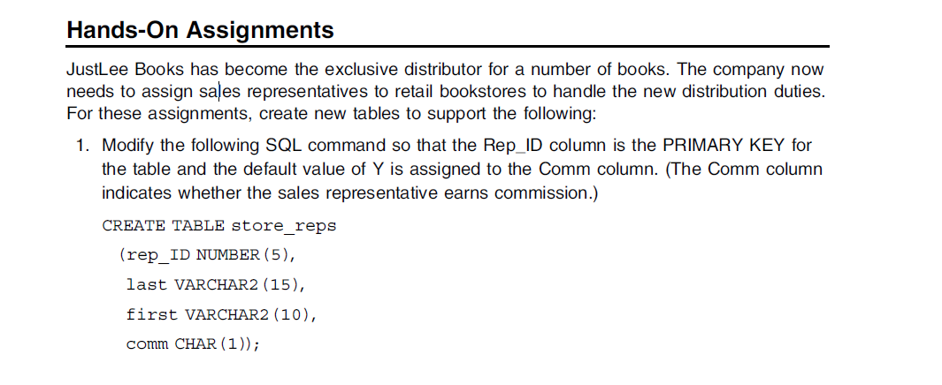

1. CREATE TABLE STORE_REPS

(rep_ID NUMBER (5) PRIMARY KEY,

 last VARCHAR2 (15),

first VARCHAR2(10),

comm CHAR(1) DEFAULT 'Y'); 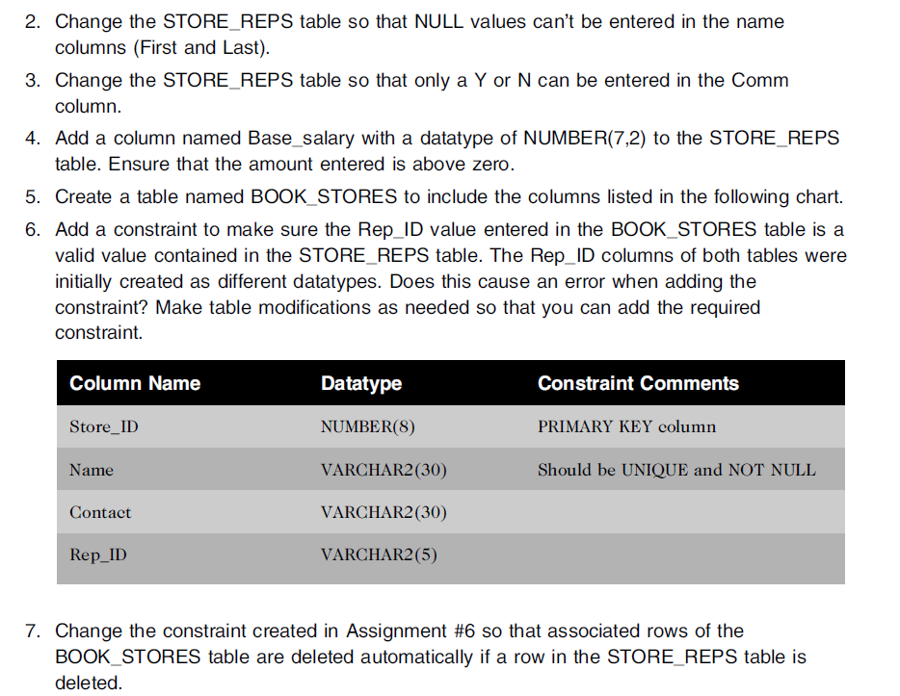

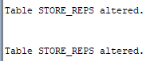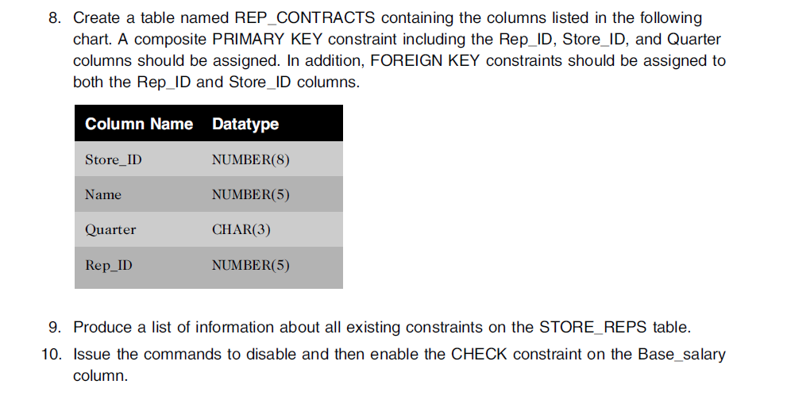

2. ALTER TABLE STORE_REPS

MODIFY last VARCHAR2(15) NOT NULL;

ALTER TABLE STORE_REPS

MODIFY first VARCHAR2(10) NOT NULL;

3. ALTER TABLE STORE_REPS

MODIFY comm CHECK (comm IN ('Y', 'N'));

4. ALTER TABLE STORE_REPS

ADD Base_salary NUMBER (7,2) CHECK(Base_salary>0);



5,6. CREATE TABLE BOOK_STORES

(

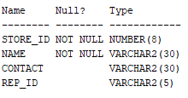 Store_ID NUMBER(8) PRIMARY KEY,

Name VARCHAR2(30)NOT NULL UNIQUE,

Contact VARCHAR2(30),

Rep_ID VARCHAR2(5)

);

7. ALTER TABLE BOOK_STORES

ADD CONSTRAINT BOOK_STORES FOREIGN KEY (Store_ID) REFERENCES STORE_REPS (rep_ID) ON DELETE CASCADE;



8. CREATE TABLE REP_CONTRACTS

(

Name NUMBER(5),

Quarter CHAR(3) PRIMARY KEY

);

ALTER TABLE Rep_CONTRACTS ADD CONSTRAINT repcontracts_storeid_fk FOREIGN KEY (Store_ID)

REFERENCES BOOK_STORES (Store_ID);

ALTER TABLE REP_CONTRACTS ADD CONSTRAINT repcontracts_repid_fk FOREIGN KEY(rep_ID)

REFERENCES STORE_REPS (rep_ID);

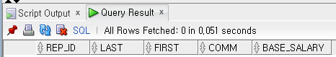9. SELECT * FROM STORE_REPS;

10.

ALTER TABLE STORE_REPS

DISABLE CONSTRAINT Base_salary;

ALTER TABLE STORE_REPS

ENABLE CONSTRAINT Ba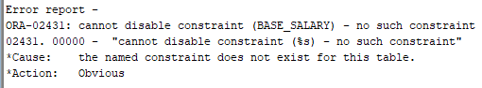se_salary;