**Assignment 3**

**This assignment is 10% worth of your overall grade**

Due Date is Midnight of March 24th

Student Name : Sungmin Lee

Student Number : 301136725

Instructions:

* Each question is worth 1 mark ( total 10)
* Please copy paste every command you run for each question under each number.
* Your Commands , any entry , any notes should be RED color.
* And also Capture screen shot of your results and copy paste under each question number.

(You can use Snipping Tool to take screen capture. You can find this tool in Windows on your computer by Searching

Submit your word document file (with SQL and Screen shots inside) in the dropbox **Assignment 3** folder.

This portion will be on JustLee Book database

Hint: You can use Group By Clause for below questions

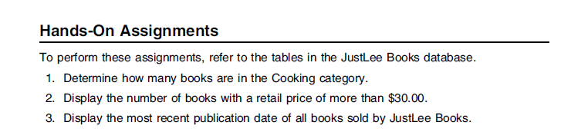

Hint: Below questions are related to Single Row Functions

4. Produce a list of all customer names in which the first letter of the first and last names is in

uppercase and the rest are in lowercase.

5. Create a list of all customer numbers along with text indicating whether the customer has

been referred by another customer. Display the text “NOT REFERRED” if the customer

wasn’t referred to JustLee Books by another customer or “REFERRED” if the customer was

referred.

Hint: Use NVL2 function for question 5

6. Display a list of all book titles and the percentage of markup for each book. The percentage

of markup should be displayed as a whole number (that is, multiplied by 100) with no

decimal position, followed by a percent sign (for example, .2793 = 28%). (The percentage

of markup should reflect the difference between the retail and cost amounts as a percent of

the cost.)

Use : ROUND function … formula should be similar to (retail-cost)/cost *100

7. Display the current day of the week, hour, minutes, and seconds of the current date setting

on the computer you’re using.

8. Determine the length of data stored in the ISBN field of the BOOKS table.

9. Produce a list of each customer number and display the position of the first occurrence of a 3 in the

customer number if it exists.

Use: INSTR for question 9

10. Produce a list of each customer number and the third and fourth digits of his or her zip

code.

1.

SELECT * FROM BOOKS

WHERE CATEGORY = 'COOKING';

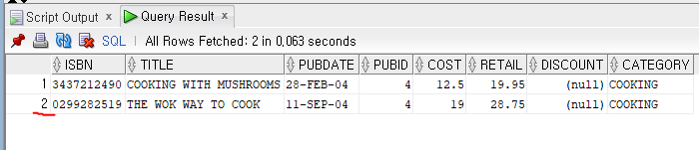

2.

SELECT * FROM BOOKS

WHERE RETAIL > 30;

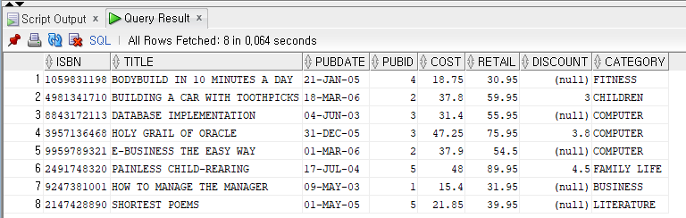

3.

SELECT MAX(PUBDATE) AS MOSTRECENT FROM BOOKS; 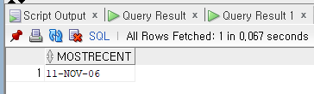

4.

SELECT UPPER(FIRSTNAME), LOWER(LASTNAME)

FROM CUSTOMERS;

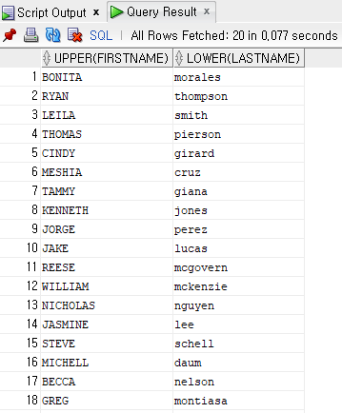

5.

SELECT CUSTOMER#, LASTNAME, FIRSTNAME, ADDRESS, CITY, STATE, ZIP, REFERRED, REGION, EMAIL, NVL2(REFERRED, 'REFFERED', 'NOT REFFERED') ISREFERRED

FROM CUSTOMERS;

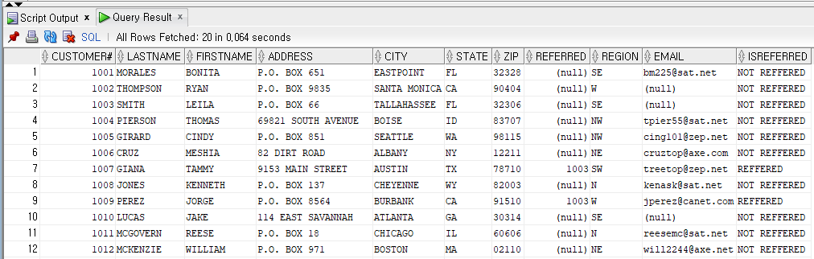

6.

SELECT TITLE, CONCAT(ROUND((RETAIL-COST)/COST *100),'%') AS MARKUP FROM BOOKS;

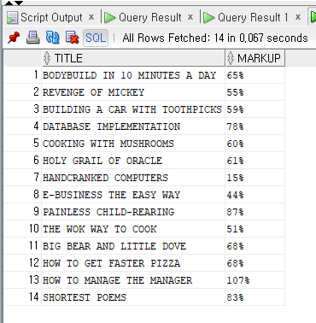

7.

ALTER SESSION SET NLS_DATE_FORMAT='YYYY-MM-DD:D:HH24:MI:SS'

SELECT SYSDATE FROM DUAL;

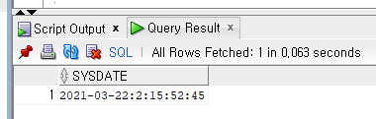

8.

SELECT DATALENGTH(ISBN) AS LENGTHISBN FROM BOOKS;

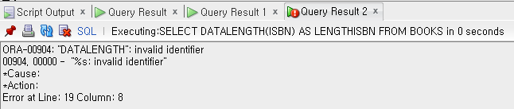

9.

SELECT CUSTOMER#, INSTR(CUSTOMER#,3) AS NUM3LOCATION FROM CUSTOMERS ORDER BY INSTR(CUSTOMER#,3) DESC;

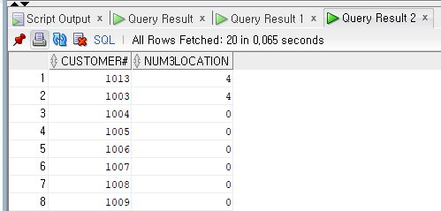

10.

SELECT * FROM CUSTOMERS;

SELECT CUSTOMER#, INSTR(ZIP, 3) AS THIRDZIP, INSTR(ZIP, 4) AS FOURTHZIP FROM CUSTOMERS ORDER BY INSTR(ZIP, 3), INSTR(ZIP,4);

