**Assignment 4 _Section 04**

**This assignment is 15% worth of your overall grade**

Due Date is Midnight of April 11th

Student Name : Sungmin Lee

Student Number : 301136725

Instructions:

* Each question is worth 1 mark ( total 10)
* Please copy paste every command you run for each question under each number.
* Your Commands , any entry , any notes should be RED color.
* And also Capture screen shot of your results and copy paste under each question number.

(You can use Snipping Tool to take screen capture. You can find this tool in Windows on your computer by Searching

Submit your word document file (with SQL and Screen shots inside) in the dropbox **Assignment 4** folder.

This portion will be on CityJail database which is given to you as SQL file to build

1. List all crimes with a status of CA (can appeal) or IA (in appeal). List the crime ID, criminal

ID, date charged, and status.

*SELECT crime_id, criminal_id, date_charged, status FROM CRIMES*

*WHERE STATUS='CA' OR STATUS='IA';*

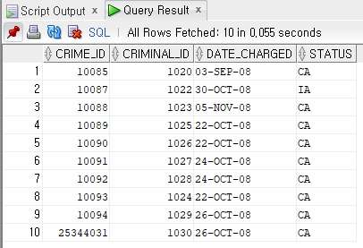

2. Produce a list showing each active police officer and his or her community assignment, indicated

by the second letter of the precinct code. Display the community description listed in

the following chart, based on the second letter of the precinct code.

Sample Output

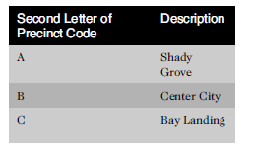

Hint: Use DECODE or CASE and inside this function you can use SUBSTR to get only 1 digit from 2nd position.. DECODE(SUBSTR(precinct, 2, 1)

SELECT CASE WHEN PRECINCT LIKE '_A%' THEN 'A'

WHEN PRECINCT LIKE '_B%' THEN 'B'

WHEN PRECINCT LIKE '_C%' THEN 'C'

ELSE 'NOT CURRENTLY ASSIGNED'

END "Second Letter of Precinct code",

CASE WHEN PRECINCT LIKE '_A%' THEN 'SHADY GROVE'

WHEN PRECINCT LIKE '_B%' THEN 'CENTER CITY'

WHEN PRECINCT LIKE '_C%' THEN 'BAY LANDING'

ELSE 'NOT CURRENTLY ASSIGNED'

END "Description" FROM OFFICERS;

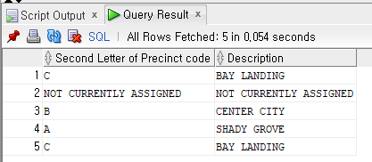

3. List all sentences with a probation officer assigned. List the sentence ID, criminal ID, and

probation officer ID. Sort the list by probation officer ID and then criminal ID.

SELECT SENTENCE_ID, CRIMINAL_ID, PROB_ID FROM SENTENCES ORDER BY PROB_ID, CRIMINAL_ID;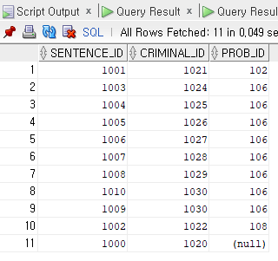

4. List all criminals along with the crime charges filed. The report needs to include the criminal

ID, name, crime code, and fine amount.

Hint : Use Inner Join

*SELECT cri.CRIMINAL_ID, cri.FIRST, cri.LAST, cc.CRIME_CODE, cc.FINE_AMOUNT FROM CRIMINALS cri*

*JOIN CRIMES cr ON cr.CRIMINAL_ID = cri.CRIMINAL_ID*

*JOIN CRIME_CHARGES cc ON cc.CRIME_ID = cr.CRIME_ID*

*ORDER BY CRIMINAL_ID, first, last, crime_code, fine_amount;*

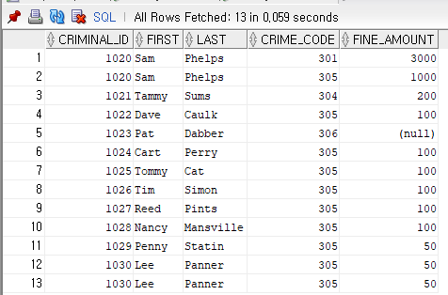

5. List all criminals along with crime status and appeal status (if applicable). The reports need

to include the criminal ID, name, crime classification, date charged, appeal filing date, and

appeal status. Show all criminals, regardless of whether they have filed an appeal.

SELECT cls.criminal_id, cls.first, cls.last, cr.classification, cr.date_charged,ap.filing_date, ap.status

FROM CRIMINALS cls

JOIN CRIMES cr ON cr.criminal_id = cls.criminal_id

JOIN APPEALS ap ON ap.crime_id = cr.crime_id

ORDER BY criminal_id;

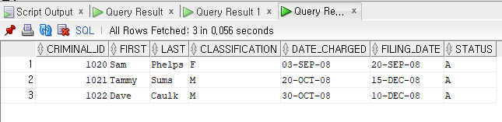

*Hint : Use LEFT or RIGHT OUTER join*

6. List all criminals along with crime information. The report needs to include the criminal ID,

name, crime classification, date charged, crime code, and fine amount. Include only crimes

classified as “Other.” Sort the list by criminal ID and date charged.

SELECT cls.criminal_id, cls.first, cls.last, cr.classification, cr.date_charged,cc.fine_amount, cc.crime_code FROM criminals cls

JOIN CRIMES cr ON cr.criminal_id = cr.criminal_id

JOIN CRIME_CHARGES cc ON cc.crime_id = cr.crime_id

WHERE classification = 'O' ORDER BY criminal_id, date_charged;

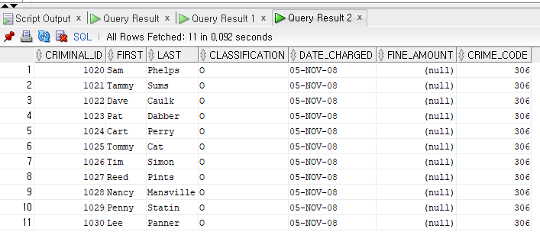

Hint : Use Inner Join

7. Create an alphabetical list of all criminals, including criminal ID, name, violent offender status,

parole status, and any known aliases.

SELECT cri.criminal_id, cri.first, cri.last, cri.v_status, cri.p_status, ali.alias

FROM CRIMINALS cri

LEFT OUTER JOIN aliases ali ON cri.criminal_id = ali.criminal_id

ORDER BY last, first;

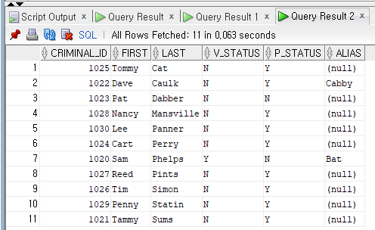

8) List all crimes with a hearing date more than 14 days after the date charged. List the crime

ID, criminal ID, date charged, and hearing date.

SELECT crime_ID, criminal_ID, date_charged, hearing_date

FROM CRIMES

WHERE hearing_date-date_charged > 14;

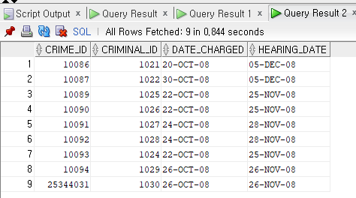

9. List all criminals with the zip code 23510. List the criminal ID, last name, and zip code. Sort

the list by criminal ID.

SELECT criminal_ID, last, zip

FROM CRIMINALS

WHERE zip = 23510;

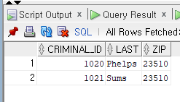

10. List all crimes that don’t have a hearing date scheduled. List the crime ID, criminal ID, date

charged, and hearing date.

SELECT crime_ID, criminal_ID, date_charged, hearing_date

FROM CRIMES

WHERE hearing_date IS NULL;

