**Lab 4 Report**

Name: 胡紹宇

Student ID: 112598045

Date:

1. **Test Plan**
   1. **Summary**

The system to be tested for this lab is Keystone. Keystone helps you build faster and scale further than any other CMS or App Framework. You can simply describe your schema, and get a powerful GraphQL API & beautiful Management UI for content and data.

* 1. **Features to be tested**

The features listed below are the test cases accomplished in this lab:

1. Post Features

* Create a post on the Admin UI page
* Search posts by keyword on the Admin UI page
* Edit a post on the Admin UI page
* Delete a post on the Admin UI page

1. Comment Features

* Create a comment on Admin UI page
* Edit a comment on Admin UI page
* Delete a comment on Admin UI page
  1. **Success criteria for completing the test**

Bugs will be rated according to their severity. The feature of lab4 has the following severity classes:

|  |  |
| --- | --- |
| **Priority** | **Requirement** |
| High | Average less than 2 unresolved bugs with severity **Minor** /module. Not over 5 unresolved bugs/module. |
| Medium | Same as above, but can contain less than average 1 unresolved bugs of severity **Normal**/module. |
| Low | No unresolved bugs with severity **Serious**. Not more than 5 unresolved bugs/module. |

* 1. **Test environment and infrastructure**
* Hardware: Macbook Air M2
* Software: Chrome, Selenium CLI, VSCode
* Test Data: KeystoneJS and personal generated fake data
  1. **Test approaches**

This lab uses “user scenarios” and “ISP” to design test case, and measure test coverage if there is enough free time. This lab uses Selenium CLI as the test tools, and use multiple testing techniques to ensure that all the test requirements can be satisfied and the goals of the test can be achieved.

* 1. **Testing Tasks**

To implement the proposed strategy, the following activities are planned to perform.

|  |  |  |  |
| --- | --- | --- | --- |
| **No.** | **Activity Name** | **Plan hours** | **Schedule Date** |
| 1 | Learn and use Keystone | 2 | 5/10 |
| 2 | Study Selenium | 2 | 5/11 |
| 3 | Design test cases for the selected methods | 20 | 5/12 |
| 4 | Implement and perform test cases | 20 | 5/12 |
| 5 | Complete Lab4 report | 3 | 5/13 |

1. **Test Design**

Refer to **Software Testing Lab4.xlsx** in the same folder.

1. **Test Implementation**
2. Post Features: tests/test_keystone_post.py

* Create a post on the Admin UI page: test_1_create_post
* Search posts by keyword on the Admin UI page: test_2_search_posts, test_3_search_posts_fail
* Edit a post on the Admin UI page: test_4_edit_post
* Delete a post on the Admin UI page: test_5_delete_post

1. Comment Features

* Create a comment on Admin UI page: test_1_create_comment
* Edit a comment on Admin UI page: test_2_edit_comment
* Delete a comment on Admin UI page: test_3_delete_comment

1. **Test Results**: execution results and screen snapshots of Selenium test scripts.
2. Post Features

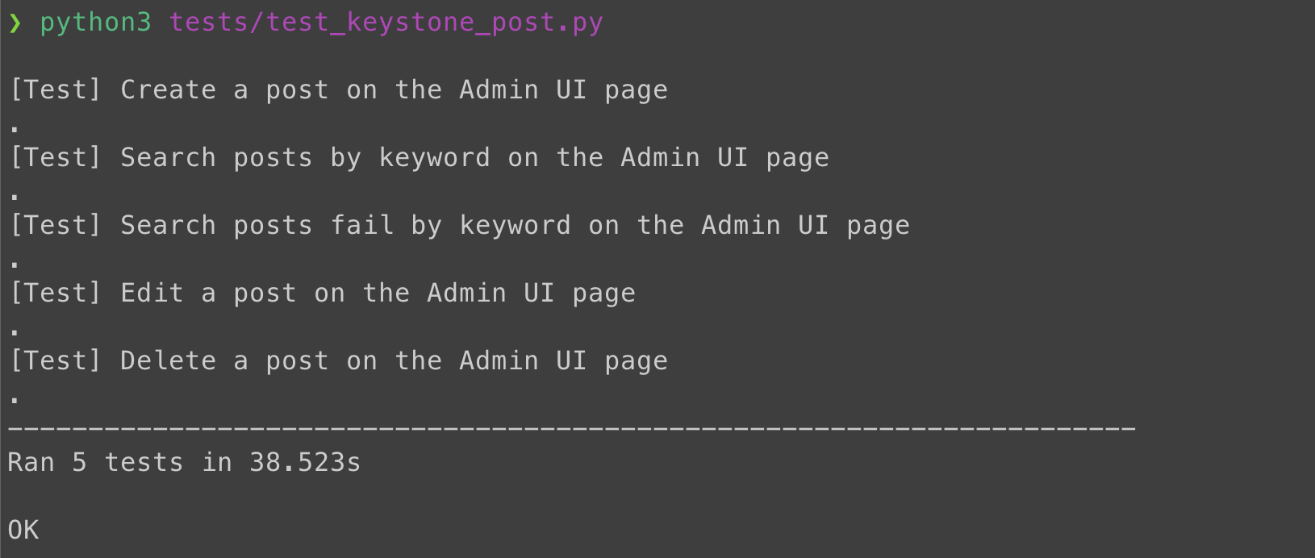

1. Comment Feature

