Microprocessor System Lab9 Check List
- Date: 2024/11/26
- Please follow the instructions, and report to TAs after finishing check points.
- If you have any questions or troubles during the experiment, please feel free to ask TAs or the teacher, discussion with classmates is also encouraged.
- Please refer to the content from class slides, you can also use the resources from the internet.

Part I. Question
Please refer to the content of the lecture and answer the question down below.

1.1 : Please describe how we programmed 8051 in this experiment?
1.2 : Please explain the functions of the three buttons in experiment 2.1 and why they
need to do these things?

Part II. Example Projects
This experiment is divided into two parts, the programmer and POV clock. Please refer to the source code on the google drive and execute it to see the result and show the demo result to TAs. (Please note that when plugging and unplugging the 8051, please be careful not to pull or press hard, otherwise it is easy to damage the 8051 pins.)
2.1 In System Programming example:
Please refer to the drawings below the handout to complete the wiring of the programmer Master and Slave and use the Master to burn the preset programs in the source code into the Slave to execute.
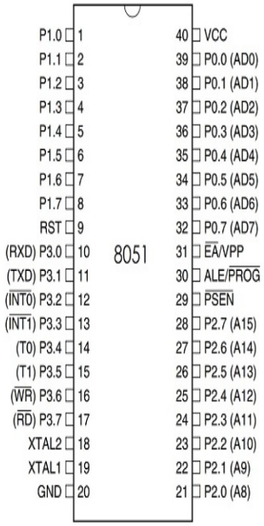
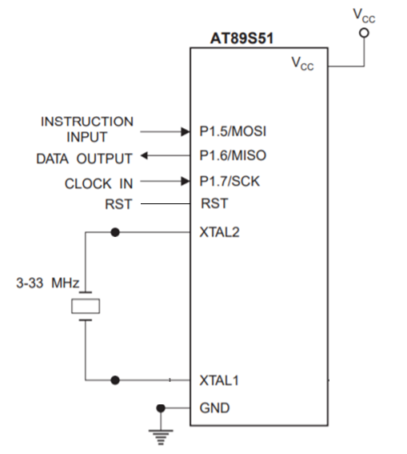

Part III. Practice
Please reference the sessions and source code of Example Project. Try to design and
implement requirements in Practice. (You can check the executed result from google cloud)
3.1: (practice 1)
Please refer to the DO RE MI project you’ve done in Lab6, now instead of burning from computer, here you must burn the program from Master to Slave to execute.
Finish the todo part in program.c and hex.h.
Please start writing at address 0x0030, since 0x0000, 0x0010, 0x0020 are predefined for interrupt functions.
3.2: (practice 2) Interrupt function in assembly code
Please refer to the Externel_Interrupt_asm folder for detailed information. Read the Lab12-Example-Project.ppt and try to understand what the assembly code in main.asm means and the starting address of each interrupt function. Then, same as practice 1, you must burn the program from Master to Slave to execute.
Finish the todo part in program.c and hex.h.
*Hint:
Observe the hex.h in Example project, the hex array is same as what you see on the 8051 burning software, which is what truly writes into 8051. What you have to do is to first observe the main.hex generated by “make”, understand what each line means, turn into the C array defined in hex.h by the transformation mechanism from https://en.wikipedia.org/wiki/Intel_HEX. Since the C array only defines the relative order of each instruction, you also have to define the starting address for writing and reading in program.c.
