Microprocessor System Project 3 POV Clock
Due Date: 2024/11/26
Part I. Description
Please refer to the content of Lab4. Use external interrupt and timer interrupt to complete the Persistence of Vision (POV) Clock.
Part II. Specification
- rotating structure with LEDs
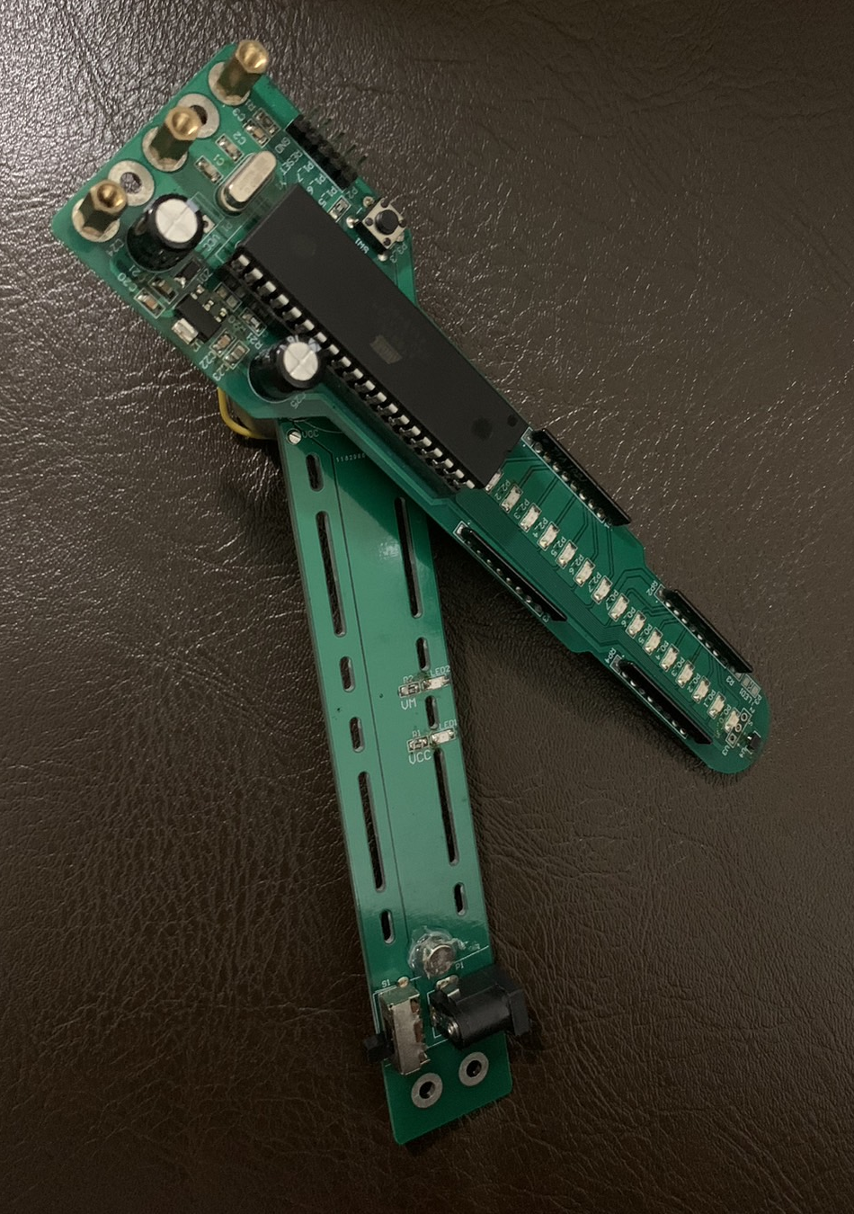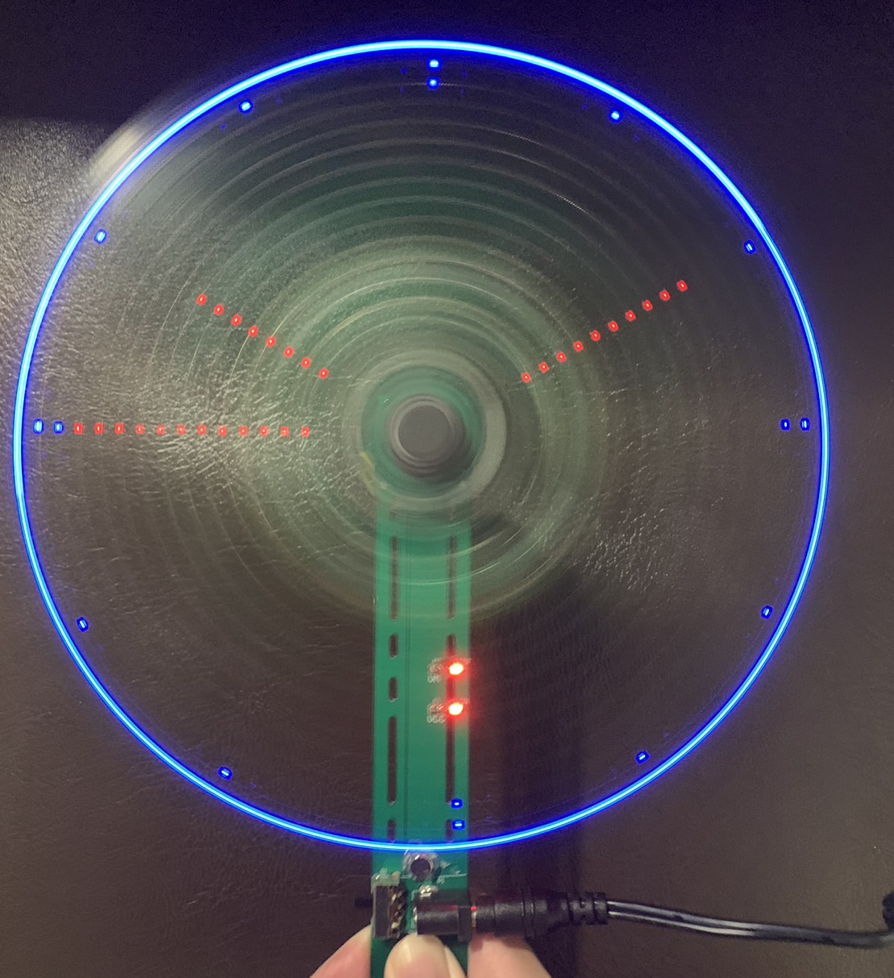
Part III. Function
- First use your red board to download the program.
- Turn off the power and move the 8051 from the red board to the rotating structure.
- The clock specifications are as shown below.
- After powering on, please start at 10:10:30.
- Second hand walk one step per second.
- We will rank the project based on the hex file size. Don’t modify the Makefile.

