Microprocessor System Lab4 Check List
- Date: 2024/10/15
- Please follow the instructions, and report to TAs after finishing check points.
- If you have any questions or troubles during the experiment, please feel free to ask TAs or the teacher, discussion with classmates is also encouraged.
- Please refer to the content from class slides, you can also use the resources from the internet.

Part I. Question
Please refer to the class content and answer the following questions.

Check Points:
- Try to explain how the Interrupt works in this experiment.
- Please give an example of the application of hall effect sensor.

Part II. Lab1 Experiment
This example is divided into 2 parts (Timer Interrupt & Hall Sensor). Please refer to the source code on the google drive and execute it to see the result.

The Timer Interrupt example shows two methods to generate a 0.5Hz signal. They are Interrupt and Polling respectively.
As for the Hall Sensor example, the program counts the times of detecting magnetic through Hall sensor and shows the result on the LED.

Check Points:
- Run the Interrupt and Polling example in the Timer example, and understand how the programs work.
- Run the Hall Sensor example, and understand how the program works.

Part III. Practice
Please refer to the class content and Lab3 Experiment source code and complete the Practice.

Description:
Please use the Hall Sensor to detect the magnetic field and calculate the time interval (with precision 1s/1ms) between two magnetic detection and display it on the seven-segment display. Demo video can be seen in the Google Drive. 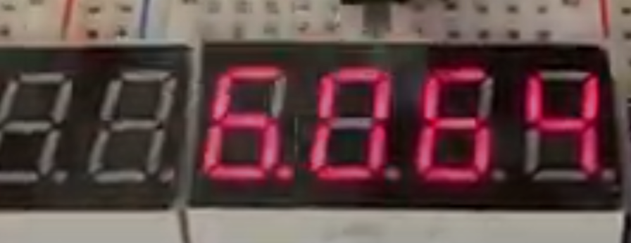
As shown in the image, when time interval is 6.064s, show ”6.064” on seven-segment display.

Extra: (Optional)
Please use the Hall Sensor to detect the magnetic field. When the magnetic field is detected, the matrix display will fill up by the time. If the magnet moves away or the INT0 button is pressed, the matrix display will pause and stop filling up. Demo video can be seen in the Google Drive.
Pattern sequence (8 patterns in each dot matrix):
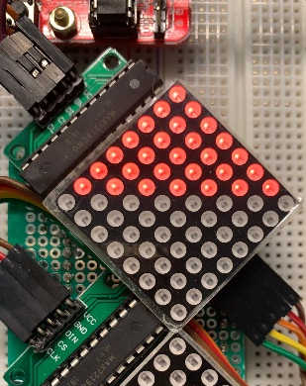
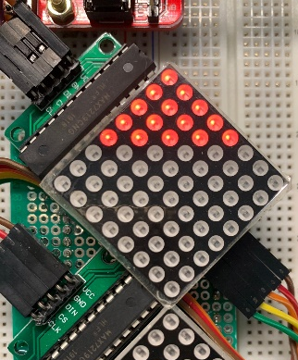
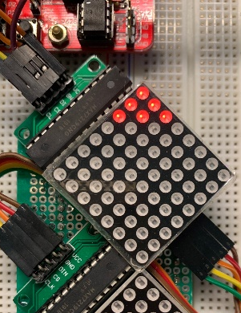
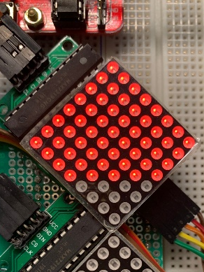
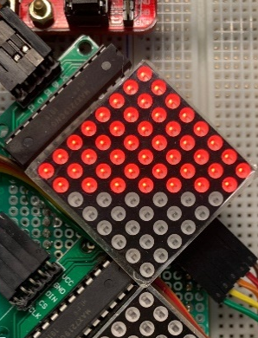
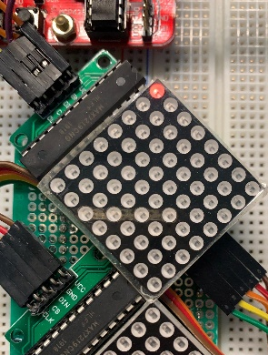

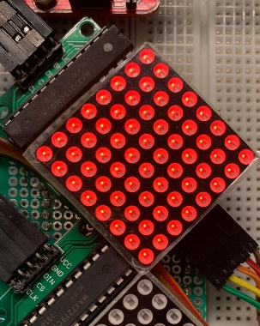
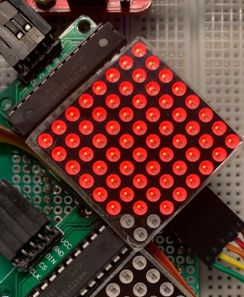
Check Points:
- Finish the basic function correctly.

