Microprocessor System Project 4 Thermometer
Due Date: 2024/12/10
Part I. Description
Please refer to the content of Lab7 to finish the thermometer.
Part II. Specification
- OLED: Display distance and temperature.
- IR Sensor: Rangefinder.
- Thermometer, Buzzer
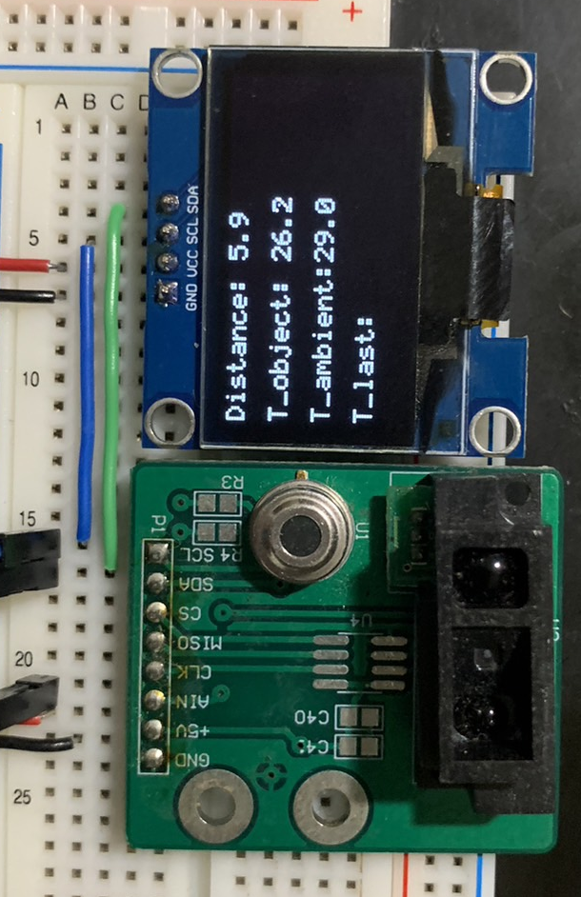
Part III. Function
- OLED needs to the four lines:
Distance: XX.X cm
T_object: XX.X °C
T_ambient: XX.X °C
T_last: XX.X °C
- Distance, T_object and T_ambient are updated regularly.
- When the object remains within 1-5cm, the buzzer should be activated as follow.
short beep(0.5s), short beep(0.5s), short beep(0.5s), long beep
- Ending of fourth beep, updated T_last value to T_object.
- If object is removed before ending of fourth beep, stop beep and don’t updated T_last.
- The beep sound and temperature measurement will be re-issued only after the object leaves the range and approaches it again.
- We will rank the project based on the hex file size. And please briefly explain the wiring method at the beginning of the program or declaration in the header file. Don’t modify the Makefile.

