Microprocessor System Project 2 Hourglass
Due Date: 2024/11/12
Part I. Description
Please refer to the contents of Lab2 to Lab4, use MPU6050 and dot matrix to complete a digital hourglass.
Part II. Specification
- Two dot matrixes: Display as an hourglass.
- MPU6050: Axis sensor.
- Timer in 8051: count as clock. Operated by interrupt function.
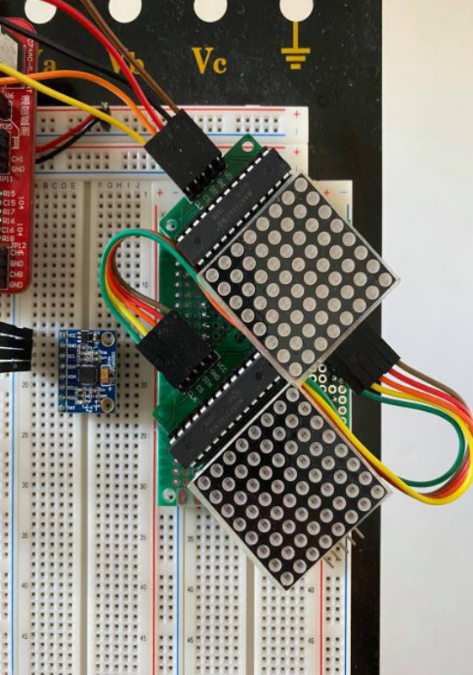
Part III. Function
- When reset, light up all points (8*8) of the top dot matrix.
- Leak one sand granule every 2 seconds, total 8*8*2 = 128 seconds leak all sand granule.
- Sand granule toward down, left down or right down one segment every 0.5 second.
- Only need to support the mode with put straight and put upside-down.
- Every 128 seconds, buzzer buzz three times.
- The heap of sand granule should satisfy the physical phenomenon in the real world. Please refer to the demo video on the google drive for details.
- We will rank the project based on the hex file size. And please briefly explain the wiring method at the beginning of the program or declaration in the header file. Don’t modify the Makefile.

