Microprocessor System Lab5 Check List
- Date: 2023/10/
- Please follow the instructions, and report to TAs after finishing check points.
- If you have any questions or troubles during the experiment, please feel free to ask TAs or the teacher, discussion with classmates is also encouraged.
- Please refer to the content from class slides, you can also use the resources from the internet.

Part I. Question
Please refer to the class content and answer the following questions.

Check Points:
1.1: Please try to explain what is the function of the timer in UART.

Part II. Lab5 Experiment
This lab is UART transmitter & receiver, please download the source codes on the google cloud and check the result after execution.

Check Points:
- Please find another classmate, 2 people as a group. One of you burn main.c in transmitter the other burn main.c in receiver. The transmitter one push the 4 buttons beside led, and the 7-segment display connected to the receiver will display the corresponding numbers. Try to realize how it works like that.
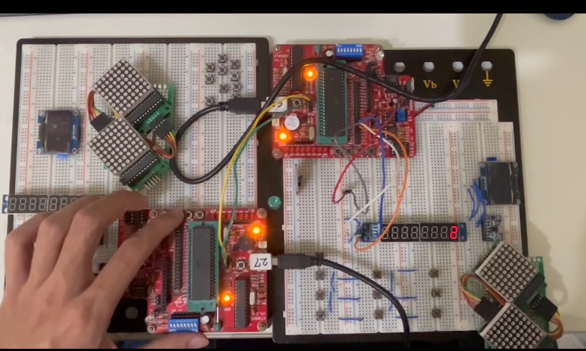

Part III. Practice
Please reference the sessions and source code of Part II. Try to design and implement the Practice. (You can check the executed result from google cloud)
3.1 :
Please integrate the code of transmitter and receiver in Part2. Try to let your hardware has both function of transmitter and receiver at the same time.
Description:
The 4 buttons beside led from left to right represents 1 to 4 respectively. Everyone can define any 7 numbers as your own key (each number is limited from 1 to 4). And complete the game : Guessing Key!
Example:
The key in Practice video is 1312234.
First, while pressing 1, since the first number of the key is also 1, the MSB of 7-segment display is 1, meaning the number guessed is correct. In the mean time, the 7th bit of 7-segmet display will show 1.
Then keep going on. Assuming your next press is 2, due to the 2nd key number is 3, the MSB of 7-segment display is 0, meaning guessing a wrong number. On the other hand, if the next press is 3, the 2nd key number is 3, too. Therefore, the MSB of 7-segment display is 1, representing that your guess is correct. And the 6th bit of 7-segmet display will show 3. Keep this way until guess the right key.
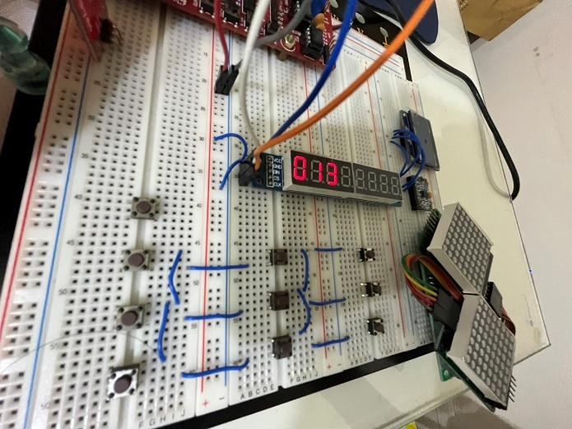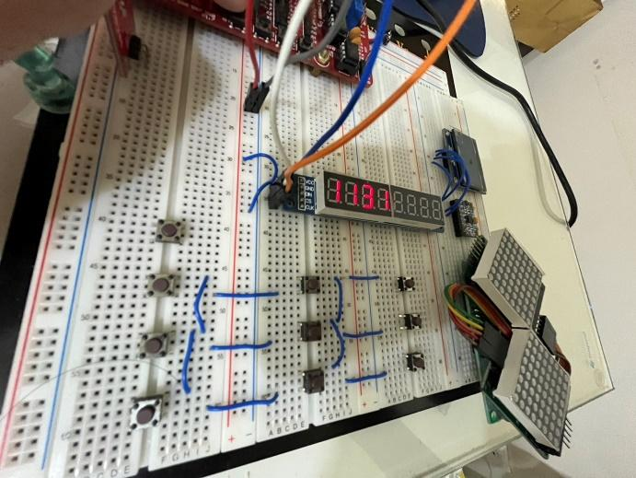

Left most bit = 0 indicates wrong guess of current digit
Left most bit = 1 indicates currect guess of current digit and display it at the same time

Note :
- When you are done, you can find someone else and play the GuessKey game together. But demo just need to be alone.
- Please connect P3_0 to P3_1 which mentioned on page 8 of lab5 ppt (Tx, Rx connects with each other).

Check Points:
- Function in Part III is correct.

