Data Analysis

Eric Cavanna

2023-05-22

#does analysis stratified and adds it onto the end of the dataframe  
strat <- "STATE" #sets strata  
byLine <- FA_By_Component(cdcUnik, strat,5:21) #does analysis  
withStrata <- left_join(cdcFAtract, byLine$Strat_FA, by="FIPS") #adds FA to big dataframe  
#adds name of strata to the last column  
names(withStrata)[length(names(withStrata))] <- paste(strat,"PA1",sep = "_")

strat <- "STATE" #sets strata  
#gets kmo stratified by state  
kmos <- as.data.frame(KMO_By_Component(cdcUnik, strat))  
kmos$KMO <- round(as.numeric(kmos$KMO),4)  
kmos %>% kable(caption = "Table of KMO stratified by State")

Table of KMO stratified by State

| STATE | KMO |
| --- | --- |
| Alabama | 0.7702 |
| Alaska | 0.7823 |
| Arizona | 0.8313 |
| Arkansas | 0.7717 |
| California | 0.8363 |
| Colorado | 0.8120 |
| Connecticut | 0.8777 |
| Delaware | 0.7404 |
| District of Columbia | 0.8015 |
| Florida | 0.8106 |
| Georgia | 0.7561 |
| Hawaii | 0.7240 |
| Idaho | 0.7347 |
| Illinois | 0.8025 |
| Indiana | 0.7968 |
| Iowa | 0.8194 |
| Kansas | 0.8258 |
| Kentucky | 0.7851 |
| Louisiana | 0.7867 |
| Maine | 0.7815 |
| Maryland | 0.7962 |
| Massachusetts | 0.8641 |
| Michigan | 0.8136 |
| Minnesota | 0.8490 |
| Mississippi | 0.7607 |
| Missouri | 0.7861 |
| Montana | 0.7494 |
| Nebraska | 0.8267 |
| Nevada | 0.8486 |
| New Hampshire | 0.8128 |
| New Jersey | 0.8627 |
| New Mexico | 0.7809 |
| New York | 0.8152 |
| North Carolina | 0.7690 |
| North Dakota | 0.7692 |
| Ohio | 0.8093 |
| Oklahoma | 0.7932 |
| Oregon | 0.7844 |
| Pennsylvania | 0.8206 |
| Rhode Island | 0.8499 |
| South Carolina | 0.7836 |
| South Dakota | 0.8195 |
| Tennessee | 0.7813 |
| Texas | 0.8219 |
| Utah | 0.7964 |
| Vermont | 0.7111 |
| Virginia | 0.7668 |
| Washington | 0.8028 |
| West Virginia | 0.7768 |
| Wisconsin | 0.8449 |
| Wyoming | 0.7149 |

boxplot(kmos$KMO, horizontal = TRUE, col = "lightblue",   
 main = "KMO Values Stratified by State")

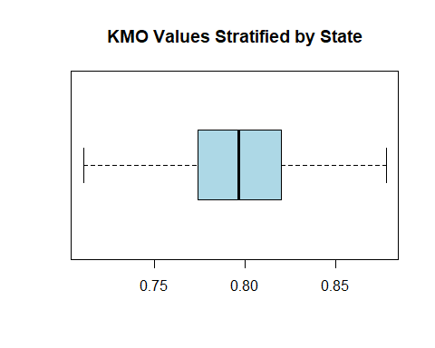

# makes pretty pictures for each strata identified  
#Histo_By_Strat(withStrata,"STATE","FULL_PA1","STATE_PA1") #compares state to country FA  
  
Histo_By_Strat(withStrata, "STATE", "RPL_THEMES", "STATE_PA1") #compares state FA to CDC country wide

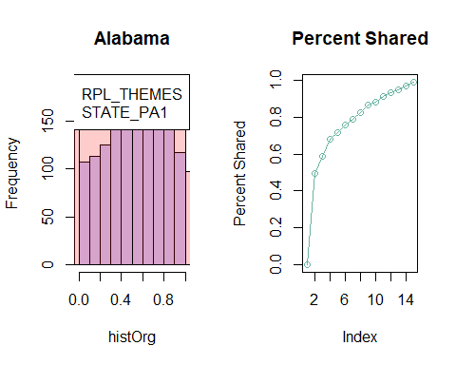

## `geom_smooth()` using formula = 'y ~ x'

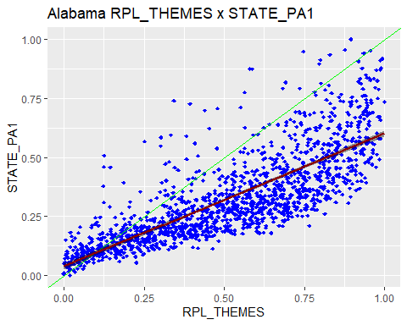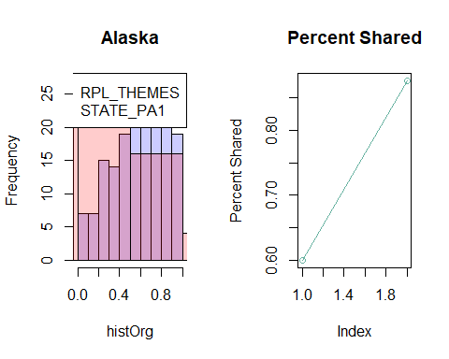

## `geom_smooth()` using formula = 'y ~ x'

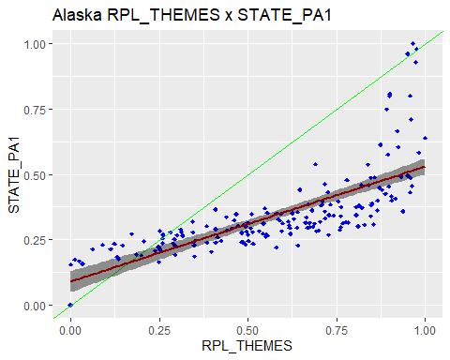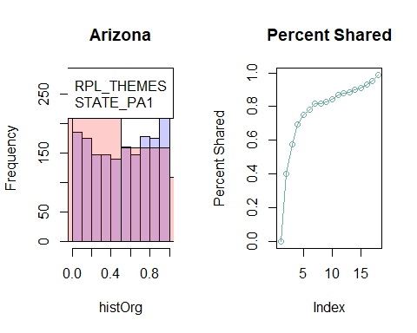

## `geom_smooth()` using formula = 'y ~ x'

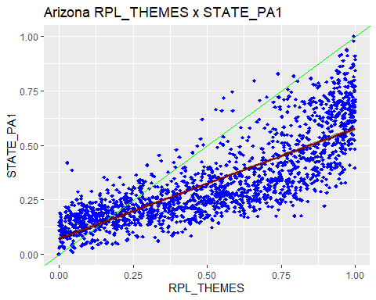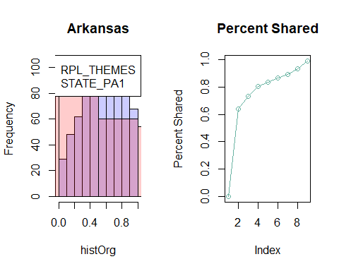

## `geom_smooth()` using formula = 'y ~ x'

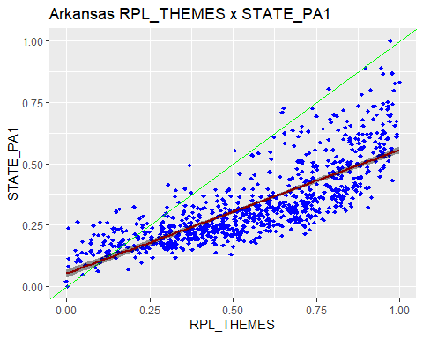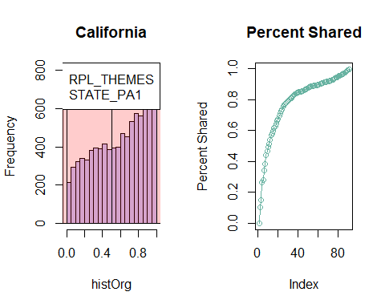

## `geom_smooth()` using formula = 'y ~ x'

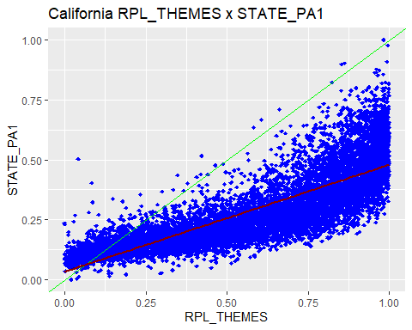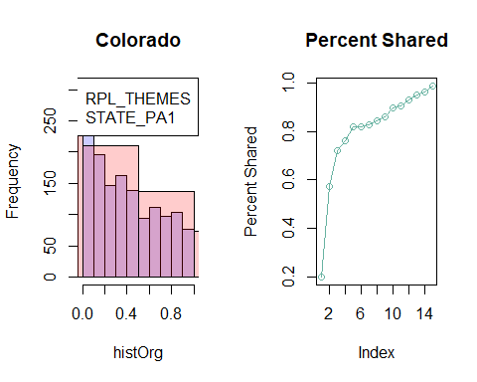

## `geom_smooth()` using formula = 'y ~ x'

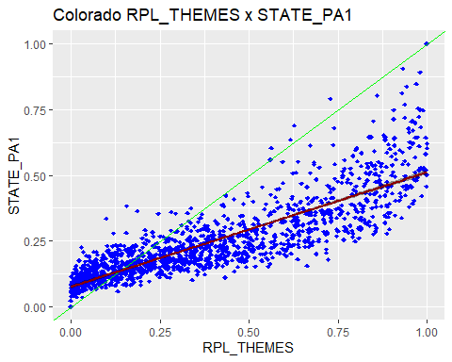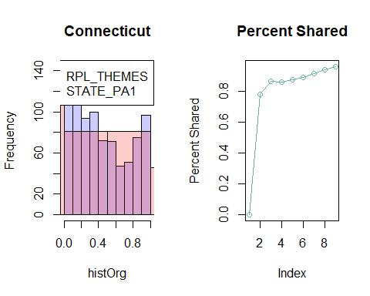

## `geom_smooth()` using formula = 'y ~ x'

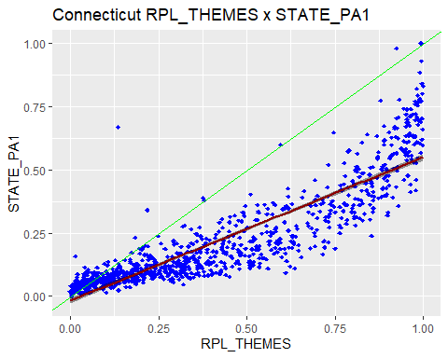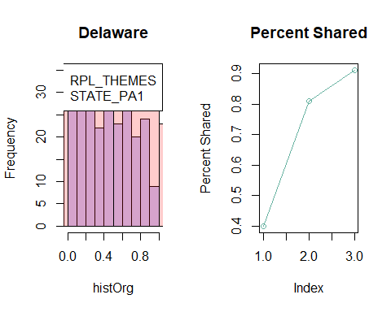

## `geom_smooth()` using formula = 'y ~ x'

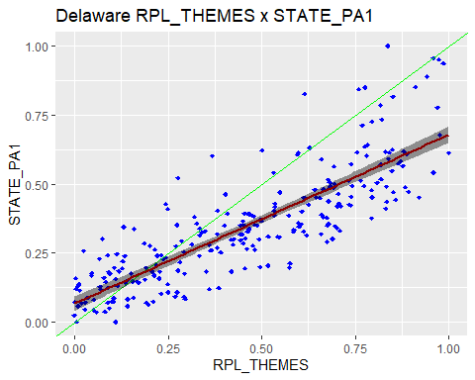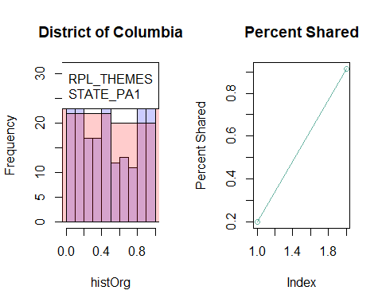

## `geom_smooth()` using formula = 'y ~ x'

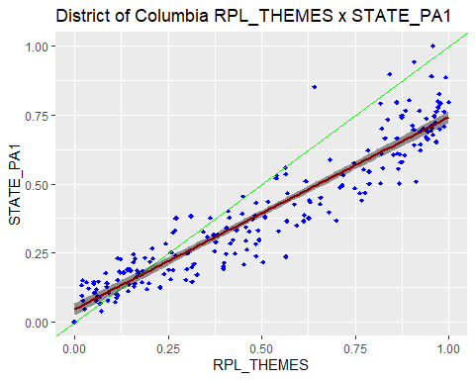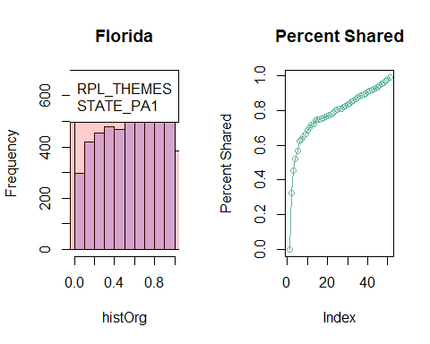

## `geom_smooth()` using formula = 'y ~ x'

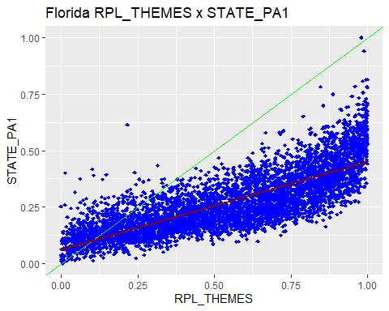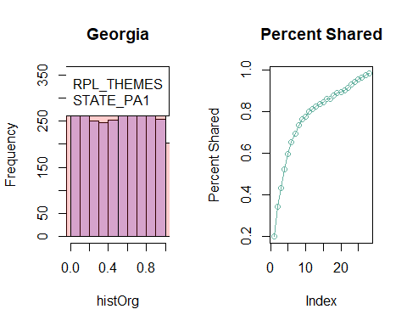

## `geom_smooth()` using formula = 'y ~ x'

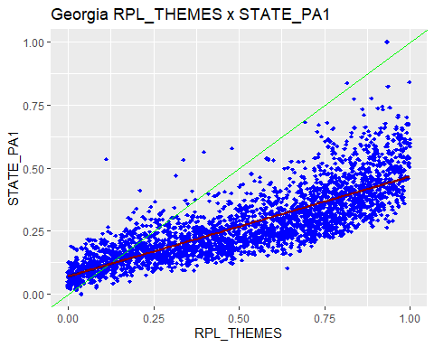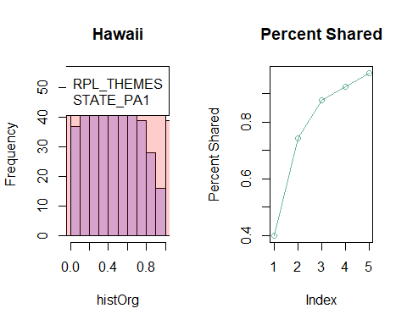

## `geom_smooth()` using formula = 'y ~ x'

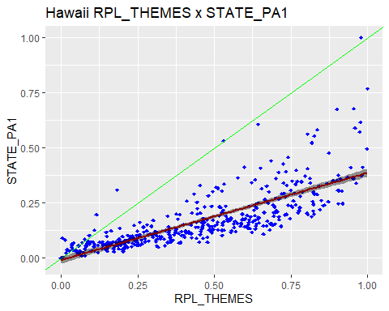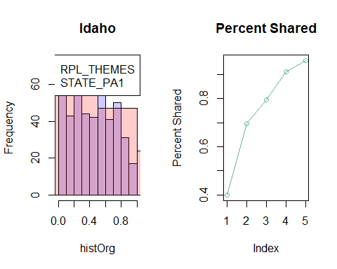

## `geom_smooth()` using formula = 'y ~ x'

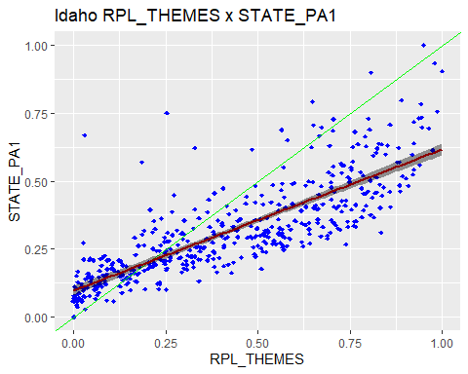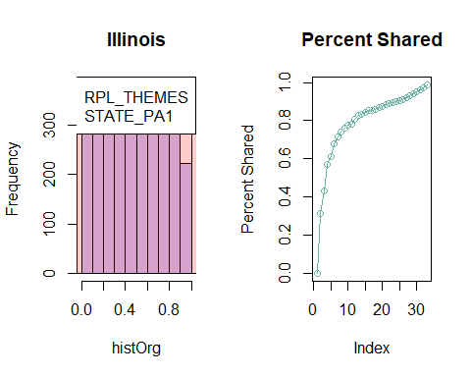

## `geom_smooth()` using formula = 'y ~ x'

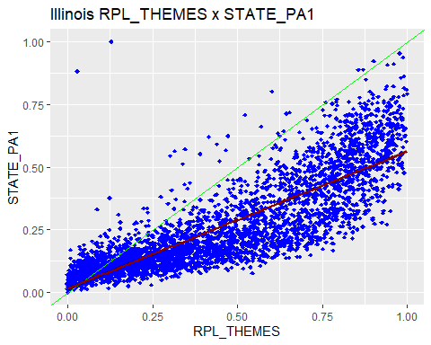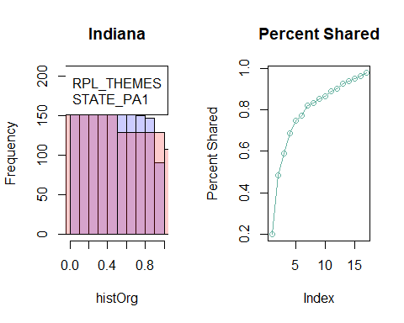

## `geom_smooth()` using formula = 'y ~ x'

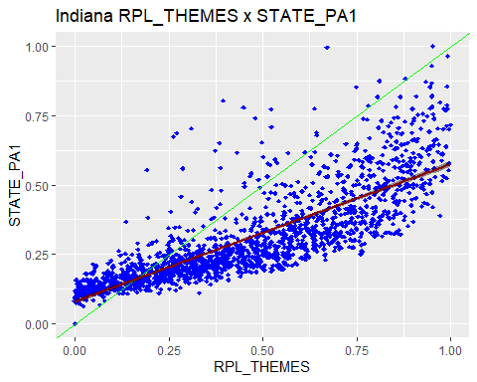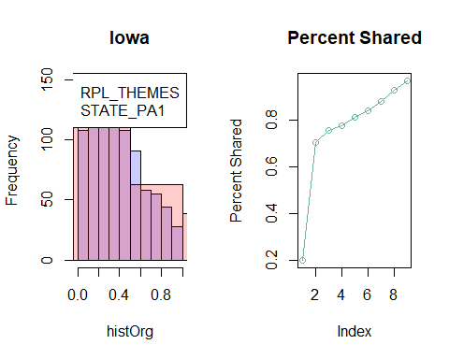

## `geom_smooth()` using formula = 'y ~ x'

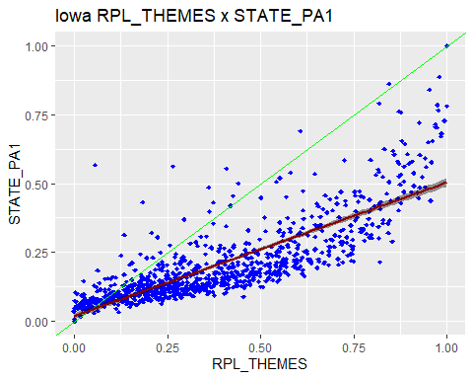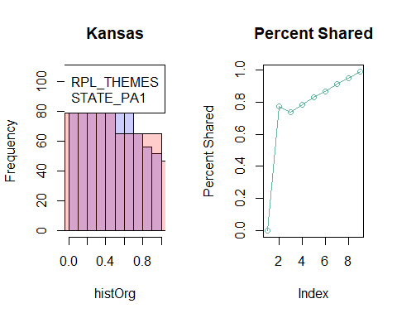

## `geom_smooth()` using formula = 'y ~ x'

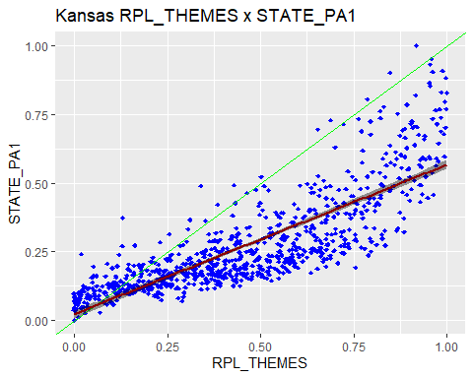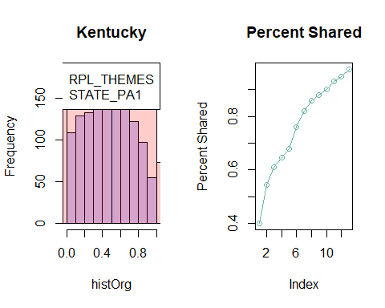

## `geom_smooth()` using formula = 'y ~ x'

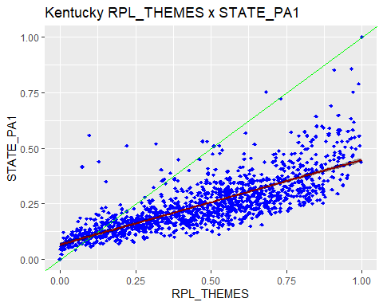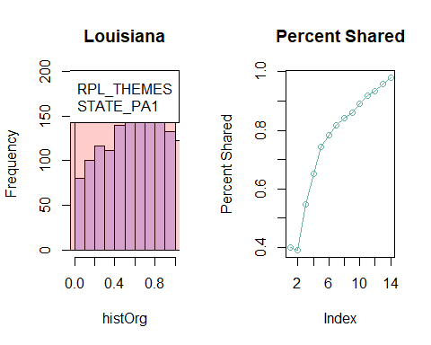

## `geom_smooth()` using formula = 'y ~ x'

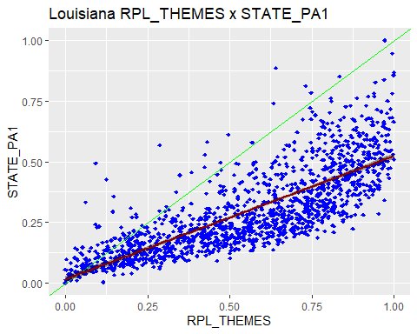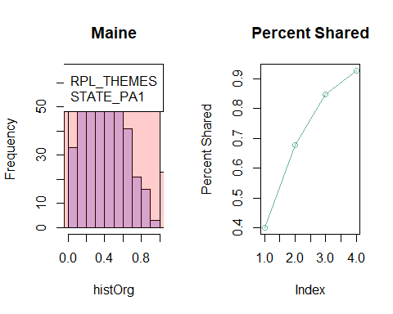

## `geom_smooth()` using formula = 'y ~ x'

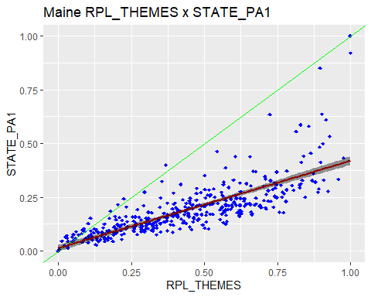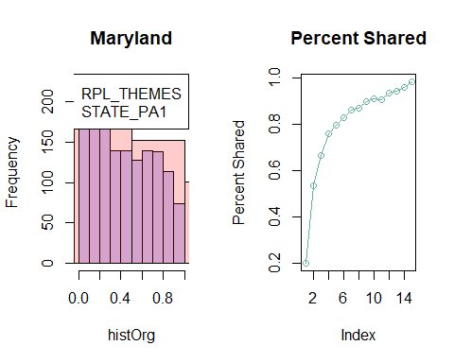

## `geom_smooth()` using formula = 'y ~ x'

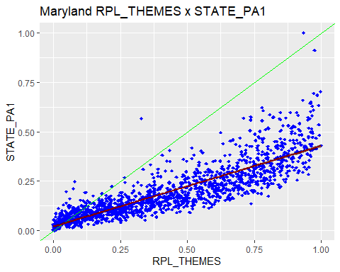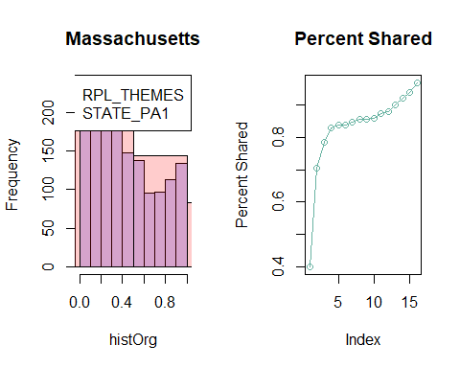

## `geom_smooth()` using formula = 'y ~ x'

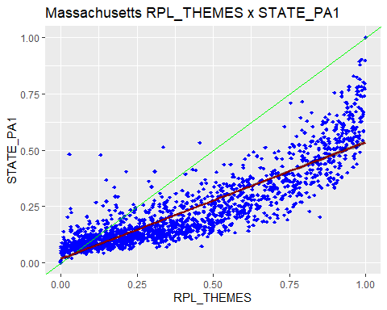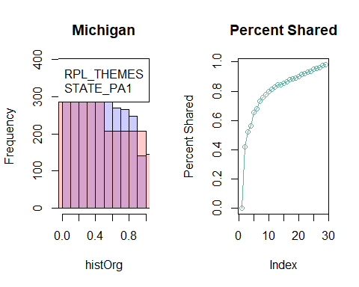

## `geom_smooth()` using formula = 'y ~ x'

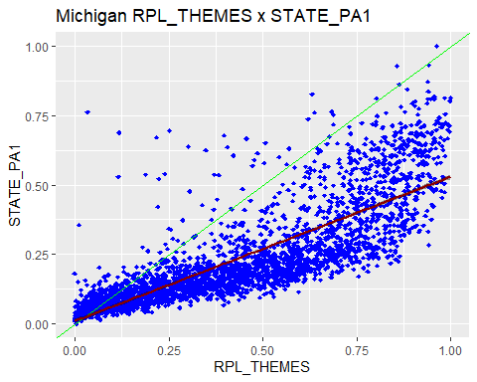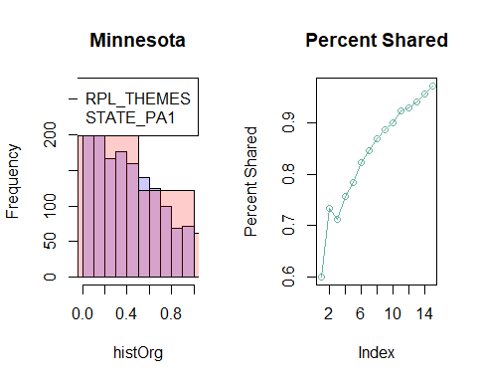

## `geom_smooth()` using formula = 'y ~ x'

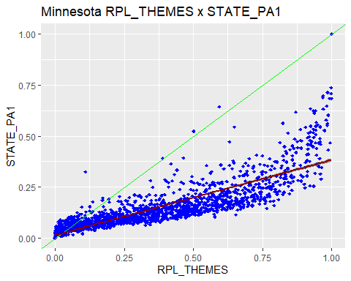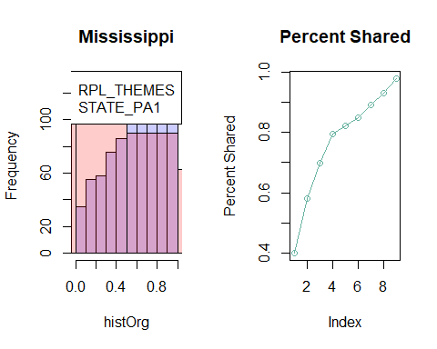

## `geom_smooth()` using formula = 'y ~ x'

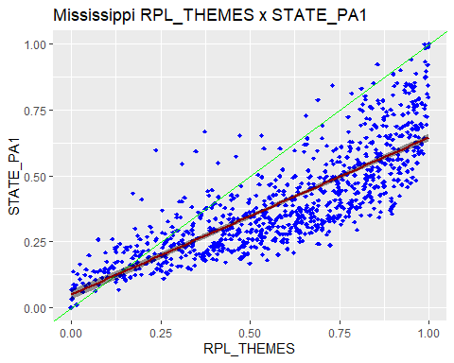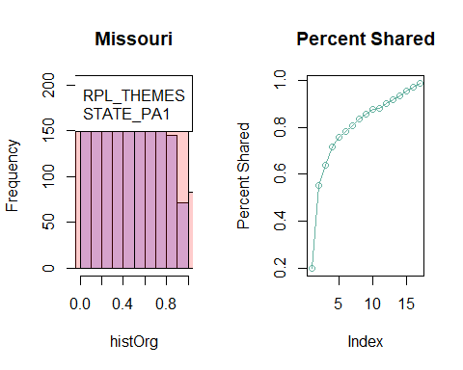

## `geom_smooth()` using formula = 'y ~ x'

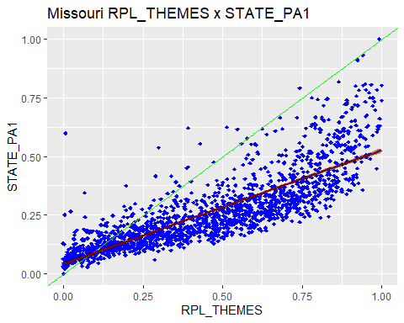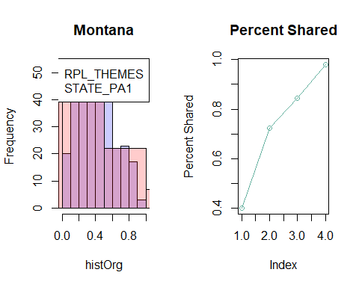

## `geom_smooth()` using formula = 'y ~ x'

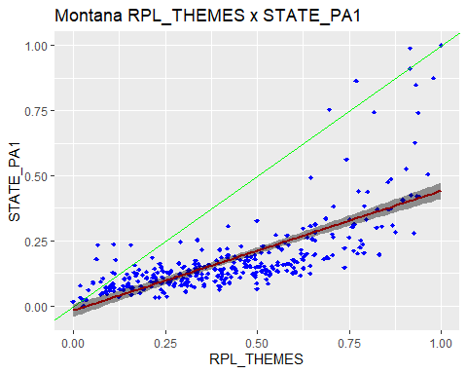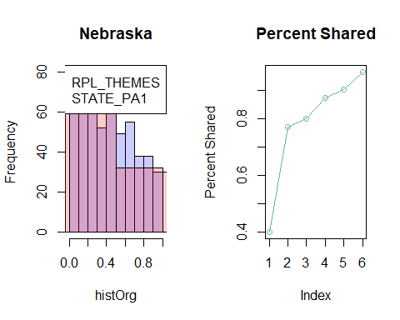

## `geom_smooth()` using formula = 'y ~ x'

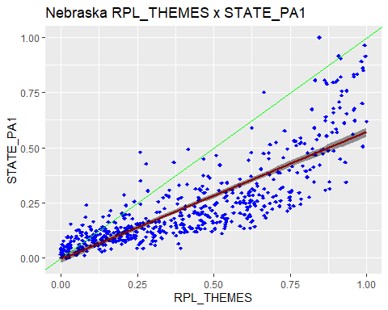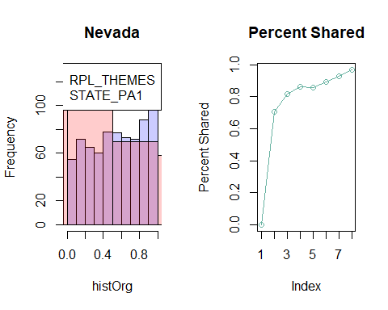

## `geom_smooth()` using formula = 'y ~ x'

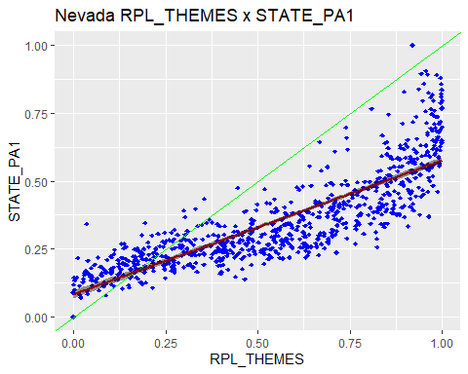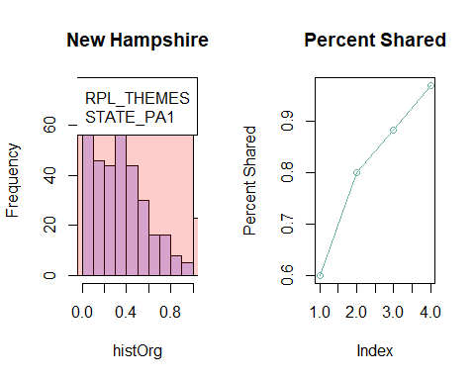

## `geom_smooth()` using formula = 'y ~ x'

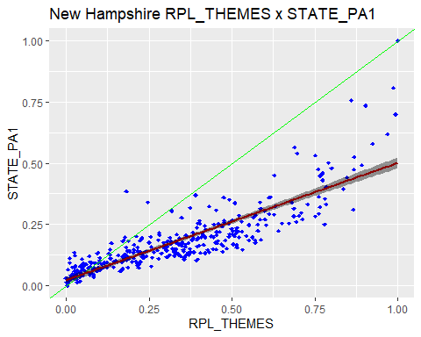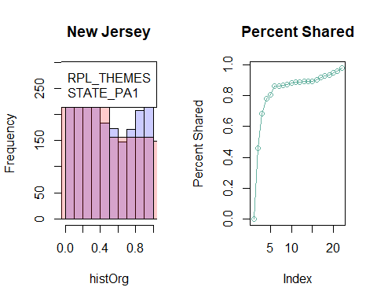

## `geom_smooth()` using formula = 'y ~ x'

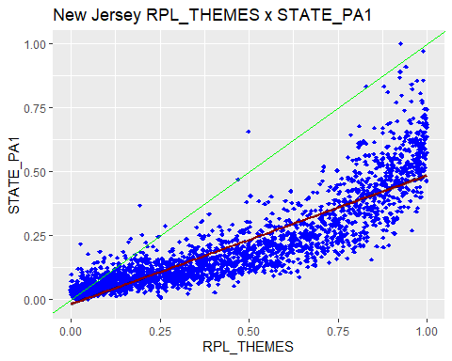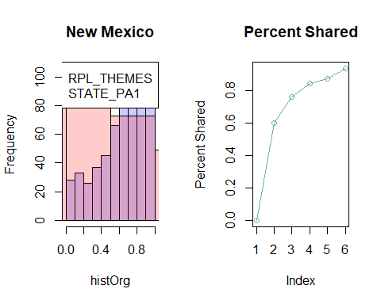

## `geom_smooth()` using formula = 'y ~ x'

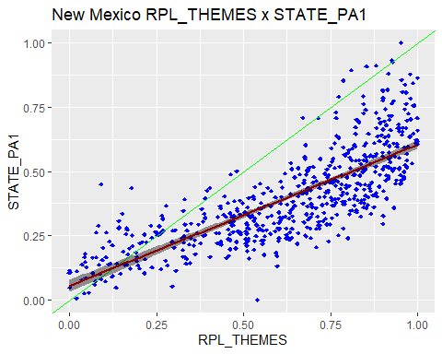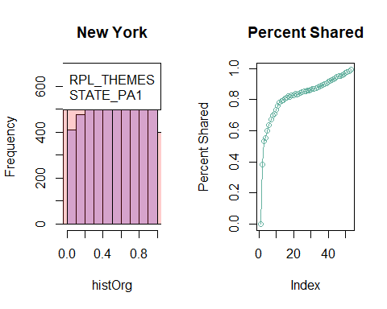

## `geom_smooth()` using formula = 'y ~ x'

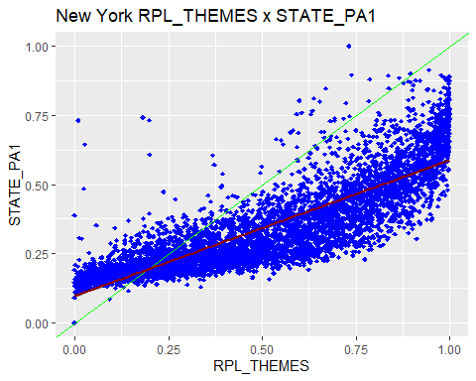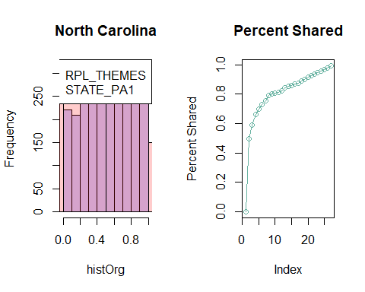

## `geom_smooth()` using formula = 'y ~ x'

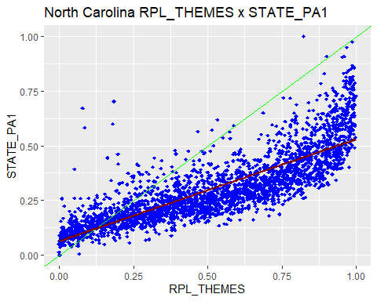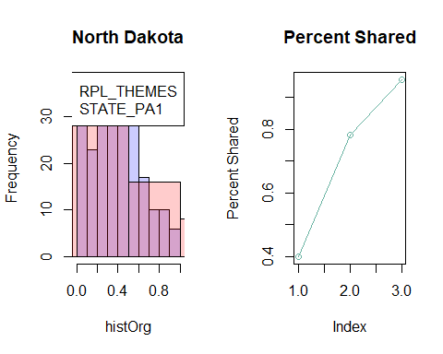

## `geom_smooth()` using formula = 'y ~ x'

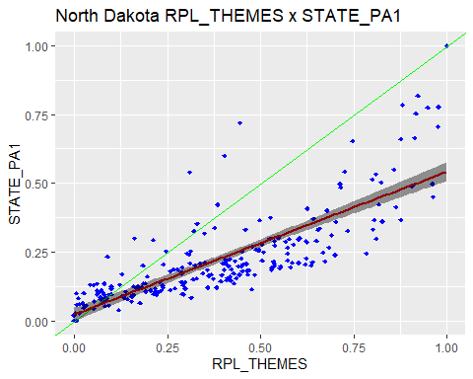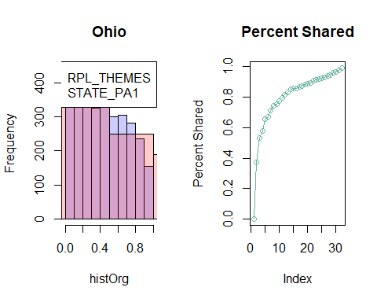

## `geom_smooth()` using formula = 'y ~ x'

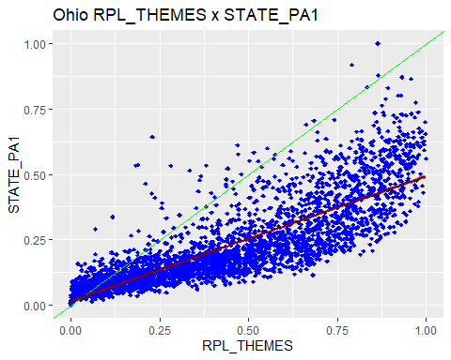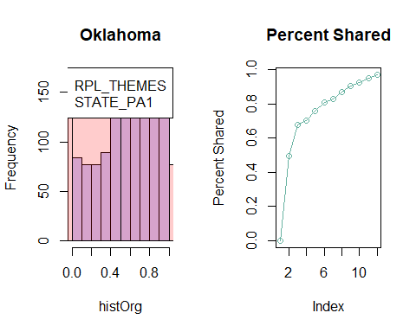

## `geom_smooth()` using formula = 'y ~ x'

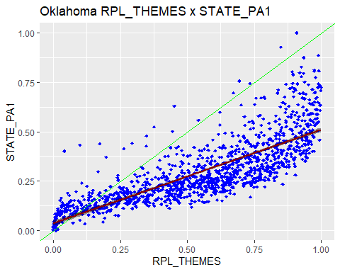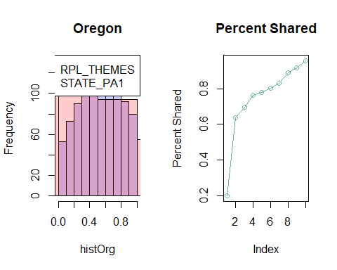

## `geom_smooth()` using formula = 'y ~ x'

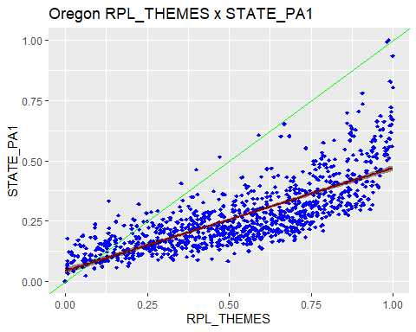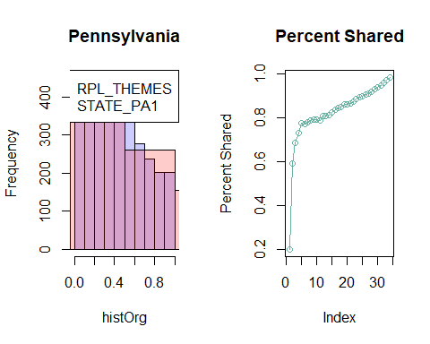

## `geom_smooth()` using formula = 'y ~ x'

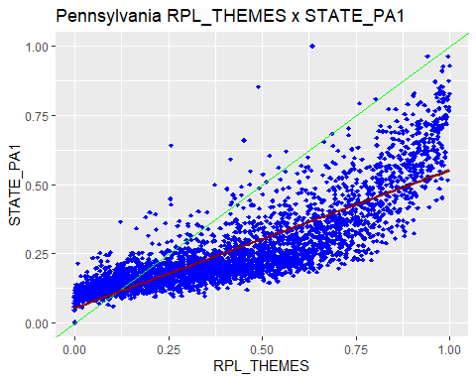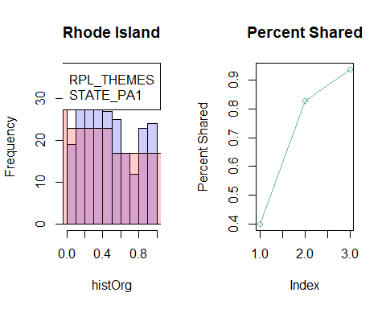

## `geom_smooth()` using formula = 'y ~ x'

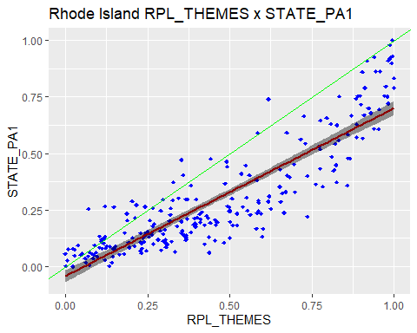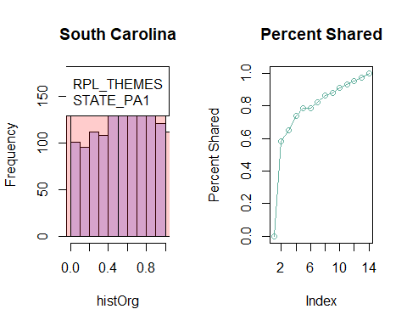

## `geom_smooth()` using formula = 'y ~ x'

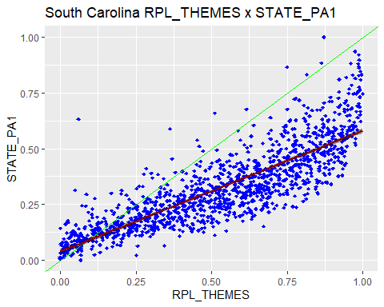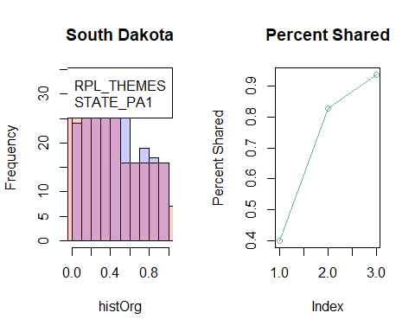

## `geom_smooth()` using formula = 'y ~ x'

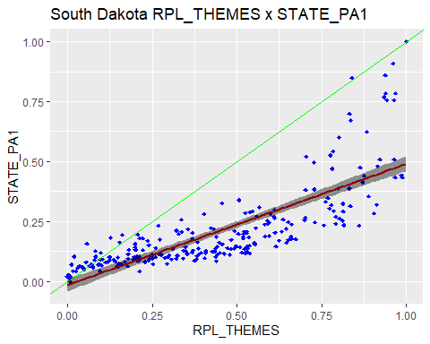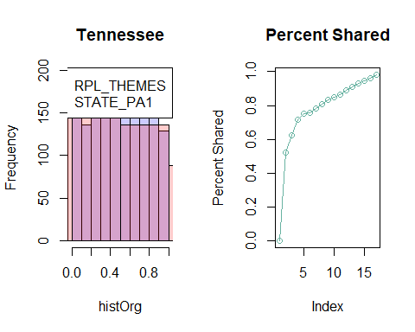

## `geom_smooth()` using formula = 'y ~ x'

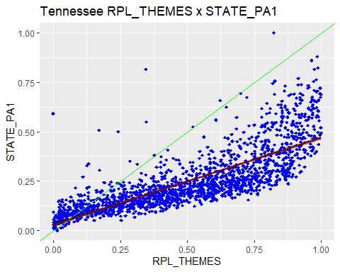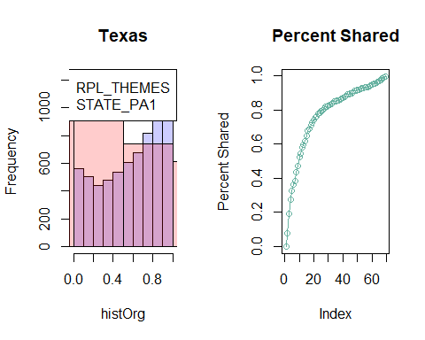

## `geom_smooth()` using formula = 'y ~ x'

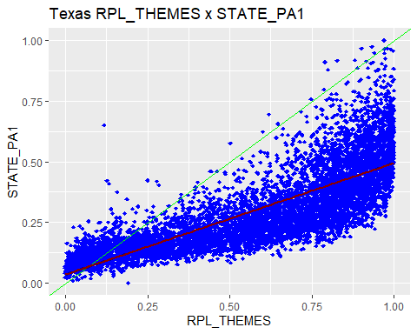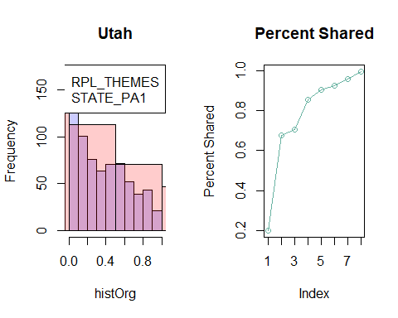

## `geom_smooth()` using formula = 'y ~ x'

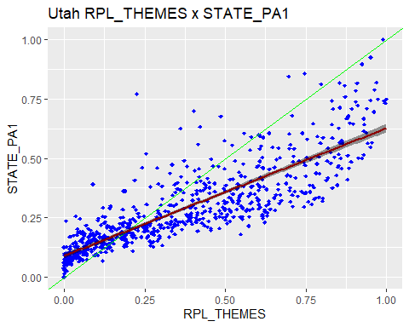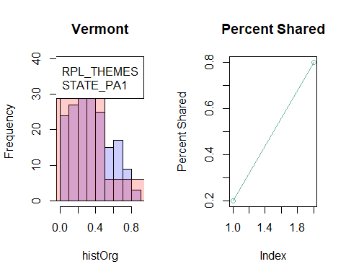

## `geom_smooth()` using formula = 'y ~ x'

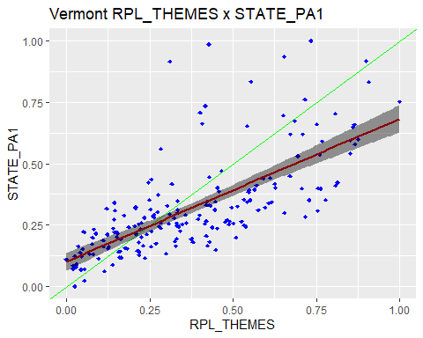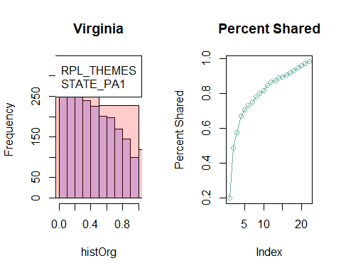

## `geom_smooth()` using formula = 'y ~ x'

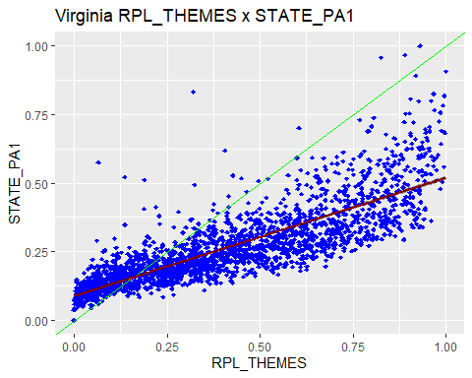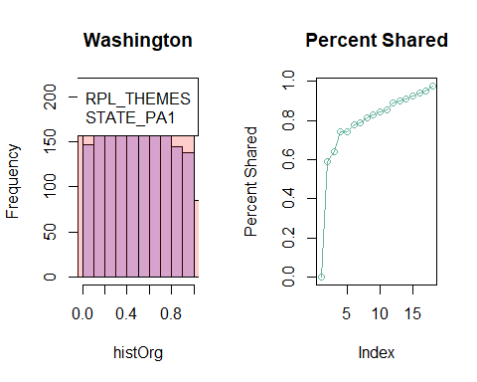

## `geom_smooth()` using formula = 'y ~ x'

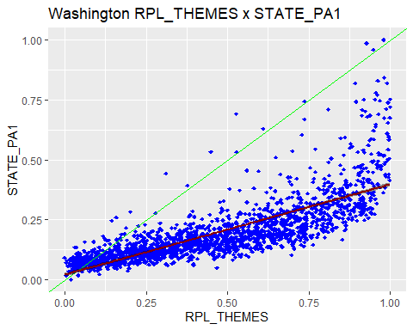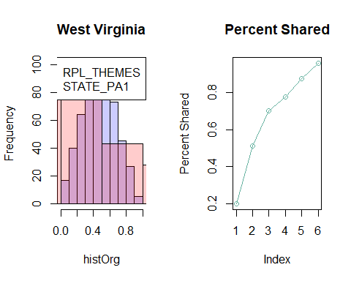

## `geom_smooth()` using formula = 'y ~ x'

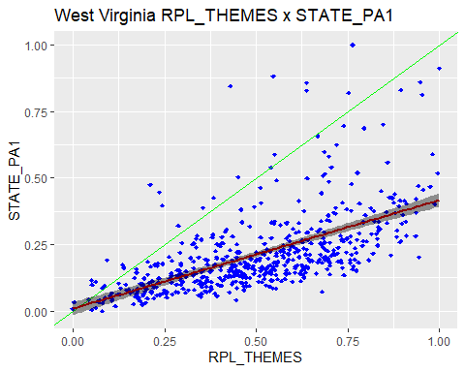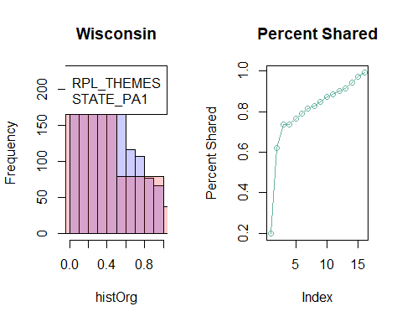

## `geom_smooth()` using formula = 'y ~ x'

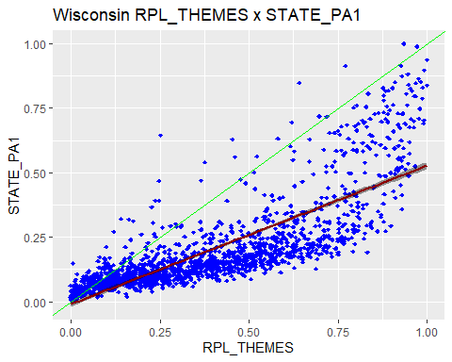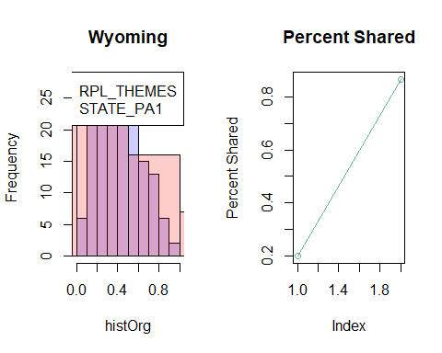

## `geom_smooth()` using formula = 'y ~ x'

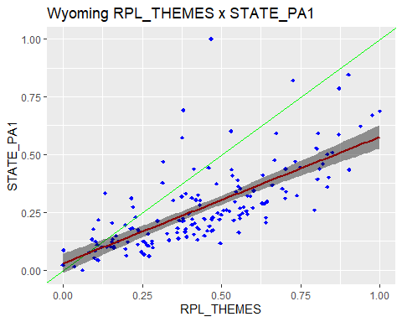

FA <- fa(cdcUnik[,5:21], nfactors = 1, fm = "pa", max.iter = 100, rotation = "promax")  
  
# Transform the matrix in long format  
loadngs <- melt(FA$loadings[,1])  
colnames(loadngs) <- c("load")  
  
loadngs$rowss <- colnames(cdcUnik[,5:21])  
  
#plots out   
natinal_level_loadings <- ggplot(loadngs, aes(x = 1, y = rowss, fill = load)) +  
 geom_tile() +  
 coord_flip() + labs(x = "Loadings", y = "Parameters from Census") +  
 theme(axis.text.y = element_text(size = 4),axis.text.x = element_text(angle = 45, hjust=1)) +  
 scale_fill_gradient(low = "white", high = "red") +  
 scale_y_discrete(labels = c("Total Population","Below 150 of Poverty","Unemployed","Housing Cost Burden","No Highschool Diploma","Uninsured","Over 65","Under 17","Diabled","Single Parent Household","English Proficiency","Minority","Multi-Unit Home","Mobile Home","Crowding Levels","No Vehicle","Group Quarters"))

# Transform the matrix in long format  
loadngs <- melt(FA$uniquenesses)  
colnames(loadngs) <- c("load")  
  
loadngs$rowss <- colnames(cdcUnik[,5:21])  
  
#plots out   
national_level_uniquness <- ggplot(loadngs, aes(x = 1, y = rowss, fill = load)) +  
 geom_tile() +  
 coord_flip() + labs(x = "Uniquness", y = "Parameters from Census") +  
 theme(axis.text.y = element_text(size = 4),axis.text.x = element_text(angle = 45, hjust=1)) +  
 scale_fill_gradient(low = "blue", high = "white") +  
 scale_y_discrete(labels = c("Total Population","Below 150 of Poverty","Unemployed","Housing Cost Burden","No Highschool Diploma","Uninsured","Over 65","Under 17","Diabled","Single Parent Household","English Proficiency","Minority","Multi-Unit Home","Mobile Home","Crowding Levels","No Vehicle","Group Quarters"))  
  
loadingsTable <- c()  
loadingsTable$loadings <- melt(FA$loadings[,1])  
loadingsTable$uniqueness <- melt(FA$uniquenesses)  
loadingsTable <- as.data.frame(loadingsTable)  
colnames(loadingsTable) <- c("Loadings","Uniqueness")  
loadingsTable %>% kable(caption = "Uniquness by varible on a national level")

Uniquness by varible on a national level

|  | Loadings | Uniqueness |
| --- | --- | --- |
| E_TOTPOP | -0.0038804 | 0.9999849 |
| EP_POV150 | 0.7382367 | 0.4550066 |
| EP_UNEMP | 0.4243155 | 0.8199564 |
| EP_HBURD | 0.6869235 | 0.5281362 |
| EP_NOHSDP | 0.7833331 | 0.3863892 |
| EP_UNINSUR | 0.5620083 | 0.6841467 |
| EP_AGE65 | -0.3729734 | 0.8608909 |
| EP_AGE17 | 0.2912390 | 0.9151799 |
| EP_DISABL | 0.1028163 | 0.9894288 |
| EP_SNGPNT | 0.5411371 | 0.7071707 |
| EP_LIMENG | 0.6553556 | 0.5705090 |
| EP_MINRTY | 0.7688415 | 0.4088827 |
| EP_MUNIT | 0.2731942 | 0.9253649 |
| EP_MOBILE | -0.0113868 | 0.9998703 |
| EP_CROWD | 0.6314795 | 0.6012336 |
| EP_NOVEH | 0.4709073 | 0.7782463 |
| EP_GROUPQ | 0.0627852 | 0.9960580 |

# Transform the matrix in long format  
df <- melt(byLine$uniqness_by_var)

## Using STATE as id variables

colnames(df) <- c("state", "cols", "value")  
  
#plots out   
state_level_uniquniess <- ggplot(df, aes(x = state, y = cols, fill = value)) +  
 geom_tile() +  
 coord_flip() + labs(x = "States", y = "Parameters from Census") +  
 theme(axis.text.y = element_text(size = 4),axis.text.x = element_text(angle = 45, hjust=1)) +  
 scale_fill_gradient(low = "blue", high = "white") +  
 scale_y_discrete(labels = c("Total Population","Below 150 of Poverty","Unemployed","Housing Cost Burden","No Highschool Diploma","Uninsured","Over 65","Under 17","Diabled","Single Parent Household","English Proficiency","Minority","Multi-Unit Home","Mobile Home","Crowding Levels","No Vehicle","Group Quarters"))  
   
  
byLine[["uniqness_by_var"]] %>% kable(caption = "Uniquness by varible and stratified by State")

Uniquness by varible and stratified by State

| STATE | E_TOTPOP | EP_POV150 | EP_UNEMP | EP_HBURD | EP_NOHSDP | EP_UNINSUR | EP_AGE65 | EP_AGE17 | EP_DISABL | EP_SNGPNT | EP_LIMENG | EP_MINRTY | EP_MUNIT | EP_MOBILE | EP_CROWD | EP_NOVEH | EP_GROUPQ |
| --- | --- | --- | --- | --- | --- | --- | --- | --- | --- | --- | --- | --- | --- | --- | --- | --- | --- |
| Alabama | 0.8982080 | 0.1898226 | 0.7139014 | 0.5034850 | 0.7159048 | 0.7031934 | 0.9732928 | 0.9967025 | 0.9142708 | 0.6943130 | 0.9697209 | 0.4695109 | 0.9615781 | 0.9941395 | 0.9430292 | 0.4984795 | 0.9631876 |
| Alaska | 0.9979432 | 0.3049479 | 0.4912355 | 0.9915151 | 0.2950769 | 0.7613614 | 0.9336506 | 0.8058898 | 0.9729232 | 0.7058879 | 0.9656401 | 0.3713291 | 0.9999955 | 0.9990866 | 0.2916303 | 0.2852761 | 0.9704234 |
| Arizona | 0.9805702 | 0.3737443 | 0.8765869 | 0.8071745 | 0.2824760 | 0.5356324 | 0.7410362 | 0.7622769 | 0.9918300 | 0.6127546 | 0.4427574 | 0.2065378 | 0.9602823 | 0.9971991 | 0.4262231 | 0.7436640 | 0.9980218 |
| Arkansas | 0.9957840 | 0.4243997 | 0.8286683 | 0.5552971 | 0.7036656 | 0.7704277 | 0.8577465 | 0.9125934 | 0.9980087 | 0.6415465 | 0.8250503 | 0.3964529 | 0.9212999 | 0.9326246 | 0.7812388 | 0.6218920 | 0.9800017 |
| California | 0.9940869 | 0.3936051 | 0.8712079 | 0.4928308 | 0.1867104 | 0.4904792 | 0.7685520 | 0.8143229 | 0.9998185 | 0.7112981 | 0.3625427 | 0.4245895 | 0.9594463 | 0.9984537 | 0.3229156 | 0.9002610 | 0.9996717 |
| Colorado | 0.9874024 | 0.5140385 | 0.9005554 | 0.6059820 | 0.2880595 | 0.5378643 | 0.9071966 | 0.9502022 | 0.9365178 | 0.7307515 | 0.4326827 | 0.2935419 | 0.9551918 | 0.9280398 | 0.5450158 | 0.8440181 | 0.9920222 |
| Connecticut | 0.9750543 | 0.1743597 | 0.5844003 | 0.2938872 | 0.2223306 | 0.6048537 | 0.7823498 | 0.9283387 | 0.8473738 | 0.5116618 | 0.3730006 | 0.2103085 | 0.7949890 | 0.9893340 | 0.5951535 | 0.3821063 | 0.9883958 |
| Delaware | 0.9683636 | 0.3165492 | 0.8453068 | 0.5789799 | 0.6701285 | 0.7926847 | 0.6729651 | 0.7799247 | 0.9870883 | 0.5463115 | 0.8192063 | 0.3223897 | 0.9281735 | 0.9951970 | 0.8103148 | 0.6681379 | 0.9779128 |
| District of Columbia | 0.9678552 | 0.2592225 | 0.4944913 | 0.3753788 | 0.3641447 | 0.8055782 | 0.9951192 | 0.5844305 | 0.5404164 | 0.3923175 | 0.9673110 | 0.1843871 | 0.9632717 | 0.9968932 | 0.8612589 | 0.9214974 | 0.9989951 |
| Florida | 0.9876791 | 0.4767851 | 0.9243139 | 0.5581877 | 0.4793673 | 0.5454089 | 0.7354139 | 0.8341771 | 0.9873529 | 0.6782388 | 0.6195713 | 0.3346862 | 0.9781625 | 0.9948573 | 0.5758618 | 0.7753859 | 0.9931171 |
| Georgia | 0.9917288 | 0.2942106 | 0.8357658 | 0.4557000 | 0.6256557 | 0.6002160 | 0.9307484 | 0.9637353 | 0.9632871 | 0.7283385 | 0.8656653 | 0.5797761 | 0.9462778 | 0.9994831 | 0.8196544 | 0.6067131 | 0.9820860 |
| Hawaii | 0.9889984 | 0.5287296 | 0.9665139 | 0.8461860 | 0.5056912 | 0.8710976 | 0.9896557 | 0.9897181 | 0.8629371 | 0.9367684 | 0.4602501 | 0.9267208 | 0.6958525 | 0.9961455 | 0.8368594 | 0.3767029 | 0.9992309 |
| Idaho | 0.9949076 | 0.4674214 | 0.9148957 | 0.8015104 | 0.4328599 | 0.5997163 | 0.9643703 | 0.9992542 | 0.8900002 | 0.9445111 | 0.6728271 | 0.6035014 | 0.9489478 | 0.9060728 | 0.8018174 | 0.8938487 | 0.9788959 |
| Illinois | 0.9708884 | 0.3509145 | 0.6044215 | 0.3235937 | 0.4526963 | 0.5864426 | 0.9167915 | 0.9670094 | 0.9472243 | 0.6521041 | 0.7934214 | 0.3005124 | 0.9758798 | 0.9932810 | 0.7723477 | 0.6707392 | 0.9950754 |
| Indiana | 0.9274582 | 0.2227156 | 0.7086508 | 0.4308048 | 0.5367655 | 0.7206878 | 0.8815071 | 0.9635234 | 0.8762549 | 0.6738371 | 0.8193548 | 0.5244716 | 0.9044762 | 0.9926898 | 0.8539022 | 0.4590929 | 0.9826673 |
| Iowa | 0.9988274 | 0.3849563 | 0.6877164 | 0.5101641 | 0.4755003 | 0.7745440 | 0.8183802 | 0.9997133 | 0.9028734 | 0.7720142 | 0.6106121 | 0.2881574 | 0.8145199 | 0.9997981 | 0.6791939 | 0.5682314 | 0.9536388 |
| Kansas | 0.9657048 | 0.3642981 | 0.7200679 | 0.6136375 | 0.3529914 | 0.3579769 | 0.8222578 | 0.9548310 | 0.9486564 | 0.7306181 | 0.5503603 | 0.3258040 | 0.9499372 | 0.9897833 | 0.7216917 | 0.6450612 | 0.9833499 |
| Kentucky | 0.9486943 | 0.2319450 | 0.7178762 | 0.5460357 | 0.6884740 | 0.9110104 | 0.9335612 | 0.9904603 | 0.8539557 | 0.7457335 | 0.9303685 | 0.7565298 | 0.9138444 | 0.9919368 | 0.8842575 | 0.4842527 | 0.9703594 |
| Louisiana | 0.9489713 | 0.2443197 | 0.7474279 | 0.4751576 | 0.6856387 | 0.7950183 | 0.9622106 | 0.9659907 | 0.9363742 | 0.6897491 | 0.9753588 | 0.3848550 | 0.9390472 | 0.9613049 | 0.9232253 | 0.4906640 | 0.9893745 |
| Maine | 0.9351294 | 0.2983734 | 0.8912096 | 0.5322244 | 0.5894155 | 0.9248084 | 0.9804174 | 0.9999600 | 0.6499532 | 0.9154636 | 0.7103346 | 0.6746683 | 0.6353112 | 0.9813421 | 0.9092210 | 0.3682128 | 0.9763057 |
| Maryland | 0.9859243 | 0.3749330 | 0.6939112 | 0.3527031 | 0.4215399 | 0.6136981 | 0.9242749 | 0.9639864 | 0.9090711 | 0.7115173 | 0.7715507 | 0.5775311 | 0.8970735 | 0.9928717 | 0.6669248 | 0.5311518 | 0.9979269 |
| Massachusetts | 0.9666638 | 0.2512010 | 0.7157862 | 0.3717642 | 0.2721658 | 0.7517261 | 0.8759559 | 0.9760411 | 0.8200022 | 0.5916773 | 0.3635774 | 0.2541998 | 0.8844749 | 0.9918592 | 0.6686191 | 0.5630808 | 0.9969700 |
| Michigan | 0.9383046 | 0.1514816 | 0.5574986 | 0.4009864 | 0.4955778 | 0.8348643 | 0.8966954 | 0.9477098 | 0.7995488 | 0.6059721 | 0.9291500 | 0.4329259 | 0.9164284 | 0.9967576 | 0.8695856 | 0.4191039 | 0.9775259 |
| Minnesota | 0.9995723 | 0.3236283 | 0.7329810 | 0.4421791 | 0.3944512 | 0.6791665 | 0.9180081 | 0.9889486 | 0.8774309 | 0.7174370 | 0.4781282 | 0.3465257 | 0.7578027 | 0.9956544 | 0.4929736 | 0.4953260 | 0.9730565 |
| Mississippi | 0.9732446 | 0.2237821 | 0.7022570 | 0.5656179 | 0.6988364 | 0.7212927 | 0.9542313 | 0.9611897 | 0.9616190 | 0.6394064 | 0.9882603 | 0.4449871 | 0.9608500 | 0.9658427 | 0.9020091 | 0.5507032 | 0.9731431 |
| Missouri | 0.9159460 | 0.2532897 | 0.7428677 | 0.4850242 | 0.5843634 | 0.6648191 | 0.9671839 | 0.9923391 | 0.8099985 | 0.7602814 | 0.9143526 | 0.6187873 | 0.9613096 | 0.9988250 | 0.8999693 | 0.4353718 | 0.9872596 |
| Montana | 0.9995932 | 0.4819353 | 0.5550115 | 0.9804810 | 0.7704693 | 0.6464962 | 0.8545636 | 0.8417978 | 0.9905858 | 0.7628082 | 0.9950873 | 0.2088026 | 0.9916737 | 0.9881967 | 0.5254333 | 0.8343372 | 0.9901968 |
| Nebraska | 0.9993756 | 0.3306705 | 0.6336977 | 0.5012176 | 0.3432555 | 0.3417931 | 0.8315987 | 0.9629297 | 0.9268435 | 0.7152434 | 0.5268848 | 0.1723064 | 0.9454123 | 0.9972627 | 0.6823865 | 0.6903622 | 0.9852600 |
| Nevada | 0.9955460 | 0.2512541 | 0.9008844 | 0.5033296 | 0.3096797 | 0.3573056 | 0.8209845 | 0.8725800 | 0.9909467 | 0.7228963 | 0.3529542 | 0.3810312 | 0.8231398 | 0.9964002 | 0.4176757 | 0.5949302 | 0.9943322 |
| New Hampshire | 0.9980096 | 0.3513250 | 0.8883053 | 0.3735267 | 0.4495659 | 0.6526278 | 0.9573834 | 0.9905842 | 0.7716828 | 0.9017356 | 0.4897983 | 0.5212104 | 0.7747099 | 0.9969145 | 0.7517240 | 0.4480382 | 0.9724963 |
| New Jersey | 0.9864591 | 0.2234374 | 0.8457055 | 0.3687618 | 0.2652466 | 0.3543917 | 0.8682440 | 0.9073074 | 0.9763183 | 0.6012232 | 0.4252866 | 0.3667549 | 0.8893224 | 0.9960614 | 0.5173210 | 0.4151123 | 0.9977655 |
| New Mexico | 0.9998450 | 0.4320439 | 0.8739584 | 0.9897075 | 0.3488840 | 0.5978991 | 0.7218060 | 0.7410539 | 0.9974548 | 0.8041468 | 0.6072351 | 0.3570412 | 0.9941362 | 0.8296881 | 0.6114642 | 0.9289257 | 0.9997932 |
| New York | 0.9960331 | 0.4586757 | 0.8130720 | 0.3300609 | 0.3258120 | 0.7227813 | 0.8277109 | 0.9112462 | 0.9868864 | 0.7251169 | 0.5115171 | 0.4159031 | 0.7645267 | 0.9413784 | 0.5088048 | 0.4933361 | 0.9994458 |
| North Carolina | 0.9975488 | 0.2694629 | 0.8101556 | 0.5756688 | 0.5401543 | 0.6195356 | 0.9175291 | 0.9361847 | 0.9515252 | 0.6636102 | 0.7647881 | 0.4645099 | 0.9929313 | 0.9935488 | 0.7874511 | 0.6833515 | 0.9797935 |
| North Dakota | 0.9924810 | 0.2760797 | 0.6507669 | 0.7534914 | 0.8738176 | 0.6320799 | 0.8481944 | 0.9985817 | 0.9388319 | 0.7255041 | 0.8589709 | 0.3213904 | 0.8282356 | 0.9834344 | 0.6572486 | 0.6246523 | 0.9501791 |
| Ohio | 0.8849193 | 0.1611141 | 0.5769597 | 0.4210166 | 0.5236451 | 0.8180080 | 0.8909423 | 0.9672373 | 0.8016383 | 0.6093146 | 0.9001273 | 0.4785036 | 0.9060017 | 0.9913912 | 0.8708785 | 0.3953182 | 0.9808845 |
| Oklahoma | 0.9909572 | 0.3053914 | 0.7532678 | 0.6485010 | 0.4563042 | 0.4876870 | 0.8689683 | 0.9569901 | 0.9407942 | 0.6903257 | 0.6894133 | 0.3914851 | 0.9491811 | 0.9895342 | 0.7802028 | 0.6323860 | 0.9723287 |
| Oregon | 0.9714119 | 0.5578851 | 0.9300739 | 0.6161209 | 0.5349251 | 0.6994735 | 0.8222036 | 0.9546646 | 0.9865361 | 0.8102122 | 0.5261791 | 0.4636868 | 0.9100064 | 0.9983397 | 0.5938371 | 0.8420598 | 0.9720865 |
| Pennsylvania | 0.9966884 | 0.2588554 | 0.6186168 | 0.4267544 | 0.5162649 | 0.8228274 | 0.8414404 | 0.9155359 | 0.8216401 | 0.5674843 | 0.6899663 | 0.3735933 | 0.9681490 | 0.9547640 | 0.7664277 | 0.4506841 | 0.9943328 |
| Rhode Island | 0.9922902 | 0.1562572 | 0.7897270 | 0.4133908 | 0.3586760 | 0.5430191 | 0.7179332 | 0.8425018 | 0.8427437 | 0.6339388 | 0.3429553 | 0.1651651 | 0.8881839 | 0.9551704 | 0.6658434 | 0.5121328 | 0.9995897 |
| South Carolina | 0.9677730 | 0.1863236 | 0.8193360 | 0.7091627 | 0.4358522 | 0.6424808 | 0.9242060 | 0.9412057 | 0.9011885 | 0.7331840 | 0.9062903 | 0.4633211 | 0.9991986 | 0.9207105 | 0.8128900 | 0.6369620 | 0.9907902 |
| South Dakota | 0.9982061 | 0.2036793 | 0.4450051 | 0.8499472 | 0.4725260 | 0.2289261 | 0.8483407 | 0.8600375 | 0.9639747 | 0.6345354 | 0.9666427 | 0.1009779 | 0.9907602 | 0.9118549 | 0.4094647 | 0.5370229 | 0.9871131 |
| Tennessee | 0.9679783 | 0.2962896 | 0.7085952 | 0.4215243 | 0.7074986 | 0.6162674 | 0.8932475 | 0.9563402 | 0.9784121 | 0.6178787 | 0.8636607 | 0.4586225 | 0.8873180 | 0.9626579 | 0.8462619 | 0.5463018 | 0.9772074 |
| Texas | 0.9997091 | 0.3306927 | 0.9074322 | 0.6848844 | 0.2917726 | 0.3448353 | 0.8947562 | 0.8516238 | 0.9915159 | 0.7220722 | 0.3720009 | 0.3828262 | 0.9764806 | 0.9984317 | 0.5222465 | 0.7816241 | 0.9997891 |
| Utah | 0.9883845 | 0.4366244 | 0.8546261 | 0.5297730 | 0.4750605 | 0.4870578 | 0.9675282 | 0.9071562 | 0.8923941 | 0.8570283 | 0.5323448 | 0.4000004 | 0.7812786 | 0.9453872 | 0.7317513 | 0.7482803 | 0.9519492 |
| Vermont | 0.9790746 | 0.4059964 | 0.9237346 | 0.3519895 | 0.8831648 | 0.9999717 | 0.9267386 | 0.8115361 | 0.8642741 | 0.9691450 | 0.8679143 | 0.7182853 | 0.6751700 | 0.9541674 | 0.9900481 | 0.3906030 | 0.8382762 |
| Virginia | 0.9940083 | 0.4028252 | 0.8388351 | 0.4292944 | 0.5966550 | 0.5862141 | 0.9274856 | 0.9737173 | 0.9480541 | 0.6490221 | 0.8702656 | 0.5848448 | 0.9357495 | 0.9986307 | 0.7555408 | 0.6202517 | 0.9897954 |
| Washington | 0.9999982 | 0.5312434 | 0.9022337 | 0.7761185 | 0.2905231 | 0.4816745 | 0.8883873 | 0.9433767 | 0.9786803 | 0.7642037 | 0.4072983 | 0.4608828 | 0.9425121 | 0.9765072 | 0.5091513 | 0.9261854 | 0.9812236 |
| West Virginia | 0.8996908 | 0.4283195 | 0.9090071 | 0.3154236 | 0.9661061 | 0.8927071 | 0.9292758 | 0.9077037 | 0.9687596 | 0.9611453 | 0.9819380 | 0.7191464 | 0.5749456 | 0.9251979 | 0.9703257 | 0.3883220 | 0.8475657 |
| Wisconsin | 0.9515377 | 0.2502535 | 0.6898310 | 0.4075573 | 0.4263657 | 0.6982984 | 0.7889718 | 0.8574451 | 0.9377904 | 0.5042623 | 0.6920268 | 0.2320242 | 0.9490707 | 0.9781825 | 0.6617983 | 0.4900753 | 0.9923668 |
| Wyoming | 0.9916111 | 0.3617253 | 0.6695442 | 0.7904834 | 0.6808656 | 0.7190070 | 0.8170413 | 0.9997638 | 0.9691583 | 0.9351945 | 0.8934964 | 0.6321879 | 0.8960592 | 0.9415340 | 0.8950269 | 0.7817287 | 0.8619940 |

# Transform the matrix in long format  
df <- melt(byLine$loadings_by_var)

## Using STATE as id variables

colnames(df) <- c("state", "cols", "value")  
  
#plots out   
state_level_loadings <- ggplot(df, aes(x = state, y = cols, fill = value)) +  
 geom_tile() +  
 coord_flip() + labs(x = "States", y = "Parameters from Census") +  
 theme(axis.text.y = element_text(size = 4),axis.text.x = element_text(angle = 45, hjust=1)) +  
 scale_fill_gradient(low = "white", high = "red") +  
 scale_y_discrete(labels = c("Total Population","Below 150 of Poverty","Unemployed","Housing Cost Burden","No Highschool Diploma","Uninsured","Over 65","Under 17","Diabled","Single Parent Household","English Proficiency","Minority","Multi-Unit Home","Mobile Home","Crowding Levels","No Vehicle","Group Quarters"))  
  
byLine[["loadings_by_var"]] %>% kable(caption = "Loadings by varible and stratified by State")

Loadings by varible and stratified by State

| STATE | E_TOTPOP | EP_POV150 | EP_UNEMP | EP_HBURD | EP_NOHSDP | EP_UNINSUR | EP_AGE65 | EP_AGE17 | EP_DISABL | EP_SNGPNT | EP_LIMENG | EP_MINRTY | EP_MUNIT | EP_MOBILE | EP_CROWD | EP_NOVEH | EP_GROUPQ |
| --- | --- | --- | --- | --- | --- | --- | --- | --- | --- | --- | --- | --- | --- | --- | --- | --- | --- |
| Alabama | -0.3190486 | 0.9000986 | 0.5348818 | 0.7046382 | 0.5330058 | 0.5447996 | -0.1634235 | 0.0574238 | 0.2927955 | 0.5528897 | 0.1740088 | 0.7283468 | 0.1960150 | -0.0765538 | 0.2386856 | 0.7081811 | 0.1918657 |
| Alaska | -0.0453522 | 0.8336979 | 0.7132773 | 0.0921136 | 0.8395970 | 0.4885065 | -0.2575837 | 0.4405794 | 0.1645502 | 0.5423210 | 0.1853643 | 0.7928877 | 0.0021259 | -0.0302233 | 0.8416470 | 0.8454134 | 0.1719784 |
| Arizona | 0.1393907 | 0.7913632 | 0.3513020 | 0.4391190 | 0.8470679 | 0.6814452 | -0.5088848 | 0.4875686 | -0.0903878 | 0.6222905 | 0.7464868 | 0.8907649 | 0.1992930 | 0.0529235 | 0.7574806 | 0.5062964 | 0.0444770 |
| Arkansas | -0.0649307 | 0.7586832 | 0.4139223 | 0.6668605 | 0.5443661 | 0.4791370 | -0.3771651 | 0.2956460 | 0.0446242 | 0.5987099 | 0.4182699 | 0.7768830 | 0.2805354 | -0.2595678 | 0.4677191 | 0.6149048 | 0.1414154 |
| California | 0.0768969 | 0.7787136 | 0.3588762 | 0.7121581 | 0.9018257 | 0.7138072 | -0.4810904 | 0.4309026 | 0.0134728 | 0.5373099 | 0.7984092 | 0.7585582 | 0.2013795 | 0.0393226 | 0.8228514 | 0.3158148 | 0.0181190 |
| Colorado | 0.1122392 | 0.6971094 | 0.3153484 | 0.6277086 | 0.8437657 | 0.6798056 | -0.3046365 | 0.2231543 | 0.2519567 | 0.5188916 | 0.7532047 | 0.8405106 | 0.2116795 | 0.2682541 | 0.6745252 | 0.3949454 | 0.0893183 |
| Connecticut | -0.1579420 | 0.9086475 | 0.6446702 | 0.8403052 | 0.8818556 | 0.6286066 | -0.4665300 | 0.2676963 | 0.3906741 | 0.6988120 | 0.7918329 | 0.8886459 | 0.4527814 | -0.1032764 | 0.6362755 | 0.7860622 | 0.1077226 |
| Delaware | 0.1778662 | 0.8267108 | 0.3933106 | 0.6488606 | 0.5743444 | 0.4553189 | -0.5718696 | 0.4691219 | 0.1136297 | 0.6735640 | 0.4251984 | 0.8231709 | 0.2680048 | -0.0693040 | 0.4355287 | 0.5760747 | 0.1486178 |
| District of Columbia | 0.1792896 | 0.8606843 | 0.7109914 | 0.7903298 | 0.7974054 | 0.4409328 | -0.0698627 | 0.6446468 | 0.6779260 | 0.7795399 | 0.1808010 | 0.9031129 | -0.1916462 | 0.0557382 | 0.3724797 | 0.2801832 | 0.0316997 |
| Florida | 0.1109996 | 0.7233359 | 0.2751111 | 0.6646896 | 0.7215488 | 0.6742337 | -0.5143793 | 0.4072136 | -0.1124594 | 0.5672400 | 0.6167890 | 0.8156677 | 0.1477752 | -0.0717128 | 0.6512589 | 0.4739347 | 0.0829630 |
| Georgia | -0.0909461 | 0.8401128 | 0.4052582 | 0.7377669 | 0.6118368 | 0.6322847 | -0.2631569 | 0.1904330 | 0.1916060 | 0.5212116 | 0.3665170 | 0.6482468 | 0.2317805 | 0.0227345 | 0.4246712 | 0.6271259 | 0.1338431 |
| Hawaii | -0.1048887 | 0.6864913 | 0.1829922 | 0.3921912 | 0.7030710 | 0.3590298 | 0.1017071 | -0.1013997 | 0.3702201 | 0.2514589 | 0.7346767 | 0.2707014 | 0.5514957 | 0.0620843 | 0.4039066 | 0.7894916 | 0.0277334 |
| Idaho | 0.0713608 | 0.7297798 | 0.2917265 | 0.4455217 | 0.7530870 | 0.6326798 | -0.1887582 | 0.0273093 | 0.3316622 | 0.2355609 | 0.5719903 | 0.6296814 | 0.2259474 | 0.3064754 | 0.4451770 | 0.3258087 | 0.1452724 |
| Illinois | -0.1706211 | 0.8056585 | 0.6289503 | 0.8224393 | 0.7397998 | 0.6430843 | -0.2884589 | 0.1816331 | 0.2297296 | 0.5898270 | 0.4545091 | 0.8363538 | 0.1553068 | -0.0819694 | 0.4771292 | 0.5738125 | 0.0701752 |
| Indiana | -0.2693359 | 0.8816373 | 0.5397678 | 0.7544503 | 0.6806133 | 0.5284999 | -0.3442280 | 0.1909886 | 0.3517742 | 0.5711067 | 0.4250238 | 0.6895857 | 0.3090693 | -0.0854994 | 0.3822274 | 0.7354639 | 0.1316539 |
| Iowa | -0.0342429 | 0.7842472 | 0.5588234 | 0.6998828 | 0.7242235 | 0.4748221 | -0.4261687 | 0.0169332 | 0.3116514 | 0.4774786 | 0.6240095 | 0.8437076 | 0.4306740 | -0.0142101 | 0.5663974 | 0.6570910 | 0.2153165 |
| Kansas | -0.1851896 | 0.7973092 | 0.5290861 | 0.6215807 | 0.8043684 | 0.8012634 | -0.4215948 | 0.2125301 | 0.2265914 | 0.5190202 | 0.6705518 | 0.8210944 | 0.2237473 | 0.1010779 | 0.5275494 | 0.5957674 | 0.1290354 |
| Kentucky | -0.2265076 | 0.8763875 | 0.5311533 | 0.6737687 | 0.5581451 | 0.2983113 | -0.2577573 | 0.0976713 | 0.3821575 | 0.5042484 | 0.2638778 | 0.4934270 | 0.2935227 | 0.0897954 | 0.3402095 | 0.7181555 | 0.1721643 |
| Louisiana | -0.2258954 | 0.8692987 | 0.5025655 | 0.7244601 | 0.5606793 | 0.4527491 | -0.1943949 | 0.1844160 | 0.2522416 | 0.5570017 | 0.1569751 | 0.7843118 | 0.2468862 | -0.1967108 | 0.2770824 | 0.7136778 | 0.1030800 |
| Maine | -0.2546970 | 0.8376315 | 0.3298339 | 0.6839412 | 0.6407687 | 0.2742110 | -0.1399378 | -0.0063208 | 0.5916476 | 0.2907514 | 0.5382057 | 0.5703786 | 0.6038947 | -0.1365939 | 0.3012955 | 0.7948504 | 0.1539297 |
| Maryland | -0.1186412 | 0.7906118 | 0.5532529 | 0.8045476 | 0.7605656 | 0.6215319 | -0.2751820 | 0.1897725 | 0.3015442 | 0.5371058 | 0.4779637 | 0.6499761 | 0.3208216 | -0.0844290 | 0.5771267 | 0.6847249 | 0.0455317 |
| Massachusetts | -0.1825822 | 0.8653317 | 0.5331171 | 0.7926133 | 0.8531320 | 0.4982709 | -0.3521990 | 0.1547867 | 0.4242615 | 0.6390013 | 0.7977610 | 0.8635973 | 0.3398898 | -0.0902264 | 0.5756569 | 0.6609986 | 0.0550456 |
| Michigan | -0.2483856 | 0.9211506 | 0.6652078 | 0.7739597 | 0.7102268 | 0.4063689 | -0.3214103 | 0.2286706 | 0.4477177 | 0.6277164 | 0.2661767 | 0.7530433 | 0.2890875 | -0.0569418 | 0.3611293 | 0.7621654 | 0.1499136 |
| Minnesota | -0.0206800 | 0.8224182 | 0.5167388 | 0.7468741 | 0.7781701 | 0.5664217 | -0.2863423 | 0.1051257 | 0.3500987 | 0.5315665 | 0.7224069 | 0.8083776 | 0.4921355 | -0.0659211 | 0.7120579 | 0.7104041 | 0.1641449 |
| Mississippi | -0.1635708 | 0.8810323 | 0.5456583 | 0.6590767 | 0.5487837 | 0.5279273 | -0.2139362 | 0.1970034 | 0.1959107 | 0.6004945 | 0.1083501 | 0.7449919 | 0.1978636 | -0.1848169 | 0.3130350 | 0.6702961 | 0.1638808 |
| Missouri | -0.2899208 | 0.8641240 | 0.5070821 | 0.7176181 | 0.6446989 | 0.5789481 | -0.1811523 | 0.0875264 | 0.4358917 | 0.4896107 | 0.2926558 | 0.6174242 | 0.1966989 | -0.0342777 | 0.3162762 | 0.7514174 | 0.1128736 |
| Montana | -0.0201695 | 0.7197671 | 0.6670746 | 0.1397104 | 0.4790937 | 0.5945618 | -0.3813613 | 0.3977464 | 0.0970269 | 0.4870235 | 0.0700904 | 0.8894928 | 0.0912485 | 0.1086431 | 0.6888880 | 0.4070169 | 0.0990113 |
| Nebraska | 0.0249873 | 0.8181256 | 0.6052292 | 0.7062453 | 0.8103977 | 0.8112995 | -0.4103673 | 0.1925364 | 0.2704747 | 0.5336259 | 0.6878337 | 0.9097767 | 0.2336402 | 0.0523194 | 0.5635721 | 0.5564511 | 0.1214084 |
| Nevada | 0.0667386 | 0.8653011 | 0.3148263 | 0.7047485 | 0.8308551 | 0.8016822 | -0.4231022 | 0.3569594 | 0.0951489 | 0.5264064 | 0.8043916 | 0.7867457 | 0.4205475 | 0.0599986 | 0.7631017 | 0.6364509 | 0.0752847 |
| New Hampshire | -0.0446139 | 0.8054036 | 0.3342075 | 0.7915007 | 0.7419125 | 0.5893829 | -0.2064379 | -0.0970349 | 0.4778255 | 0.3134716 | 0.7142841 | 0.6919462 | 0.4746473 | -0.0555469 | 0.4982730 | 0.7429413 | 0.1658425 |
| New Jersey | -0.1163654 | 0.8812279 | 0.3928034 | 0.7945050 | 0.8571776 | 0.8034976 | -0.3629820 | 0.3044547 | 0.1538885 | 0.6314877 | 0.7580985 | 0.7957670 | 0.3326825 | -0.0627585 | 0.6947510 | 0.7647795 | 0.0472702 |
| New Mexico | 0.0124482 | 0.7536286 | 0.3550234 | 0.1014521 | 0.8069176 | 0.6341143 | -0.5274409 | 0.5088675 | 0.0504497 | 0.4425531 | 0.6267096 | 0.8018471 | -0.0765753 | 0.4126886 | 0.6233264 | 0.2665976 | 0.0143806 |
| New York | 0.0629834 | 0.7357474 | 0.4323518 | 0.8184981 | 0.8210895 | 0.5265156 | -0.4150773 | 0.2979157 | 0.1145147 | 0.5242929 | 0.6989155 | 0.7642623 | 0.4852560 | -0.2421191 | 0.7008532 | 0.7118033 | 0.0235413 |
| North Carolina | -0.0495098 | 0.8547146 | 0.4357114 | 0.6514071 | 0.6781192 | 0.6168179 | -0.2871775 | 0.2526169 | 0.2201699 | 0.5799912 | 0.4849865 | 0.7317719 | 0.0840758 | 0.0803192 | 0.4610303 | 0.5627153 | 0.1421494 |
| North Dakota | 0.0867119 | 0.8508351 | 0.5909594 | 0.4964964 | 0.3552216 | 0.6065642 | -0.3896224 | 0.0376605 | 0.2473219 | 0.5239235 | 0.3755385 | 0.8237777 | 0.4144447 | 0.1287073 | 0.5854497 | 0.6126563 | 0.2232059 |
| Ohio | -0.3392354 | 0.9159071 | 0.6504155 | 0.7609096 | 0.6901847 | 0.4266052 | -0.3302389 | 0.1810048 | 0.4453782 | 0.6250483 | 0.3160263 | 0.7221471 | 0.3065913 | -0.0927835 | 0.3593348 | 0.7776129 | 0.1382587 |
| Oklahoma | -0.0950937 | 0.8334318 | 0.4967214 | 0.5928735 | 0.7373573 | 0.7157604 | -0.3619830 | 0.2073883 | 0.2433225 | 0.5564839 | 0.5573031 | 0.7800737 | 0.2254304 | -0.1023023 | 0.4688253 | 0.6063118 | 0.1663470 |
| Oregon | 0.1690801 | 0.6649172 | 0.2644355 | 0.6195798 | 0.6819640 | 0.5482029 | -0.4216591 | 0.2129212 | 0.1160341 | 0.4356464 | 0.6883465 | 0.7323341 | 0.2999893 | -0.0407469 | 0.6373091 | 0.3974169 | 0.1670734 |
| Pennsylvania | -0.0575467 | 0.8608976 | 0.6175623 | 0.7571299 | 0.6955107 | 0.4209187 | -0.3981955 | 0.2906271 | 0.4223267 | 0.6576593 | 0.5568067 | 0.7914586 | 0.1784686 | -0.2126876 | 0.4832931 | 0.7411585 | 0.0752808 |
| Rhode Island | -0.0878053 | 0.9185547 | 0.4585553 | 0.7659042 | 0.8008271 | 0.6760036 | -0.5310996 | 0.3968605 | 0.3965555 | 0.6050299 | 0.8105830 | 0.9136930 | 0.3343891 | -0.2117301 | 0.5780628 | 0.6984749 | 0.0202559 |
| South Carolina | -0.1795189 | 0.9020402 | 0.4250459 | 0.5392933 | 0.7510977 | 0.5979291 | -0.2753071 | 0.2424754 | 0.3143430 | 0.5165423 | 0.3061203 | 0.7325837 | -0.0283092 | 0.2815840 | 0.4325621 | 0.6025263 | 0.0959675 |
| South Dakota | -0.0423547 | 0.8923681 | 0.7449798 | 0.3873665 | 0.7262741 | 0.8781081 | -0.3894345 | 0.3741157 | 0.1898033 | 0.6045367 | 0.1826398 | 0.9481677 | 0.0961238 | 0.2968924 | 0.7684629 | 0.6804242 | 0.1135204 |
| Tennessee | -0.1789460 | 0.8388745 | 0.5398192 | 0.7605759 | 0.5408340 | 0.6194616 | -0.3267301 | 0.2089492 | 0.1469283 | 0.6181596 | 0.3692416 | 0.7357836 | 0.3356814 | -0.1932410 | 0.3920945 | 0.6735712 | 0.1509722 |
| Texas | -0.0170553 | 0.8181120 | 0.3042496 | 0.5613516 | 0.8415625 | 0.8094224 | -0.3244130 | 0.3851963 | 0.0921093 | 0.5271886 | 0.7924639 | 0.7856041 | 0.1533602 | 0.0396017 | 0.6911971 | 0.4673071 | 0.0145218 |
| Utah | -0.1077750 | 0.7505835 | 0.3812793 | 0.6857310 | 0.7245271 | 0.7161998 | -0.1801992 | -0.3047029 | 0.3280333 | 0.3781160 | 0.6838532 | 0.7745964 | 0.4676766 | 0.2336938 | 0.5179273 | 0.5017168 | 0.2192048 |
| Vermont | 0.1446560 | 0.7707163 | 0.2761619 | 0.8049910 | 0.3418116 | -0.0053226 | -0.2706684 | -0.4341243 | 0.3684099 | 0.1756559 | 0.3634360 | 0.5307681 | 0.5699386 | -0.2140854 | 0.0997592 | 0.7806389 | 0.4021490 |
| Virginia | -0.0774061 | 0.7727709 | 0.4014534 | 0.7554506 | 0.6350945 | 0.6432619 | -0.2692850 | 0.1621195 | 0.2279163 | 0.5924339 | 0.3601867 | 0.6443253 | 0.2534768 | 0.0370036 | 0.4944282 | 0.6162372 | 0.1010177 |
| Washington | 0.0013407 | 0.6846580 | 0.3126761 | 0.4731612 | 0.8423045 | 0.7199482 | -0.3340848 | 0.2379565 | 0.1460125 | 0.4855886 | 0.7698712 | 0.7342460 | 0.2397663 | 0.1532738 | 0.7006060 | 0.2716885 | 0.1370271 |
| West Virginia | -0.3167163 | 0.7560955 | 0.3016502 | 0.8273913 | 0.1841029 | 0.3275560 | -0.2659402 | -0.3038031 | 0.1767497 | 0.1971159 | 0.1343949 | 0.5299562 | 0.6519619 | -0.2734998 | 0.1722622 | 0.7820985 | 0.3904284 |
| Wisconsin | -0.2201415 | 0.8658790 | 0.5569282 | 0.7697030 | 0.7573865 | 0.5492737 | -0.4593780 | 0.3775645 | 0.2494185 | 0.7040864 | 0.5549533 | 0.8763423 | 0.2256752 | -0.1477075 | 0.5815511 | 0.7140901 | 0.0873680 |
| Wyoming | -0.0915910 | 0.7989210 | 0.5748529 | 0.4577298 | 0.5649198 | 0.5300877 | -0.4277367 | -0.0153698 | 0.1756180 | 0.2545692 | 0.3263488 | 0.6064751 | 0.3223985 | 0.2417975 | 0.3239955 | 0.4671951 | 0.3714916 |

#this compares the national level FA vs the CDC SIV  
national_level_vs_cdc <- ggplot(withStrata, aes(x=rank(RPL_THEMES), y=rank(FULL_PA1))) +  
 geom_point(shape=18, color="lightgreen") +  
 geom_abline(intercept = 0, slope = 1, color="red") +  
 geom_smooth(method=lm, se=T, color="blue4", fill="black") +  
 ggtitle(paste("CDC SVI Ranks x national FA Ranks")) +  
 xlab(paste("CDC SVI Rank")) + # for the x axis label  
 ylab(paste("National FA Rank")) # for the y axis label  
  
#this compares the stratified state level FA vs the CDC SIV rankings  
stratStateRank <- c()  
  
for(i in unique(withStrata$STATE)){  
 subCat <- filter(withStrata,withStrata$STATE == i)  
 x <- rank(subCat$RPL_THEMES)  
 y <- rank(subCat$STATE_PA1)  
 stratStateRank <- as.data.frame(rbind(stratStateRank, cbind(x,y)))  
}  
  
  
state_level_vs_cdc <- ggplot(stratStateRank, aes(x=x, y= y)) +  
 geom_point(shape=18, color="lightgreen") +  
 geom_abline(intercept = 0, slope = 1, color="red") +  
 geom_smooth(method=lm, se=T, color="blue4", fill="black") +  
 ggtitle(paste("CDC SVI Ranks x State FA Ranks stratified by state")) +  
 xlab(paste("CDC SVI Rank")) + # for the x axis label  
 ylab(paste("State FA Rank")) # for the y axis label

#create %overlap for each state  
perct <- 0.10  
region <- c()  
pct <- c()  
pctfull <- c()  
pctSharedbyState <- c()  
  
for(i in unique(withStrata$STATE)){  
 subCat <-withStrata %>% filter(withStrata$STATE == i)  
 lngth <- nrow(subCat) * perct  
 #selects top amount  
 topOrg <- subCat %>% arrange(desc(get("RPL_THEMES"))) %>% slice(1:lngth) %>% select(FIPS)  
 topStr <- subCat %>% arrange(desc(get("STATE_PA1"))) %>% slice(1:lngth) %>% select(FIPS)  
 topStrFul <- subCat %>% arrange(desc(get("FULL_PA1"))) %>% slice(1:lngth) %>% select(FIPS)  
 #compares Fips from each to see the overlap  
 samect <- round(sum(topStr[,1] %in% topOrg[,1])/nrow(topStr), 3)  
 samectfull <- round(sum(topStrFul[,1] %in% topOrg[,1])/nrow(topStr), 3)  
 region <- rbind(region, i)  
 pct <- rbind(pct, samect)  
 pctfull <- rbind(pctfull, samectfull)  
 }   
  
pctSharedbyStateAll <- cbind.data.frame(region = region,pct = pct, pctfull = pctfull)  
summary(pctSharedbyStateAll$pct)

## Min. 1st Qu. Median Mean 3rd Qu. Max.   
## 0.3670 0.5180 0.5880 0.5943 0.6785 0.7930

pctSharedbyStateAll %>% kable(caption = "The percentage of overlap of the top 10% between SVI and the FA")

The percentage of overlap of the top 10% between SVI and the FA

|  | region | pct | pctfull |
| --- | --- | --- | --- |
| i | Alabama | 0.514 | 0.549 |
| i.1 | Alaska | 0.588 | 0.647 |
| i.2 | Arizona | 0.491 | 0.514 |
| i.3 | Arkansas | 0.573 | 0.561 |
| i.4 | California | 0.493 | 0.496 |
| i.5 | Colorado | 0.643 | 0.629 |
| i.6 | Connecticut | 0.793 | 0.782 |
| i.7 | Delaware | 0.480 | 0.520 |
| i.8 | District of Columbia | 0.550 | 0.600 |
| i.9 | Florida | 0.625 | 0.619 |
| i.10 | Georgia | 0.522 | 0.529 |
| i.11 | Hawaii | 0.500 | 0.619 |
| i.12 | Idaho | 0.511 | 0.400 |
| i.13 | Illinois | 0.569 | 0.582 |
| i.14 | Indiana | 0.565 | 0.554 |
| i.15 | Iowa | 0.697 | 0.730 |
| i.16 | Kansas | 0.728 | 0.704 |
| i.17 | Kentucky | 0.566 | 0.550 |
| i.18 | Louisiana | 0.441 | 0.463 |
| i.19 | Maine | 0.575 | 0.675 |
| i.20 | Maryland | 0.614 | 0.614 |
| i.21 | Massachusetts | 0.730 | 0.736 |
| i.22 | Michigan | 0.547 | 0.578 |
| i.23 | Minnesota | 0.718 | 0.725 |
| i.24 | Mississippi | 0.552 | 0.552 |
| i.25 | Missouri | 0.606 | 0.612 |
| i.26 | Montana | 0.710 | 0.710 |
| i.27 | Nebraska | 0.764 | 0.745 |
| i.28 | Nevada | 0.675 | 0.688 |
| i.29 | New Hampshire | 0.676 | 0.706 |
| i.30 | New Jersey | 0.681 | 0.681 |
| i.31 | New Mexico | 0.367 | 0.433 |
| i.32 | New York | 0.641 | 0.646 |
| i.33 | North Carolina | 0.640 | 0.644 |
| i.34 | North Dakota | 0.682 | 0.682 |
| i.35 | Ohio | 0.590 | 0.619 |
| i.36 | Oklahoma | 0.513 | 0.529 |
| i.37 | Oregon | 0.616 | 0.616 |
| i.38 | Pennsylvania | 0.752 | 0.767 |
| i.39 | Rhode Island | 0.708 | 0.792 |
| i.40 | South Carolina | 0.585 | 0.592 |
| i.41 | South Dakota | 0.708 | 0.750 |
| i.42 | Tennessee | 0.575 | 0.593 |
| i.43 | Texas | 0.428 | 0.437 |
| i.44 | Utah | 0.643 | 0.600 |
| i.45 | Vermont | 0.368 | 0.579 |
| i.46 | Virginia | 0.588 | 0.565 |
| i.47 | Washington | 0.608 | 0.653 |
| i.48 | West Virginia | 0.407 | 0.463 |
| i.49 | Wisconsin | 0.724 | 0.717 |
| i.50 | Wyoming | 0.467 | 0.400 |

pctSharedbyState <- pctSharedbyStateAll[,1:2]  
states <- map_data("state")  
colnames(pctSharedbyState) <- c("region","pct")  
pctSharedbyState$region <- tolower(pctSharedbyState$region)  
  
shared.geo <- merge(states,pctSharedbyState,by = "region")  
shared.geo <- shared.geo[order(shared.geo$order),]  
  
state_level_map <- ggplot(shared.geo,aes(long, lat))+  
 geom_polygon(aes(group=group, fill= pct))+  
 coord_map() + scale_fill_gradient2(  
 low = "yellow",   
 mid = "green",   
 high = "blue",  
 midpoint = 0.5)

pctSharedbyState <- pctSharedbyStateAll[,c(1,3)]  
states <- map_data("state")  
colnames(pctSharedbyState) <- c("region","pct")  
pctSharedbyState$region <- tolower(pctSharedbyState$region)  
  
shared.geo <- merge(states,pctSharedbyState,by = "region")  
shared.geo <- shared.geo[order(shared.geo$order),]  
  
national_level_map <- ggplot(shared.geo,aes(long, lat))+  
 geom_polygon(aes(group=group, fill= pct))+  
 coord_map() + scale_fill_gradient2(  
 low = "yellow",   
 mid = "green",   
 high = "blue",  
 midpoint = 0.5)

#percent shared across all states:  
top_Precentage(withStrata,"FULL_PA1","RPL_THEMES",10)

## perct pctsame  
## 1 10 0.6043916

#lowest ranked fips  
chunk <- withStrata %>% arrange(desc(get("FULL_PA1"))) %>% slice(1:9705)  
tbl <- as.data.frame(table(chunk$STATE))  
tblfull <- as.data.frame(table(withStrata$STATE))  
yy <- inner_join(tbl, tblfull, by = "Var1")  
yy$pct <- yy$Freq.x/yy$Freq.y  
yy$pctTotal <- yy$Freq.x/9705

par(mfrow = c(1, 2))  
  
#natinal level uniquness and loadings  
natinal_level_loadings

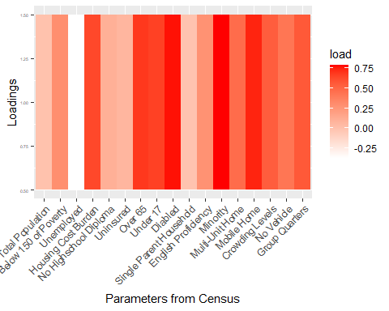

national_level_uniquness

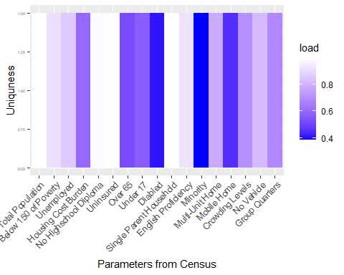

state_level_map

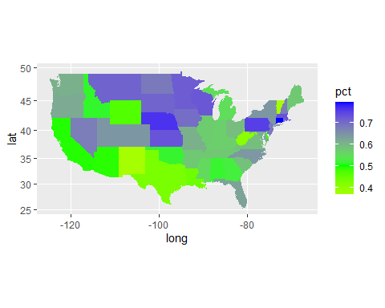

national_level_map

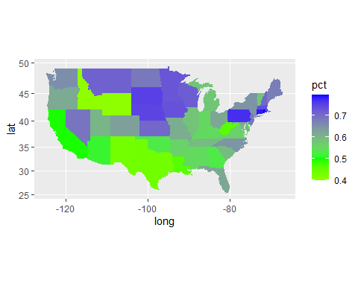

#write out the FA results  
withFIPS <- TRUE  
if(withFIPS == T){  
 write.csv(withStrata, "C:\\Users\\Ecava\\OneDrive\\Desktop\\research\\withStrata.csv", row.names=FALSE)}  
  
  
end.time <- Sys.time()  
time.taken <- end.time - start.time  
time.taken

## Time difference of 1.097538 mins