**Methods [...]**

**Network comparison across ages**. Finally, we estimated and compared the network structures corresponding to the subsample of patients falling into each of the following five developmental stages of adolescence and adulthood: suggested by the World Health Organization:

* early adolescence (11–15, n = 208),
* late adolescence (16–18, n = 314),
* young (or “emerging”, [(Arnett 2000)](https://paperpile.com/c/vEPXYz/fVAu)) adulthood (19 –25, n = 390),
* adulthood (26 +, n = 294),

The above ranges have been adapted from the guidelines suggested by the World Health Organization[1] and supported by the existing literature [(Arnett 2000)](https://paperpile.com/c/vEPXYz/fVAu). A very similar categorization has been already employed by the authors of another study reporting a psychometric network analysis of EDs [(Christian et al. 2020)](https://paperpile.com/c/vEPXYz/AWy7).

Because of the limited number of individuals in the subsample , the fifth category (i.e., middle-late adulthood) was not further considered for analysis.

## Data-driven approach to identify appropriate age intervals

The exact classification of the human life cycle into developmental stages has been largely discussed and solved by many similar (but never perfectly overlapping) biological and/or psychological theories. We propose here a data-driven approach to identify age intervals based on the topological properties suggested by our psychometric data. More precisely, we first inspected the density of graphs resulting from the partition of the sample into age ranges having equal width. As a second step, we also repeated the analysis for the case of equal frequency bins, that is, bins corresponding to partitions into subsamples of equal size.

In the first case, the best performance (i.e., similar density across subsamples) was that corresponding to bins of width = 4, followed by that with width = 5.

In the second case, either the partition into 3, 4 or 5 breaks resulted to be pretty stable.

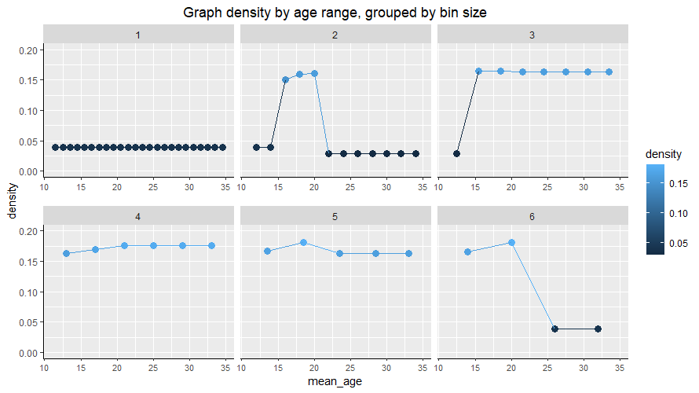

## 

## **Model 3: Network comparison across ages**

## Network estimation

The networks corresponding to each of the four developmental stages under analysis are shown in Figure 1. Very few edges with absolute weight above 0.05 were detected in both the early adolescence and the early-middle adulthood networks, maybe because of the reduced subsample size. In the late adolescence and young adulthood networks few negative edges were also found.

|  | |
| --- | --- |
| **Figure 1.** FGL networks for each developmental stage | |

## Network Stability

### **Edge weight accuracy**

We computed the edge weight accuracy through the nonparametric bootstrap procedure described above. Figure 2 shows the resulting plots.

*[ [ADD INTERPRETATION] Large bootstrapped CIs indicate that many edge-weights likely do not significantly differ from one-another. As with any CI, non-overlapping CIs indicate two statistics significantly differ at the given significance level. The reverse is not true; statistics with overlapping CIs might still significantly differ. ]*

|  |  |
| --- | --- |
|  |  |
| **Figure 2.** Edge-weights accuracy plots for each developmental stage | |

### Centrality indices stability

The results of the case-dropping bootstrap were not as good as for the cross-sample network, probably because of the small subsample sizes. Most of the CS-coefficients were in fact estimated to be below the minimum threshold needed for a reliable interpretation, that, according to the simulation studies carried by Epskamp et al. [(2018)](https://paperpile.com/c/vEPXYz/CE8rM/?noauthor=1) should be preferably above 0.5 and, at any rate, not below 0.25. For more details, please refer to Table 1 and Figure 3.

|  |  |
| --- | --- |
|  |  |
| **Figure 3.** Stability of the centrality indices | |

|  | CS-coefficients | | | |
| --- | --- | --- | --- | --- |
|  | Expected influence | Strength | Betweenness | Closeness |
| Early adolescents | 0.048 | 0.048 | 0 | 0 |
| Late adolescents | 0.207 | 0.127 | 0.051 | 0..051 |
| Young adults | 0.282 | 0.282 | 0.128 | 0.128 |
| Adults | 0.282 | 0.282 | 0 | 0 |
| **Table 1**. CS-coefficients for each developmental stage. Centrality indices are reliable if the corresponding CS-coefficient is not below 0.25, preferably above 0.5 | | | | |

## Network description

### **Connectivity**.

As a consequence of the limited subsample size and small number of detected edges, both the early adolescence and early-middle adulthood networks resulted to be not connected, extremely sparse and characterized by a very low average connectivity.

| (node) connectivity |  | smallest number of vertices whose failure disconnects some pair of vertices |
| --- | --- | --- |
| average (node) connectivity |  | expected number of vertices that must fail in order to disconnect an arbitrary pair of nonadjacent vertices → more reliable communication network |

[TO DO: t-test for average connectivity] We also ran a two-sample T-test to check whether the average connectivity was significantly different between each pair of networks. Result of the comparison between late adolescence and young adulthood:

*# Ttest_indResult(statistic=16.383301756527334, pvalue=1.0747374570147805e-59)*

More details about connectivity of all the networks are reported in Table 2.

| **Network** | **Connected** | **No. of edges** | **No. of clusters** | **Size of connected component** | **Isolated nodes** | **Sparsity (1-density)** | **Average connectivity** |
| --- | --- | --- | --- | --- | --- | --- | --- |
| Early adol. | No | 34 | 56 | 17 | 50 | 0.9889646 | 0.0658877 |
| Late adol. | Yes | 617 | 1 | 79 | - | 0.7997403 | 12.9873418 |
| Young adult. | Tes | 612 | 1 | 79 | - | 0.8013632 | 11.6949043 |
| Adulthood | No | 146 | 12 | 63 | 8 | 0.9526128 |  |
| **Table 2.** *Density and connectivity properties of the symptom network corresponding to GGMs estimated for each developmental stage. All graphs are composed of 79 vertices, while edges vary in number and are intended to be bidirectional.* | | | | | | | |

We also computed the **weighted minimum edge cut** of the late adolescence and young adulthood networks by means of the Stoer-Wagner algorithm implemented in the Python module Networkx. Interestingly, we found that the partition corresponding to the minimum cut was the same for both graphs, with nodes *I have to be careful with my tendency to abuse drugs* (72; ED) and *I have to be careful with my tendency to abuse alcohol* (81; ED) on one side and all the other half. The sum of the edge weights in the minimum cut was instead slightly different: 0.4275838 for the late adolescence graph, and 0.3916729 for the young adulthood graph.

### Centrality measures

The centrality indices rankings computed for each of the four estimated networks are reported in Figure 4. We chose to consider the expected influence only as it resulted to be the most reliable index from the previous stability analysis, even though these results should be taken with care.

Apart from the items *I am preoccupied with the desire to be thinner* (32; DT) and *I think my hips are too large* (45; BD) that figured among the strongest items in all the developmental stages, many differences emerged, in particular:

* the item *I have feelings that I find difficult to identify* (60; ID) scored among the three strongest items in all networks except for the early adolescence one;
* the item *I am terrified of gaining weight* (16; DT) was particularly strong only among adolescents;
* the items *I feel ineffective as a person* (10; LSE) and *I feel that I must do things perfectly or not do them at all* (52; P) was particularly strong only among late adolescents and young adults;
* the items If *I gain a pound, I worry that I will keep gaining* (49; DT) and *I think that my stomach is too big* (2; BD) was particularly strong only among early adolescents;
* finally, the item *I go out of my way to experience pleasure* (-; 71) was the only item with negative expected influence but only in the late adolescence and young adulthood networks.

[ Comparison with cross-sample results ]

|  |  |
| --- | --- |
|  |  |
| **Figure 4.** Expected influence of EDI-3 items for each developmental stage | |

## **Network comparison**

The NCT returned non-significant results for both the network invariance test and the global strength invariance test, therefore differences among individual edges were not further investigated. Nevertheless, the test on centrality measure revealed that six nodes had a significant different expected influence in the two graphs, namely: *I think that my stomach is too big* (2; BD*), the happiest time in life is when you are a child* (14; MF), *I would rather be an adult than a child* (22; MF), *the demands of adulthood are too great* (35; MF), *I feel happy that I am not a child anymore* (39; MF), and *I feel that I really know who I am* (91; PA). Coherently with the dataset partition, most of the differences were found in symptoms belonging to the *“maturity fear”* subscale, suggesting that these items are suitable to assess EDs in adolescent patients but are not useful anymore in case of adult patients. More details about the NCT can be found in Table 3.

|  |  | **Network Invariance** | | **Global Strength Invariance** | | | | **EI Comparison** |
| --- | --- | --- | --- | --- | --- | --- | --- | --- |
|  |  |  | |  | | | |  |
| **N1** | **N2** | **M (observed)** | ***p*-value** | **S(N1)** | **S(N2)** | **S (observed)** | ***p*-value** | **Significant different items** |
| early adol. | late adol. | 0.5 | 0.12 | 1.99 | 34.32 | 32.33 | 0.04 | 3,4,13,14,18,24, 26,31,32,33,38,39,45,46,64,74,83, 84 |
| early adol. | young adults | 0.43 | 0.4 | 1.99 | 33.56 | 31.57 | 0.06 | 3,4,10,22,32,35, 38,39.45,46,51, 64,84,85 |
| early adol. | middle adults | 0.34 | 0.15 | 1.99 | 13.40 | 11.41 | 0.39 | 4,38,46,59,45 |
| late adol. | young adults | 0.24 | 0.02 | 34.3 | 33.6 | 0.77 | 0.3 | 22,35,79 |
| late adol. | middle adults | 0.28 | 0.26 | 34.3 | 13.4 | 20.92 | 0.26 | 2,11,14,29,74 |
| young adults | middle adults | 0.27 | 0.47 | 33.6 | 13.4 | 20.16 | 0.46 | 2,3,6,14,22,39,47 |
| **Table 3**. Summary of NCT results for Model 3. The first two columns indicate the networks under comparison; the third is the value of the maximum difference in edge weights of the observed networks, while the fourth is the corresponding p-value; the fifth and sixth columns indicate the global strength values of each of the two networks, the seventh their difference and the eight the corresponding p-value. Finally, the last column contains the numbers of the EDI-3 items that were found to be significantly different in the two tests under comparison. | | | | | | | | |

Since the results of the invariant network test for the comparison between the late adolescence and young adulthood network indicated that there was at least one significantly different edge (M = 0.24, p = 0.02), we also performed the invariant edge strength test with Bonferroni correction for multiple testing to investigate which edge(s) differed between significantly. The results of this test are shown in Table 4.

| **Edge Strength Invariant Test** | | | | | | |
| --- | --- | --- | --- | --- | --- | --- |
| EDI 18 - DI 20 |  | EDI 16 - DI 49 |  | EDI 55 - DI 73 |  | EDI 74 - DI 82 |
| EDI 03 - EDI 22 |  | EDI 01 - EDI 55 |  | EDI 51 - DI 74 |  | EDI 23 - EDI 83 |
| EDI 17 - DI 22 |  | EDI 10 - DI 56 |  | EDI 57 - DI 74 |  | EDI 04 - EDI 84 |
| EDI 06 - EDI 23 |  | EDI 23 - EDI 59 |  | EDI 40 - DI 76 |  | EDI 23 - EDI 85 |
| EDI 35 - DI 43 |  | EDI 17 - EDI67 |  | EDI 73 - DI 76 |  | EDI 54 - DI 87 |
| EDI 23 - DI 46 |  | EDI 55 - DI 68 |  | EDI 35 - DI 78 |  | EDI 51 - DI 89 |
| EDI 11 - DI 49 |  | EDI 56 - DI 68 |  | EDI 30 - DI 82 |  | EDI 82 - DI 89 |
| EDI 77 - EDI 90 |  | EDI 01 - EDI 91 |  | EDI 86 - DI 91 |  |  |
| **Tabella 4.** Significantly different edges resulted from the edge strength test between the late adolescence and young adulthood network. | | | | | | |

## Discussion

Comparison with Christian et al. <https://www.louisvilleeatlab.com/uploads/1/1/7/6/11768007/christian_et_al._2019_age_networks.pdf>

## Reference List

[Arnett, J. J. 2000. “Emerging Adulthood. A Theory of Development from the Late Teens through the Twenties.” *The American Psychologist* 55 (5): 469–80.](http://paperpile.com/b/vEPXYz/fVAu)

[Christian, C., V. L. Perko, I. A. Vanzhula, J. P. Tregarthen, K. T. Forbush, and C. A. Levinson. 2020. “Eating Disorder Core Symptoms and Symptom Pathways across Developmental Stages: A Network Analysis.” *Journal of Abnormal Psychology* 129 (2): 177–90.](http://paperpile.com/b/vEPXYz/AWy7)

[Epskamp, Sacha, Denny Borsboom, and Eiko I. Fried. 2018. “Estimating Psychological Networks and Their Accuracy: A Tutorial Paper.” *Behavior Research Methods* 50 (1): 195–212.](http://paperpile.com/b/vEPXYz/CE8rM)

1. <https://apps.who.int/adolescent/second-decade/section/section_2/level2_2.php>