Image result for nutritionix logo****Image result for php logoImage result for unity logoImage result for xampp logoImage result for nutritionix logoImage result for mysql logo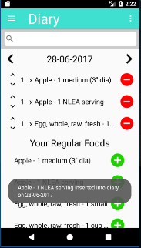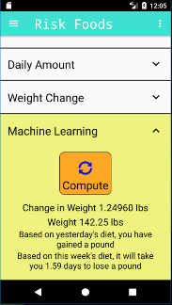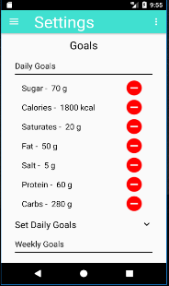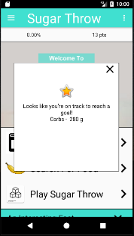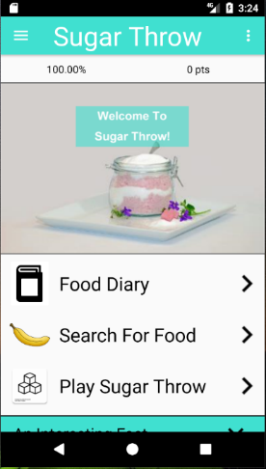

The app is developed in Android and allows the user to utilise an online database to search for foods they have eaten. An SQLite database stores this data into a food diary, which is accessible within the app. The database

also stores information on the user, their

daily and weekly goals, and the nutriti-

onal content of food. The latter table

caches the food contents from the

API, so it is readily accessible.

**User Studies and Evaluation**

To evaluate the app, user studies were conducted on a sample of students. These students were asked about their eating habits and comparisons were made before and after the app was used. The study determined that feedback was the most effective of the three gamification techniques utilised within the app, and showed a significant reduction in sugar consumption from respondents throughout the week. Evaluations were also made on the app itself (users were given open-ended questions to give their feedback on how the app could be improved).

**Machine Learning (Extension)**

Unsupervised machine learning

algorithm (linear regression) was

used to predict potential weight gain

/ loss given a person’s diet. The features

consisted of the percentage contribution to reference intake for calories, fat, sugar, salt, protein, carbs, and saturates. The test data was collected from the user studies and yielded an equation which predicted weight change. The process was then evaluated by looking at my weight change over 2 weeks – found to have better prediction than St.Mifflin-Jeor equation.

**Server/Free-Throw Game**

The SQLite database is local to

each device so data from users

was not accessible. As a result, my

desktop was used as a server so that

an online MySQL database could be used. It

now handles any requests on port 80 and can be

accessed using a dynamic domain name. The app also utilises a free-throw game which users can only play if they have logged foods for that day. This encourages students to track their diets (self-monitoring) and influences them to use the app regularly.

Three Gamification techniques were examined from prior studies and are subsequently used within this app – these are feedback, self-monitoring, and goal-setting. Users are given personalised feedback on their eating

habits and can also set their own goals.

Points are also attainable (for positive

reinforcement). They are gained

when food is logged, a goal is rea-

ched or positive feedback given.

Students are known for their unhealthy lifestyles – research suggests that 59% suffer from malnutrition. Unhealthy behaviours are carried forward into later life, so it is crucial that their habits are improved for them to stay healthy in the future. This project aims to encourage students to eat healthy, with an emphasis on them cutting down on their sugar intake. Subsequently, a gamified smartphone app has been developed to educate students to improve their healthy behaviour and educate them on the risks they are taking.

**Author:** Rich Ellor **Supervisor:** Peter Flach

**Measuring the Effectiveness of a Gamified Smartphone App in Encouraging Healthy Behaviour Amongst Students**

**Sugar Throw**