Multimodal Alzheimer's Disease Diagnostic Model (5-Class): Workflow and Pipelines
Author: YO | Date: October 2026 | Status: Research prototype on fully synthetic data. Not a medical device.
1. Objective and problem statement
Distinguishing the Alzheimer's continuum is hard because the signal is spread across modalities: subjective decline appears in what patients and families report, MCI staging in cognitive scores, and dementia in atrophy and functional loss. Goal: build and deploy one model that fuses structural MRI (vision), clinical notes (text) and cognitive, volumetric and plasma biomarkers (numeric) to classify patients as CN, SMC, EMCI, LMCI or AD, and that keeps working when a modality is missing.
2. Clinical and regulatory considerations
- Intended use: clinical decision support for neurologists and memory-clinic specialists, not autonomous diagnosis. Low-confidence or QC-failed cases are routed to the clinician (refer_to_clinician flag).
- Regulatory path (US): Software as a Medical Device; a novel 5-class diagnostic claim most likely needs De Novo, versus 510(k) for narrower volumetric claims. Follow FDA Good Machine Learning Practice, a Predetermined Change Control Plan for retraining, QMSR (ISO 13485 aligned), IEC 62304, ISO 14971 risk management, and 21 CFR Part 11 audit trails (implemented as PHI-free request logs with model version).
- Privacy: DICOM de-identification (PS3.15 Basic Profile subset, consistent UID remap, date shift), numbers stripped from notes, only de-identified derivatives sent to annotation vendors under a BAA.
- Clinical validity: labels should follow NIA-AA / ADNI criteria with amyloid confirmation; validate across sites, scanners, age, sex and APOE4 status; real-world prevalence differs between memory clinics and primary care (spectrum bias).
3. Tools for end-to-end development and deployment
Stage | Tools
Data and imaging I/O | pydicom, nibabel, tifffile, Pillow, OpenCV, SciPy
DICOM workflow and PACS | pydicom de-identification, pynetdicom (C-ECHO/C-FIND/C-MOVE/C-STORE), DICOMweb (QIDO/WADO/STOW), Orthanc
Curation and annotation | FiftyOne (uniqueness, mistakenness), Roboflow (labelling, versioning), V7 Darwin (expert DICOM/NIfTI annotation)
Modelling | PyTorch, Hugging Face transformers + tokenizers (BERT), Ultralytics YOLO11 (ROI detection), scikit-learn
Deployment | ONNX, ONNX Runtime (CPU/CUDA/TensorRT/CoreML providers), NVIDIA TensorRT + Triton + DeepStream, Core ML, FastAPI, Docker, Kubernetes (HPA, PDB, NetworkPolicy), Prometheus

4. Data and preprocessing
Three synthetic source datasets were generated for 500 patients (CN 130, SMC 80, EMCI 110, LMCI 100, AD 80) with deliberate real-world defects, then harmonized and merged (500 studies x 500 notes x 500 numeric records -> 500 multimodal patients).
- Vision (125 each of .dcm, .nii, .tiff, .jpg): format-specific loaders produce one axial slice; resize to 96x96, percentile rescale, non-local-means denoising when the noise index exceeds threshold, orientation check against a population template, connected-component skull stripping, and brain-masked z-scoring to remove scanner-vendor intensity differences. QC caught and fixed 100% of flipped and high-noise studies with no false positives.
- Text (514 notes): removed 6 duplicates and 8 orphan notes, filled 3 empty notes, expanded clinical abbreviations, replaced numbers, kept the latest note per patient; WordPiece tokenizer trained on the training split only.
- Numeric (515 rows, 21 columns): removed 15 duplicate rows, harmonized IDs and label/sex coding, fixed 103 cm3-to-mm3 unit errors at one site and 6 decimal typos, added missing indicators for plasma markers, then median imputation, log transform and z-scoring fitted on train.
- Merge and split: inner join on harmonized PT-####, stratified patient-level 70/15/15 split (350/75/75). Final tensors: image (500, 1, 96, 96), tokens (500, 96), numeric (500, 22).
5. Model development
Three encoders feed a fusion head: a residual CNN for MRI, a Hugging Face BertModel (2 layers) for notes, and an MLP for numeric features. A gated attention layer weights the three 128-d embeddings per patient (interpretable), modality dropout (25%) trains robustness to missing inputs, and auxiliary per-modality losses stop the model from leaning on the easiest modality. Training used class-weighted cross-entropy with label smoothing, AdamW with one-cycle LR and early stopping on validation macro-F1. Each model was trained with 3 seeds; the best-validation seed is deployed. A YOLO11n detector localizes the hippocampus and lateral ventricles for ROI QC and future high-resolution crops.
6. Performance evaluation and results (held-out test set, n = 75)
Model (mean +/- SD, 3 seeds) | Accuracy | Macro-F1 | Macro AUC
Image only | 0.52 +/- 0.04 | 0.47 +/- 0.03 | 0.85 +/- 0.01
Text only | 0.78 +/- 0.01 | 0.76 +/- 0.01 | 0.95 +/- 0.01
Numeric only | 0.79 +/- 0.00 | 0.78 +/- 0.00 | 0.96 +/- 0.00
Fusion | 0.89 +/- 0.04 | 0.88 +/- 0.05 | 0.98 +/- 0.00

- Deployed fusion model: accuracy 0.92, macro-F1 0.92 (95% bootstrap CI 0.84 to 0.98), macro AUC 0.99, quadratic kappa 0.97. Per-class F1: CN 0.95, SMC 0.92, EMCI 0.87, LMCI 0.90, AD 0.96. Temperature scaling cut calibration error (ECE) from 0.080 to 0.036.
- Missing-modality robustness (macro-F1): all 0.92; without image 0.90; without text 0.78; without numeric 0.75; numeric alone 0.82.
- Subgroups: stable across sex (0.91 / 0.92) and APOE4 status (0.93 / 0.92). JPEG-sourced scans were weakest (0.83 vs 0.94 to 1.00 for lossless formats), so lossy images should be flagged at intake.
- Explainability: modality attention weights, Grad-CAM on the image encoder, and permutation importance (self-reported ECog, CDR-SB and MoCA rank highest). YOLO ROI detector: test mAP50 0.995, mAP50-95 0.93.
- Caveat: the image branch is the weakest component, and n = 75 gives wide intervals; results on synthetic data do not predict clinical performance.
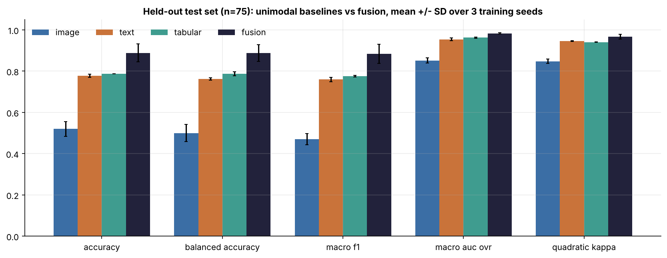  Figure 1. Test performance, mean +/- SD over 3 seeds | 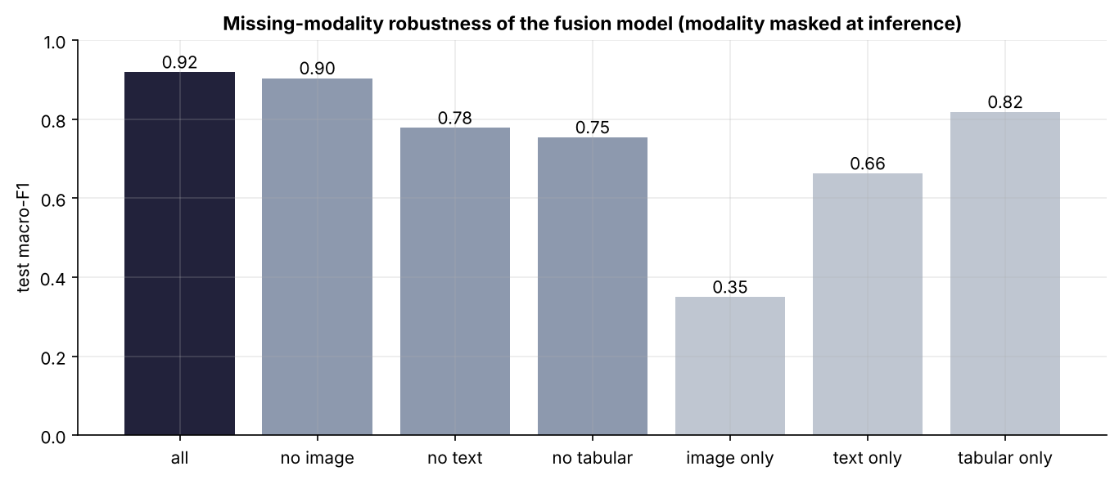  Figure 2. Fusion robustness when a modality is missing
7. Model deployment
The fusion model is exported to ONNX with calibrated softmax built in. ONNX Runtime matches PyTorch exactly (max difference 3e-7, 100% agreement) and runs at 2.0 ms per patient on 2 CPU threads (2.8x faster than PyTorch; 580 patients/s at batch 32). Dynamic INT8 shrinks the model 3.3x with identical predictions but is slower on CPU, so INT8 is reserved for TensorRT with calibration on GPU. The FastAPI service accepts any image format plus note and numeric JSON, applies the identical preprocessing, and returns probabilities, modality weights, QC and a referral flag. It ships as a non-root Docker image and runs on Kubernetes (2 to 10 replicas via HPA, probes, PDB, NetworkPolicy, TLS ingress). High-volume GPU serving uses Triton with TensorRT FP16 and dynamic batching; DeepStream runs the YOLO ROI detector on streamed slices; Core ML export supports on-device inference. PACS integration was verified with C-ECHO and C-STORE (5/5 studies, 0.3 s), and results go back to PACS as a DICOM Secondary Capture.
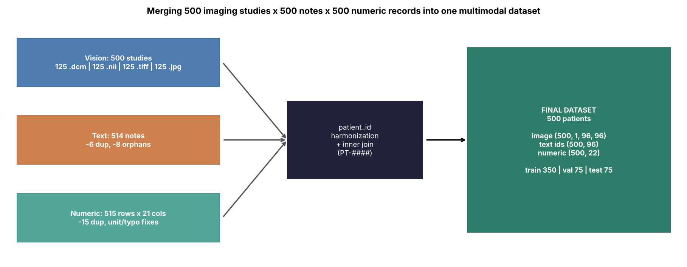  Figure 3. Merging the three source datasets | 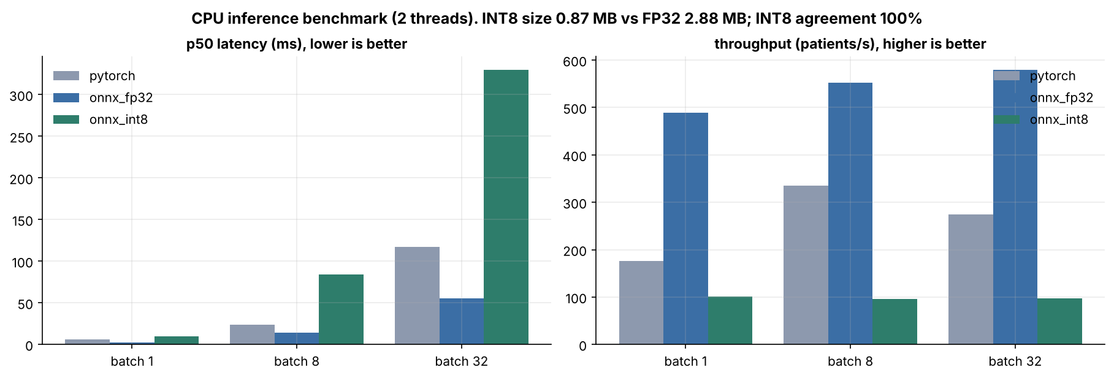  Figure 4. CPU inference benchmark
8. Next steps and post-deployment activities
- Real-data validation: retrain and externally validate on ADNI, AIBL and BioFINDER using 3D T1 volumes, a pretrained 3D backbone and Bio_ClinicalBERT; run a prospective reader study against neuroradiologists.
- Monitoring: track input drift (scanner, protocol, format mix), prediction-class mix, confidence and referral rate through Prometheus; run monthly subgroup performance audits on adjudicated cases.
- Controlled updates: retrain under the PCCP with locked test sets, champion/challenger shadow deployment, and rollback.
- Clinical integration: HL7 FHIR output to the EHR, DICOM SR in place of Secondary Capture, clinician feedback loop into FiftyOne / V7 for relabelling.
- Safety and security: post-market surveillance and complaint handling, annual bias review, SBOM, image signing and penetration testing.

