CX Performance Optimization: One-Pager
Star-schema data model, governed KPI framework and in-house Marketing Mix Model | Brands: DxI Immunoassay, DxH Hematology (Beckman Coulter), PrecivityAD2 (C2N Diagnostics) | 156 weeks x 5 regions x 7 channels | Synthetic data
1. OBJECTIVE / PROBLEM STATEMENT
About $27M/yr of marketing is planned on last year's split and conflicting vendor reports. Leadership needs one governed answer: what did each channel return, where should the next dollar go, and is customer experience improving?
2. CLINICAL AND REGULATORY CONSIDERATIONS
- Aggregated, de-identified commercial data; no patient data or PHI in any table; pseudonymous account IDs (HIPAA).
- Every campaign row carries an MLR approval ID, tying measured activity to approved, on-label content (FDA-cleared IVD labeling; validated LDT claims).
- Congress, webinar and rep activity reconciles to Sunshine Act / Open Payments; budget shifts never change fair-market-value rules (AdvaMed Code). Consent flag enforces email eligibility.
3. TOOLS (END TO END)
Snowflake / Redshift data layer | dbt transforms and tests (proposed) | Python: pandas, SciPy, statsmodels | Power BI semantic model (DAX) | GitHub Actions data-contract CI | Airflow weekly refresh | upgrade path: PyMC-Marketing or Google Meridian.
4. DATA MODEL AND PREPROCESSING
- Layer separation: data (conformed star schema) > semantic (12-KPI catalog, SQL views, DAX; one definition per KPI) > visualization (Power BI).
- Facts: marketing activity (week x brand x region x channel), orders (week x brand x region), CX interactions (one row each). Dims: date, brand, channel, region, campaign, account, touchpoint. 23 data-contract checks (grain, foreign keys, non-negative measures).
- Spend pivoted to brand x region x week; geometric adstock (carry-over) and Hill saturation (diminishing returns); trend, Fourier seasonality and holiday controls; 13-week time-ordered hold-out.
5. MODEL DEVELOPMENT
- Geo-pooled MMM: 780 region-weeks per brand, shared channel parameters, decay searched within business-plausible ranges, media effects constrained >= 0.
- MAP estimation with weakly informative ROI priors and geo lift-test priors for low-spend channels (email, webinars): MMM and experiments triangulated.
- 200-draw block bootstrap for ROI intervals; SLSQP optimizer at flat total budget (channels 0.6x to 1.5x; field force at most -15% per cycle).
6. SUCCESS METRICS AND RESULTS
Metric | Target | DxI | DxH | PrecivityAD2
National R-squared | >= 0.80 | 0.91 | 0.87 | 0.98
13-week hold-out MAPE | <= 10% | 1.8% | 2.1% | 4.2%
ROI vs known truth (correlation) | >= 0.80 | 0.88 | 0.87 | 0.94
Incremental revenue from reallocation, same budget | > 0 | +4.7% | +4.0% | +6.4%
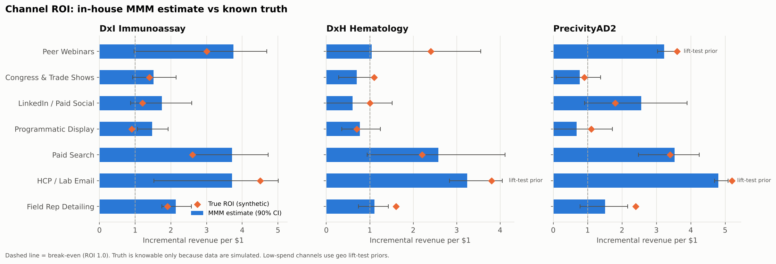
Channel ROI: MMM estimate with 90% interval vs known synthetic truth (reports/figures/analytics/07).
KPI scorecard FY25 vs FY24: NPS 41 (+18 pts) | CSAT top-2-box 75% (+10.7 pts) | first-contact resolution 72% (+8.2 pts) | resolution time 18.7 h (-17%) | revenue +10.1% | cost per order +7.2% (flagged for action).
7. RESULTS / BUSINESS IMPACT
- Portfolio incremental marketing ROI 1.88x; reallocation worth about $2.6M/yr incremental revenue at flat budget, shifting toward paid search, HCP/lab email and peer webinars and away from congress spend and saturated display or social.
- One governed KPI layer replaces conflicting vendor reports; the scorecard links the mid-2024 CX program to measurable service gains.
- Next: geo holdout tests on the two largest proposed shifts before full reallocation.

