CX Predictive Algorithms: One-Pager
Attrition early-warning + Next-Best-Action uplift, proven through a pre-registered A/B pilot | Customers: Beckman Coulter clinical labs and C2N Diagnostics ordering practices | Synthetic data
1. OBJECTIVE / PROBLEM STATEMENT
Outreach is spent on accounts that would order anyway, and at-risk accounts surface only after volume drops. Attrition early-warning ranks 12-month disengagement risk so Customer Success works the riskiest 10% with actionable reasons. Next-Best-Action (NBA) uplift picks whom to contact so outreach changes behavior, and suppresses accounts where it backfires.
2. CLINICAL AND REGULATORY CONSIDERATIONS
- Account-level, de-identified B2B data; no PHI in features, logs or training sets (HIPAA). Not a clinical decision tool and not SaMD.
- Models choose who and when; content comes only from MLR-approved, on-label material (FDA-cleared IVD labeling; validated claims for C2N's CLIA-lab test).
- Consent-gated email (CAN-SPAM, CCPA/CPRA); Sunshine Act / Open Payments logging; no outreach tied to remuneration (Anti-Kickback Statute, AdvaMed Code).
- Responsible AI gates: subgroup AUC parity (within 0.05), reason codes, human-in-the-loop CSM review, model cards, versioned approvals.
3. TOOLS (END TO END)
Snowflake / Redshift feature tables | Python: pandas, scikit-learn, statsmodels, SciPy | MLflow tracking and registry | Airflow | Docker + GitHub Actions CI/CD | Salesforce / Veeva CRM and Marketo activation | Power BI monitoring | PSI drift monitor.
4. PIPELINE AND PREPROCESSING
Generate > engineer > train + calibrate > offline gates > offline policy evaluation > A/B pilot > batch scores to CRM > drift monitor > retrain. Unified service-pain index (instrument downtime for BEC, result turnaround for C2N, z-scored within business); NPS non-response flag with median imputation; log volume; renewal-within-120-days flag; one-hot segments; unit-tested leakage guard.
5. MODEL DEVELOPMENT
- Attrition: logistic regression vs gradient boosting, 5-fold stratified CV, Platt calibration, 30% hold-out; ties go to the simpler model (logistic regression won).
- Uplift: T-learner (treated and control gradient-boosting models) trained on a historical 50/50 randomized campaign.
- Pilot: Arm A = today's rule (top 30% most engaged) vs Arm B = top 30% predicted uplift at equal capacity; one-sided z-test, alpha 0.05, power 0.80, MDE 1.5 pts (8,481 accounts per arm).
6. SUCCESS METRICS AND RESULTS
Product | Metric | Target | Result
Attrition | ROC-AUC (5-fold CV) | >= 0.80 | 0.891 (0.889 +/- 0.008)
Attrition | Top-decile lift / churners captured | >= 3x | 4.6x / 46%
Attrition | Brier score; subgroup AUC range | < 0.10; within 0.05 | 0.083; 0.877 to 0.913
Uplift | Qini coefficient; true uplift top 30% vs random | > 0; > 1.5x | 0.55; 2.4x (9.5 vs 3.9 pts)
Pilot | 60-day conversion lift (ITT) | +1.5 pts, p < 0.05 | +2.75 pts (95% CI 1.77 to 3.74), p = 2e-8
Pilot | Unsubscribe guardrail | <= +0.3 pts | +0.15 pts (pass)
Monitoring | Score PSI; feature PSI | < 0.10; < 0.25 | 0.05; email open rate 0.42 triggers review
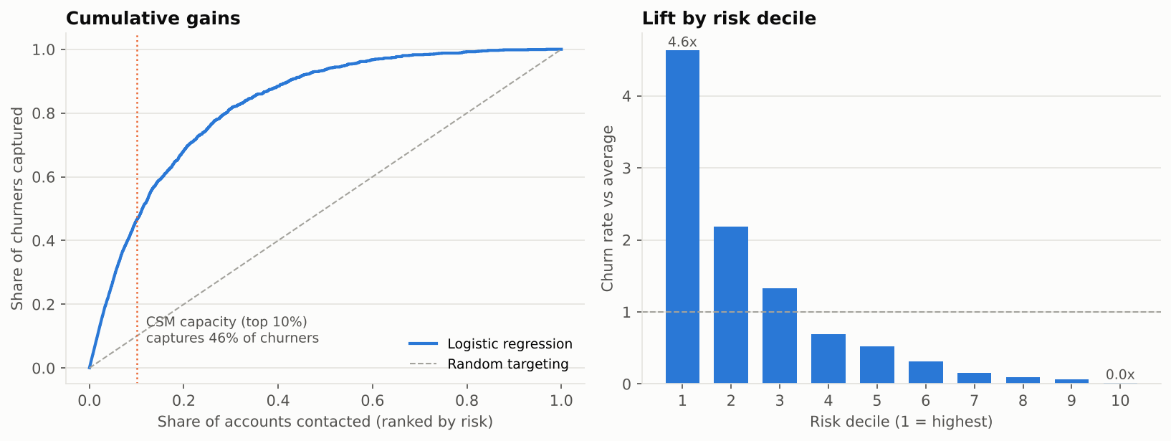
Attrition model: contacting the top 10% by risk captures 46% of churners; top decile churns at 4.6x the average (reports/figures/ml/03).
7. RESULTS / BUSINESS IMPACT
- At an assumed 20% save rate, the worklist retains about 360 accounts per cycle versus about 80 from same-size untargeted outreach (24,000-account book).
- Pilot: +20.5% relative conversion at equal outreach volume, about $0.96M incremental margin per 10,000 accounts ($3,500 per conversion assumed). Decision: ship, scale to Wave 2.
- A response model looked nearly as good offline; uplift won because it also suppresses negative-uplift accounts and protects opt-out rates.

