Setup Python Development Environment

1, Make current directory as git repository

|  |
| --- |
| git init    2, Push all contents of this directory in the repository |

3, In Github create a new repository with same name like local repository

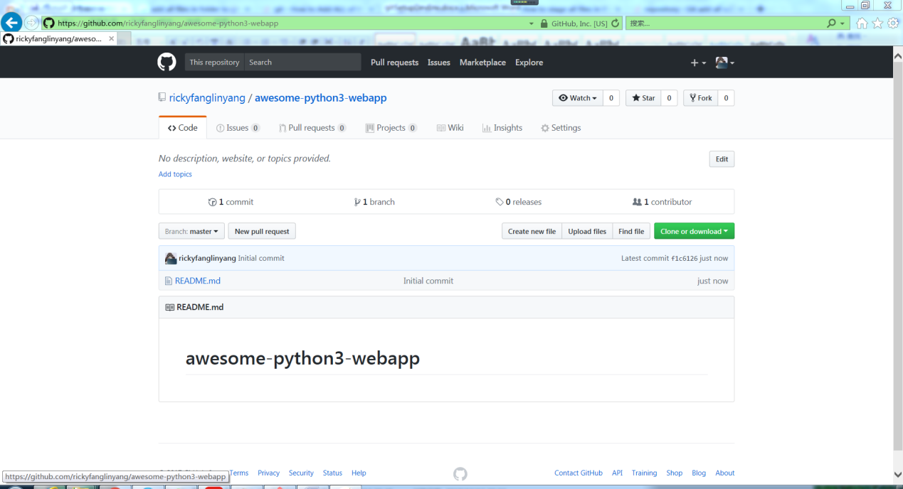

3, Associate local repository and remote repository

|  |
| --- |
| Git remote add origin git@github.com:rickyfanglinyang/awesome-python3-webapp.git |