Instructions (Readme)

1. Our MyUNLV application was developed using MERN stack technologies. This implementation is client side as opposed to server side. The site is currently running on Amazon AWS which proved to be a much bigger challenge than we originally intended. We decided to go the route of MERN and AWS because we wanted to learn something new as well as acquire skills that we’ll need in the real world as Computer Science professionals. Both of these technologies are widely implemented. MERN stack is a set of Open Source components that together, provide an end-to-end framework for building dynamic web applications, starting from the top (code running in the browser) to the bottom (database).

* M stands for MongoDB: database- used by back-end application to store its data as JSON documents
* E stands for Express.js: the back-end framework running on top of Node.js
* R stands for ReactJS: the front-end web application framework, a JavaScript library developed by Facebook.
* N stands for Node.js: JavaScript runtime environment that runs the back-end.

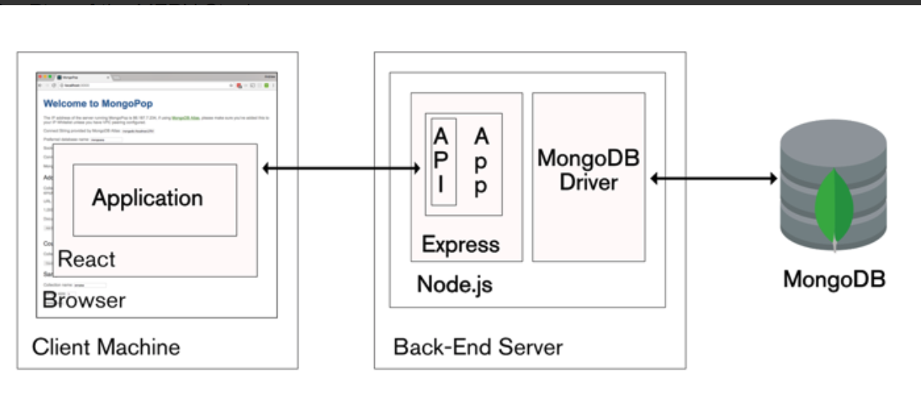

(note: API stands for application programming interface, it is the part of the server that receives requests and sends response(s).)

2. MyUNLV Application URL: <http://myunlv-client.s3-website-us-west-1.amazonaws.com/>

3. Our project was developed on the revision control system, GitHUB, our source code can be found here: <https://github.com/rickyhuang824/my-unlv-webapp>

4. Once you download the source code from github, you can run our project using a local environment after following the next steps below.

* First, install MongoDB and Node, follow the instructions enclosed in the following links specific to your environment:

MongoDB: <https://www.mongodb.com/>

Node: <https://nodejs.org/en/>

* Second: Install the Reactjs by entering following command in your terminal:

npm i -g create-react-app

(note: npm is the node package manager which is installed when you install Node)

* Third: Install the Robo 3T which is the GUI for MongoDB:

<https://robomongo.org/>

* Fourth: Open two additional terminal windows for a total of three:
  + In the first terminal, type the following command in the root directory:

mongod

(note: this will open the MongoDB default port: 207107)

* + In the second terminal, navigate to the “server” directory inside the folder called “my-unlv” and run following command:

npm start

(note: the definition of this command is in package.json file)

* + In the third terminal, navigate to “client” directory inside the folder called “my-unlv” and run the following command:

npm start

(note: this will run the front-end (browser side) and you should see our web-application open up in a new browser window)

Credentials to Login to MyUNLV

NSHE: 200

PW: 123

NSHE: 300

PW:123