- Project eSourcing (Globe Telecom)
E-Sourcing is Globe Telecom’s new way to interact with its suppliers. With this, the company is enhancing its procurement approach and infrastructure in order to maximize the benefits that can be derived in participating in this collaborative environment. Globe made use of its own SMTP server and TxtConnect (Text Messaging Service on web) to communicate with its users, primarily the suppliers.

E-Sourcing has five interfaces, namely:
- Public Site / E-Sourcing Site / EBid Site
This is the main interface of Globe’s E-Sourcing Site. It is where buyers create bid events and auction events for vendors to participate in. This site is accessible privately inside Globe WLAN and through the internet/public.
- Private Site / E-Sourcing Administration Site / EBidAdmin Site
This site is used to manage users, items, etc. Only administrators are allowed to use this site. This site is only accessible inside Globe WLAN.
- Window Service
This window service is responsible for auto updating the database without any user intervention.
- TxtConnect
This is Globe’s text messaging service available through web. E-Sourcing made use of TxtConnect in sending alerts or invitations to vendors’ mobile phones, but is limited to mobile phones within the Philippines only.
- SMTP Server
This is Globe’s SMTP server responsible for sending email invitations, alerts and messages to all users of the system, including bid and auction invitations, password recovery, and other notifications.

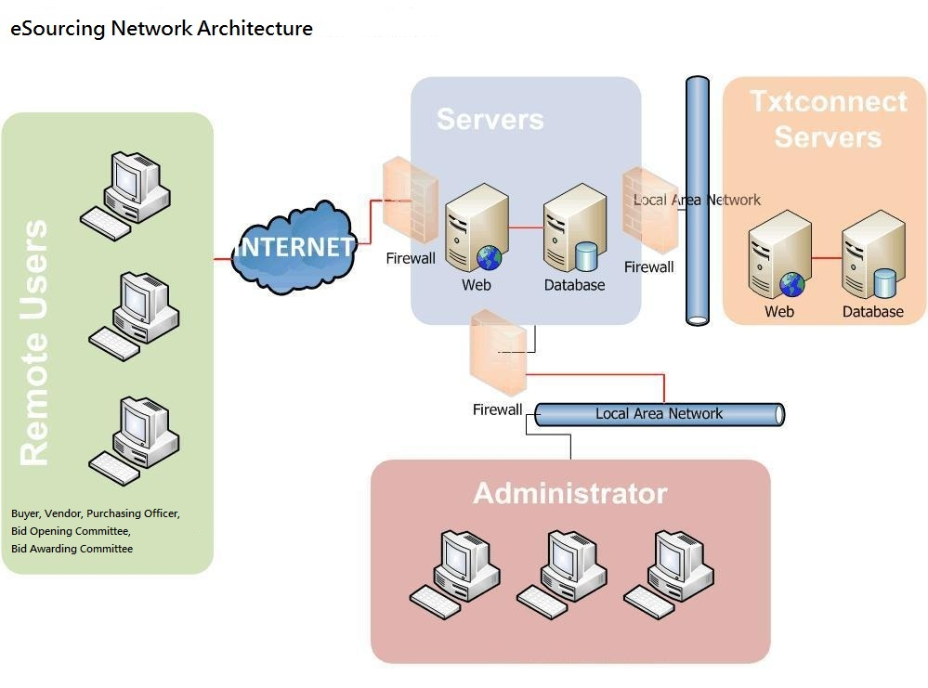

- Project Gold (Globe Telecom)
Project Gold is a middleware platform between WesternUnion and GCash. It facilitates translation of Westernunion Requests to GCash transactions. And returns the appropriate response codes to GCash and WesternUnion for auditing purposes. There are sufficient provisions to support scaling horizontally and vertically. And also features that will enable report generation and investigations from the database and the application logs.

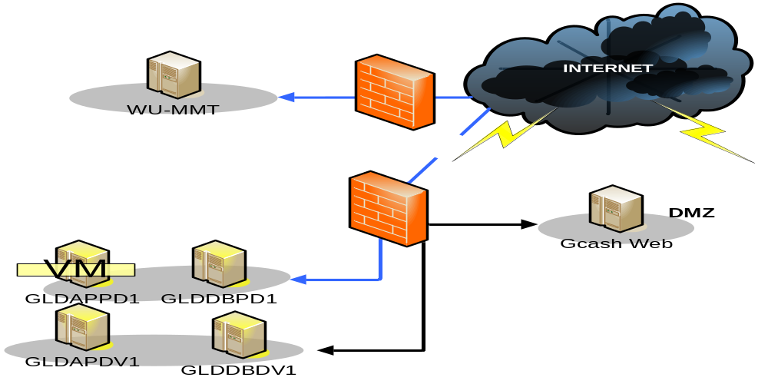

- Project Waterman (Globe Telecom)
Project Waterman is a middleware platform between Remco Agent Partners and WIRE Platform. It facilitates translation of Remco Agent Transactions to WIRE transactions. And returns the appropriate response codes to Wire and Waterman Result Codes for auditing purposes. There are sufficient provisions to support scaling horizontally and vertically.

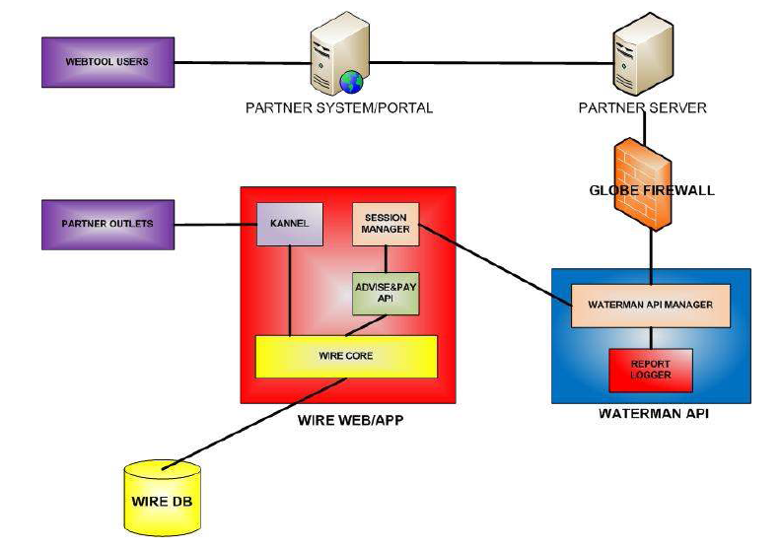

- Project Milestone (Globe Telecom)
Project Milestone is a middleware platform between Yahoo and Unlitxt Platform. It facilitates routing of messaging, subscription mapping and other IM related operations. It has features that will enable report generation and investigations from the application logs.

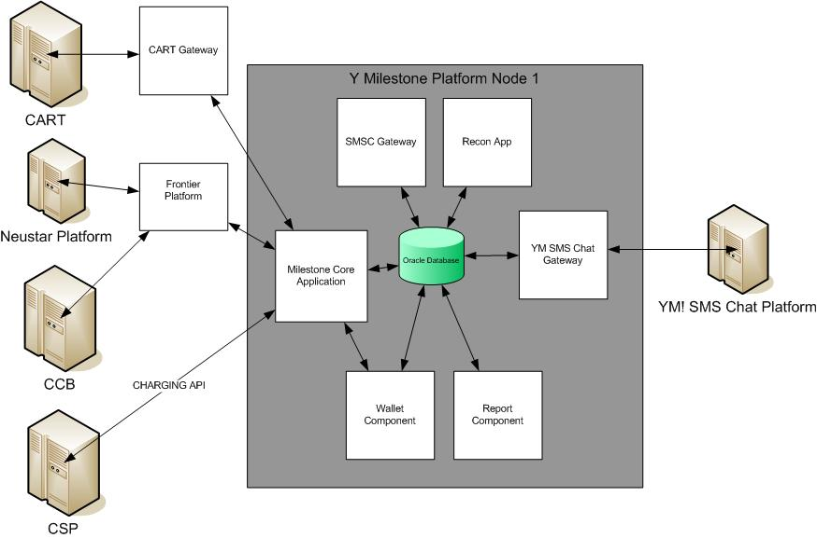

- Project FUN2 (Globe Telecom)
Fun2 is an interface application that will be developed to communicate with each platform. The system will be configurable wherein it will allow simultaneous communication to each platform for one transaction. It may also be configured to allow the result of a communication from one of the components be the dependency or prerequisite before triggering an event or communication to another component. Platform that will be interfaced are: RBT, CCB, IN, HLR, ODS, Geoprobe, and SMP.

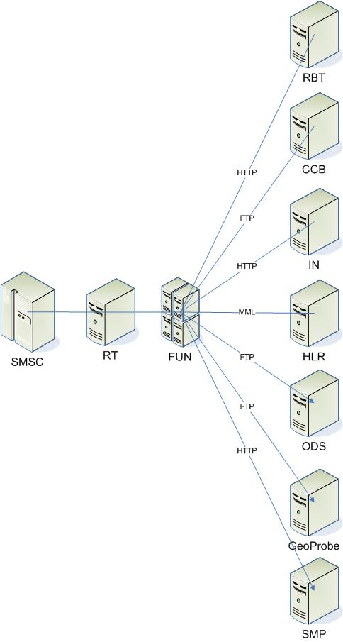

- Project Moneygram (Globe Telecom)
Project Moneygram is a middleware platform between Homesend and GCash. It facilitates translation of Homesend Requests to GCash transactions. And returns the appropriate response codes to GCash and Homesend for auditing purposes. There are sufficient provisions to support scaling horizontally and vertically. And also features that will enable report generation and investigations from the database and the application logs.
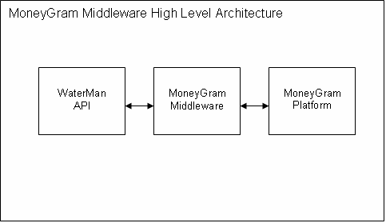

- Chevron CGE System
The three systems – Chemlab, Geoscience and Environmental Systems will be converted to Oracle using Designer/2000 to develop the front-end applications and SQL*Loader to migrate the data from R:BASE to Oracle.
With the use of Designer/2000, the systems models (e. g., Entity-Relationship Diagrams, Function Hierarchy Diagrams) will be stored in a repository that resides in an Oracle database. This will make it possible to generate the screens and reports necessary to support the data and function models within Developer/2000.
SQL*Loader, on the other hand, will be able to read a text file from R:BASE into an Oracle table. The migration details are discussed in a separate section below.
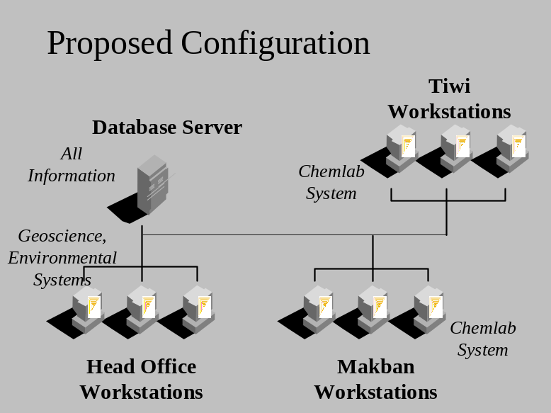The system will be implemented using a client-server technology. This means that the Oracle database will reside on the server running Windows NT while the screens and reports will be installed and run from a client workstation running Windows 95 or Windows NT client. Another alternative is to use an application server which will contain the screens and reports. The client workstations will access the screens and reports on the application s server but will run the executables locally (on the workstations themselves).

- Chevron EASE System
Project EASE (Environmental Aspects Significance Evaluation) is a conversion from MySQL Database using PHP into Oracle Database using ASP.NET to develop the front-end application and SQL*Loader to migrate the data from MySQL to Oracle. The Oracle database will reside on the server running Windows 2000 while the screens and reports will be run from another machine running Windows XP, Windows 2000 or Windows NT. The screens and reports will be accessible via web browser, internet explorer.

- Chevron PTGS System (Pressure Temperature and Gradient)
The current systems for the Production and PTGS Systems are using R:BASE, while the Generation System uses Microsoft Excel. At the same time, the current versions are not Year 2000 compliant. There is now a direction to port the existing systems from R:BASE and Excel to Oracle and to ensure that the systems are Year 2000 compliant.
With the use of Designer/2000, the systems models (e. g., Entity-Relationship Diagrams, Function Hierarchy Diagrams) will be stored in a repository that resides in an Oracle database. This will make it possible to generate the screens and reports necessary to support the data and function models within Developer/2000.
SQL*Loader, on the other hand, will be able to read a text file from R:BASE into an Oracle table. The migration details are discussed in a separate section below.

- Chevron RTRE System

- Chevron - LTS System (Library Tracking)

- Chevron - Document Management System

- Chevron - Landuse Information Management System

- South Star Drug - Point Of Sale System

- Peterson – Inventory and Trading System

- Oceanic – Waybill System

- Oceanic – Human Resource Information System

- TPJ – Catch System

- TPJ – Human Resource Information System

- TPJ – Inventory System

- TPJ – Payroll System

- TPJ – Accounting System

