單變量黃金時間數列分析

林子立

2025-05-18

## ── Attaching packages ─────────────────────────────────────── tidyverse 1.3.2 ──  
## ✔ ggplot2 3.5.1 ✔ dplyr 1.1.4  
## ✔ tibble 3.2.1 ✔ stringr 1.5.0  
## ✔ tidyr 1.3.0 ✔ forcats 0.5.2  
## ✔ purrr 1.0.2   
## ── Conflicts ────────────────────────────────────────── tidyverse_conflicts() ──  
## ✖ dplyr::filter() masks stats::filter()  
## ✖ dplyr::lag() masks stats::lag()  
##   
## 載入套件：'zoo'  
##   
##   
## 下列物件被遮斷自 'package:base':  
##   
## as.Date, as.Date.numeric  
##   
##   
## Registered S3 method overwritten by 'quantmod':  
## method from  
## as.zoo.data.frame zoo   
##   
## Rows: 14497 Columns: 2  
## ── Column specification ────────────────────────────────────────────────────────  
## Delimiter: ","  
## dbl (1): LBMA Gold Prices - daily - euro - AM (LBMA/gold_D/gold_D_EUR_AM)  
## date (1): period  
##   
## ℹ Use `spec()` to retrieve the full column specification for this data.  
## ℹ Specify the column types or set `show_col_types = FALSE` to quiet this message.  
## Rows: 10268 Columns: 2  
## ── Column specification ────────────────────────────────────────────────────────  
## Delimiter: ","  
## dbl (1): DCOILWTICO  
## date (1): observation_date  
##   
## ℹ Use `spec()` to retrieve the full column specification for this data.  
## ℹ Specify the column types or set `show_col_types = FALSE` to quiet this message.  
##   
## 載入套件：'aTSA'  
##   
##   
## 下列物件被遮斷自 'package:tseries':  
##   
## adf.test, kpss.test, pp.test  
##   
##   
## 下列物件被遮斷自 'package:graphics':  
##   
## identify  
##   
##   
##   
## 載入套件：'forecast'  
##   
##   
## 下列物件被遮斷自 'package:aTSA':  
##   
## forecast

#Step1: Exploratory Data Analysis

##Data Visualization

# 時間向量與價格  
dates <- AU_OIL$Date  
gold <- AU_OIL$GoldPrice_interp  
  
# 繪圖（線圖，不畫 x 軸）  
plot(dates, gold, type = "l",  
 main = "Gold Price Time Series",  
 ylab = "Gold Price",  
 xlab = "Date",  
 xaxt = "n") # 不畫預設 x 軸  
  
# 建立每年 1 月 1 日的日期向量  
years <- seq(from = as.Date("2010-01-01"), to = as.Date("2025-01-01"), by = "year")  
  
# 標上年份作為 x 軸刻度  
axis(side = 1, at = years, labels = format(years, "%Y"))

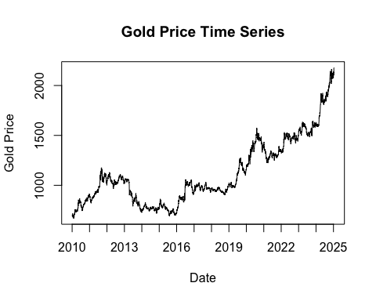

adf.test(gold)

## Augmented Dickey-Fuller Test   
## alternative: stationary   
##   
## Type 1: no drift no trend   
## lag ADF p.value  
## [1,] 0 2.71 0.99  
## [2,] 1 2.52 0.99  
## [3,] 2 2.46 0.99  
## [4,] 3 2.50 0.99  
## [5,] 4 2.54 0.99  
## [6,] 5 2.46 0.99  
## [7,] 6 2.47 0.99  
## [8,] 7 2.46 0.99  
## [9,] 8 2.53 0.99  
## [10,] 9 2.58 0.99  
## Type 2: with drift no trend   
## lag ADF p.value  
## [1,] 0 1.37 0.99  
## [2,] 1 1.18 0.99  
## [3,] 2 1.11 0.99  
## [4,] 3 1.16 0.99  
## [5,] 4 1.24 0.99  
## [6,] 5 1.17 0.99  
## [7,] 6 1.20 0.99  
## [8,] 7 1.16 0.99  
## [9,] 8 1.25 0.99  
## [10,] 9 1.31 0.99  
## Type 3: with drift and trend   
## lag ADF p.value  
## [1,] 0 -0.133 0.990  
## [2,] 1 -0.319 0.990  
## [3,] 2 -0.383 0.987  
## [4,] 3 -0.333 0.989  
## [5,] 4 -0.288 0.990  
## [6,] 5 -0.362 0.988  
## [7,] 6 -0.345 0.989  
## [8,] 7 -0.356 0.988  
## [9,] 8 -0.287 0.990  
## [10,] 9 -0.233 0.990  
## ----   
## Note: in fact, p.value = 0.01 means p.value <= 0.01

此圖呈現的是自2010年以來，LMBA黃金每日拍賣價（AM）的價格。從圖中可以看到，價格以大週期來看可以以2016年為分界找到兩個趨勢。在2016年以前黃金價格經歷先升後降的趨勢；2016年之後則是持續攀升。其中值得注意的現象是，黃金價格兩、三年就會存在一次跳動情形，造成短期價格劇烈變化的情況，如2013年終、2016年底、2019年底、2021年初及2024年初。 除了部分時間存在劇烈跳動的價格變化以外，長期趨勢也存在單調遞增與增加速度加快的趨勢。從此觀點出發，合理懷疑此資料序列存在單根。近一步使用Augmented Dickey-Fuller檢定（以下簡稱ADF檢定），可以發現不管有無趨勢(Trend)或飄移（Drift）的加入，以及滯後期為0-9期之間，強烈的證據都指向單根存在於此序列資料中。為了符合對於穩定態（Stationary）資料的統計假設，以下使用常見的資料處理方法：取對數及差分進行探討。

# 時間向量與價格  
dates <- AU_OIL$Date  
gold <- log(AU_OIL$GoldPrice_interp)  
  
# 繪圖（線圖，不畫 x 軸）  
plot(dates, gold, type = "l",  
 main = "Gold Price Time Series",  
 ylab = "Gold Price",  
 xlab = "Date",  
 xaxt = "n") # 不畫預設 x 軸  
  
# 建立每年 1 月 1 日的日期向量  
years <- seq(from = as.Date("2010-01-01"), to = as.Date("2025-01-01"), by = "year")  
  
# 標上年份作為 x 軸刻度  
axis(side = 1, at = years, labels = format(years, "%Y"))

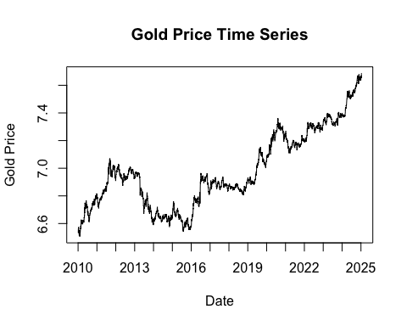

adf.test(gold)

## Augmented Dickey-Fuller Test   
## alternative: stationary   
##   
## Type 1: no drift no trend   
## lag ADF p.value  
## [1,] 0 2.14 0.990  
## [2,] 1 2.01 0.990  
## [3,] 2 1.97 0.988  
## [4,] 3 1.99 0.989  
## [5,] 4 1.98 0.989  
## [6,] 5 1.92 0.986  
## [7,] 6 1.92 0.986  
## [8,] 7 1.92 0.987  
## [9,] 8 1.93 0.987  
## [10,] 9 1.92 0.987  
## Type 2: with drift no trend   
## lag ADF p.value  
## [1,] 0 0.00958 0.956  
## [2,] 1 -0.11378 0.944  
## [3,] 2 -0.15154 0.939  
## [4,] 3 -0.12829 0.942  
## [5,] 4 -0.04057 0.952  
## [6,] 5 -0.09845 0.946  
## [7,] 6 -0.05907 0.951  
## [8,] 7 -0.11796 0.944  
## [9,] 8 -0.07078 0.950  
## [10,] 9 -0.04267 0.952  
## Type 3: with drift and trend   
## lag ADF p.value  
## [1,] 0 -1.15 0.914  
## [2,] 1 -1.30 0.876  
## [3,] 2 -1.34 0.857  
## [4,] 3 -1.31 0.869  
## [5,] 4 -1.27 0.887  
## [6,] 5 -1.34 0.857  
## [7,] 6 -1.32 0.865  
## [8,] 7 -1.35 0.853  
## [9,] 8 -1.32 0.867  
## [10,] 9 -1.31 0.872  
## ----   
## Note: in fact, p.value = 0.01 means p.value <= 0.01

首先嘗試的分析方法為一次差分。從圖中可以發現資料仍舊存在短期的劇烈變動以及穩定的增加趨勢。而且可以發現此增加趨勢似乎沒有緩和的現象，表明此時間數列可能存在單根。是以，近一步透過ADF檢定方法，分析趨勢、飄移及滯後期之下的資料是否存在單根。從檢定結果的報表中可以發現不管有無趨勢(Trend)或飄移（Drift）的加入，以及滯後期為0-9期之間，強烈的證據都指向單根存在於此序列資料中。為了符合對於穩定態（Stationary）資料的統計假設，以下使用常見的資料處理方法：取對數及差分進行探討。

# Step 1: 差分後的價格  
gold_diff <- diff(AU_OIL$GoldPrice_interp)  
  
# Step 2: 調整時間向量（去掉第一天，因為差分少一天）  
dates_diff <- AU_OIL$Date[-1] # 或 tail(dates, -1)  
  
# Step 3: 繪圖（關閉預設 x 軸）  
plot(dates_diff, gold_diff, type = "l",  
 main = "Differenced Gold Price Time Series",  
 ylab = "Differenced Gold Price",  
 xlab = "Date",  
 xaxt = "n")  
  
# Step 4: 標出每年 1 月 1 日的位置  
years <- seq(from = as.Date("2010-01-01"), to = as.Date("2025-01-01"), by = "year")  
  
# 只選擇 years 有在日期範圍內的  
valid_years <- years[years %in% dates_diff]  
  
# Step 5: 畫上 x 軸標籤（以年份顯示）  
axis(side = 1, at = valid_years, labels = format(valid_years, "%Y"))

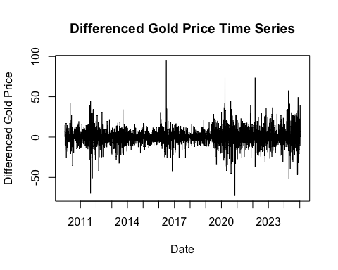

adf.test(diff(AU_OIL$GoldPrice_interp))

## Augmented Dickey-Fuller Test   
## alternative: stationary   
##   
## Type 1: no drift no trend   
## lag ADF p.value  
## [1,] 0 -69.8 0.01  
## [2,] 1 -49.7 0.01  
## [3,] 2 -41.9 0.01  
## [4,] 3 -37.0 0.01  
## [5,] 4 -32.2 0.01  
## [6,] 5 -29.6 0.01  
## [7,] 6 -27.3 0.01  
## [8,] 7 -26.2 0.01  
## [9,] 8 -25.1 0.01  
## [10,] 9 -23.4 0.01  
## Type 2: with drift no trend   
## lag ADF p.value  
## [1,] 0 -69.8 0.01  
## [2,] 1 -49.8 0.01  
## [3,] 2 -41.9 0.01  
## [4,] 3 -37.1 0.01  
## [5,] 4 -32.2 0.01  
## [6,] 5 -29.7 0.01  
## [7,] 6 -27.4 0.01  
## [8,] 7 -26.3 0.01  
## [9,] 8 -25.2 0.01  
## [10,] 9 -23.5 0.01  
## Type 3: with drift and trend   
## lag ADF p.value  
## [1,] 0 -69.9 0.01  
## [2,] 1 -49.8 0.01  
## [3,] 2 -42.0 0.01  
## [4,] 3 -37.1 0.01  
## [5,] 4 -32.3 0.01  
## [6,] 5 -29.8 0.01  
## [7,] 6 -27.5 0.01  
## [8,] 7 -26.4 0.01  
## [9,] 8 -25.3 0.01  
## [10,] 9 -23.6 0.01  
## ----   
## Note: in fact, p.value = 0.01 means p.value <= 0.01

其次，嘗試的資料屬於進行差分處理的資料，從資料來看，雖然仍舊有部分時間的資料有劇烈波動，但是相較前兩個圖形，明顯少了穩定上升的現象。進一步檢測資料的單根，可以發現與前兩個方法完全不同的結果。不論趨勢是否存在以及落後期數，在以0.05的信心水準之下，所以組合的檢定結果都表明這個方法處理的資料不具有單根，合理推測此筆資料適合進行分析。總結來看，透過差分處理的資料不再有單根，僅剩劇烈的波動問題存在於此筆資料。

# Step 1: 差分後的價格  
gold_diff <- diff(log(AU_OIL$GoldPrice_interp))  
  
# Step 2: 調整時間向量（去掉第一天，因為差分少一天）  
dates_diff <- AU_OIL$Date[-1] # 或 tail(dates, -1)  
  
# Step 3: 繪圖（關閉預設 x 軸）  
plot(dates_diff, gold_diff, type = "l",  
 main = "Differenced Gold Price Time Series",  
 ylab = "Differenced Gold Price",  
 xlab = "Date",  
 xaxt = "n")  
  
# Step 4: 標出每年 1 月 1 日的位置  
years <- seq(from = as.Date("2010-01-01"), to = as.Date("2025-01-01"), by = "year")  
  
# 只選擇 years 有在日期範圍內的  
valid_years <- years[years %in% dates_diff]  
  
# Step 5: 畫上 x 軸標籤（以年份顯示）  
axis(side = 1, at = valid_years, labels = format(valid_years, "%Y"))

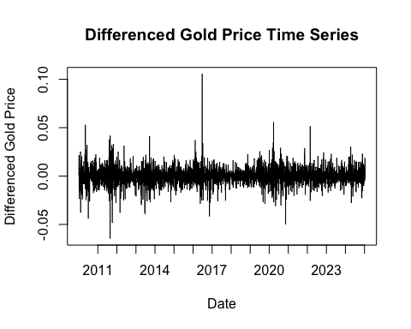

adf.test(diff(log(AU_OIL$GoldPrice_interp)))

## Augmented Dickey-Fuller Test   
## alternative: stationary   
##   
## Type 1: no drift no trend   
## lag ADF p.value  
## [1,] 0 -69.5 0.01  
## [2,] 1 -49.7 0.01  
## [3,] 2 -41.8 0.01  
## [4,] 3 -36.8 0.01  
## [5,] 4 -31.9 0.01  
## [6,] 5 -29.5 0.01  
## [7,] 6 -27.1 0.01  
## [8,] 7 -25.7 0.01  
## [9,] 8 -24.4 0.01  
## [10,] 9 -22.8 0.01  
## Type 2: with drift no trend   
## lag ADF p.value  
## [1,] 0 -69.6 0.01  
## [2,] 1 -49.8 0.01  
## [3,] 2 -41.8 0.01  
## [4,] 3 -36.9 0.01  
## [5,] 4 -32.0 0.01  
## [6,] 5 -29.6 0.01  
## [7,] 6 -27.2 0.01  
## [8,] 7 -25.8 0.01  
## [9,] 8 -24.5 0.01  
## [10,] 9 -22.9 0.01  
## Type 3: with drift and trend   
## lag ADF p.value  
## [1,] 0 -69.6 0.01  
## [2,] 1 -49.8 0.01  
## [3,] 2 -41.8 0.01  
## [4,] 3 -36.9 0.01  
## [5,] 4 -32.0 0.01  
## [6,] 5 -29.6 0.01  
## [7,] 6 -27.2 0.01  
## [8,] 7 -25.8 0.01  
## [9,] 8 -24.5 0.01  
## [10,] 9 -22.9 0.01  
## ----   
## Note: in fact, p.value = 0.01 means p.value <= 0.01

再來，嘗試結合差分與對數處理的方法。從圖中可以看到劇烈波動趨於穩定，且同樣少了長期穩定上升的趨勢，合理推測此種方法不只消除單根、也緩和劇烈波動的現象。進一步檢測資料的單根，可以發現與前兩個方法完全不同的結果。不論趨勢是否存在以及落後期數，在以0.05的信心水準之下，所以組合的檢定結果都表明這個方法處理的資料不具有單根，合理推測此筆資料適合進行分析。 總結個段資料處理方法可以發現，原始資料存在的劇烈波動及穩定上升趨勢（單根），透過結合差分及對數的處理為相對較佳的方法。故而，後續將以此方法進行深入分析與建立解釋模型。

##Data mining

par(mfrow=c(2,1))  
acf(gold_diff, lag.max=300)  
acf(gold_diff, lag.max=50)

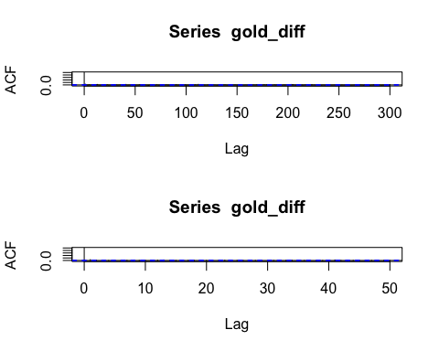

pacf(gold_diff, lag.max=300)  
pacf(gold_diff, lag.max=50)

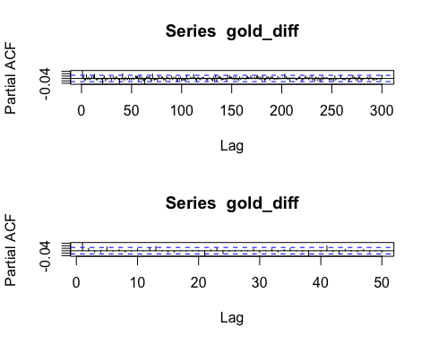

par(mfrow=c(1,1))

AR(1) ,MA(1)

model1 <- arima(log(AU_OIL$GoldPrice_interp), order = c(1,1,1))  
model1

##   
## Call:  
## arima(x = log(AU_OIL$GoldPrice_interp), order = c(1, 1, 1))  
##   
## Coefficients:  
## ar1 ma1  
## 0.2256 -0.1624  
## s.e. 0.1665 0.1678  
##   
## sigma^2 estimated as 5.253e-05: log likelihood = 19256.16, aic = -38506.31

plot(fitted(model1))  
nrow(AU_OIL)

## [1] 5490

lines(1:nrow(AU_OIL), y=log(AU_OIL$GoldPrice), type="l", lwd=2, col="blue")

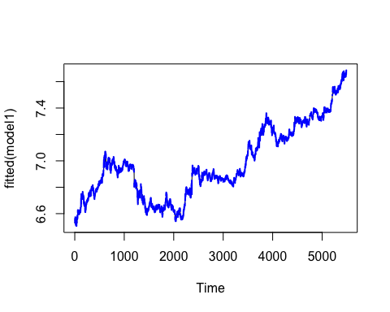

AR1, MA1的模型看起來不錯，

acf(residuals(model1))

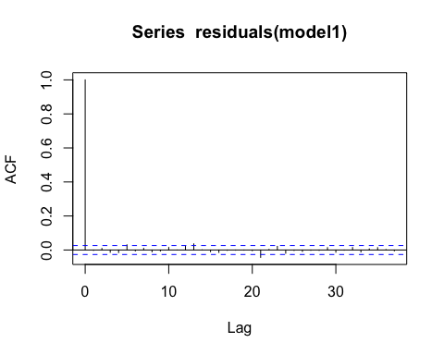

qqnorm(residuals(model1)); qqline(residuals(model1))

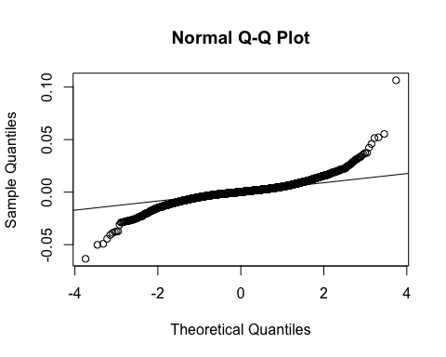

ks.test(residuals(model1), "pnorm")

##   
## Asymptotic one-sample Kolmogorov-Smirnov test  
##   
## data: residuals(model1)  
## D = 0.48664, p-value < 2.2e-16  
## alternative hypothesis: two-sided

library(nortest)  
ad.test(residuals(model1))

##   
## Anderson-Darling normality test  
##   
## data: residuals(model1)  
## A = 119.85, p-value < 2.2e-16

Box.test(residuals(model1), lag = 20, type = "Ljung-Box")

##   
## Box-Ljung test  
##   
## data: residuals(model1)  
## X-squared = 21.921, df = 20, p-value = 0.3448

對殘差作分析，以便符合模型設計。分析問題有：是否為常態、殘差是否有自相關性、變異數是否相等

set.seed(42) # 固定隨機種子  
  
# 假設你用的是模型殘差  
res <- residuals(model1)  
  
# 分組  
n <- length(res)  
half <- floor(n / 2)  
group1 <- res[1:half]  
group2 <- res[(half + 1):n]  
  
# 真實標準差差異  
obs_diff <- abs(sd(group1) - sd(group2))  
  
# 置換檢定  
n_perm <- 10000  
perm_diffs <- replicate(n_perm, {  
 perm <- sample(res) # 隨機重組  
 g1 <- perm[1:half]  
 g2 <- perm[(half + 1):n]  
 abs(sd(g1) - sd(g2))  
})  
  
# p 值  
p_value <- mean(perm_diffs >= obs_diff)  
cat("Permutation test p-value:", p_value, "\n")

## Permutation test p-value: 0

可以發現不管怎麼變動，p值都小於0.01，顯示該筆資料以ARIMA模型配置來說是相當合適得。

library(forecast)  
  
# Fit ARIMA(1,1,1) model  
model1 <- arima(log(AU_OIL$GoldPrice_interp), order = c(1,1,1))  
  
# Extract fitted differences (Δlog_price)  
z_fit <- fitted(model1) # length = N - 1  
  
# Get full time series  
log_gold <- log(AU_OIL$GoldPrice_interp)  
dates <- AU_OIL$Date  
  
# Initialize fitted log-price vector  
log_price_hat <- rep(NA, length(log_gold))  
log_price_hat[2:length(log_gold)] <- z_fit

## Warning in log_price_hat[2:length(log_gold)] <- z_fit:  
## 被替換的項目不是替換值長度的倍數

# Residual standard deviation  
resid_sd <- sd(residuals(model1), na.rm = TRUE)  
  
# CI quantiles  
z95 <- qnorm(0.975)  
z90 <- qnorm(0.95)  
  
# Confidence intervals on log scale  
upper95 <- log_price_hat + z95 * resid_sd  
lower95 <- log_price_hat - z95 * resid_sd  
upper90 <- log_price_hat + z90 * resid_sd  
lower90 <- log_price_hat - z90 * resid_sd  
  
# Plot  
plot(dates, log_gold, type = "l", col = "black", lwd = 1.5,  
 main = "ARIMA(1,1,1) Fitted Values with 95% and 90% CI",  
 xlab = "Date", ylab = "log(Gold Price)")  
  
lines(dates, log_price_hat, col = "blue", lwd = 2)  
lines(dates, upper95, col = "red", lty = 2)  
lines(dates, lower95, col = "red", lty = 2)  
lines(dates, upper90, col = "orange", lty = 3)  
lines(dates, lower90, col = "orange", lty = 3)  
  
legend("topleft", legend = c("Actual log price", "Fitted", "95% CI", "90% CI"),  
 col = c("black", "blue", "red", "orange"),  
 lty = c(1, 1, 2, 3), lwd = c(1.5, 2, 1, 1))

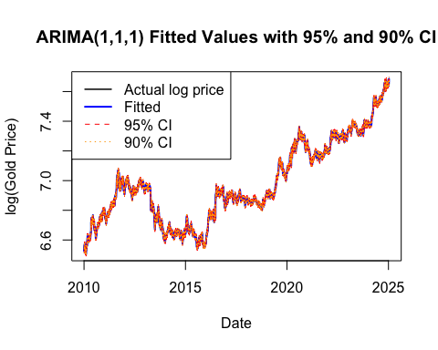 所有的觀測值都落在fitted value的95%信賴區間內

p <-predict(model1, n.ahead = 12)  
exp(p$pred)

## Time Series:  
## Start = 5491   
## End = 5502   
## Frequency = 1   
## [1] 2178.263 2178.295 2178.302 2178.304 2178.304 2178.304 2178.304 2178.304  
## [9] 2178.304 2178.304 2178.304 2178.304

library(zoo)  
roll_sd <- rollapply(log(AU_OIL$GoldPrice_interp), width = 365, FUN = sd, align = "right", fill = NA)  
  
plot(AU_OIL$Date, roll_sd, type = "l",  
 main = "Rolling Standard Deviation (1 Year)",  
 ylab = "SD", xlab = "Date")

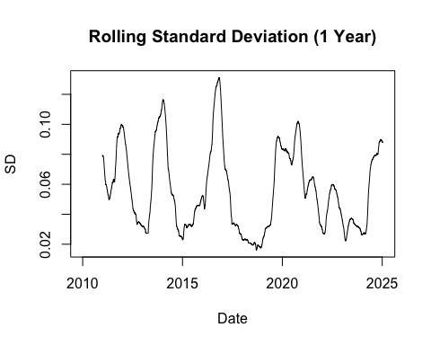 所有的觀測值都落在fitted value的95%信賴區間內