多變量黃金時間數列模型

林子立

2025-06-11

—Section3 Time Series Analysis for the Yield rate of the Treasury Bond

## ── Attaching packages ─────────────────────────────────────── tidyverse 1.3.2 ──  
## ✔ ggplot2 3.5.1 ✔ dplyr 1.1.4  
## ✔ tibble 3.2.1 ✔ stringr 1.5.0  
## ✔ tidyr 1.3.0 ✔ forcats 0.5.2  
## ✔ purrr 1.0.2   
## ── Conflicts ────────────────────────────────────────── tidyverse_conflicts() ──  
## ✖ dplyr::filter() masks stats::filter()  
## ✖ dplyr::lag() masks stats::lag()  
##   
## 載入套件：'zoo'  
##   
##   
## 下列物件被遮斷自 'package:base':  
##   
## as.Date, as.Date.numeric  
##   
##   
## Registered S3 method overwritten by 'quantmod':  
## method from  
## as.zoo.data.frame zoo   
##   
## Rows: 14497 Columns: 2  
## ── Column specification ────────────────────────────────────────────────────────  
## Delimiter: ","  
## dbl (1): LBMA Gold Prices - daily - euro - AM (LBMA/gold_D/gold_D_EUR_AM)  
## date (1): period  
##   
## ℹ Use `spec()` to retrieve the full column specification for this data.  
## ℹ Specify the column types or set `show_col_types = FALSE` to quiet this message.  
## Rows: 10268 Columns: 2  
## ── Column specification ────────────────────────────────────────────────────────  
## Delimiter: ","  
## dbl (1): DCOILWTICO  
## date (1): observation_date  
##   
## ℹ Use `spec()` to retrieve the full column specification for this data.  
## ℹ Specify the column types or set `show_col_types = FALSE` to quiet this message.  
##   
## 載入套件：'aTSA'  
##   
##   
## 下列物件被遮斷自 'package:tseries':  
##   
## adf.test, kpss.test, pp.test  
##   
##   
## 下列物件被遮斷自 'package:graphics':  
##   
## identify  
##   
##   
##   
## 載入套件：'forecast'  
##   
##   
## 下列物件被遮斷自 'package:aTSA':  
##   
## forecast  
##   
##   
## 載入需要的套件：parallel  
##   
##   
## 載入套件：'rugarch'  
##   
##   
## 下列物件被遮斷自 'package:purrr':  
##   
## reduce  
##   
##   
## 下列物件被遮斷自 'package:stats':  
##   
## sigma  
##   
##   
## 載入需要的套件：MASS  
##   
##   
## 載入套件：'MASS'  
##   
##   
## 下列物件被遮斷自 'package:dplyr':  
##   
## select  
##   
##   
## 載入需要的套件：strucchange  
##   
## 載入需要的套件：sandwich  
##   
##   
## 載入套件：'strucchange'  
##   
##   
## 下列物件被遮斷自 'package:stringr':  
##   
## boundary  
##   
##   
## 載入需要的套件：urca  
##   
##   
## 載入套件：'vars'  
##   
##   
## 下列物件被遮斷自 'package:aTSA':  
##   
## arch.test

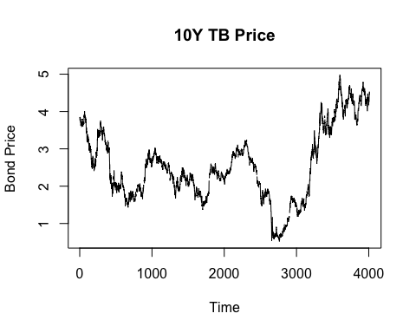

繪圖結果類似

做線性插補

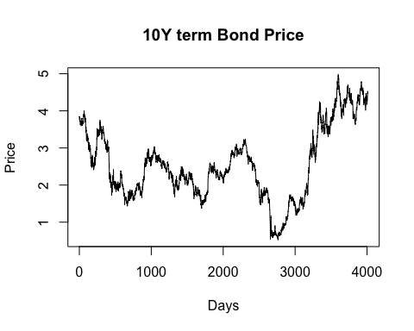

## Augmented Dickey-Fuller Test   
## alternative: stationary   
##   
## Type 1: no drift no trend   
## lag ADF p.value  
## [1,] 0 -0.330 0.549  
## [2,] 1 -0.301 0.557  
## [3,] 2 -0.299 0.558  
## [4,] 3 -0.288 0.561  
## [5,] 4 -0.287 0.561  
## [6,] 5 -0.299 0.558  
## [7,] 6 -0.250 0.572  
## [8,] 7 -0.254 0.571  
## [9,] 8 -0.233 0.577  
## [10,] 9 -0.214 0.582  
## Type 2: with drift no trend   
## lag ADF p.value  
## [1,] 0 -1.41 0.557  
## [2,] 1 -1.39 0.565  
## [3,] 2 -1.34 0.581  
## [4,] 3 -1.32 0.589  
## [5,] 4 -1.33 0.586  
## [6,] 5 -1.34 0.581  
## [7,] 6 -1.29 0.598  
## [8,] 7 -1.27 0.608  
## [9,] 8 -1.25 0.615  
## [10,] 9 -1.24 0.618  
## Type 3: with drift and trend   
## lag ADF p.value  
## [1,] 0 -1.93 0.607  
## [2,] 1 -1.89 0.622  
## [3,] 2 -1.88 0.630  
## [4,] 3 -1.86 0.637  
## [5,] 4 -1.86 0.636  
## [6,] 5 -1.88 0.629  
## [7,] 6 -1.81 0.656  
## [8,] 7 -1.81 0.658  
## [9,] 8 -1.78 0.670  
## [10,] 9 -1.76 0.678  
## ----   
## Note: in fact, p.value = 0.01 means p.value <= 0.01

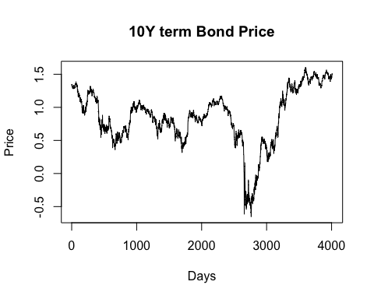

## Augmented Dickey-Fuller Test   
## alternative: stationary   
##   
## Type 1: no drift no trend   
## lag ADF p.value  
## [1,] 0 -0.752 0.410  
## [2,] 1 -0.738 0.415  
## [3,] 2 -0.698 0.429  
## [4,] 3 -0.643 0.449  
## [5,] 4 -0.598 0.465  
## [6,] 5 -0.674 0.438  
## [7,] 6 -0.646 0.448  
## [8,] 7 -0.580 0.471  
## [9,] 8 -0.527 0.490  
## [10,] 9 -0.547 0.483  
## Type 2: with drift no trend   
## lag ADF p.value  
## [1,] 0 -1.85 0.390  
## [2,] 1 -1.84 0.392  
## [3,] 2 -1.74 0.434  
## [4,] 3 -1.63 0.477  
## [5,] 4 -1.54 0.510  
## [6,] 5 -1.69 0.452  
## [7,] 6 -1.66 0.464  
## [8,] 7 -1.51 0.521  
## [9,] 8 -1.42 0.554  
## [10,] 9 -1.47 0.534  
## Type 3: with drift and trend   
## lag ADF p.value  
## [1,] 0 -2.00 0.576  
## [2,] 1 -1.99 0.580  
## [3,] 2 -1.90 0.620  
## [4,] 3 -1.80 0.663  
## [5,] 4 -1.72 0.697  
## [6,] 5 -1.86 0.637  
## [7,] 6 -1.82 0.651  
## [8,] 7 -1.69 0.709  
## [9,] 8 -1.60 0.746  
## [10,] 9 -1.65 0.725  
## ----   
## Note: in fact, p.value = 0.01 means p.value <= 0.01

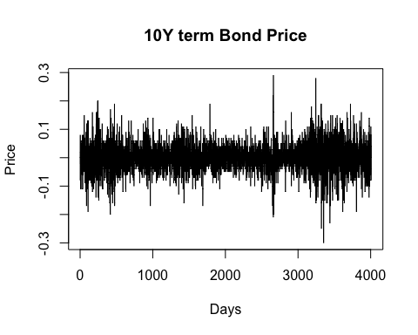

## Augmented Dickey-Fuller Test   
## alternative: stationary   
##   
## Type 1: no drift no trend   
## lag ADF p.value  
## [1,] 0 -63.0 0.01  
## [2,] 1 -46.4 0.01  
## [3,] 2 -37.8 0.01  
## [4,] 3 -32.2 0.01  
## [5,] 4 -28.6 0.01  
## [6,] 5 -26.1 0.01  
## [7,] 6 -24.8 0.01  
## [8,] 7 -23.1 0.01  
## [9,] 8 -21.6 0.01  
## [10,] 9 -19.8 0.01  
## Type 2: with drift no trend   
## lag ADF p.value  
## [1,] 0 -63.0 0.01  
## [2,] 1 -46.4 0.01  
## [3,] 2 -37.8 0.01  
## [4,] 3 -32.2 0.01  
## [5,] 4 -28.6 0.01  
## [6,] 5 -26.1 0.01  
## [7,] 6 -24.8 0.01  
## [8,] 7 -23.1 0.01  
## [9,] 8 -21.6 0.01  
## [10,] 9 -19.8 0.01  
## Type 3: with drift and trend   
## lag ADF p.value  
## [1,] 0 -63.0 0.01  
## [2,] 1 -46.5 0.01  
## [3,] 2 -37.9 0.01  
## [4,] 3 -32.3 0.01  
## [5,] 4 -28.7 0.01  
## [6,] 5 -26.2 0.01  
## [7,] 6 -24.9 0.01  
## [8,] 7 -23.2 0.01  
## [9,] 8 -21.6 0.01  
## [10,] 9 -19.9 0.01  
## ----   
## Note: in fact, p.value = 0.01 means p.value <= 0.01

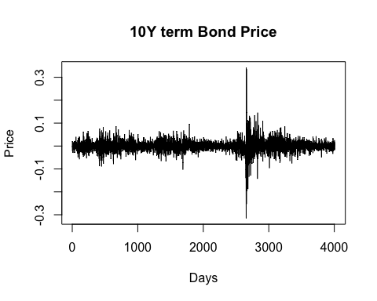

## Augmented Dickey-Fuller Test   
## alternative: stationary   
##   
## Type 1: no drift no trend   
## lag ADF p.value  
## [1,] 0 -63.1 0.01  
## [2,] 1 -47.3 0.01  
## [3,] 2 -40.1 0.01  
## [4,] 3 -35.4 0.01  
## [5,] 4 -28.6 0.01  
## [6,] 5 -26.2 0.01  
## [7,] 6 -26.4 0.01  
## [8,] 7 -25.6 0.01  
## [9,] 8 -22.8 0.01  
## [10,] 9 -20.6 0.01  
## Type 2: with drift no trend   
## lag ADF p.value  
## [1,] 0 -63.1 0.01  
## [2,] 1 -47.3 0.01  
## [3,] 2 -40.1 0.01  
## [4,] 3 -35.4 0.01  
## [5,] 4 -28.6 0.01  
## [6,] 5 -26.2 0.01  
## [7,] 6 -26.4 0.01  
## [8,] 7 -25.6 0.01  
## [9,] 8 -22.8 0.01  
## [10,] 9 -20.6 0.01  
## Type 3: with drift and trend   
## lag ADF p.value  
## [1,] 0 -63.1 0.01  
## [2,] 1 -47.4 0.01  
## [3,] 2 -40.1 0.01  
## [4,] 3 -35.5 0.01  
## [5,] 4 -28.6 0.01  
## [6,] 5 -26.2 0.01  
## [7,] 6 -26.4 0.01  
## [8,] 7 -25.6 0.01  
## [9,] 8 -22.9 0.01  
## [10,] 9 -20.7 0.01  
## ----   
## Note: in fact, p.value = 0.01 means p.value <= 0.01

In this step, we uses 2*2 design factors (log-scaled & Difference) to pre-processing the data. From the graph, it shows that two graph without the differecing processed has the trend to grow unstoppably which may imply the unit root in these series. On the other hand, the two graph with the differenced pre-processed has the obvious zero-mean and no continually growing trend. Also, the ADF test for the series shows that the data has significant evidence to show that the series is stationary. Explore deeper to the data.

Bond_diff<- diff(log(Bond_interp))  
##EDA  
par(mfrow=c(2,2))  
acf(Bond_diff, lag.max=50)  
pacf(Bond_diff, lag.max=50)  
acf(Bond_diff, lag.max=100)  
pacf(Bond_diff, lag.max=100)

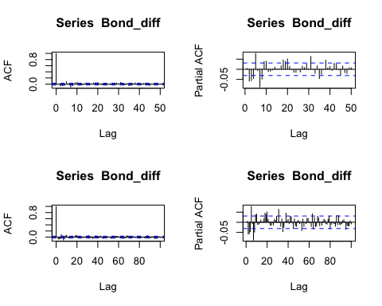

par(mfrow=c(1,1))

ARMA(1,1) model is good for the differenced Bond Price, or ARIMA(1,1,1) model for the non-differenced Bond Price Data.

model1 <- arima(Bond_diff, order=c(1,0,1))  
model1

##   
## Call:  
## arima(x = Bond_diff, order = c(1, 0, 1))  
##   
## Coefficients:  
## ar1 ma1 intercept  
## -0.7608 0.7838 0e+00  
## s.e. 0.1191 0.1144 4e-04  
##   
## sigma^2 estimated as 0.0007032: log likelihood = 8861.6, aic = -17715.21

summary(model1)

##   
## Call:  
## arima(x = Bond_diff, order = c(1, 0, 1))  
##   
## Coefficients:  
## ar1 ma1 intercept  
## -0.7608 0.7838 0e+00  
## s.e. 0.1191 0.1144 4e-04  
##   
## sigma^2 estimated as 0.0007032: log likelihood = 8861.6, aic = -17715.21  
##   
## Training set error measures:  
## ME RMSE MAE MPE MAPE MASE ACF1  
## Training set 9.305988e-06 0.02651837 0.01770416 NaN Inf 0.7217095 -0.01800045

The Auto-Regression model for the data shows the significant effect on the previous data. From the summary, both the coefficient for the AR and MA has the large t-value as well as the high p-value, which support the causality of the previous data for the future data.

Residual Analysis

res1 <-residuals(model1)  
  
Box.test(res1,type="Ljung-Box",lag = 10)

##   
## Box-Ljung test  
##   
## data: res1  
## X-squared = 117.62, df = 10, p-value < 2.2e-16

ad.test(res1)

##   
## Anderson-Darling normality test  
##   
## data: res1  
## A = 58.182, p-value < 2.2e-16

ks.test(res1, "pnorm")

##   
## Asymptotic one-sample Kolmogorov-Smirnov test  
##   
## data: res1  
## D = 0.46517, p-value < 2.2e-16  
## alternative hypothesis: two-sided

kurtosis(res1)

## [1] 25.30319

skewness(res1)

## [1] 0.139799

當我們進行時間序列建模時，殘差的統計檢定結果往往反映出模型能否有效掌握資料的動態特性。本次初步以 ARIMA(1,0,1) 模型對資料進行建構，並進行了兩項常見的殘差診斷：Box-Ljung 自相關檢定與 Anderson-Darling 正態性檢定，藉此探討模型的適配性與殘差特性。

Box-Ljung 檢定結果顯示，統計量為 117.62，在自由度 10 下的 p 值小於 2.2 × 10⁻¹⁶，顯示殘差存在顯著的自相關性。這代表目前所選的 ARIMA 模型尚無法捕捉資料中潛藏的結構特徵。另一方面，Anderson-Darling 正態性檢定亦指出殘差並不符合常態分佈，p 值同樣小於 2.2 × 10⁻¹⁶，顯示殘差分佈可能具有偏態或厚尾的特性。

為暸解殘差的分布特性是否具有偏態或厚尾，本段利用峰值與偏度作為判斷依據。由上表可知，此分布應該不具有偏態，但具有厚尾的現象，顯示誤差的常態分佈假設可能不符合資料型態 。 鑑於此，我們進一步思考是否有更合適的模型能涵蓋資料間潛在的交互影響。在這樣的脈絡下，向量自回歸模型（VAR）成為一個合理且具有彈性的替代方案。與單變數的 ARIMA 模型不同，VAR 模型能同時處理多個時間序列變數，並捕捉它們之間的雙向影響與延遲關係。若原始資料中包含例如某變數的影響或其他共同變動因子，VAR 模型將更能體現這些關聯，並提升模型解釋力與預測準確度。

因此，未來的分析方向應轉向建立合適階數的 VAR 模型，並重新檢定殘差的自相關與正態性，以確保模型的統計性質符合假設。若配合適當的變數選擇與前處理，VAR 不僅有助於修正目前模型的不足，也為理解時間序列變數間的動態交互關係提供更全面的框架。

—Section 3 the Vector Autoregressive model

merged_data_interp <- as.data.frame( merged_data_interp)  
merged_data_interp_diff<-cbind( diff(log(merged_data_interp$Gold)),diff(log(merged_data_interp$Bond)) )  
colnames(merged_data_interp_diff) <-c("Gold_Return", "Bond_Return")  
var_model <- VAR(merged_data_interp_diff, p=1)  
var_model

##   
## VAR Estimation Results:  
## =======================   
##   
## Estimated coefficients for equation Gold_Return:   
## ================================================   
## Call:  
## Gold_Return = Gold_Return.l1 + Bond_Return.l1 + const   
##   
## Gold_Return.l1 Bond_Return.l1 const   
## 0.0543356897 -0.0488383796 0.0001968821   
##   
##   
## Estimated coefficients for equation Bond_Return:   
## ================================================   
## Call:  
## Bond_Return = Gold_Return.l1 + Bond_Return.l1 + const   
##   
## Gold_Return.l1 Bond_Return.l1 const   
## 2.653196e-03 8.097136e-02 3.946201e-05

summary(var_model)

##   
## VAR Estimation Results:  
## =========================   
## Endogenous variables: Gold_Return, Bond_Return   
## Deterministic variables: const   
## Sample size: 5484   
## Log Likelihood: 32737.227   
## Roots of the characteristic polynomial:  
## 0.07457 0.06074  
## Call:  
## VAR(y = merged_data_interp_diff, p = 1)  
##   
##   
## Estimation results for equation Gold_Return:   
## ============================================   
## Gold_Return = Gold_Return.l1 + Bond_Return.l1 + const   
##   
## Estimate Std. Error t value Pr(>|t|)   
## Gold_Return.l1 0.0543357 0.0133572 4.068 4.81e-05 ***  
## Bond_Return.l1 -0.0488384 0.0046302 -10.548 < 2e-16 ***  
## const 0.0001969 0.0000969 2.032 0.0422 *   
## ---  
## Signif. codes: 0 '***' 0.001 '**' 0.01 '*' 0.05 '.' 0.1 ' ' 1  
##   
##   
## Residual standard error: 0.007173 on 5481 degrees of freedom  
## Multiple R-Squared: 0.0237, Adjusted R-squared: 0.02334   
## F-statistic: 66.52 on 2 and 5481 DF, p-value: < 2.2e-16   
##   
##   
## Estimation results for equation Bond_Return:   
## ============================================   
## Bond_Return = Gold_Return.l1 + Bond_Return.l1 + const   
##   
## Estimate Std. Error t value Pr(>|t|)   
## Gold_Return.l1 2.653e-03 3.890e-02 0.068 0.946   
## Bond_Return.l1 8.097e-02 1.348e-02 6.005 2.04e-09 ***  
## const 3.946e-05 2.822e-04 0.140 0.889   
## ---  
## Signif. codes: 0 '***' 0.001 '**' 0.01 '*' 0.05 '.' 0.1 ' ' 1  
##   
##   
## Residual standard error: 0.02089 on 5481 degrees of freedom  
## Multiple R-Squared: 0.006549, Adjusted R-squared: 0.006187   
## F-statistic: 18.07 on 2 and 5481 DF, p-value: 1.513e-08   
##   
##   
##   
## Covariance matrix of residuals:  
## Gold_Return Bond_Return  
## Gold_Return 5.145e-05 -6.680e-06  
## Bond_Return -6.680e-06 4.364e-04  
##   
## Correlation matrix of residuals:  
## Gold_Return Bond_Return  
## Gold_Return 1.00000 -0.04458  
## Bond_Return -0.04458 1.00000

本研究利用向量自回歸（VAR）模型探討金價回報率（Gold_Return）與債券回報率（Bond_Return）之間的動態關係。模型分別對兩個回歸方程式進行估計，並分析其相互影響。在金價回報的回歸方程式中，結果顯示金價回報率的變動主要受到其自身前期回報的影響，且顯示出與債券回報率之間存在負向關聯。具體而言，金價回報的前期回報（Gold_Return.l1）對金價回報率的影響為正，估計係數為0.0543，並且具有顯著性（p-value = 4.81e-05）。與此同時，債券回報的前期回報（Bond_Return.l1）對金價回報率的影響為負，估計係數為-0.0488，顯示出顯著的負向關聯。常數項（const）為0.0002，顯示出即使其他變數為零時，金價回報率亦會呈現微小的正向變動。該方程式的R平方值為0.0237，意味著模型對金價回報率的解釋能力較弱，僅能解釋2.37%的變異性。該模型的F統計量為66.52（p-value < 2.2e-16），顯示出整體模型的顯著性。

在債券回報的回歸方程式中，結果顯示債券回報的變動主要受到其自身前期回報的影響，且此影響具有顯著性。具體而言，債券回報的前期回報（Bond_Return.l1）對債券回報率的影響為正，估計係數為0.08097，並且在統計上具有顯著性（p-value = 2.04e-09）。然而，金價回報的前期回報（Gold_Return.l1）對債券回報率的影響甚微，估計係數為0.0027，且在統計上不顯著（p-value = 0.946）。常數項（const）為0.00004，亦未顯示顯著性（p-value = 0.889）。該方程式的R平方值為0.0065，顯示出模型對債券回報率的解釋能力極為有限，僅能解釋0.65%的變異性。該模型的F統計量為18.07（p-value = 1.513e-08），顯示整體模型的顯著性。

在殘差分析中，金價回報與債券回報之間的殘差協方差為-6.68e-06，顯示出兩者之間存在微弱的負相關性。殘差的相關係數為-0.04458，這進一步強化了金價回報與債券回報之間存在輕微負相關的結論。儘管金價回報與債券回報之間的負向相關性不強，但該結果依然表明兩者之間存在某些程度的聯繫。

總體而言，儘管金價回報與債券回報之間的關聯性較弱，但金價回報仍顯示出一定程度的負向影響。對於債券回報，金價回報的影響並不顯著，表明金價回報與債券回報之間的聯繫相對較弱。模型的解釋能力較低，尤其對債券回報的解釋能力有限，這提示未來研究可能需要引入更多的變數或更為複雜的模型，以提高預測的準確性和解釋力。

# 提取每個變數的殘差  
residual_gold <- residuals(var_model)[, "Gold_Return"]  
residual_bond <- residuals(var_model)[, "Bond_Return"]  
Box.test(residual_gold, type = "Ljung-Box")

##   
## Box-Ljung test  
##   
## data: residual_gold  
## X-squared = 0.19545, df = 1, p-value = 0.6584

qqnorm(residual_gold)  
qqline(residual_gold)

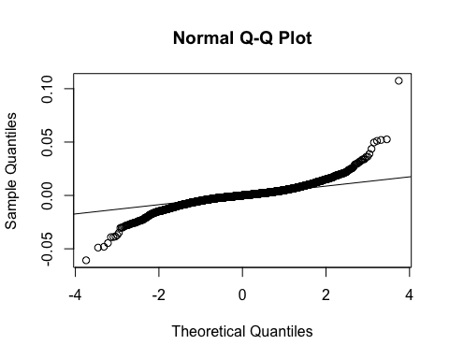

ad.test(residual_gold)

##   
## Anderson-Darling normality test  
##   
## data: residual_gold  
## A = 117.76, p-value < 2.2e-16

在對金價回報率（Gold_Return）殘差進行檢定時，兩項重要的統計檢定結果顯示了不同的結論。首先，根據Ljung-Box檢定的結果（X-squared = 0.19545, df = 1, p-value = 0.6584），我們未能拒絕殘差無自相關的假設。這表明金價回報率的殘差不顯示顯著的自相關性，意味著模型已經適當地捕捉了數據中的時間序列結構，並且殘差的自相關性可以視為隨機的。

然而，根據安德森-達林正態性檢定（A = 117.76, p-value < 2.2e-16），金價回報率的殘差顯著偏離正態分佈。由於該檢定的p值極小，顯示出殘差無法通過正態分佈檢驗，這表明模型的殘差並不符合正態分佈假設。這一結果提示，儘管金價回報率的殘差未顯示自相關性，殘差的非正態性仍需要在後續的模型改進過程中加以考量，可能需要透過轉換或選擇其他模型來進一步改善模型的擬合度。

# 提取每個變數的殘差  
residual_gold <- residuals(var_model)[, "Gold_Return"]  
residual_bond <- residuals(var_model)[, "Bond_Return"]  
Box.test(residual_bond, type = "Ljung-Box")

##   
## Box-Ljung test  
##   
## data: residual_bond  
## X-squared = 0.007025, df = 1, p-value = 0.9332

qqnorm(residual_bond)  
qqline(residual_bond)

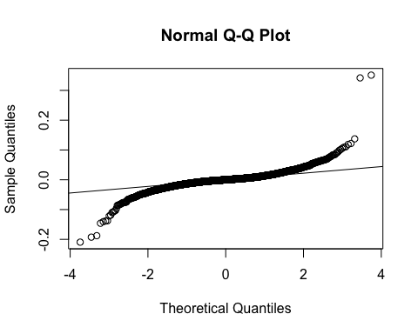

ad.test(residual_bond)

##   
## Anderson-Darling normality test  
##   
## data: residual_bond  
## A = 174.57, p-value < 2.2e-16

在對債券回報率（Gold_Return）殘差進行檢定時，兩項重要的統計檢定結果顯示了不同的結論。首先，根據Ljung-Box檢定的結果（X-squared = 0.19545, df = 1, p-value = 0.6584），我們未能拒絕殘差無自相關的假設。這表明金價回報率的殘差不顯示顯著的自相關性，意味著模型已經適當地捕捉了數據中的時間序列結構，並且殘差的自相關性可以視為隨機的。

然而，根據安德森-達林正態性檢定（A = 117.76, p-value < 2.2e-16），金價回報率的殘差顯著偏離正態分佈。由於該檢定的p值極小，顯示出殘差無法通過正態分佈檢驗，這表明模型的殘差並不符合正態分佈假設。這一結果提示，儘管金價回報率的殘差未顯示自相關性，殘差的非正態性仍需要在後續的模型改進過程中加以考量，可能需要透過轉換或選擇其他模型來進一步改善模型的擬合度。