EQUITY RESEARCH | INITIATION OF COVERAGE | 22 July 2026
DRAFT BUILT ON SAMPLE DATA — ILLUSTRATIVE ONLY, NOT FOR PUBLICATION

PT Bank Rakyat Indonesia (Persero) Tbk
BBRI.JK | Indonesia — Banks
Rating | [SET RATING — assumptions yaml] | P/E (FY25) | 12.2x
Price target (RI fair value) | IDR 3,980 | P/E (FY+1E, own est.) | 11.4x
Last close (2026-07-20) | IDR 4,380 | P/B | 2.0x
Upside / (downside) | -9.1% | Dividend yield | 7.9%
Market cap | IDR 664 tn | ROE / ROA | 16.0% / 2.57%
52-week range | 3,570 – 4,990 | Cost of equity (CAPM) | 11.40%

Analyst: Ricky Reinaldo | Indonesian Equity Research

Investment thesis
[TO WRITE — the system deliberately does not write this. Suggested structure below.]
1. Thesis point 1 — the core reason to own (or avoid) the stock. State it in one sentence, then support it with two or three paragraphs of evidence.
2. Thesis point 2 — what the market is missing or mispricing.
3. Thesis point 3 — the catalyst path and timing.

Company overview
[TO WRITE — franchise, segment mix, funding profile, management, ownership.]

Valuation
Primary methodology is a residual income model — appropriate for banks, where value accrues on book equity. Cost of equity of 11.40% is CAPM-derived: risk-free 6.4% (Indonesia 10Y) + beta 1.00 × equity risk premium 5.0%. ROE fades linearly from 16.0% to 17.0% over 5 years on a 80% payout; beyond the horizon, residual income grows at 5.0% with the sustainable-growth payout of 70.6%. All inputs live in assumptions/BBRI.yaml.
Residual income fair value: IDR 3,982 per share (implied P/B 1.80x, justified terminal P/B 1.88x). DDM cross-check: IDR 3,982. Upside/(downside) vs last close: -9.1%.

Residual income forecast path
 | ROE | BVPS open | EPS | DPS | Residual income | PV of RI
Year 1 | nan | nan | nan | nan | nan | nan
Year 2 | nan | nan | nan | nan | nan | nan
Year 3 | nan | nan | nan | nan | nan | nan
Year 4 | nan | nan | nan | nan | nan | nan
Year 5 | nan | nan | nan | nan | nan | nan
PV of explicit residual income 435 + PV of terminal value 1,330 + opening BVPS 2,217 = fair value 3,982.

Sensitivity — fair value: COE × terminal ROE
COE \ terminal ROE | 15.0% | 16.0% | 17.0% | 18.0% | 19.0%
10.40% | 4,010 | 4,352 | 4,696 | 5,043 | 5,393
10.90% | 3,690 | 3,998 | 4,309 | 4,622 | 4,938
11.40% | 3,419 | 3,699 | 3,982 | 4,267 | 4,555
11.90% | 3,187 | 3,444 | 3,703 | 3,964 | 4,227
12.40% | 2,986 | 3,222 | 3,461 | 3,701 | 3,944
Shaded cell = base case.

Foreign flow monitor
IDX blue chips trade with foreign money, and BBRI is no exception: over the trailing year the correlation between daily net foreign flow and daily returns is 0.55 (0.41 on weekly data). Net foreign flow is +4.9 IDR tn over 3M and +2.6 IDR tn over 12M (data through 2026-07-20). Correlation is contemporaneous co-movement, not a forecasting claim.
 | 1W | 1M | 3M | 6M | YTD | 12M
Net foreign flow (IDR tn) | +0.3 | +2.3 | +4.9 | +2.8 | +2.4 | +2.6
[TO WRITE — interpret positioning: who has been accumulating/distributing, and what would turn the flow.]

Key exhibits
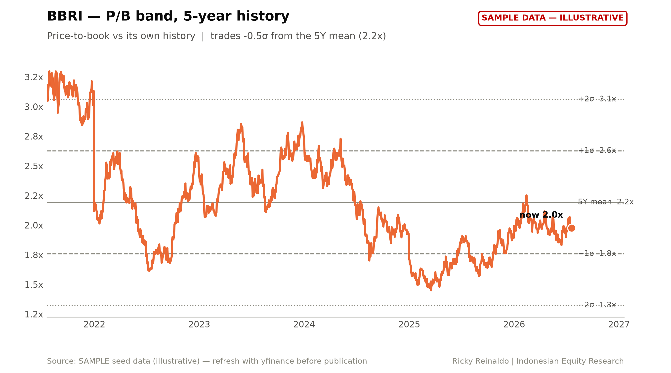
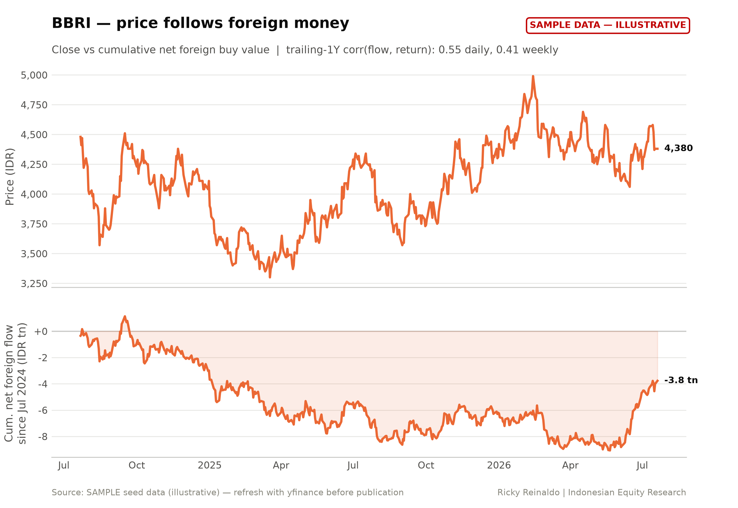
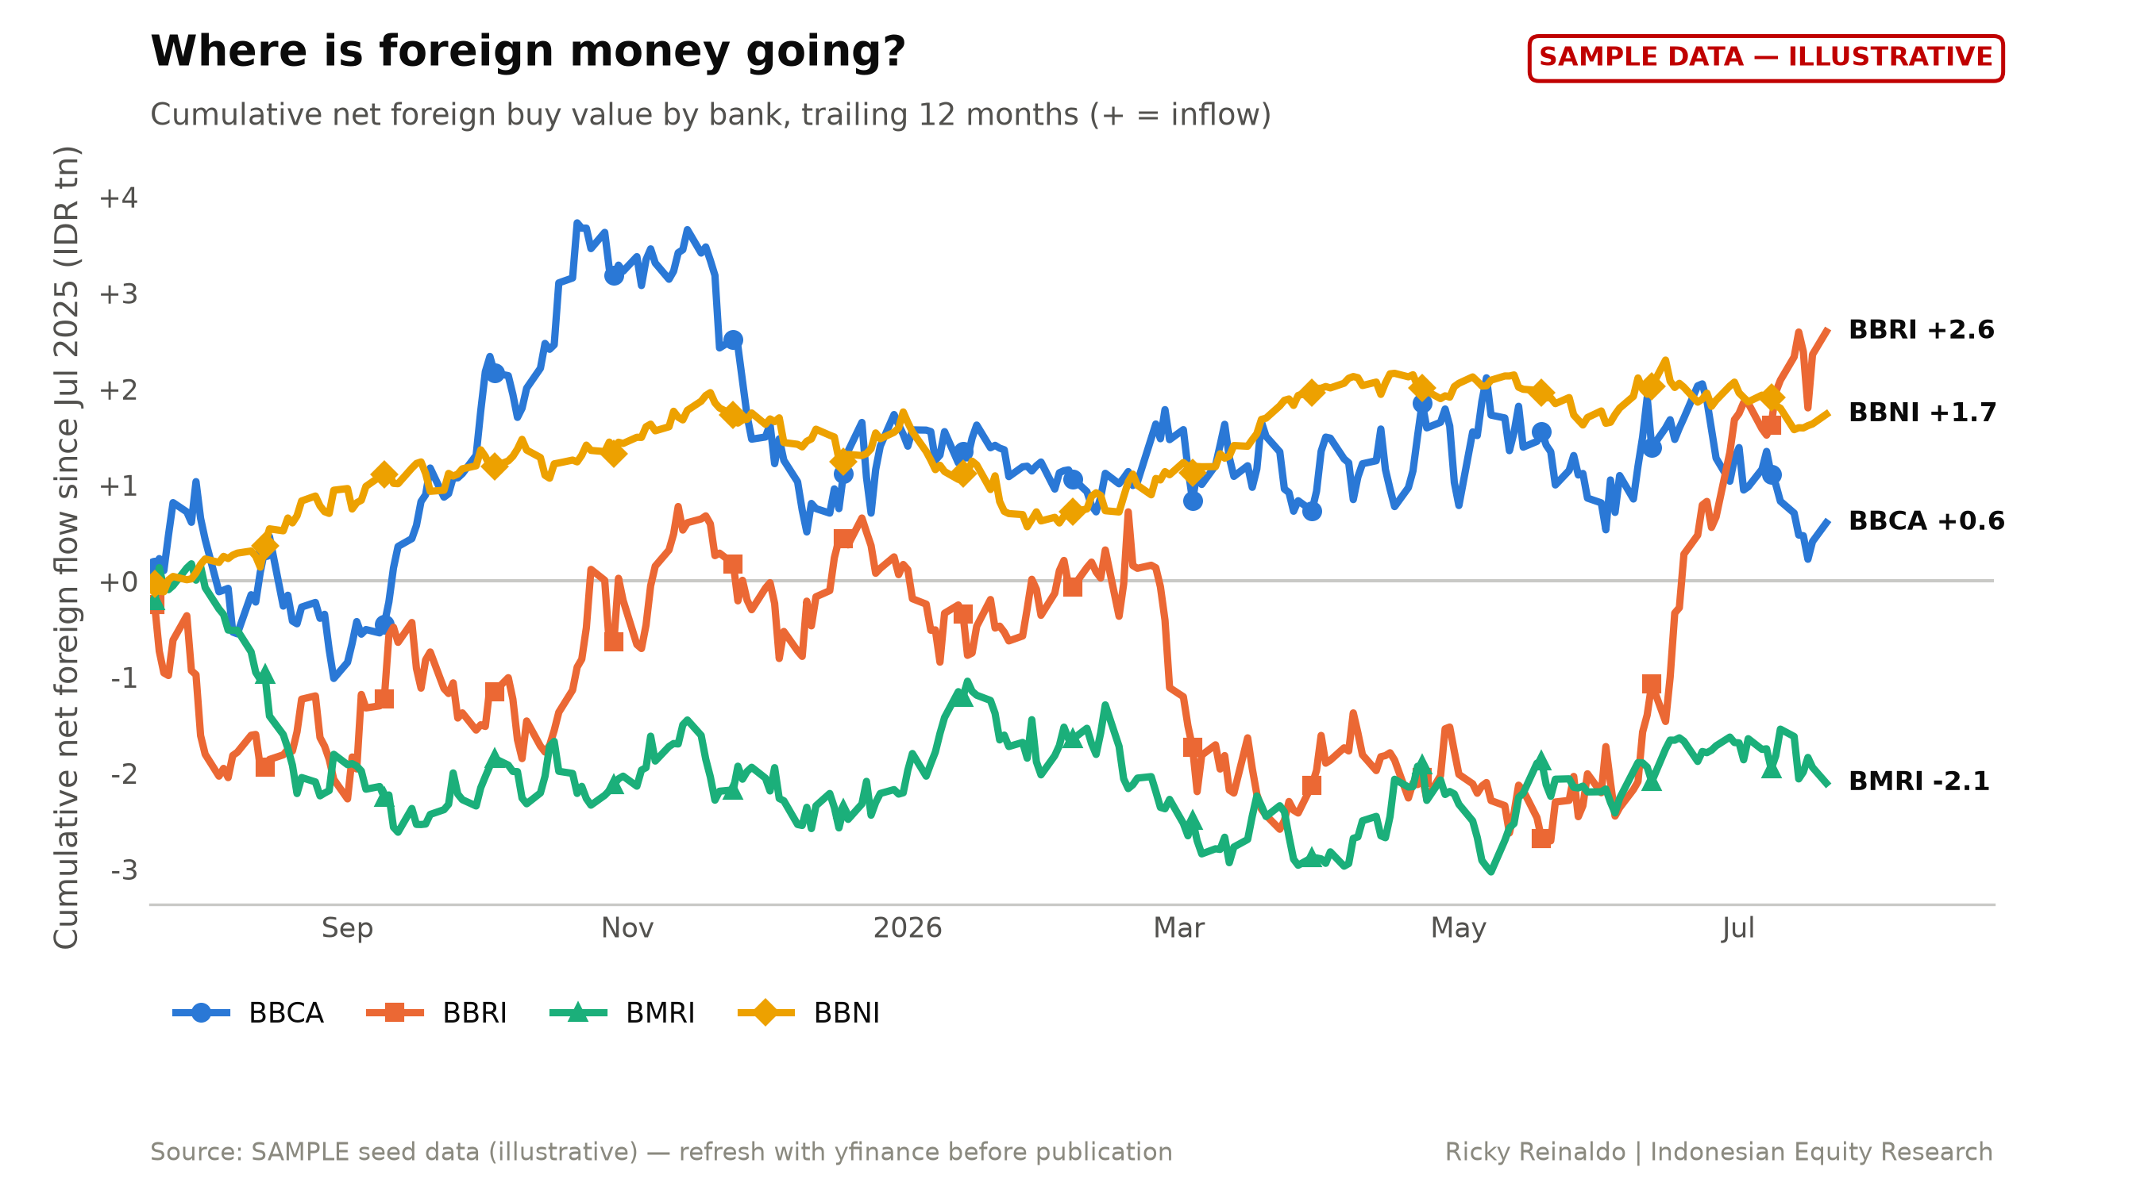
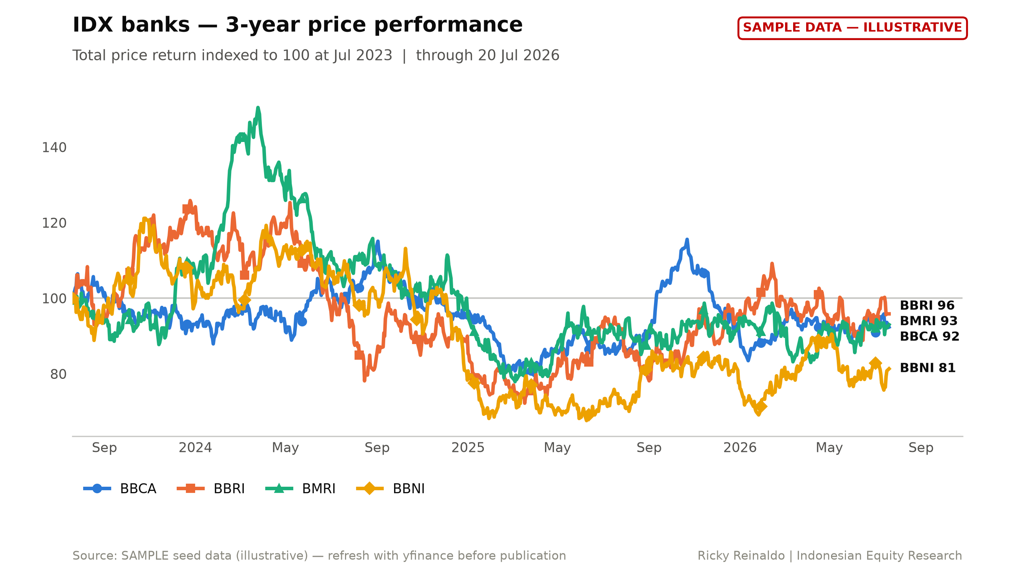
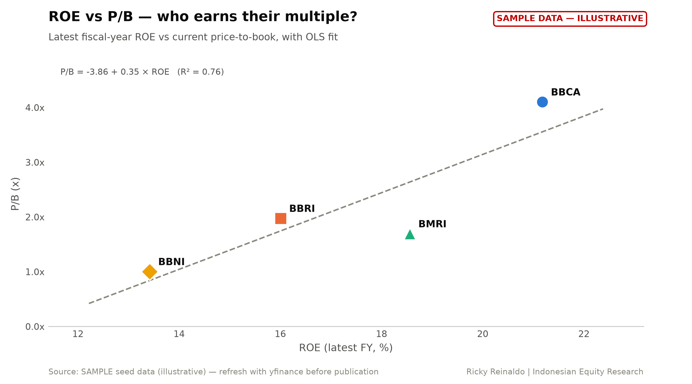
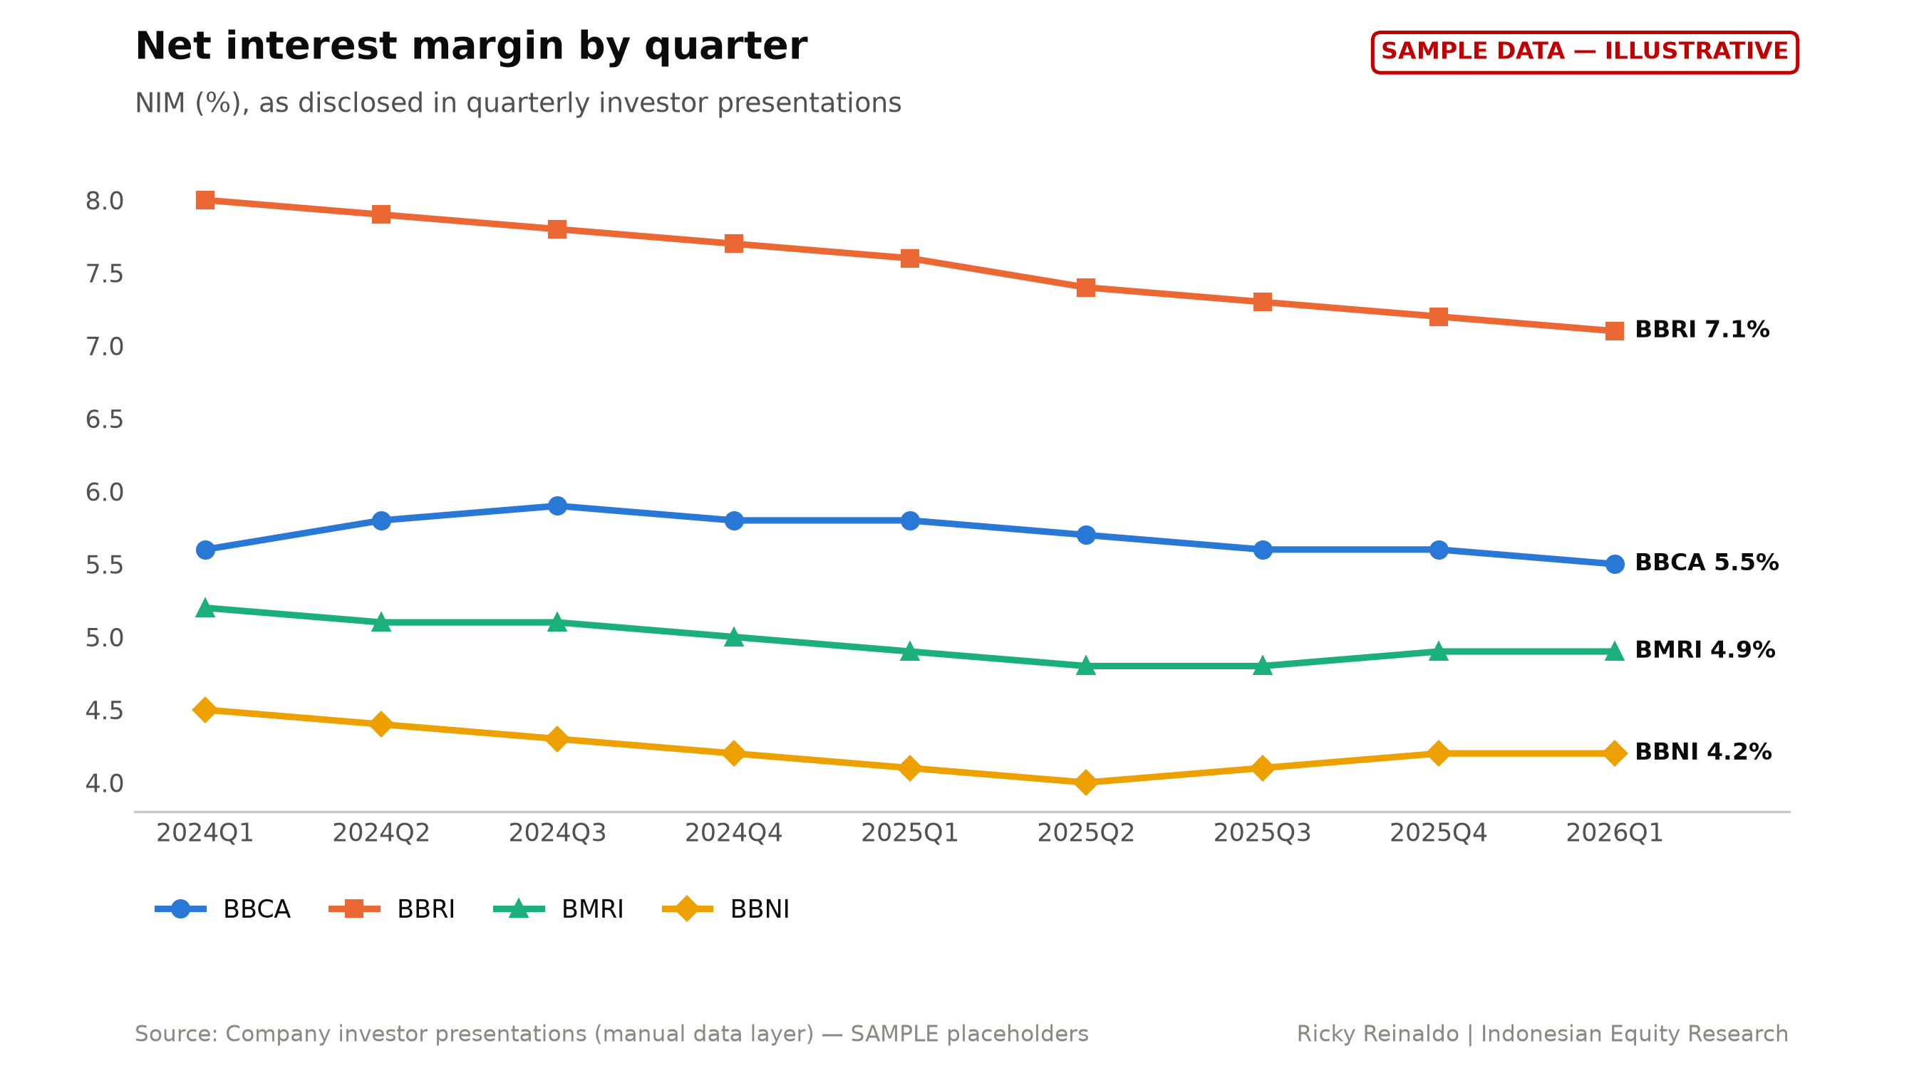
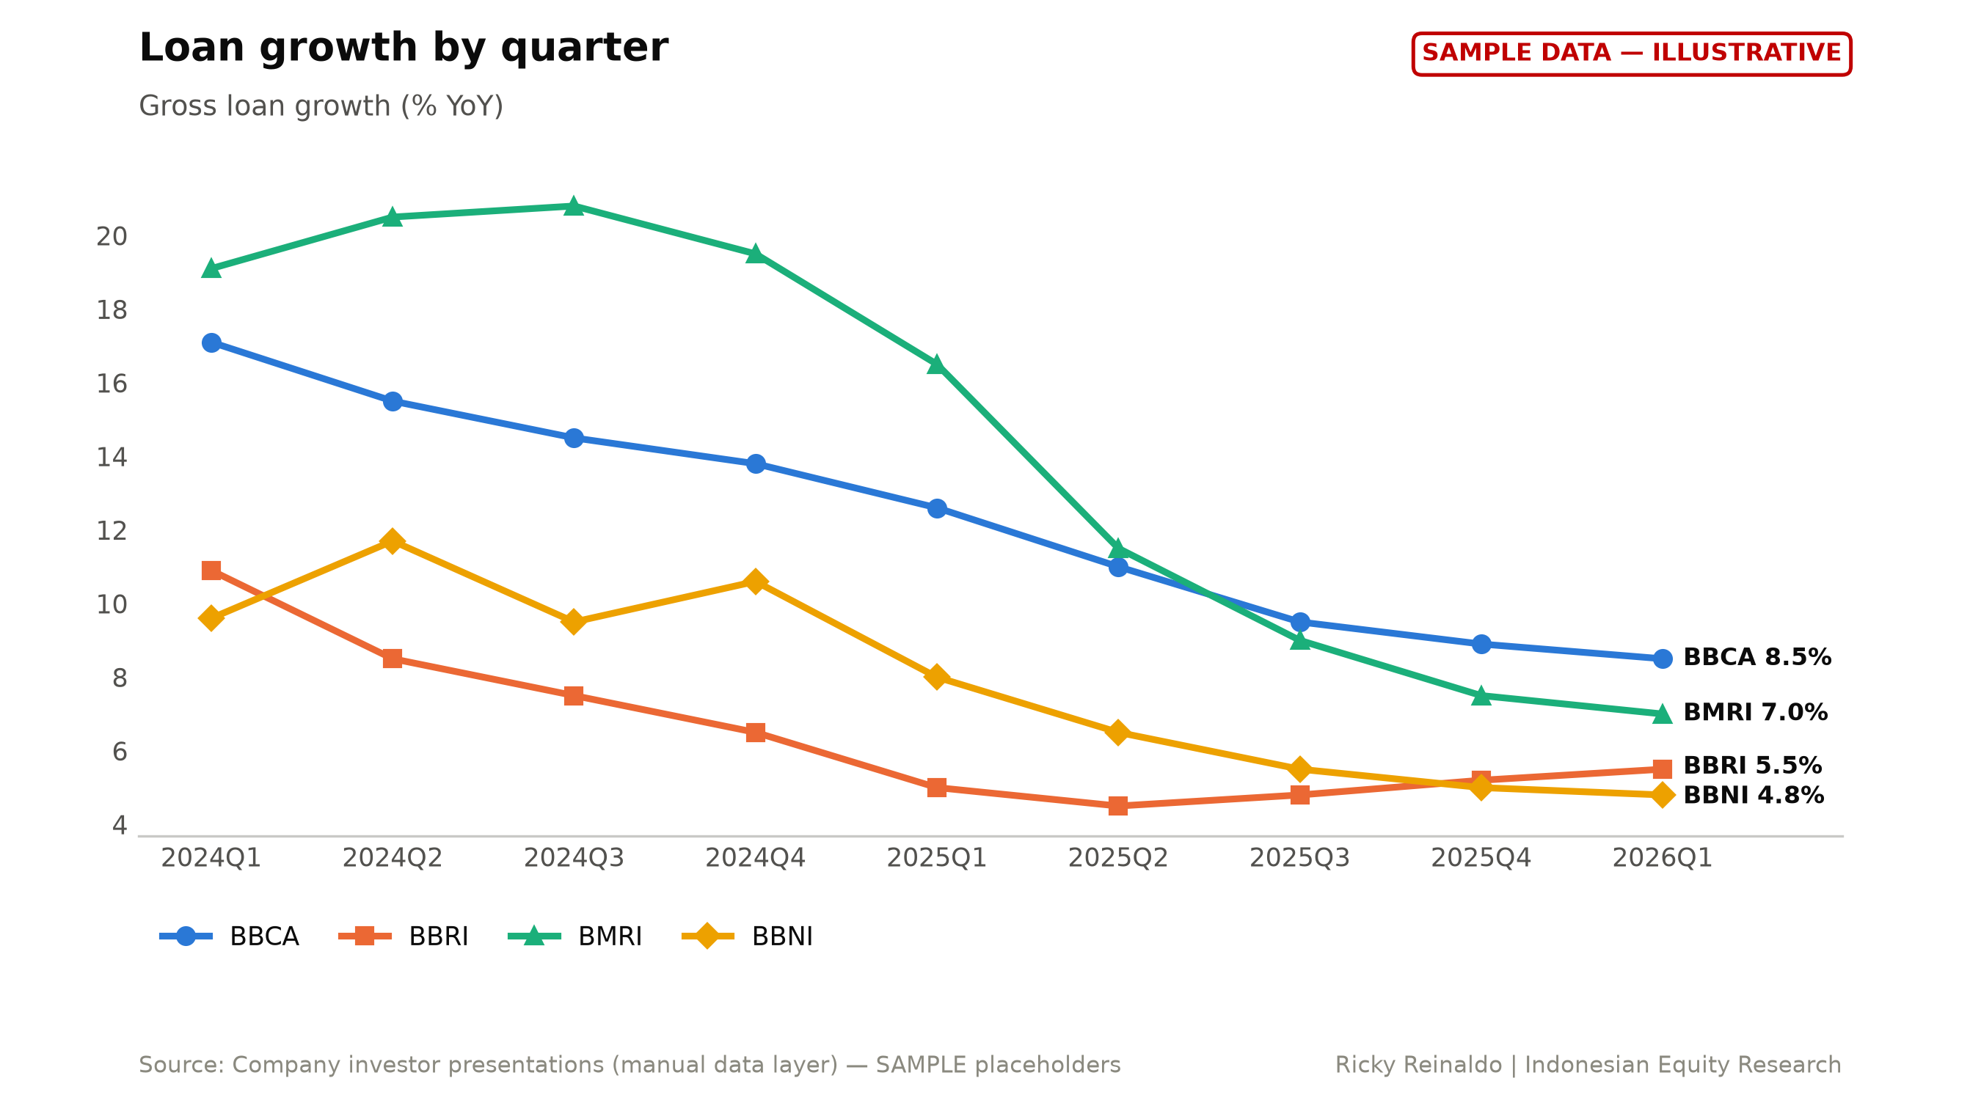

Financials appendix
Annual | FY20 | FY21 | FY22 | FY23 | FY24 | FY25
Net income (IDR tn) | nan | nan | nan | nan | nan | nan
Total equity (IDR tn) | nan | nan | nan | nan | nan | nan
Total assets (IDR tn) | nan | nan | nan | nan | nan | nan
EPS (IDR) | nan | nan | nan | nan | nan | nan
BVPS (IDR) | nan | nan | nan | nan | nan | nan
DPS (IDR) | nan | nan | nan | nan | nan | nan
ROE | 9.2% | 12.5% | 17.2% | 19.3% | 18.2% | 16.0%

Quarterly bank metrics (manual layer)
Metric | 2024Q2 | 2024Q3 | 2024Q4 | 2025Q1 | 2025Q2 | 2025Q3 | 2025Q4 | 2026Q1
NIM | nan | nan | nan | nan | nan | nan | nan | nan
CASA | nan | nan | nan | nan | nan | nan | nan | nan
NPL | nan | nan | nan | nan | nan | nan | nan | nan
CAR | nan | nan | nan | nan | nan | nan | nan | nan
Loan growth YoY | nan | nan | nan | nan | nan | nan | nan | nan
Cost of credit | nan | nan | nan | nan | nan | nan | nan | nan
Cost/income | nan | nan | nan | nan | nan | nan | nan | nan

Risks
[TO WRITE — tailor to the name; generic sector list below.]
• Macro: BI policy path, IDR volatility, sovereign yield moves.
• Asset quality: NPL formation and cost of credit vs assumptions.
• Competition/funding: deposit pricing pressure on NIM.
• Regulatory/political: SoE dividend policy, directed lending.

Disclosures
This material is independent research prepared for educational purposes. It is not investment advice, an offer, or a solicitation to buy or sell any security. Figures may contain errors; verify against primary filings.
Data: Yahoo Finance via yfinance (prices, financial statements); company quarterly investor presentations (bank-specific ratios, transcribed by the analyst); IDX daily trading summary / broker exports (net foreign flow); Bank Indonesia / market data (macro). Forward EPS estimates are the analyst's own — no consensus feed is used.
THIS DRAFT WAS BUILT ON SAMPLE PLACEHOLDER DATA — figures are illustrative and must not be published.

