Test Suite – Login

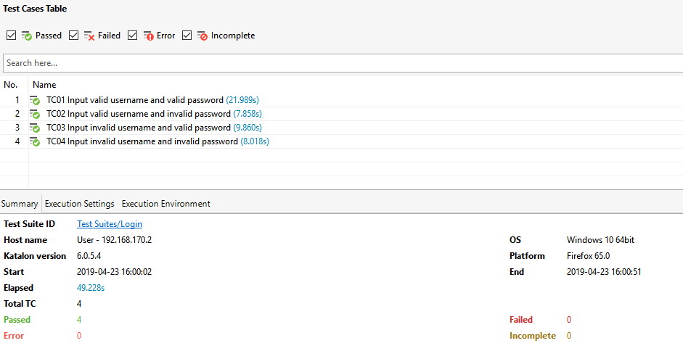

Test Suite – Product List

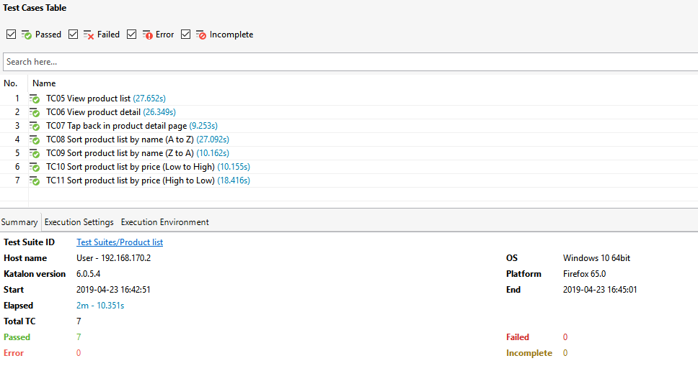

Test Suite – Checkout

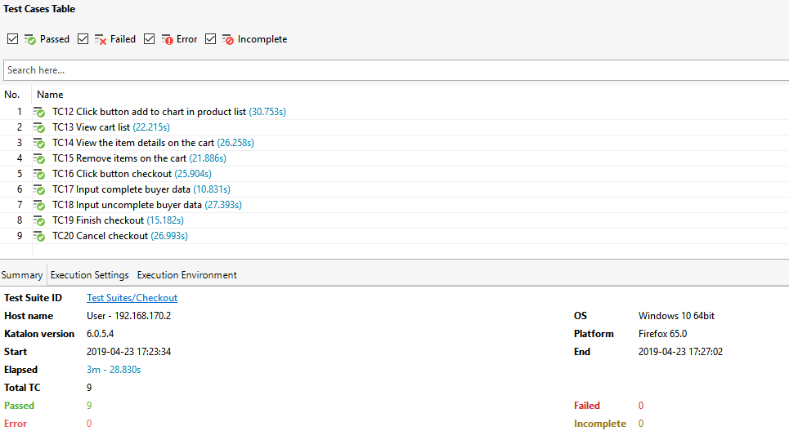

Bug found :

1. Can checkout without any items selected
2. There are no constraints for buyer information, for example the number of characters that can be accommodated, a combination of characters or numbers for names
3. No one can add to the number of items chosen, only 1 per item