Mosquito/Bug Zapper

Report

Project members:

Thomas Suarez, Frank Yee, Ricky Zhang

*This senior design project is supervised by Professor David Westerfeld. The project team consist of three members, two electrical engineers and one computer engineer. This project will utilize skills learned from our classes throughout our engineering programs, circuit design, digital signal processing, programming, etc. The project goal was to create a more effective product than current models in the market. The product was to be able to attract, detect, and eliminate mosquitoes. Current methods of eliminating mosquitoes utilize a bait (typically UV light). Once the target is within the trap, a high voltage electric shock will eliminate anything that makes contact. However, these methods are ineffective towards mosquito population control because the UV bait does not only attract mosquitoes, but other insects as well. Consequently, other insects are also eliminated instead. Our end-product will consist of more advanced methods that will increase chances eliminating our target.*

*We would like to thank Professor Westerfeld for advising us in our circuit analysis, and Professor Monica Bugallo in help with digital signal processing.*

# Table of Contents

* Section 1. Goals and Impacts
* Section 2. Background

1. Survey
2. Project Planning

* Section 3. System Design (ESE 440)

1. Design Constraints
2. Design Considered
3. Final Design

* Section 4. Results and Discussions

1. Multi-Disciplinary Issue
2. Professional/Ethical Issues
3. Impact of Project on Society or Contemporary Issues

* Section 5. Summary and Conclusion
* References

# Section 1. Goals and Impacts

The goal of this project is to demonstrate and design an effective way to control mosquito population through the means of a better mosquito trap. Current consumer grade appliances are not sophisticated enough target mosquitos only. Our specialized bug zapper will record and process the data recovered by a microphone. With recorded data it will then be processed and used to identify mosquitos by sex and species through frequencies.

A better designed mosquito trap will not only improve the overall efficiency of bug zappers, but is also capable of impacting personal health on a global scale. By eliminating female mosquitos in dense human populations, the disease and viruses spread through mosquito blood transmission can be better controlled or even possibly eliminated. Through this means of prevention, it can even save research and development time and money from creating the necessary vaccine/drugs used to combat mosquito borne diseases.

As an alternative use, the device can be configured to not kill but retrieve useful data. Such data includes mosquito population by area, female to male ratios, or even track the frequency of mosquito activity. With the Bluetooth incorporated it can communicate said data with person(s) nearby. The World Health Organization uses information like this for their Malaria Vector Control Strategy [1].

# Section 2. Background

## 2.1 Survey

Mosquito population is an extremely difficult thing to control because of how easily they can reproduce and how they can thrive in many environments [2]. Due to these increasing large populations of both humans and mosquitoes, deadly diseases are easily transmitted from one to the other in very short spans of time.

It can be debated whether keeping eradicating all mosquitoes is beneficial or may have detrimental consequences on the world. Some experts state that they are needed as food for other insects and animals, while others argue that there are almost no negative aspects to eradicating all mosquitoes [3]. Therefore, controlling the mosquito population must be done correctly and accurately.

To control them, many people use bug zappers to eliminate mosquitoes.

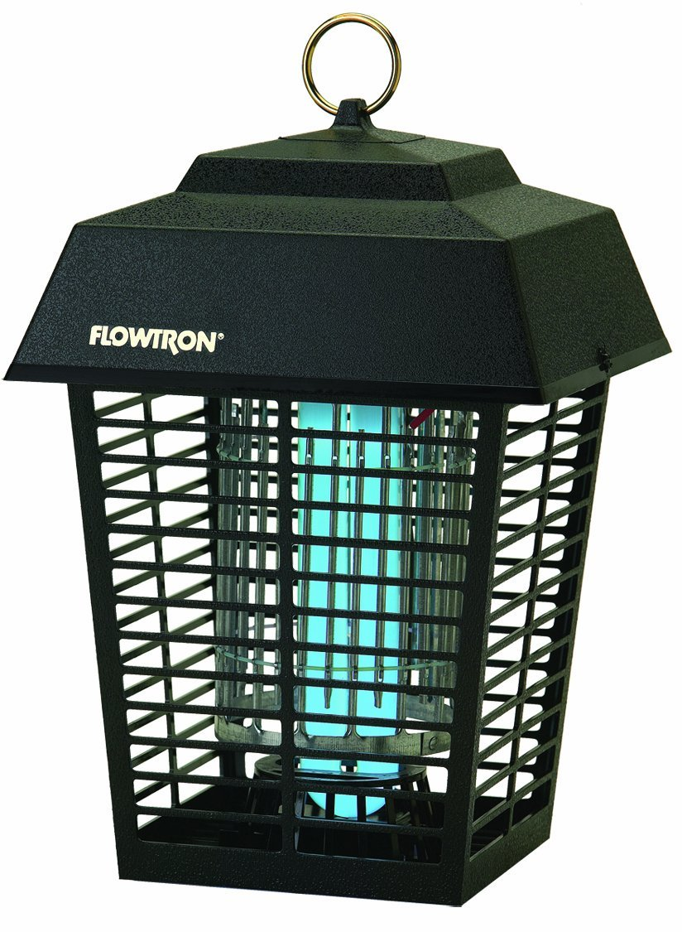

However, these methods are ineffective because mosquitoes are not attracted to UV light, and other insects are harmed instead. Therefore, many products out in the market today do not eliminate the target correctly.

The reason for mosquito population control stems from an article and infographic by Bill Gates [4]. Malaria is one of the deadliest diseases that plague much of the world today, and is a life-threatening blood disease that are contracted by mosquitoes. Other mosquito borne diseases includes Zika and West Nile. With over 9000 cases and 264 human fatalities, due to West Nile virus alone were reported in the U.S. [5] Based on these numbers, it would be of interest to design a mosquito trap with these facts in consideration.

As mentioned earlier, our sophisticated trap utilizes sound and furthermore processes said sound into useful data. The detection of mosquitoes by flight sounds has a long history dating back to 1949 with Offenhauser and Kahn and has continued since. In 2007, a group of engineers created a field deployable acoustic insect flight detector [6]. The device was constructed only to recording insects with no further applications. The recorded data was then analyzed afterwards. The usage of noise cancelling, filtering, and recording aspects of that design is applicable to our design.

One more additional modern design that's under development, is a laser based bug zapper that uses a non-lethal lasers to detect then analyze an object's frequency. If the frequency meets the parameters then a lethal laser is activated and precisely uses the nonlethal laser to aim at the object. [7]

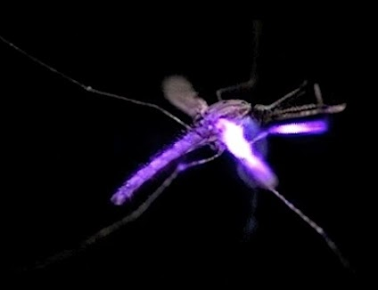

## 2.2 Project Planning

Since our project team consists of two electrical engineers and one computer engineer, work can be split amongst our members. Each member will demonstrate and brief the teammates how the respective design was implemented. The electrical engineers will focus on circuit design, while keeping design constraints in mind. The computer engineer is tasked with programming the computer and digital signal processing of input signals.

Knowledge for circuit design comes from various ESE courses, anything else lacking will come from research as well. Research includes microphone selection, the analog to voltage converter that follows the microphone, and the specifics of the components meant to zap the mosquitoes. For programming the Raspberry Pi, Python will be the main coding language, and the specifics of the language will be researched on to utilize its functions. Familiarity of the Raspberry Pi will be a must, therefore side projects with the Pi to learn basic functionality is to be expected for all teammates. The DSP will be done within the Raspberry Pi, so programming must be specifically tailored, and further research on this topic is required.

Professors have also been a very reliable resource in the beginning of our design. Professor Westerfeld, is a great source of advice for the general outline of the design concerning core components. Professor Monica Bugallo who teaches Communication Theory explains how signals can be processed and analyzed. First, we need to learn to recognize the signal of a mosquito. Then, we must also consider the different species of mosquitos and the different signals that female and male mosquitoes create.

# Section 3. System Design

## 3.1 Design Constraints

There are several design constraints and tradeoffs in our project.

1. Speed and Performance

Can our signal be passed through the circuit quick enough for real time analysis and the execution of the zapper? Our design must be able to utilize acquire the voltages from the microphone, amplify, convert it from an analog signal to a digital signal, and the CPU must utilize its 1.2 GHz 64-bit quad-core speed to output the signal to the zapper.

1. Filtering and Amplification

Should filtering be done with hardware or software? Hardware implementation will need more circuitry and drive up the total cost, however a software implementation may cause timing delays and increase the burden on the processor.

1. Voltage output of the Zapper

Professor Westerfeld has suggested that the zapper should get 4kV, to ensure that the target gets eliminated.

1. Budget and Time

With a budget of $115 per project member, the design and testing process will contain no more than a single prototype and final product. With a larger budget, various stages could be individually tested and multiple prototypes could be designed to improve the product in each cycle. Also, giving a limited amount of time to research, optimization of the circuit may not be maximized.

## 

## 

## 3.2 Design Considered

For the final design, several considerations have been made. Making a safe and reliable product to be FDA compliant, we must follow guidelines set by the government or other agencies. But should only be considered after we get a working prototype.

As for hardware and circuitry, the use of passive filters vs active filters has also been investigated. Current design makes use of passive filters because it does not require a power supply and no bandwidth limitation, which is critical when we want to operate within specific ranges for mosquito detection. However, using passive filters would require inductors which is a huge matter that must be properly dealt with.

The proposal had originally planned to make use of an Atmel microcontroller from AVR family. The team has opted to use the RasberryPi which utilizes an ARM Cortex A53. This can provide us with more computing power at a higher cost of power which we can afford since the decision has been made to make our bug zapper powered from the wall and not battery powered. From a coding perspective, we would like to work and learn python over assembly/C. The Raspberry Pi in itself is much more like a computer, with built in Ethernet port and is more Wi-Fi ready should the project advance into app design.

## 3.3 Final Design

The first design for the input component is a simple noise cancelling microphone connect to an amplifier with a lowpass filter. R1 powers the microphone with C1 preventing any DC voltages from the signal. R3 and R4 for DC offset if needed. R2 and R5 controlling gain of the amplifier. R6 and C2 provide a low pass filter with R5 also providing protection to the circuit in case of short circuits. Since raspberry pi does not have an internal Analog to Digital Converter an external ADC will be needed.

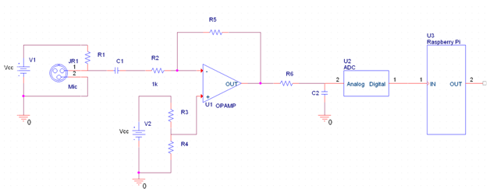

The part of the device that will zap the mosquito will receive a pulse from the microcontroller that will turn on a transistor and relay switch that will then send a voltage to a step-up transformer to charge a capacitor(C3) that generates a voltage high enough to zap a mosquito. LED is used as a visual indicator that the circuit is primed. Diodes throughout will help direct the flow of current, and prevent any unwanted spikes going in the wrong polarity.

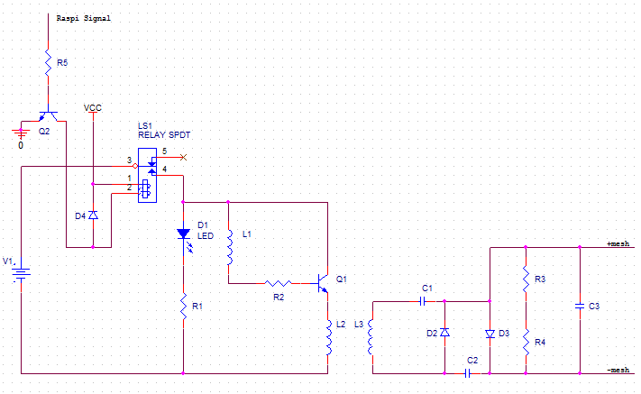

What follows is a flowchart of how the software programmed in the Raspberry Pi will interact with an input signal.

RaspberryPiFns (1).png

# Section 4. Discussions

## 4.1 Multi-Disciplinary Issue

As a team of 3 members who have experience in both Electrical Engineering and Computer Engineering, each member will have an important role in each part of our circuit design. Although each project member will be active in the development of each part in the circuit, the electrical engineers will design the audio detection, amplification, zapper, while the computer engineer will be focusing on programming the Raspberry Pi for the applications needed to fulfill our goals. Two members of our team have taken a class for signals processing using techniques such as Fourier Transforms. All members have also taken PCB design to make development of the circuit more compact and simple.

## 4.2 Professional/Ethical Issues

Our product is designed to affect the insect population, which will have a direct impact on the environment. If too large of the mosquito population is eliminated by our product, the food chain will be disrupted by a lack of prey for other animals. However, it has been debated by scientists whether it is detrimental at all to eradicate all mosquitoes because of the overwhelming negative consequences of their survival.

For professional considerations, our group wishes for our product to be optimized in both quality and cost. For now, our group has decided that a working effective product is the first step, and creating another circuit which can be cheaper, with less powerful components can be a later extension of the overall project goal.

## 4.3 Impact of Project on Society or Contemporary Issues

The goal of this project is to create a mosquito detecting and eliminating unit that can potentially save lives. Although, expertise in the engineering field may be needed to build and create the design, the final product can definitely be applied in other fields of biology using audio sensing. Audio detection can be used in many fields spanning from the music industry (audio engineering) to biology, to security and surveillance systems.

With the recent Zika virus outbreaks in Central and South America the need mosquito control has increased with fears of it spreading further. The World Health organization does try to track mosquito populations and a device like this that has the capabilities to detect and record amount of mosquitoes may be useful in the tracking of mosquito populations.

# Section 5. Summary and Conclusions

The goal in mind for this project is to create a working mosquito detector and zapper. We must design the product within the constraints set by Professor Westerfeld, and from our own considerations. For a quick overview of the circuit, audio is fed from the microphone through an amplifier into our Raspberry Pi. The Raspberry Pi will take the signal in the time domain and get frequencies for each sample and on a certain condition where the frequencies that correlate to a mosquito is met, the zapper will be set off.

The end product must work and be effective in eliminating the target with a low error percentages. Further improvements in our circuit can be to use a less expensive and powerful controller such as the ATxMega microcontrollers, more effective mosquito bait, and a better design of the mesh trap. An improvement to our current design could be to add Wi-Fi/Bluetooth capabilities that can communicate from the Raspberry Pi to a mobile device. Overall, our current design will meet our goals, but can be improved.

Our research has led us into various fields in engineering that we would normally not have been exposed to which will help in shaping us as engineers in the working field.

# References

1. World Health Organization, “Malaria vector control and personal protection” 7.1 On appropriate strategies and operational issues in eco-epidemiological settings, pp51-53
2. World Health Organization, “Malaria vector control and personal protection” 5. Effectiveness and challenges of implementing malaria vector control and personal protection strategies in the context of the various eco- epidemiological types, pp13-39
3. Janet Fang, “Ecology: A world without mosquitoes” Nature 466, web <<http://www.nature.com/news/2010/100721/full/466432a.html>>
4. Bill Gates , “The Deadliest Animal in the World”, web <<https://www.gatesnotes.com/Health/Most-Lethal-Animal-Mosquito-Week>>
5. Hayes, E. B., and D. J. Gubler. 2006. “West Nile virus: Epidemiology and clinical features of an emerging epidemic in the United States.” Annual Review of Medicine 57: pp181‐194
6. D. Raj Raman, Reid R. Gerhardt, John B. Wilkerson “Detecting Insect Flight Sounds in the Field: Implications for Acoustical Counting of Mosquitoes” <<http://lib.dr.iastate.edu/cgi/viewcontent.cgi?article=1055&context=abe_eng_pubs>>
7. Myhrvold, Nathan “Could this laser zap malaria?”, Talk 2010 California, TED <<https://www.ted.com/talks/nathan_myhrvold_could_this_laser_zap_malaria>>