„Are you ready to change your life? Give me a Yeah !!“

If this sounds like somethingyou can do, give me an:
„I can do this“

If you have seen this, tell me:
„If seen this“, because I‘m sure you have seen this before

If you see the abuse, give me a:
„They suck!“

If you are read to shut them down, give me a:
„Shut them down“

People worth being generous to exist in the world and I attract them into my life

If you‘re ready to ris, let me hear:
„Let‘s outsmart them“

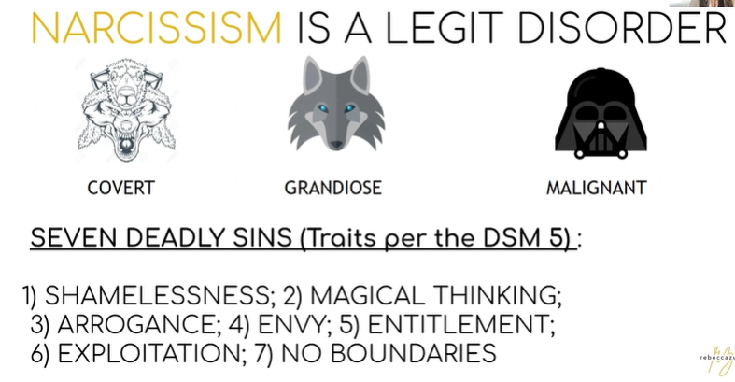

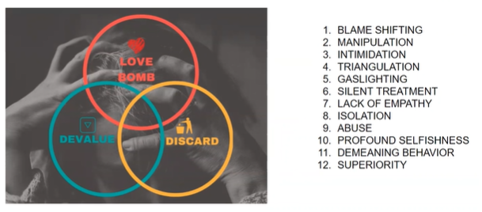
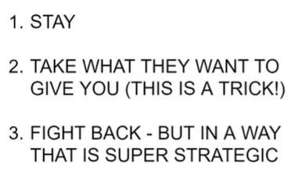
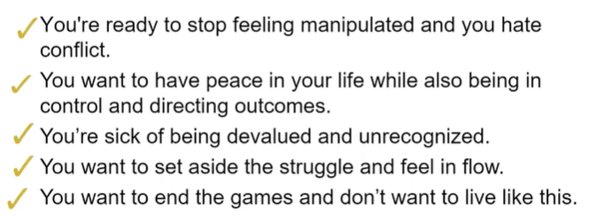
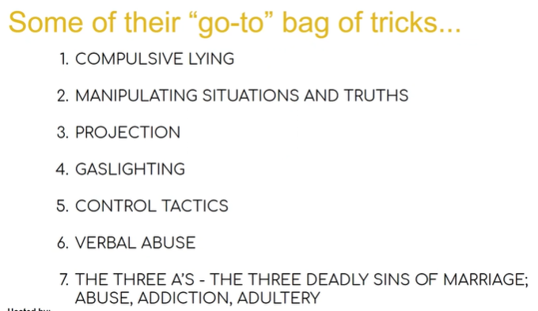
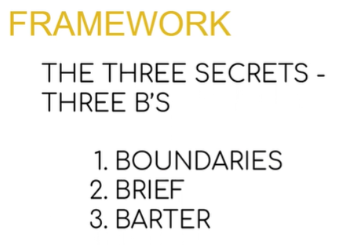
use Apps
minimum contact
check passwords

brief
just the facts
avoid: explain, justify, overshare
have a plan to get in and out of conversations (e.g. take a shower)

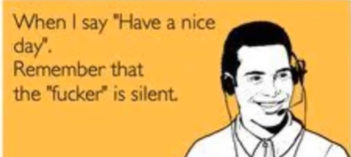
Thank you for your e-mail.
I deny your allegations.
You can pick up Jonny on Wednesday

barter → give something to get something
→ fluffing up the ego → compliments, supply
(e.g. soup → you‘re so good, kids will profit so much more)

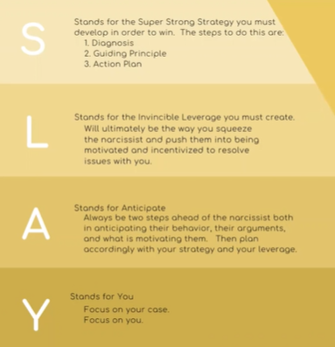

coverts, grandious, malignant

-------------------------

get respect from narcissist
https://www.youtube.com/watch?v=kSMWYT7RkpU

#6 keep distance
#5 stay independent (no need)
#4 have something they want (influence, prestige)
#3 assume position of control, or control of group
#2 show them you respect them, avoid talking narcisim
#1 be self assured

don‘t panic, if they panic

-------------------------

words that destroy (inflame and trigger rage)
https://www.youtube.com/watch?v=17gwc4oBImc

their acts are traumatic
fragile little ego on the planet
no internal value, value derived from external by sucking life out of everybody around
← narcisstic supply:
positive: money, influence
negative: control, devalue

1) You‘re a loser (no inner worth)
divert → avoid slightest hint of tone + body language
2) I don‘t believe you (pathological liars)
„I respect your opinion“ → avoid confrontation
3) I‘m busy
„I can make time at this time“ → still need to interact
4) ignore their texts
5) „You‘re wrong“ → don‘t even bother
waist of breath, only admit wrongdoing for strategic reasons
(see below: revenge)
6) Avoid the word „No“ → softer words, minimize contact, write

„Just the facts“ → calm + curious
avoid: justify, defend, overshare

inflamed narcissist might enrage you as well →
getting you angry feeds their supply (!!)
you will look worse than they do

---------------

covert narcissist
https://www.youtube.com/watch?v=fW_fWJFy_K4
female?
1) actions don‘t match word → I want your best, results are your worst
2) strangers over family → be aware, don‘t let it hurt you, it is their supply
3) stare at you, check social media, copy you (!!!) → not flattering, but creepy, no boundaries
4) don‘t like to give gifts, always strings involved
5) chameleons → one way with one group, another way with other group (no self)
6) take credit for other people‘s ideas, always shift blame → energy vampire
7) act strong, then play the victim

Say it with me: „Energy Vampires“

---------------------

https://www.forbes.com/sites/tanyatarr/2017/09/05/here-are-five-negotiation-tactics-to-use-with-a-narcissistic-boss/?sh=1004fd311c97

1) Maintain your own integrity. Always conduct yourself respectfully
2) Stick to facts and evidence.
3) Continue to collaborate. Keep making suggestions.
4) Document everything. Send follow up emails. Document how long it takes for you to complete tasks that you were given, particularly the unreasonable ones. Take screen shots.
5) Have walk away plan.

-----------------------------

Naive empath for narcissist
https://www.youtube.com/watch?v=7rjXDIaI_Rk

Trying to prove the wrong or feelings of revenge provide fuel to the narcissist (!!)
→ thrive of attention or reaction !!

------------------------------------

5 WAYS TO CRUSH A NARCISSIST IN NEGOTIATION
https://www.youtube.com/watch?v=zOeoIcVTAV4

from: drama, drama, and chaos
to: freedom, possibility, and purpose

love-bombing → devaluing → discarding
e.g. unpredictable rewards
love-bombing ↔ devaluing
almost like drug addiction → perfect and first, than isolated and no kick

symbiotic relationship with empaths → „we can love everybody back to health“
reasonable agreement ↔ battle

1) know your buttons → otherwise you feel in a bad light
2) know when you are disrespected → screaming, mean, swear words
(getting you to this level feeds their supply)
(don‘t talk to me like that, nevertheless: here is your answer)
3) document, to check your strategy and create a „fixed point“ (gas-lighting)
(always in mode of self-preservation)
no internal value → biggest fear is being exposed → leverage
4) expect their behaviour, don‘t take it personally
5) ask for way more + ask for things, that you actually don‘t(!) want → act like they won
6) never let them see you sweat → emotional, angry, cry → maintain control
(they get supply from getting under your skin) → (1) know your buttons

------------------

Ways to Trick Narcissists (Ethically Manipulate The Manipulator)
https://www.youtube.com/watch?v=CWuO7Uvrk4Y

narcissist live in a world of scarcity → if you can have it, I can not
manipulating the process, moving the goal post
→ go on the offense

1) narcissitic fluffing, bartering → value for value → adulation (Scheichelei), compliments, money
2) don‘t tell them what you actually want ↔ pretend you want something you don‘t → do some act
3) don‘t let the the narcissist know, you know → they will act around it
4) don‘t show them your leverage → they will act around it
(3) + (4) all at once at the opportune time

-------------

6 Things Narcissists Do at the End of a Relationship
https://www.youtube.com/watch?v=AJbF4mznHXc

love-bombing → devaluing → discarding

1) talk to people „I‘m so concerned about ...“ → plant the seed
2) black and white: my friends, my money, my kids
3) role of the victim → call others narcissists
4) make you feel isolated + and the world is against you
5) money grab → most of the time recoverable → bad in court anyway
6) blame game
7) last minute love-bombing: compliments + future faking (I will change)
8) guilt trip → time is bad, I did so much, what about the kids, we are just about to xyz, …
9) flood of demands, push agreements, show up at your house
10) get between you and your advisors
→ bad-mouthing lawyer or therapist, point out the wasted money
(nobody else should be in control)

------------------

How to Shut Down a Narcissist's Smear Campaign
https://www.youtube.com/watch?v=Ticeojual-g

leave idea that:
something wrong with you
you are not what they thought you are
you did something to the narcissist

„plant the seed“ ahead of time → passive aggressiv → „he wants to be a good parent, but ...“

unsecure people are more open to gossip, narcissist sprinkles in truth to make it plausible
1) isolate you → supply
2) make you emotional (angry, sad, …) → supply

1) be emotionally prepared
2) ignore, don‘t feed the fire
3) „I disagree“

„I have received your e-mail, I deny the allegation, I will see you on Wed to pick up the kids“
don‘t get sucked into the vortex

4) get your own future → stay in creation mode

Facebook: Rebecca Zung Narcissist Negotiators

-----------------------

6 Things Narcissists Do When You Go No Contact
https://www.youtube.com/watch?v=XEbBc3xkJVI

stand in my shoes and want to be me → go no contact to save your soul

1) revive the best phase → love-bomb, devalue, discard → ping, hoovering
2) even escalate effort
3) triangulation → smear campaign → effort to feel isolated
4) rage triggered → even use their anger to intimidate, but
5) → start making mistakes → undoing + collapse
6) find supply somewhere else → stick with no-contact

-------------------

Narcissists & Sex Part 1
https://www.youtube.com/watch?v=_nCStUeDKxw
Stages of Narcissistic Sexual Abuse (Narcissists and Sex Part 2 of 3)
https://www.youtube.com/watch?v=LBAoOZaKeEQ

tools to control
no self-worth, no empathy, not able to care

1) you are not desireable → area to gaslight
2) their pleasure matters
3) you are greedy
4) if they know, what you want, they will take it away
5) jealousy → demanding control
6) victim card → make them feel secure again
7) malignant → unsafe + violent
8) use sex as a weapon

------------------

Why Narcissists Ruin Holidays
https://www.youtube.com/watch?v=d4w1T3oGHBw

1) It‘s about somebody else → supply distracted
2) hate to take care of others
3) love for you to be upset → they feed on you being upset

don‘t show weakness, expect their behaviour,
like a 2-year old, let them have their tantrum, just drink your

----------------

5 Ways to EXPOSE a Covert Narcissist's TRUE Nature
https://www.youtube.com/watch?v=Ydyi1eZ45x4

1) inherently lazy → give them deadlines → covert
→ initial flurry of activity → then hang back → ask for updates
2) generally no own ideas → give deadline as well
3) create a group setting to present ideas + deadlines
4) People worth being generous to exist in the world and I attract them into my life
5) Get them to respect you → see above (distance, leverage, fluffing)
6) accept that they are hypocrites → document
→ don‘t like person → still hang out
→ are sick → end up going
7) accept that they like gaslighting → document
→ remember this + that → way to make you insecure → make you question your mind

----------------

5 Questions Narcissists Can't Answer
https://www.youtube.com/watch?v=Qbo5HrH3l7Q

1) the truth → document → lie even when they don‘t have to
2) giving credit → „What benefit did you get from this person?“ → scarcity mentality
3) failing or losing → magical thinking
4) shaming or vulnerability → enormous sense of shame → always victim
5) how well they interact with others → great at beginning → difficult to maintain

Vague answers, gaslighting, projection, blame & shame → create instability

--------------------

Self Care to Cope with A Narcissist (How to Survive then Thrive)
https://www.youtube.com/watch?v=7RPfar47338

1) movie 1940 → gaslight → blew out gaslight, pretend it never burned
2) love-bomb – devalue cycle → addiction
3) lack of boundaries
4) passive-aggressive behaviour
5) „wicked witch of the west → flying monkeys as helpers
7) intimitation, threat of stalking

1) avoid victim mode, go to creative mode, rest of your life mode
2) have things to think about instead (pivoting)
3) change breathing (meditation)
4) be active

-------------------------------

COVERT NARCISSISM IN RELATIONSHIPS (and How to Manage Them)
https://www.youtube.com/watch?v=qegzkBLkUPs

1) normal on surface, even more toxic
2) shy or depressed, always the victim → part of their plan
3) appear super helpful → turns to passive aggressive → isolating
4) play the victim → sick, unable to work
5) lack empathy → apologize on the surface

trying to get under your skin + get a rise out of you

1) don‘t react
2) call them out with documentation (no emotion, no smugness)
→ just notice, don‘t seem bothered
3) avoid emotion, react factual
4) avoid gaslighting → We talked about this? We agreed?
5) come to your room, read your mail → no boundaries
→ close down communication

----------

Surprising Ways to Beat a Narcissist in Mediation
https://www.youtube.com/watch?v=QVuzfhkRxNI

---------------

todo:

youtube rebecca zung collapse of a narcisst

--------------

Sharing good news with a narcissist
https://www.youtube.com/watch?v=FY5auXK6MhE

good news
- not feed-back, not critisism
- activates: inadequacy, insecurity, jealousy, envy
→ triggers of shame
→ rage or passive aggressive or contempt or silent treatment

→ really confusing in relationship
→ not because you‘re not enough
→ narcissist just has no empathy
→ finds a way (loud or quiet) to punish you (for their emotions)
→ no magic way to get their attention

→ victim → not sharing good news at all

→ presonal mistake: every dinner conversation was about accomplishments !!!

----------------------------

Stop Saying This to Narcissists
https://www.youtube.com/watch?v=cbZvMGTbJqw

you can‘t interact →
only incentivized by supply →
vampires of energy, anger, humiliation → don‘t say it to them, don‘t write it to them
don‘t mind being caught lying
project, reflect, deny → survival at risk
you will end up in the mud with them → document, don‘t react
don‘t show weakness, don‘t assume victim‘s position
be carful, when you talk to yourself: I‘m excited, I‘m not scared.
„I agree that that‘s your position“ → positive trigger of supply

----------------------------

How to Outsmart a Narcissist (The Right Way)
https://www.youtube.com/watch?v=SW9rFOqBZaU

you think the two of you are looking for a resolution
drama, drama, chaos
leverage: fear of being exposed
strategy: don‘t respond → your response is their supply
escalation: scare you, degrade you, debase you
strategy: refuse to be a victim, don‘t respond, but build invisible fence around them

step 1: don‘t respond line by line to their accusations
„I‘m in receipt of your correspondence and I deny your allegations“
end goal: be a brick wall

step 2: disengage emotionally
know your triggers, pretend they do not exist (upset, angry, sad), be a bystander (no supply)

step 3: act like you don‘t care about things, never show, that you‘ve won

step 4: create leverage
best case ↔ worst case
my side (details), other side (details)
leverage (incentives)
offer

----------------------

Make Sure You Hide This From The Narcissist
https://www.youtube.com/watch?v=d1OVFx5ff0Q

drama-drama-chaos

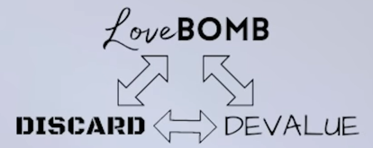

get you, before you get them → all or nothing
burn the bridge on the way out → leave them feeling hated

do not share what you want
do not share your leverage → use strategically for barter
hide what is upsetting you → pretend you don‘t care

----------------------------

8 Phrases That Silence Narcissists
https://www.youtube.com/watch?v=oyr4JvLYDZk

1) „I agree with you“ (just don‘t write it down)
2) „I‘m sorry, if that‘s what you think“ → not a real sorry, actually:
„I‘m sorry that we are in this situation“,
„I‘m sorry this happenend to us“ → supply
3) You have every right to your opinion → dis-engage → un-trigger-able
4) „I can see that you are ...“ → make them the center of attention
Observing the situation gives you leverage.
5) „If you wanna talk now, I will insist on calm and respectful“
→ Set boundaries !!
6) „I believe that‘s how you feel“
→ they don‘t know what to do, (they only know what to do with pushing against each other)
7) „That‘s an interesting perspective.“ → it‘s just words I heard → un-trigger-able
8) „This approach / this conversation is not working for me“
→ no accusation, still end of conversation → not against other person per se

Phrases help you feel more powerful

----------------------------

Do This Instead To WIN EVERY TIME | Lisa Romano
https://www.youtube.com/watch?v=-ZuO2URlEuY

Shut – shut → do not react
Hold your posture → shoulders down, stand tall
Come back to the goal → I hear you, I disagree, this is the goal
Try not to blink or figetting
Keep your integrity, especially when children are present
Focus on your reactions: abandonment, guilt, anger, defending
Ask, „Okay, but what is your next step?“

Codependent → Feeling abandont or „not good enough“
Narcissist → Feels perfect, provides validation, dangles it to conrol you
Feeling invisible + „not worth it“

-------------------------------

What is "narcissistic rage"?
https://www.youtube.com/watch?v=pEyKLMMj-FA

anger → out of frustration or surprise
→ sign that something is not good

rage → loud, obscene, targeting other person, breaking things → „possessed“
narcissistic rage → grown-up tantrum → minimal triggers

btw: first sign in narcissistic relationship !!
→ nobody wants to be the messenger → avoiding the rage

children
→ anxiety
→ always on edge
→ fear of conflict
→ fear of own anger
→ chose narcissistic partner → governed by someone elses rage

-------------------------------

How narcissists are made
https://www.youtube.com/watch?v=d79qPeIt1GY

over and under appreciated
sad child makes mummy sad → child learns that their emotions cause problems

→ no chance to learn regulation
→ child like tantrums → to protect internal insecurity

-------------------------------

These Are the Signs Someone Was Raised By a Narcissist
https://www.youtube.com/watch?v=uRMhS6oeehY

overinlflated self
no empathy
false outside image
insecure self
believe in limited resources
believe in limited attention

healthy relationship
→ intimicy → willingness to vulnerability ↔ power struggle

-------------------------
-------------------------

https://www.psychologytoday.com/us/blog/understanding-narcissism/201908/10-stages-in-the-treatment-narcissistic-disorders
10 steps

Stage 1: Symptom Relief or Appeasement (want to please someone)
Stage 2: Avoid Future Pain (know triggers)
Stage 3: Identify their Coping Mechanisms.
Stage 4: Create New Coping Mechanisms.
Stage 5: Form New Habits (neuronal change)
Stage 6: Impact on Other People (other people’s needs into consideration)
Stage 7: Focus on Childhood Pain (defenses against shame not at the center any more)
Stage 8: Update the Inner Voice.
Stage 9: Empathy for Other People (until here: lens of self benefit)
Stage 10: Authenticity (feel trust that they can be authentic)

-------------------------

https://www.goodtherapy.org/learn-about-therapy/issues/narcissism

… help a person understand their emotions and psychological states, so that they can respond to others in less harmful ways.

Effective therapy for NPD is free of judgment and stigma, and honors the client’s goals.

-------------------------

https://www.youtube.com/watch?v=nffO-KJicQw
6 alternatives to calling out the narcissist

1) put energy in evaluating alternative situations
2) put energy in understanding narcissism
3) grey rocking (dis-engagement)
not taking bait
no invalidating conversation
not sharing achievments to not have them minimized
not sharing pain, there is no empathy
just superficial, unemotional topics
it‘s not a deep relationship, but the fact is: there never was
4) don‘t go deep, avoid the drama
5) sources of support (social groups, therapy, venting space)
6) radical acceptance … these are the limits of this person, the relationship will not change
7) don‘t defend, don‘t explain, don‘t personalize
8) distraction (e.g. binge watch !!)

rage will pull in bystanders (children) and might make matters worse
-------------------------

https://www.youtube.com/watch?v=Lt56nGmGG-0
The 5 Signs Someone Has Suffered Narcissistic Abuse

-------------------------

10 ways to become resistant to narcissists
https://www.youtube.com/watch?v=8EqSlSPHjR0

already in relationship, confronted as a parent

1) gaslight repellent
value your own opinion, don‘t consider them smart
2) stop falling for charisma and charme
intoxicating or larger than life, usually covering something up
3) smart + educated is not the same as a nice person
toxic, rude, unkind ↔ kindness
4) rich + successful → potential for gaslighting
pay attention to words and actions
5) watch how they treat other people and talk about other people
distinguish public face and face for people close to them
6) study their telling signs
conditions of frustration and disappointment → blaming others
7) learn to set boundaries
just say: No, learn to tolerate their discomfort, don‘t be the one to always compromise
entitled people take the middle
8) dump the enablers
cloud of denial, passing down inter-generational patterns
9) no second chances
10) suround yourself with good people
narcissist are like weeds, they demand all of your time, want control and isolate
save time for healthy people

11) start getting comfortable with the lonely path
skip some events and get-togethers
12) grey-rocking is narcissist repellent for new narcissist

-------------------------

How to point out a narcissist to other people
https://www.youtube.com/watch?v=Bj1y6Oc7h4w

flying monkeys:
Wizard of Oz → Wicked Witch of the West → Sends Flying Monkeys
To maintain the illusion of the power they have over you, the narcissist will employ the use of third parties, through which they will attempt to continue control and manipulate you.

Very hard
Showing the behaviour → usually fires back
Gaslighting → You‘re too sensitive
Resistance → You‘re petty, bad person, unforgiving, labelling
excuses, justifications, and rationalizations / blamed yourself / just assumed as normal
Alternative: boundaries, gray rock, no contact

Sie hatte es auch schwer, hat sooo viel gemacht, etc.
family members: possible flying monkeys, certainly enablers
those who understood: Already found little ways to support you

narcissist usually put on show on the outside, two faces
Cry for help we go unheeded, people stay silent for years, focus on materialistic benefits
Even more disbelief, invalidation, and gaslighting
Easier for them to maintain their status quo
Even real proof of videos, rage
People will believe that everybody can change
Couple therapist vulnerable to charm of narcissist‘s show, recommends better communication
Couple therapists and HR departments will not accept labelling, they stick to script.
Work place, just provide documentation, never meet alone

Enablers of compative, difficult, entitled, poorly regulated person:
People should not be mean, we don‘t know her back story
Maybe she needs compasion and love and she will change
The consequences for her would just be too severe

Just give them another chance, they did not know what they were doing

Rage .. Wut, Furor

Slowly disengage, narcissist finds new target,
plant the seed of doubt with new person by pointing out, that this was not okay
„This is not good for me, so I need to step away from it“
„I respect other people‘s choices, and I have no place questioning those“
Still some push-back, yet it is still a stronger statement.
Most people only get, when experiencing abuse themselves...

How to point out a narcissist to other people
Answer: Give narcissist the space to hurt one after the other, they rarely dissapoint
Experience is the best teacher
No justice? Life is not fair. It is not your job (except parent)
Step out of the way, you are not the human shield. Self-preservation.
Redemption? Personalities don‘t change easily

-------------------------

How to "firewall" the narcissist
https://www.youtube.com/watch?v=49HGOGy8lzw

Grey rocking works, but we need to be able to interact (work, traffic, home)
step 1) understand behaviour, notice red flags
step 2) understand enablers
step 3) radical acceptance, these patterns don‘t change
step 4) don‘t defend, engage, explain, or personalize
you can‘t talk malware off a computer !!
step 5) it‘s not personal, anybody would get that computer virus
step 6) don‘t share or make yourself vulnerable
step 7) keep at arm‘s length, slowly disengage

-------------------------

COPARENTING WITH A NARCISSIST WITH DR RAMANI PART 1
https://www.youtube.com/watch?v=lf0nQTljUyI

-------------------------

The fate of the brainwashed child
https://www.youtube.com/watch?v=YLzmzfWB_hw

-------------------------

How to think about your narcissistic parent
https://www.youtube.com/watch?v=z1JVHyTBAbw

making excuses for bad behaviour
anxiety
guilt, shame, and anger
drama bonded relationships
managing the enablers

step 1) you were robbed
pettiness, manipulation, gaslighting → damages the soul from inside out
unconditional love + acceptance, be seen and valued, childs need first
every family holiday is a tsunami of shame over horrible negative emotions

step 2) acceptance is temporary
important step of grieve
this is your story, you can‘t change it
on some days, acceptance is impossible

step 3) stop gaslighting yourself
„don‘t be so sensitive
„that never happenend
„I didn‘t really mean that
„It started with you saying this / that

step 4) it‘s not your fault, it was just bad luck
your are not responsible for their selfishness, rages, manipulations, invalidations, gaslighting
you have spent a childhood wondering:
„If only I did not say that
„If only I‘ve kept my room clean
„Maybe if I could do this she would notice me
NO !
Kids and partners get it the worst

step 5) they sacrificed so much
No they didn‘t. This is a rationalization of a child to make self of it
Parenting is a privilege, they should see it as a divine role.
Compromise has to happen on the part of the parent, not the child

step 6) peace may come only when they have passed
It‘s hard to admit it.
This relief is often coupled with guilt.

Step 7) step away from your family enablers
People will make excuses for them, especially parents and friends
Enablers want to keep their happy world, even when children suffer right before their eyes
Denial + culture + stupidity

setp 8) „no contact“ vs „gray rock“
People may shame you, but you are a surviver.
To „gray rock“ you need to know your triggers and the bait you fall for

step 9) Stop excusing people based on their back-story
No direct reason for gaslighting, dismissiveness, and rage
Most people with difficult back stories don‘t let it out on their children !!
Actually, it helps you realize, they will never going to change

setp 10) Stop getting stuck in the „if only different“ vortex
What would I have been like
if they divorced, not divorced
Usually a dead-end
They are who they are, they are not different

step 10a) Reparent yourself
If you‘re lucky, you had a person who showed love and compasion.
lucky, you had a family member who was present and had a safe and special space for you.
Treat yourself, how you would have treated a child.
Do it for the next generation, but start with yourself.

What does a healthy parent do:
Love unconditionally
Keep them safe
Authentically mirror their emotions
Support and encourage aspirations
Compromise for them and put own stuff aside for the child

It‘s not easy, but it‘s not too late.

Step 11) They will never change
Actually, as they loose power and capacity, it gets worse
Cancel that child-like hope, that maybe today will be different
It won‘t.
It is not a relationship you chose.

Rethink
Create boundaries
Stop blaming yourself
Set yourself free from their negative voices.
Most people will not get it, they will gaslight and enable.

Important: This will not define you. Most people go on to rather heroic adulthoods.

-------------------------

How narcissists use money to shame you
https://www.youtube.com/watch?v=cJu3rPul2wc

-------------------------

6 things narcissist enablers say to you
https://www.youtube.com/watch?v=Ok4-7RJut6I

-------------------------

11 tactics for not letting narcissists into your life in the first place
https://www.youtube.com/watch?v=UdcGsbcANj8

-------------------------

Blockade lösen für Leichtigkeit, Freiheit und Fülle

-------------------------

Explain narcissism to others using the C.R.A.V.E.D. method
https://www.youtube.com/watch?v=M4ypZnVF03M

CRAVED

C .. conflict → always baiting, always fighting
R .. rigid → never gives in
A .. antagonistic → manipulativ, explitative, gas-lighting, deceit
V .. vulnarable + vindictive (rachsüchtig) + victimized → everything unfair, bad-mouthing
E .. entitled → defining feature for narcissist → preferred treatment → otherwise rage
D .. disregulated → reactive, not regulating emotions

-------------------------

7 WAYS TO OUTSMART A NARCISSIST IN CONVERSATION: Disarm the Narcissist
https://www.youtube.com/watch?v=b0dR4acY09M

step 1) limited + simple communication
step 2) understand personality → black + white view → all good or all bad
no empathy → don‘t go for revenge → not productive
step 3) distance from narcissist and enablers → maybe come back later
step 4) narcissist injured by boundaries → either baits or triggers → hoover or argument
„That‘s nice“ or „Unfortunate you feel that way“ → dry response → don‘t defend yourself
step 5) indicate happiness → powerful words when problems arise: „So what?“
if they insist that you should care, ask back: „Why do you care?“
They want you to feel bad about who you are. Own it, but don‘t explain
step 6) highlight ugliness, but remain calm → „That was really, really mean.“
passive aggressive → ask → what does that mean
step 7) keep a close eye on your emotional state → danger zone → you‘re likely to react
narcissist triggers wounds in you

"It's unfortunate you feel that way," is better than saying "I'm sorry you feel that way."
Never apologize to a narcissist. Validation is not required.

-------------------------

Emotionally Abusive Narcissists Will Lose Their Minds IF Empaths Do These 10 Things
https://www.youtube.com/watch?v=WkcLfOx81a0

-------------------------

How to speak to a narcissist
https://www.youtube.com/watch?v=Q95in8mCPRM

-------------------------

Managing A Narcissist | Ann Barnes | TEDxCollingwood
https://www.youtube.com/watch?v=2pq-shPP4cw

-------------------------

GASLIGHTING TYPES, PHASES & PHRASES: Don't Fall for
https://www.youtube.com/watch?v=hN8IMnLdw04

-------------------------

10 Ways to Make A Narcissist Respect You
https://www.youtube.com/watch?v=j14kNoVsbTw

they can respect what they want from themselves
on the other hand, that respect makes them envious

1) high self-esteem is high value

2-4) limited availability is high value

2) let narcissist know, that you can abandon them, with many other options

3) disengage, otherwise drama, drama, and chaos
only engage, if fun and kind-of-nice to be around

4) grey-rock technique → simple sentences, like they not exist

5) calmly end conversations if not productive or being steared away

6) present yourself as high-status
respect will turn into envy, devalue, and discard

7) do not walk on egg-shells, if no danger of physical violence
narcissist rage about every detail.
Being to passive exposes their hyper-sensitivity

8) set your own boundaries
narcissists boundaries are too inconsistent

9) let them know, how busy you are

10) play hard to get
novelty seeking behaviour
want to prove they can conquer you

-------------------------

8 Ways To Outsmart The Controlling Narcissist
https://www.youtube.com/watch?v=wAW1NS2Sspw

outsmart the controller who want to make you a mini-version of themselves
→ anger issues on part of controlled person !!

in/out reference → with me or against me → test this by changing the rules constantly
dont‘t attempt to gain entrance, just be there

demonize if you speak against their agenda → „You‘re impossible to deal with“
„I would like have my own definition and decide for myself“

narcissists activate enablers („flying monkeys“)
don‘t try to convince them, show them CRAVE

narcissists supresses your creativity and activities
Enjoy your own activities, don‘t talk about it

-------------------------

6 Signs You Have BEAT The Narcissist
https://www.youtube.com/watch?v=Gvs8RqBIIHs

-------------------------

Highly sensitive people and narcissism
https://www.youtube.com/watch?v=8o7kcZim-F0

-------------------------

