**technical papers**

**development process**

No pseudo-labels were used, only labeled data was used for supervised training. Spacing and crop size referred to the preprocessing parameters in nnUnet[1].

**Training tips**

Preprocessing part: each data spacing is (0.3,0.3,0.3), the original data dimension is (B,1,H,W,C), Crop is (112,160,128), and it is normalized according to channel.

Data enhancement: flip, elastic transformation (Elastic), Gaussian smoothing, Gaussian noise, intensity transformation, Mixup+CutMix

**Model section:**

DynUnet

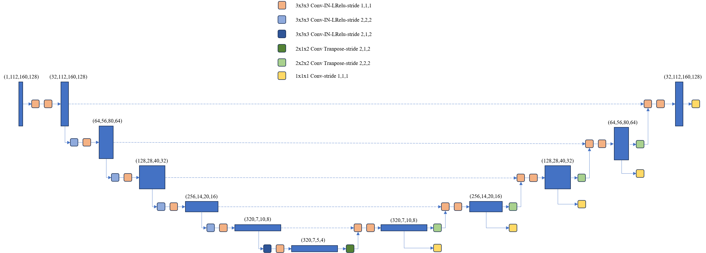

**Training section:**

The loss function is FocalLoss+DiceLoss, the optimizer is AdamW, the learning rate lr=5e-4, the learning rate is adjusted by cosine annealing, and the epoch is 1000

TTA: The strategy is horizontal flip, vertical flip.

**Innovative ideas**

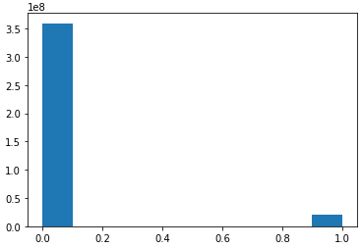

Figure 1 Proportions of voxels in foreground and background

1. Due to the imbalance between foreground and background, FocalLoss is used to better learn foreground information.

2. Use a larger Unet with more subsampling and use deep supervision.

3. The appropriate Spacing can greatly improve the performance of the model. After adding Spacing, the score in the test set is 0.7437

It goes up to 0.8075

4. Mixup and CutMix are also important factors to improve model performance.

**Split result display:**

test set:

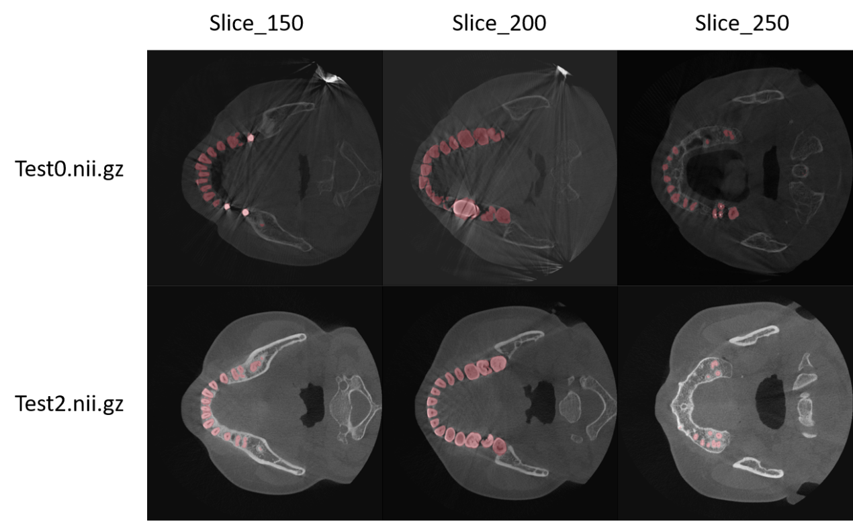

**Corresponding evaluation indicators:**

Score：0.8075，dice：0.8123，iou：0.8431，hausdorff_distance：0.2344

validation set:

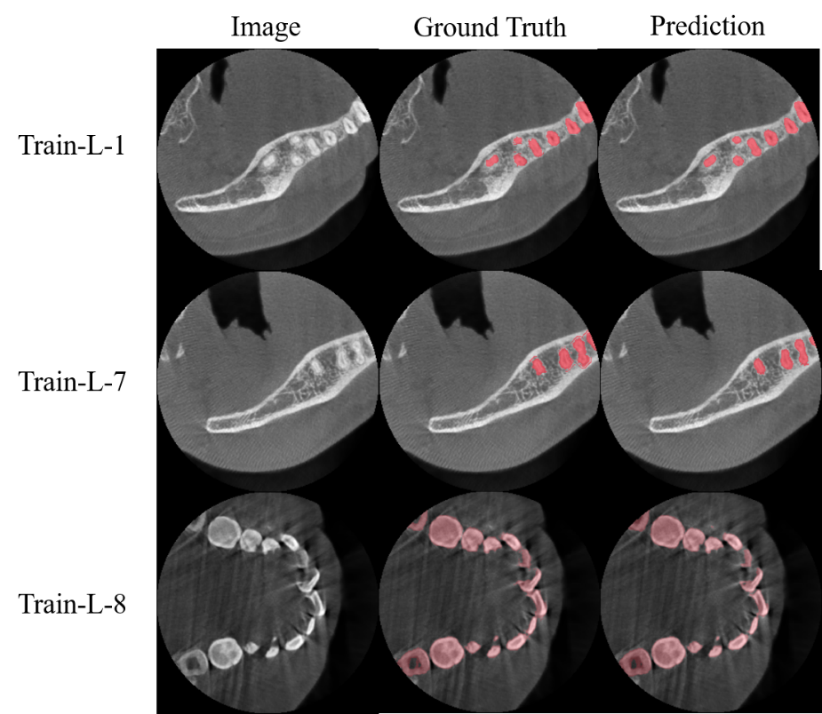

**reference documentation:**

[1] Isensee, F., Jaeger, P. F., Kohl, S. A., Petersen, J., & Maier-Hein, K. H. (2021). nnU-Net: a self-configuring method for deep learning-based biomedical image segmentation. Nature methods, 18(2), 203-211.